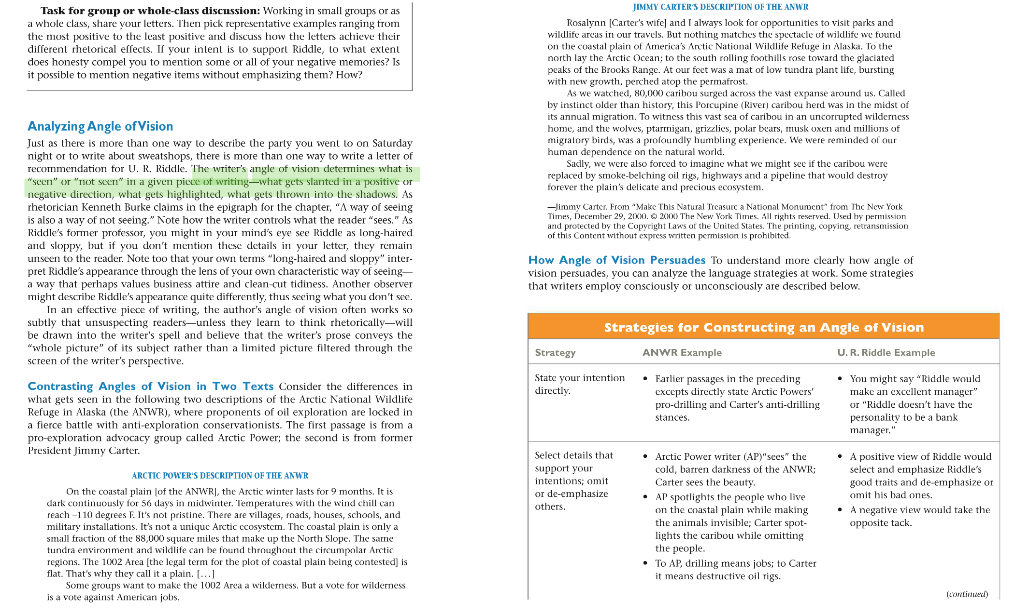

Artic and Jimmy carter description are the passages

