CSC 352/452: Database Programming
Mid-term Exam
(300 Points)

Late exams will not be accepted or graded.

Due on Sunday, 2/21/2016 at 11:59PM

- The mid-term exam is a take-home exam. You can use any of your class notes and readings to complete the exam.
- You may not consult in any form with any other person while doing this take-home exam.
- Please submit a text file containing all your answers to D2L before or on due date. All other file types (e.g., DOC, DOCX, RTF, PDF, JPG, or ZIP) will be rejected. In D2L, only the most recent submission is kept.
- Please review your assignment file before submitting it to make sure you have the correct one. It is your responsibility to ensure that you upload the correct assignment file. If you submit a blank/wrong file, you will simply receive a grade of zero.
- The mid-term exam is due by 11:59 pm Sunday, February 21, 2016. Do not wait until the last day to submit your assignment file! Submit ahead in case of unforeseen circumstances such as a computer crash or illness. There are no exceptions to the deadline.

Part I (CSC 352 and CSC 452 - 120 points)

There are a total of 12 questions. Each question is worth 10 points. Please read each question carefully and choose the correct answer.

Assume that the tab1 table exists in the underlying database.

Q1. In which section of a PL/SQL block is a WHEN TOO_MANY_ROWS THEN clause allowed?

A. DECLARATION
B. EXECUTION
C. EXCEPTION
D. All of the above

Q2. Evaluate the following CURSOR statement:

DECLARE
CURSOR c_1 (p_ename VARCHAR2(50)) IS
SELECT * FROM tab1 WHERE c90 = p_ename;

Why will this statement cause a syntax error?

A. The size of the p_ename parameter cannot be specified.
B. The SELECT statement is missing the INTO clause.
C. The UPPER or LOWER function is missing in the WHERE clause.
D. All of the above.

Q3. What is the purpose of the FETCH command in using an explicit cursor?

A. To define a cursor to be used later.
B. To execute the query and identify the active set.
C. To retrieve rows (records) from the active set into local variables.
D. To close a cursor.

Q4. PL/SQL records of the same declared type can be compared for equality by using the equality operator (=).

DECLARE
TYPE t_1 IS RECORD (col_1 NUMBER, col_2 NUMBER);
v_1 t_1;
v_2 t_1;
BEGIN
……
IF v_1 = v_2 THEN
DBMS_OUTPUT.PUT_LINE('v_1 = v_2');
ELSE
DBMS_OUTPUT.PUT_LINE('v_1 != v_2');
END IF;
……
END;

A. FALSE
B. TRUE

Q5. Evaluate the following PL/SQL block:

DECLARE
v_stock BOOLEAN;
v_quota BOOLEAN := TRUE;
v_approval BOOLEAN := TRUE;
v_option BOOLEAN := NULL;
BEGIN
v_option := v_approval;
v_approval := v_option AND v_stock AND v_quota;
END;

Which value is assigned to v_approval?

A. NULL
B. FALSE
C. TRUE
D. None of the above

Q6. What is the value of v_flag when the following PL/SQL block is executed successfully?

DECLARE
v_flag BOOLEAN;
v_n NUMBER;
BEGIN
SELECT COUNT(*) INTO v_n FROM tab1;
v_flag := SQL%FOUND;
END;

A. The value is TRUE if and only if the tab1 table is empty.
B. The value is FALSE if and only if the tab1 table is empty.
C. The value is NULL if and only if the tab1 table is empty.
D. The value is always TRUE.
E. The value is always FALSE.
F. The value is always NULL.

Q7. Evaluate the following PL/SQL block:

DECLARE
CURSOR c_1 IS SELECT * FROM tab1 ORDER BY c20;
v_1 c_1%ROWTYPE;
BEGIN
OPEN c_1;
LOOP
SELECT c_1 INTO v_1;
EXIT WHEN c_1%NOTFOUND;
IF c_1%ROWCOUNT > 5 THEN
DBMS_OUTPUT.PUT_LINE(v_1.c2);
END IF;
END LOOP;
CLOSE c_1;
END;

Why will the above block cause a syntax error?

A. The %ROWTYPE attribute can only be used in reference to actual tables.
B. The %ROWCOUNT attribute can only be used in implicit cursors.
C. The EXIT WHEN statement is illegal.
D. The SELECT-INTO statement is illegal.

Q8. Which guideline relates to a CURSOR FOR Loop?

FOR c_idx IN cursor_name LOOP
statement1;
statement2;
......
END LOOP;

A. The user must explicitly declare the c_idx in the DECLARATION section.
B. It does not require a FETCH statement.
C. The cursor must return at least one row.
D. All of the above

Q9. Consider the following SELECT-INTO statement in a PL/SQL block. What happens if there is no row satisfying the WHERE condition?
……
SELECT COUNT(*)
INTO v_count
FROM tab1
WHERE c10 = 0 AND c20 > 0;
……

A. The SELECT-INTO statement executes successfully.
B. A TOO_MANY_ROWS exception is raised.
C. A NO_DATA_FOUND exception is raised.
D. A ZERO_DIVIDE exception is raised.
E. All of the above

Q10. In a PL/SQL block, when a variable is declared as NOT NULL, you must initialize the variable when it is declared.

A. FALSE
B. TRUE

Q11. To which of the following will an exception raised in the DECLARATION section of the block B_2 propagate?

<<B_1>>
DECLARE
v_4 NUMBER;
v_5 NUMBER;
BEGIN
v_4 := 10;
v_5 := v_4 + 80;

<<B_2>>
DECLARE
v_3 NUMBER := 90;
v_4 NUMBER := v_3 / (v_3 - v_5);
-- Run-time error, propagate to?
BEGIN
v_3 := v_3 * v_4 + 1;
v_4 := v_3 + v_4;
EXCEPTION
WHEN OTHERS THEN
DBMS_OUTPUT.PUT_LINE('ERROR (B_2)!');
END B_2;
v_4 := v_4 * v_4;

<<B_3>>
DECLARE
v_2 NUMBER := 0;
v_5 NUMBER := v_4;
BEGIN
……
EXCEPTION
WHEN OTHERS THEN
DBMS_OUTPUT.PUT_LINE('ERROR (B_3)!');
END B_3;

<<B_4>>
DECLARE
v_1 NUMBER := 3;
BEGIN
……
EXCEPTION
WHEN OTHERS THEN
DBMS_OUTPUT.PUT_LINE('ERROR (B_4)!');
END B_4;
……
EXCEPTION
WHEN OTHERS THEN
DBMS_OUTPUT.PUT_LINE('ERROR (B_1)!');
END B_1;

A1. The B_1 block’s DECLARATION section
A2. The B_2 block’s DECLARATION section
A3. The B_3 block’s DECLARATION section
A4. The B_4 block’s DECLARATION section
B1. The B_1 block’s EXECUTION section
B2. The B_2 block’s EXECUTION section
B3. The B_3 block’s EXECUTION section
B4. The B_4 block’s EXECUTION section
C1. The B_1 block’s EXCEPTION section
C2. The B_2 block’s EXCEPTION section
C3. The B_3 block’s EXCEPTION section
C4. The B_4 block’s EXCEPTION section
D. None of the above

Q12. How many rows will be inserted into the tab1 table after the following PL/SQL block has been executed successfully (no runtime error)?

DECLARE
v_count NUMBER := 1;
v_1 NUMBER := 1;
BEGIN
DELETE FROM tab1;
COMMIT;

FOR i IN REVERSE 6..11 LOOP
INSERT INTO tab1 VALUES (i, i*2, i+3);
END LOOP;

SELECT COUNT(*)
INTO v_count
FROM tab1;

FOR i IN 2..v_count + 10 LOOP
INSERT INTO tab1 VALUES (i, i+10, i+20);
END LOOP;

INSERT INTO tab1 VALUES (99, 205, 306);

SELECT COUNT(*)
INTO v_1
FROM tab1;

WHILE v_1 >= 7 LOOP
IF v_1 = 10 OR v_1 = 25 OR v_1 = 35 OR v_1 = 45 THEN
INSERT INTO tab1 VALUES (v_1*20, v_1*30, v_1*40);
ELSE
v_1 := v_1 - 1;
END IF;
v_1 := v_1 - 2;
END LOOP;

FOR i IN 2..48 LOOP
IF i = 4 OR i = 16 OR i = 47 OR i = 48 THEN
INSERT INTO tab1 VALUES (i*20, i*30, i*40);
END IF;
INSERT INTO tab1 VALUES (i*21, i*31, i*41);
END LOOP;

INSERT INTO tab1 VALUES (616, 222, 243);
INSERT INTO tab1 VALUES (77, 88, 99);
COMMIT;
END;

A. 72
B. 73
C. 74
D. 75
E. 76
F. None of the above

Part II (CSC 352 and CSC 452 - 180 points)

- You are not allowed to create/use temporary tables/views/functions/procedures/triggers.
- If you modified the DEPARTMENT and EMPLOYEE tables created in Assignment #1, you need to delete and re-populate them.
- The Exception section in your program is optional.

1) (CSC 352 and CSC 452 - 60 points)

The BIRTHDAY_DISTRIBUTION table consists of every day of the year, from January 1 to December 31, along with a ranking based on how many babies were born in the United States on that date between 1973 and 1999. Rank 1 is the most popular, rank 2 is the next most popular, and so forth.

Create and populate the BIRTHDAY_DISTRIBUTION table by using the following SQL statements. (You have to connect to CDM’s Oracle server to populate the birthday_ distribution table.)

CREATE TABLE birthday_distribution
(MONTH NUMBER,
DAY NUMBER,
RANK NUMBER);

INSERT INTO birthday_distribution SELECT * FROM hchen.birthday_distribution;
COMMIT;

SELECT COUNT(*) FROM birthday_distribution;

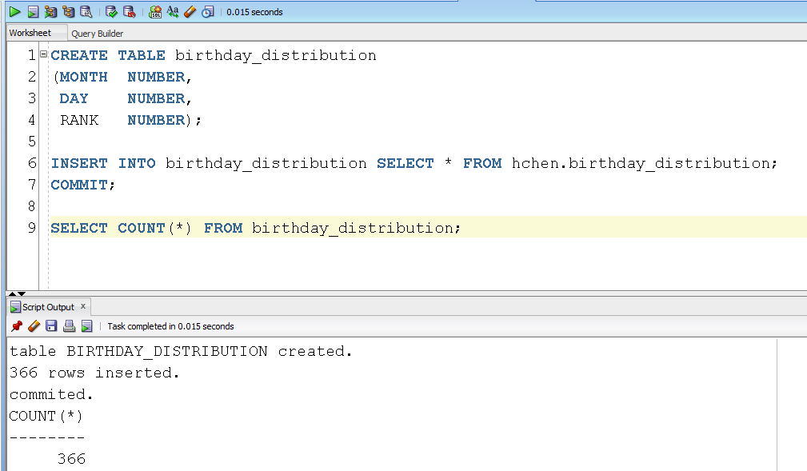

Please make sure that there are 366 rows in your BIRTHDAY_DISTRIBUTION table.

In the BIRTHDAY_DISTRIBUTION table, you can find that September 16 is the most popular birthday (rank = 1) and February 29 is the least popular birthday (rank = 366). Excluding leap years, December 25 is the least popular birthday (rank = 365).

========================= Begin (1a) CSC 352 only ========================

1a) (CSC 352 only)

Write a PL/SQL anonymous block that displays top three (3) most popular birthdays along with the ranks for each month. Sort your output in ascending order by months and then ranks.

- You will lose 10 points if the title lines are missing in your output.
- You will lose 10 points if your output has an incorrect format. For example, you must display the birthdays and ranks for the same month in one line.
- If you have hard coded the birthdays or ranks (e.g., DBMS_OUPT.PUT_LINE('1 20 240 14 260 27 262') in your PL/SQL block, you will receive 0 points.
- Submitting more than one PL/SQL program will receive 0 points.

Test your program. You must ensure that the output of your program matches the following output (one month per line):

Output:

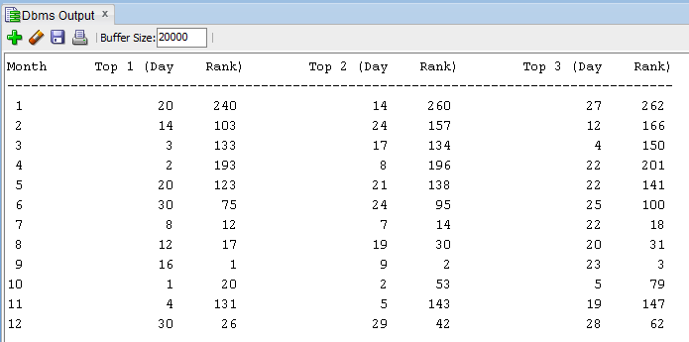

========================== End (1a) CSC 352 only ========================

========================== Begin (1b) CSC 452 only =======================

1b) (CSC 452 only)

Write a PL/SQL anonymous block that displays three (3) most and three (3) least popular birthdays along with the ranks for each month. Sort your output in ascending order by months, most popular birthdays, and then least popular birthdays.

- You will lose 10 points if the title lines are missing in your output.
- You will lose 10 points if your output has an incorrect format. For example, you must display the birthdays and ranks for the same month in one line.
- If you have hard coded the birthdays or ranks (e.g., DBMS_OUPT.PUT_LINE('1 20 240 14 260 27 262')) in your PL/SQL block, you will receive 0 points.
- Submitting more than one PL/SQL program will receive 0 points.

Test your program. You must ensure that the output of your program matches the following output (one month per line):

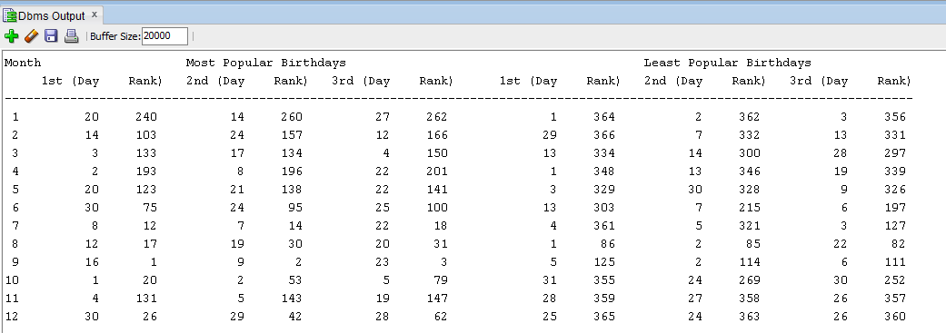

========================== End (1b) CSC 452 only =======================

2) (CSC 352 and CSC 452 - 60 points)

ABC Airlines Inc. keeps track of its employees in its Human Resources database. The PERSON table contains basic employee information. The JOB_TYPE field indicates whether a person is a full-time employee (F) or a part-time employee (P). The JOB_STATUS field indicates whether a person is an active (A) or inactive (I) employee. The structure of the table is shown below along with some sample records:

PERSON
PERSON_ID | LAST_NAME | FIRST_NAME | HIRE_DATE | JOB_TYPE | JOB_STATUS
NUMBER PK | VARCHAR2(30) | VARCHAR2(30) | DATE | CHAR | CHAR
1000 | Smith | Ryan | 04-MAY-90 | F | I
1170 | Brown | Dean | 01-DEC-92 | P | A
2010 | Fisher | Jane | 12-FEB-95 | F | I
2080 | Brewster | Andre | 28-JUL-98 | F | A
3190 | Clark | Dan | 04-APR-01 | P | A
3500 | Jackson | Tyler | 01-NOV-05 | F | A
4000 | Miller | Mary | 11-JAN-08 | F | A
4100 | Jackson | Peter | 08-AUG-11 | P | I
4200 | Smith | Ryan | 08-DEC-12 | F | A

An employee (full-time employee as well as part-time employee) can be a pilot. In this case, the information related to pilots is kept inside a separate table PILOT as shown below:

PILOT
PERSON_ID | PILOT_TYPE
NUMBER PK, FK | VARCHAR2(100)
1170 | Commercial pilot
2010 | Airline transport pilot
3500 | Airline transport pilot

For example, Brewster Andre is a full-time employee and is not a pilot while Tyler Jackson is a full-time employee and is also a pilot. On the other hand, Dean Brown is a part-time employee and is also a pilot. However, Dan Clark is a part-time employee but is not a pilot.

Create and populate the PERSON and PILOT tables by using the following SQL statements.

CREATE TABLE person
(
person_id NUMBER PRIMARY KEY,
last_name VARCHAR2(30) NOT NULL,
first_name VARCHAR2(30) NOT NULL,
hire_date VARCHAR2(30) NOT NULL,
job_type CHAR NOT NULL,
job_status CHAR NOT NULL
);
/
INSERT INTO person VALUES (1000, 'Smith', 'Ryan', '04-MAY-90','F', 'I');
INSERT INTO person VALUES (1170, 'Brown', 'Dean', '01-DEC-92','P', 'A');
INSERT INTO person VALUES (2010, 'Fisher', 'Jane', '12-FEB-95','F', 'I');
INSERT INTO person VALUES (2080, 'Brewster', 'Andre', '28-JUL-98', 'F', 'A');
INSERT INTO person VALUES (3190, 'Clark', 'Dan', '04-APR-01','P', 'A');
INSERT INTO person VALUES (3500, 'Jackson', 'Tyler', '01-NOV-05', 'F', 'A');
INSERT INTO person VALUES (4000, 'Miller', 'Mary', '11-JAN-08', 'F', 'A');
INSERT INTO person VALUES (4100, 'Jackson', 'Peter', '08-AUG-11', 'P','I');
INSERT INTO person VALUES (4200, 'Smith', 'Ryan', '08-DEC-12', 'F','A');
COMMIT;
/
CREATE TABLE pilot
(
person_id NUMBER PRIMARY KEY,
pilot_type VARCHAR2(100) NOT NULL,
CONSTRAINT fk_person_pilot FOREIGN KEY (person_id)
REFERENCES person(person_id)
);
/
INSERT INTO pilot VALUES (1170, 'Commercial pilot');
INSERT INTO pilot VALUES (2010, 'Airline transport pilot');
INSERT INTO pilot VALUES (3500, 'Airline transport pilot');
COMMIT;
/

Write a PL/SQL anonymous block that accepts a last name (LAST_NAME) from the user input and displays employee’s information (name, hire date, job type, job status, and pilot type). Sort your output in ascending order by the name (Last Name, First Name) and hire date.

- If the last name is NOT in the PERSON table (LAST_NAME), your program displays information about ALL employees.
- If the last name is in the PERSON table (LAST_NAME), your program displays the corresponding employee’s information. We have duplicate names in the PERSON table.
- The name is not case sensitive (e.g., Jackson = JACKSON). You will lose 10 points if you do not use the UPPER (or LOWER) function in your program.
- The job type (“F” or “P”) must be displayed as “Full-Time” or “Part-Time” in your output. You will lose 10 points if you fail to do so. (Hint: you can use IF…THEN…ELSE/CASE/DECODE statement/function to convert one string to another.)
- The status (“A” or “I”) must be displayed as “Active” or “Inactive” in your output. You will lose 10 points if you fail to do so. (Hint: you can use IF…THEN… ELSE/CASE/DECODE statement/function to convert one string to another.)
- If an employee is not a pilot, the pilot type is shown as “------” in your output.
- You will lose 10 points if the title lines are missing in your output.
- You will lose 10 points if your output has an incorrect format.
- Using different table/column names will receive 0 points.
- Submitting more than one PL/SQL program will receive 0 points.

Test your program. You must ensure that the output of your program matches the following sample output:

Case 1)
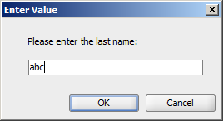

Output:
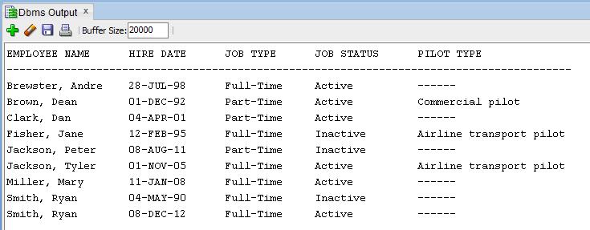

Case 2)
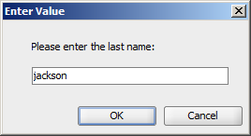

Output:
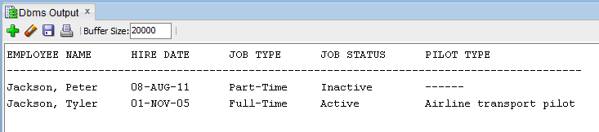

Case 3)
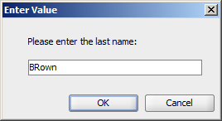

Output:
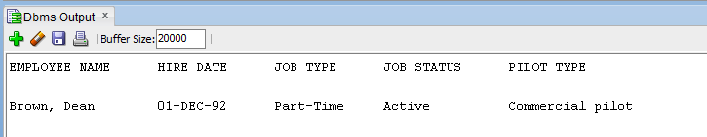

Case 4)
……

3) (CSC 352 and CSC 452 - 60 points)

========================= Begin (3a) CSC 352 only ========================

3a) (CSC 352 only)

Based on the tables created in Assignment #1, write a PL/SQL program that accepts an employee ID from the user input and displays 1) employee name, job, hire date, and his/her department name (If the given employee does not belong to any department, the department name is shown as “------” in your output.), and 2) all employees (alone with their jobs and hire dates) who work in the same department as the given employee and were hired before the given employee (or “NO OUTPUT”). Sort your output by the employee name.

- Hard coding (e.g., IF v_emp_id = 7596 THEN v_1 := ...) will receive 0 points.
- You will lose 10 points if the title lines are missing in your output.
- You will lose 10 points if your output has an incorrect format.
- Submitting more than one PL/SQL program will receive 0 points.

To avoid complicating issues, you can assume that the user always enters input from keyboard that consists only of the digits 0 through 9 and Enter.

Test your program. You must ensure that the output of your program matches the following sample output:

Case 1)
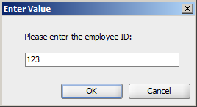

Output:
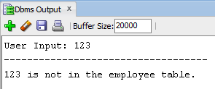

Case 2)
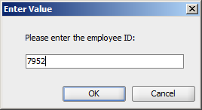

Output:
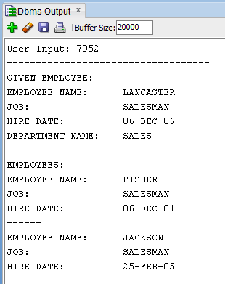

Case 3)
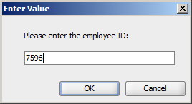

Output:
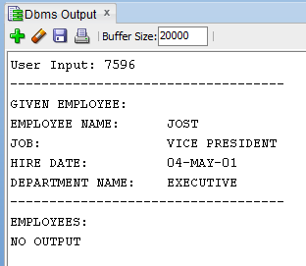

Case 4)
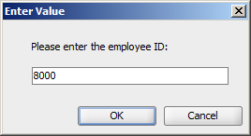

Output:
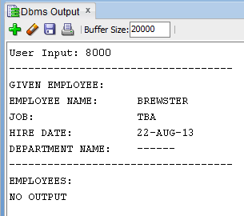

========================= End (3a) CSC 352 only =========================

========================= Begin (3b) CSC 452 only ========================

3b) (CSC 452 only)

Based on the tables created in Assignment #1, write a PL/SQL anonymous block that displays all employees who were hired on the days of the week on which the highest number of employees were hired. The output of the program must contain all the hire dates, employee names, job, their corresponding department names (If an employee does not belong to any department, the department name is shown as “------” in your output.), and the names and hire dates of their corresponding managers (If an employee does not have a manager, the manager name and hire date are shown as “------” in your output.). Sort your output by days of the week (Monday, Tuesday, …, Friday) and the hire date.

- You will lose 10 points if the title lines are missing in your output.
- You will lose 10 points if your output has an incorrect format.
- Hard coding (e.g., IF v_day = 'Thursday' OR v_day = 'Friday' OR v_max_num = 4 THEN …) will receive 0 points.
- Submitting more than one PL/SQL program will receive 0 points.

Hints:
(1) TO_CHAR(hire_date, 'Day')
(2) TRIM(TO_CHAR(hire_date, 'Day'))
(3) TRIM(TO_CHAR(hire_date, 'D')
(4) GROUP BY TO_CHAR(hire_date, 'Day')

The output of your program must match the following:

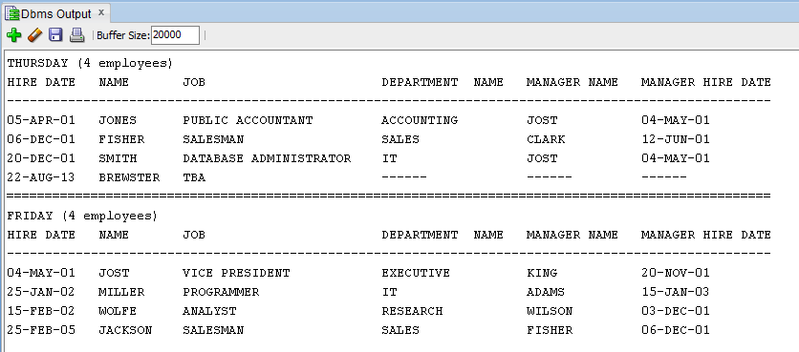

========================= End (3b) CSC 452 only ========================

