It was not very long ago that Dr Pepper was practi­
cally unknown in many parts of the United States.

)r Pepper
ompany

•aul Rabinowitz
Inspite of its new-found fame, Dr Pepper is far from being a new soft drink. The company has evolved from a small, regional soft drink firm to an interna­ tional beverage organization.
As Figure 1 reveals, the company's sales have risen 10 years in a row and earnings have been in­ creasing as well.
Recent analyses by Fortune have shown Dr Pep­ per to have one of the highest performances of the 1000 largest manufacturing firms (the first 500 and second 500) as measured by combined return: capi­ tal appreciation and dividend yield. As Fortune points out (December 1973, pp. 120-124, 128 ff.), the company and its stock has had remarkable per­ formance without technological breakthroughs, mergers, or diversification.

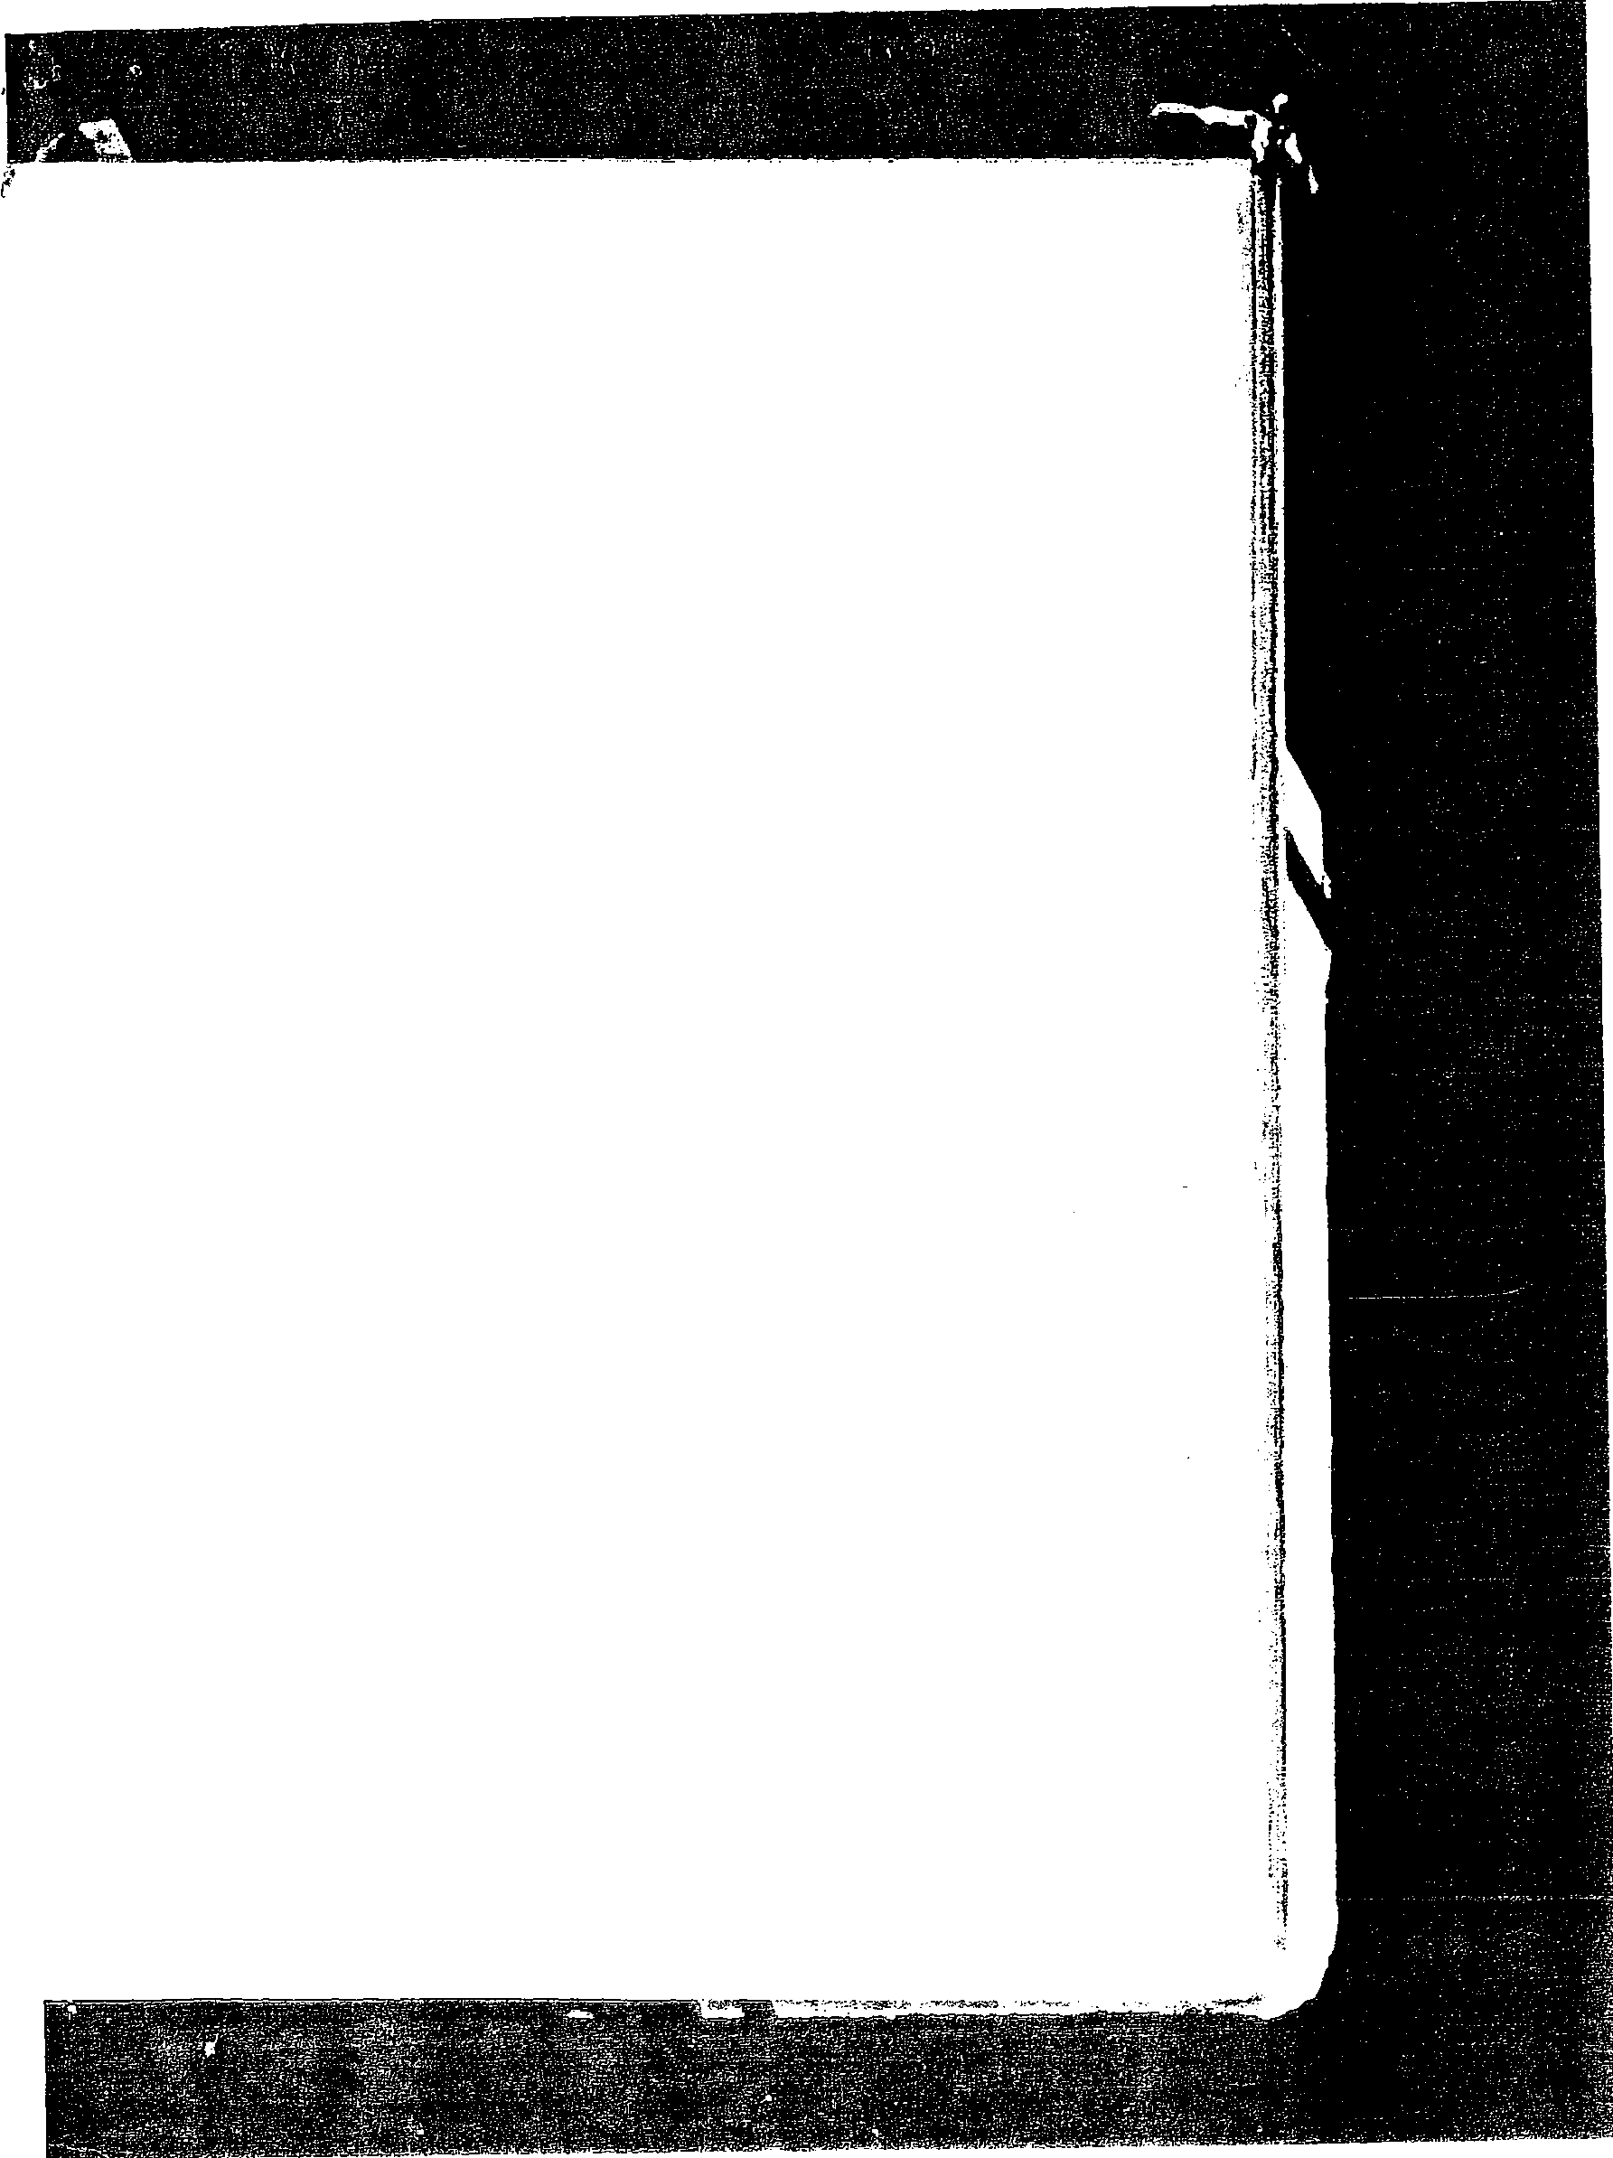

Dr Pepper then and now
The Dr Pepper Company traces its beginning to the 1880s. It is said that a young soda jerk working at an establishment known as the Old Corner Drug Store in Waco, Texas, concocted a new fountain flavor which he named after his father-in-law (Dr Pepper). After undergoing further refinement by a beverage .chemist, Robert Lazenby, the drink began to be marketed on a commercial basis in 1885. It was not until 1922 that an extensive sales and distribu­ tion program was initiated.
Dr Pepper was still a minor factor in the soft drink industry, even in the early 1960s. The com­ pany's volume amounted to about $13 million annu­ ally, and distribution covered only three-fourths of the country. Even today, in the $5 billion soft drink industry, Dr Pepper is still a rather small factor. (For further information, see the preceding selec­ tion, "A Note on the American Soft Drink In­ dustry.") Total sales volume for 1974 is $120 mil­ lion, but its recent growth has been so meteoric that it has already overtaken Royal Crown Cola as the fourth largest selling soft drink in the nation behind Coca-Cola, Pepsi, and Seven-Up.
Dr Pepper produces a soft drink marketed under that name and Sugar. Free Dr Pepper, a diet soft drink. The industry faced problems when the gov­ ernment banned cyclamate, the ingredient used in Sugar Free Dr Pepper's predecessor, Diet Dr Pep­ per.

489

zi;11:- \t y\{:Z._: , .

- '.- .;. • '.'!.. ;

120 -
no - ·
100 -

90

80

:70 -

·60 '"

so- -
40 -

30 -

20 -

10

01965 '66 '67 '68 '69 '70 "71 '72 '73 '74

.55

.so 3
.45

.40

.35

.30

.25

..20

. .JS

.10

.05

...,_00
1965 '66 '67 '68 '69 '70 '71 '72 '73

FIGUR E 1 Iii NeJ sales and eanings per shae. 1965-Hl74.
·,.,._
.::)ri:

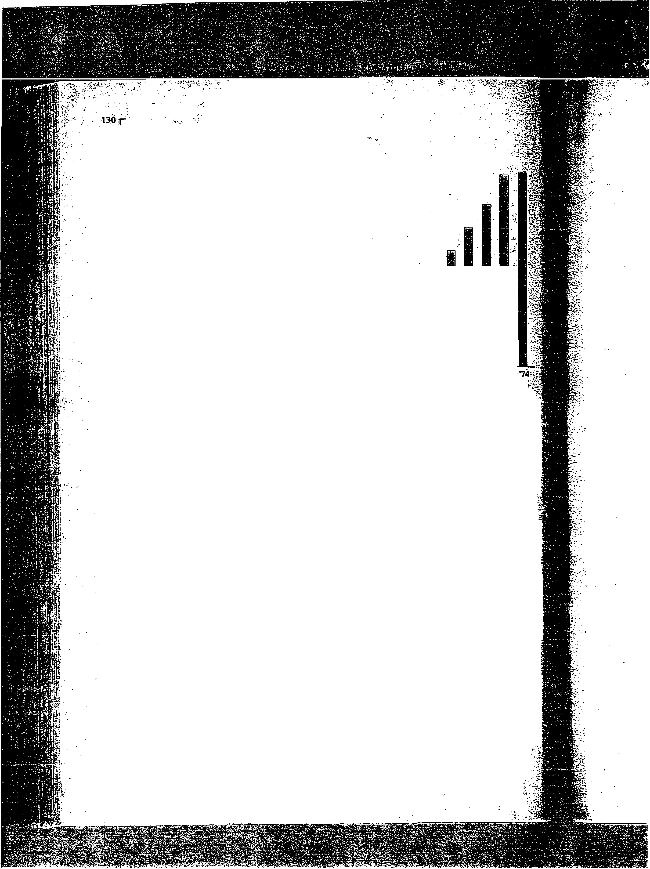
Dr -Pepper is sking to prevent another major loss and is>keeping its di_; drink inventories low. It has also prepared se\'.eral new formulations for iJ. placement, ·Nevertheless; the psychological impact . of a ban on sacch;:uine1' .
might· cause investors to critically reevaluate the current value of the shl!,fel of Dr Pepper or any other soft drink _manufacturer's stock. At present, thi1
diet drinks. sell about $510 million yearly. Dr Pepper's share is abou($10: million. . per year. Dr Pepper is not diversified. As far as diversificatio1f'···::­ concerned; W. W. Clements, its president, is leaving that to other compani "With our untapped -potential, it would be criminal to branch off into som
tluilg else," he said recently. ";i/?-
The company makes and sells concentrate for use in the preparation of dii· bottled and canned bever,,age and for fountain drinks; Two syrup manufacti#i§ ing plants located in Dallas, _Texas, and Birmingham, Alabama, produce t' concentrate. Company-owned bottling plants are located in Dallas, Wll'.,
Fort Worth, and San Antonio, Texas, and a small cup vending plant (Harryi
Fountain Supply Co.) is in Dallas. )/
The key to its rapid growth has been the company's aggressive marketi11&i strategy. Expansion of its distribution through over 500 franchised bottlj, in the United States, Canada, and Puerto Rico (with concentration in)_:: South and Southwest); and intensive advertising and promotional campai;
have enabled Dr Pepper to rise quickly, it appears. >F':
In early December 1973, Dr Pepper launched its first overseas distributi.on . of Dr Pepper.through franchise bottling operations in Tokyo and Tone, Japlin:' This follqwed the creation of a joint venture (Dr Pepper Japan, Ltd.) with:
Tokyo Coca-.Cola Bottling Co., Ltd. Initial distribution in Okinawa has alsq:
begun. It seems safe to assume that entrance to other foreign markets is bein& contemplated. · · ·\'
.··.:•

490 o Choice of strategy and strategic planning 4941

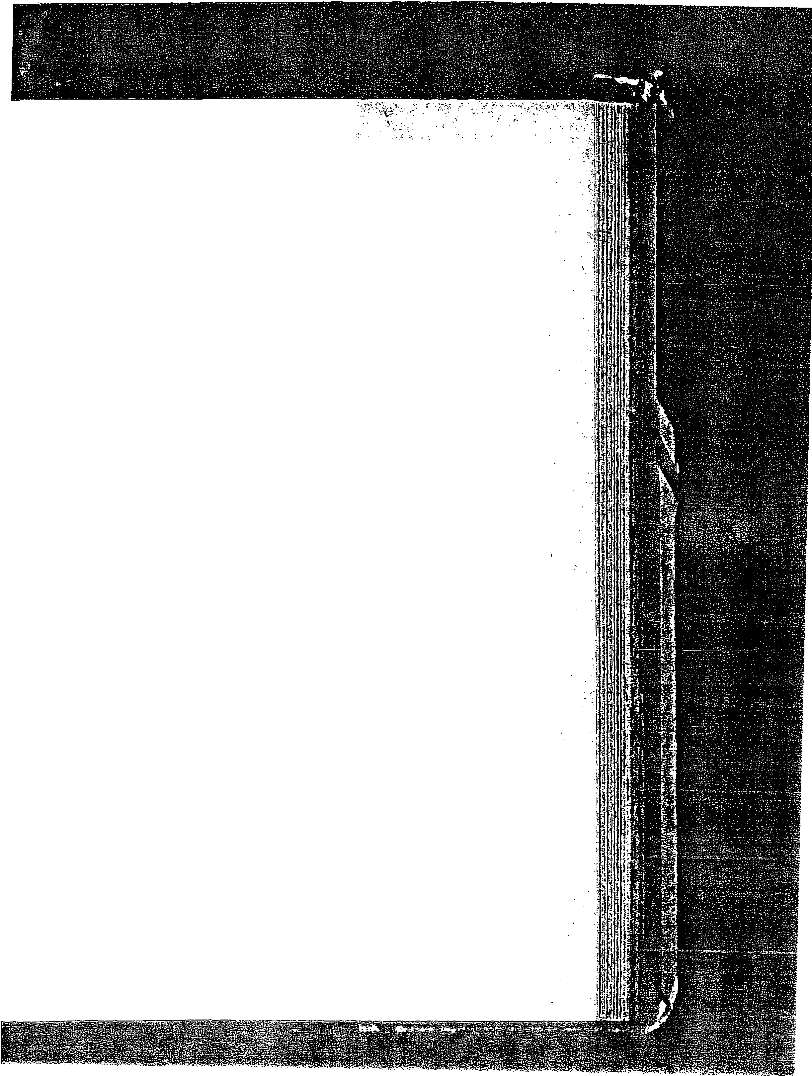

Jff"··- r? ?,;;.""4(1'_:':}tf:'\Jl A?-:?·,.J;:1:·)1,t;\;;' :r.:;t _-
. : '.:'

- ...

Dr . Pepper is professicinally managed. It.has sor:p.e family control. Virginia Lazeriby O'Hara, . daughter of the founder; owns approximately 9 percent of
the stk. Mrs. O'Hara's late husbarid- was president, then chairman, from 1933 to 1961. He was succeeded· bf.Wesby R. Parker, who joined the firm
after some years with General Foods. Three of -his top executives died in ;:i.n airplane crash_ in 1964; and Parker died in ·1967. He-was succeeded by Rascal Billingsley. All these presidents came from the financial or operations function.
- The current chairman and president is the first with major background in marketing: Woodrow Wilson Clements. "Foots," as Clements likes to be called, studied ·at Howard College and graduated from the University of Alabama (1935), :where he played football. He went from route salesman to sales manager of the Dr Pepper Bottling Co. of Tuscaloosa, 1935 to 1942, He joined the parent Dr Pepper Co. in 1942.He was_ successively district man;iger, sales promotion manager, assistant managetof the bottler service; and general sales manager, 1942-1951. He became vice presi_peilt and general sales man­ ager, 1951-1957; vici: president, marketing; 1957-1967; executive vice presi­ dent and director,. 1967-1969; president and chief operating officer, 1969; president and chairman,' 1970. _
"Foots'' Clements reflects his rural Alab_ama upbringing in his folksy ap­ proach to employees and bottlers. He relishes telling tales. Clements is the supersalesman who enjoys drinking the .company product hot or cold. He preoicts that Dr Pepper will exceed the sales of Coca-Cola, probably within 20 years. · . . ·
One executive vice president is Joe K. :Hughes. Joe Hughes studied at North Texas State and graduated from Southern Methodist University in 1948. He was a writer, then assistant city editor of the Dallas Times Herald, 1948-1953;
then he was manager: of the Dallas office of Harshe-Rotman, Inc., public
relations firm, 1-953-1955; account executive, vice president, and manager of the Dallas office of Grant Advertising Co., 1956-1964; then he was executive
vice president; 1964:--1968 (with Grant). He joined Dr Pepper in 1948 as vice president, franchise, 1968-1969; then vice presi4ent, marketing services, and then executive vice president. ·
Other top executives and their ages are follows: Frederick E Avery,
executive vice president, 44; John R. Albers, vice president, 43; Jerry M. CorQin, vice president; 42; Frank Doran, controller, ·38; Hilton Folkes, assist-
. ant secretary, 65; Charles P: Grier, vice president, ¥ ; T. C. Hunter, vice
president, 56; A. J.. Kincaid, vice president, 62; Alvin H.· Lane, Jr., vice president, secretary, and treasurer, 32; W. F. Massmann, vice president, 55;
C. W. Reeves, vice president, Japan operations, 50; Hal. Stockstill, vice presi­ dent, 48; Robert L. Stone, vice president, 58.
The board of directorS of the Dr Pepper Company includes the following persons (1974): H. S. Billingsley, former chairman of the board, Dr Pepper Company, Dallas, Texas; W. W. Clements, chairman of the board, president and chief executive officer, Dr Pepper Company, Dallas, Texas; Edwin L. Cox, oil _and gas producer, Dallas, Texas, and chairman of the board, Keebler Company, Elmhurst, Hlinois; Robert B. Cullum, chairman of the board, the Cullum Companies, Inc., Dallas, Texas; Raymond H. Cummins, chairman of the_ board arid chief executive officer, Goldsmith's Department Store, Mern-

4 41 El Dr Pepper Company


.• : :, ' . . .·. . . . .. .· . . }f:ltff01:... .
.pllis 'l'essee;; d vi .prident, Fderated.Depa°.1et Stores, Inq{fi;\;t
Davt, Dr J>.epper Bottijrig Ci:,mpanyi Roanoke, V1rgm1a; E. ·Burke G1b
. c.hafrman of the),oard, Waef-Lambert Company, Morris Plains,_ ·. ...
Jersey; Jmes A: Gooding, Jr., president and general mlinager, Dr. Petr
Bottling Company, Dnver, Colorado; Lamar Hunt, president and ow1{ Kansas_ City Chiefs Football Club, Dallas, Texas; W. R. Roberson, jr.,
pr ...
dent, Roberson's Beverages, Inc.,.Waship.gton, North Carolina; John M.St,' mons; president, Industrial Properties Corporation, Dallas, Texas;· Joll@:_.:­ Tbompson, chairman of the board, the Southland Corporation, Dallas, 'I'e Jack C. Vaughn; president, Vaughn Petroleum, Inc., and Investments, Da
Texas; W. D.White, senior partner, White, McElroy, White & Sides, attorne "": at law, Dallas, Texas. · · ·f}:

Merchandising the product
Dr Pepper is different from any brand of soft drink. It is not a cola, nor a root i: nor any single flavor but a blend of a nu1mber of pure fruit flavors. Many attempts hav been made to copy the distinctive flavor of the product but none have succeeded. Thiir. has become an ever-incring f11ctor in Dr Pepper's growing success. Al; ost cusio{
ers say .. . . "THERE'S NOTHING QUITE LIKE DR PEPPER . . .IT'S DISTIJllcy-
TIVELY DIFFERENT." . . f'i:
. 1!
So states the company _in a recent annual report. The company's produt is distinctive and is not a cola. it is competing with the colas for the mau.,
market, the consumers who drink two or three bottles a day. Dr f epper'.ia£, not a cola, because a judge has so ruled. "When people say it has a cherry;:._
. taste, I know they are becoming regular Dr Pepper drinkers," says W. W;t
Clements. "And once we get. our taste established with the consumer theref is no other dri11k that can satisfy it." Also as a result of its.distinctive taste;\ the company can franchise w.ith Coke, Pepsi, and Royal Crown bottlers. t/
Essentially,. Pr Pepper's product line includes the following: ';) 61h-oui1ce gl bottle Dr Pepper (returnable and nonreturnable)
10-:ounce glass bottle Dr. Pepper (returnable and nonreturnable)
12-ounce glass bottle Dr Pepper (returnable and nonreturnable)
- 26-ounce glass bottle Dr Pepper (returnable and nonreturnable) 32-ounce glass bottle Dr Pepper (introduced 1974)
48-ounce glass bottle Dr Pepper (introduced 174) 12-ounce can Dr Pepper
6-ounce glass bottle Sugar Free Dr Pepperl 16-ounce glass bottle Sugar Free Dr Pepper
Salute:2 six _flavors of other·soft drinks (introduced 1963) Waco:2 fountain syrups-same flavors as Salute

1 Sugar Free Dr Pepper is the saccharine-based product introduced in 1971 to replace the Diet:::· Dr Pepper introduced in 1962 (containing cyclamate). Sugar Free Dr Pepper is estimated to_ , account for 12·percent of dollar sales and is the leading diet drink in many markets. ··. · ·
·2 Salute and Waco are estimated to account for approximately 1 percent of dollar sales. ·These',.
are distributed in only a few regions:

492 B Choice of strategy and strategic planning

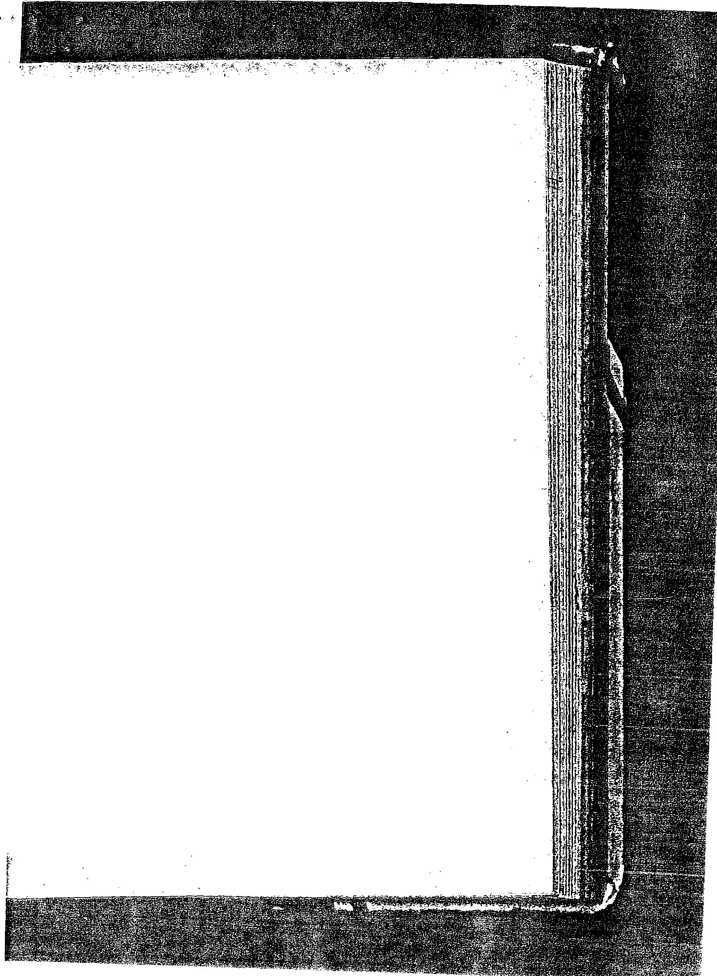
Dt f epper offr:e& fatger-siied bottles· of ·ihit '.produtt later" than their .·
. competitors, The: cot;ripany . felt !e largesize. boles conveyed a lowprice image. -- yet,. tlie1r<plans to. offer 68ounce or l2 ounce Dr Pepper are unknown.-'lt is.estimated that·about-.50 percentof saj. are presently .in non-
returnable containers. ' . .; ' . . .
The firm also distributes (on a1imited basis) Pommac (a Swedish cognac­
.flavored diet soft drink),. for which it obtained Western Hemisphere distribu- tion rights, in 1963 and Hustle, a high7energy, high-protein drink. .
Dr Pepper Company's two entries,Dr Pepper and Sugar Free Dr Pepper,
face a ·tremendous competition.. From the CocaCola Company they must contend with eoca...Cola, Sprite,· Tab, Fresca, Mr: PiBB, Fanta flavors, and
Simba. From Pepsico come Pepsi-Co1a, Diet Pepsi, Teem, Mountain Dew, Patio flavors, and Tropic Surf. From Royal Crown Cola Company come such soft drinks as Royal Crown Cola, the Diet Rite line, Nehi, and·Par-T-Pak. And Seven-Up has its 7UP, Diet 7UP, and Howdy flavors. In addition, many regional and private-label entries help make market share hard to come by. Dr Pepper is essentially a one-brand domestic company; whereas Coke and Pepsi are multibrand international companies. Dr Pepper is not. the leading seller in any major market in the United States. Dr Pepper's president W. W. Clements felt he was already ahead of RC Cola in the United States and Canada and close to 7UP. In 1970, Clements projected, for the next 5 years, annual 15 to 20 percent increases in sales, baseEI on the New York success and llntapped overseas markets. So far, he has been on target in bis predictions, and if things continue in spite of recent economic troubles, by 1975Dr Pepper sales will range somewhere between $120 and· $150 million and move up to
the number four spot iri national sales.
One attempt to "extend the product line" was Wesby Parker's promotion of Hot Dr Pepper during the lower sales months of November through March. Hot Dr Pepper bas caught on:._as witness such sales as 17,000 at a chilly football game--and this has done wonders for business in the normally slow winter season. "We actually can't determine bow much Dr Pepper is being consumed bot," said Clements when he was vice presidt of marketing. "All we know is that our sales have shown phenomenal gains during normally unseasonal soft drink months. We know that our Hot Dr Pepper idea bas met with favor among consumers and we know ·that many like the drink. What actually happens, we suspect, is that housewives buy Dr Pepper with all intentions.of serving it hot, but before this happens, someone in the household chills the-drink and enjoys it cold."
Dr Pepper pursues active marketing research program. The company
has not been content to have its products used as beverages, exclusively. Work
-is currently being conducted toward finding riew and improved uses in the preparation of food and other· culinary applications. A Dr Pepper ice cream topping, which may also be poured over flapjacks, has been deyeloped. The company has been promoting the product as a cooking ingredient and has prepared over 400 recipes for its use in this way.

Sales trends
Table 1 presents some recent statistics on sales and income of Dr Pepper. Just to give a not-too-distant look back into Dr Pepper's recent past, con-

'• 493 l'l'I Dr Pepper Company

t

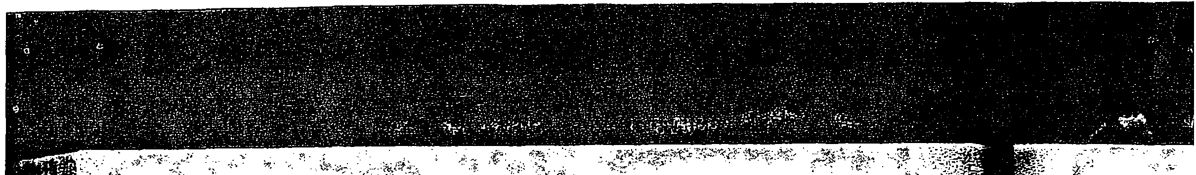
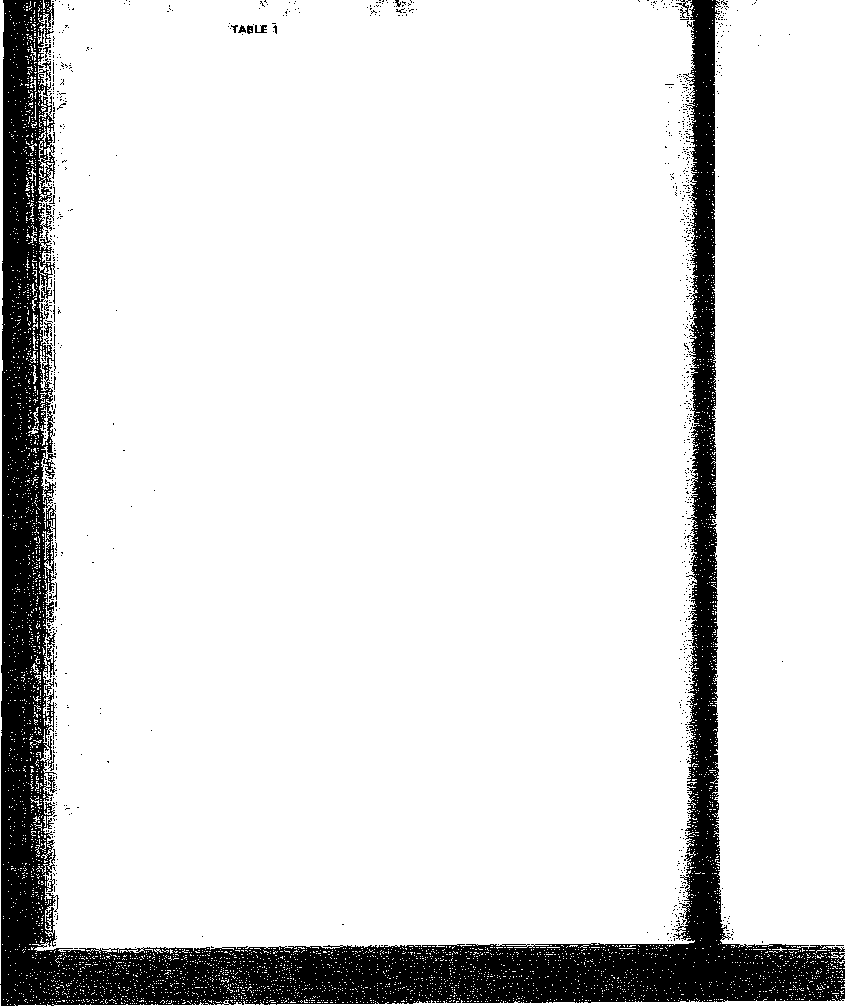
::./ . . .:
a( sAt s:A'r.io 1111coiiiiE·:0RoWTH 11N M1Li.10Ns oF ooLLARs1 oi::.nR;"--
PEP;:.· ·· .....• ·:., ercent . . Net . . . Per:ent . r}c: i
saies . (increase) income (increase)• _-;.;,
19.63 2L8- 25 ,;,. i.4 ·45
1964 24:6 13 1.8 30
1_965 27.5 12 2.4 28
1966 28.7 . 4 2.9 23
1967 ·33,a 18. 3.5 2.1
1968 . 41;9 · 24 4.1 18
1969 '49.5 18 4.6 13
"1970 57.5 16- 5.6 21
1971 63:6 1 1 6.8 20
1972 77.4 22 8.1 20
1973 9.8.6 30 9.7 19
1974 128.2 , 30 9.9 Less than. 1% . ::;

--: \

sider thefollowing: (1958}"Dr Pepper announced it was expanding into new markets for 1959. Now distributing in 40 states and Hawaii; the companyh bounded out of Texas with its eye on full national distribution by 1960:'' They
had some prol:,lems, and national distribution was not reached until late 197(). For most of its 74 years, Dr Pepper has been a predominantly Southern drink. The company, organized in Texas; has a distribution pattern that has
followed a slow-moving franchise bottling plan -across the South, Southwt, and Midwest. The Chicago area was not opened until 1948, and. New York was not successfully entered until 1970. t One recent trend -which may have some long-run impact is the increasing cost consciousness of consumers. The sugar. price increases have led to soft - drink price increases. The result could be softened demand or ·a. shift fo ·
low-cost private-labeldrinks. Supermarket chains and mass merchandisers are contracting forthefr own house brands of soft drinks, which now account approximately 12 tci 15 percent of indust!Y volume. Driringthe ever-increasing _, rise in the cost of living, in particular food costs, cost-conscious consumers _._·. have been buying in bulk and looking for the bargain prices. Private:]abel so ./: drinks have lower delivery costs. and. no advertising expense. Superm,ar)c¢t ,­ chains' brands can be retailed for adequate profits at far lower prices. ·
for
A more direct threat may be the introduction by Coca-Cola of Mr: PiBB. The product's name is similar. to .Dr Pepper's, an.d Coke advertises it as cherry-flavored. Coke has been promoting this product heavily in the 70 markets it has entered so far (l974}. But thereis another problem. Ina number of markets, such as New York, Dr Pepper is distributed by the Coke bottler.
1n 1972, Dr Pepper sued Coca-Cola, charging the company with trademark
infringement. A Coca-Cola bottler was introducing a product .called Peppo which, Dr Pepper said, had a similarity in. flavor and some similarity in nani.
Coke test-marketed Mr. PiBB in Temple, Texarkana, and -Waco, Texas, and in Starkville and Columbia, Mississippi. Coke contends it did not use the Fanta name on their new cherry drink because Fanta drinks are all single flavors, whereas Mr. PiBB 1s a multiple-flavor drink, including cherry.
- Speaking. at their annual bottlers meeting, a Dr Pepper official said, "We . ;
know that strong efforts and intense pressures have been and will contiriiie ·:-. to be exerted by our competition [Coke]on certain of the combination Coca- ;· Cola-Dr Pepper bottlers, bui ·despite these pressures and efforts, 25 additional ·· Coca-Cola bottlers have acquired Dr Pepper since our last meeting." ·

45:4 :::i Choice of strategy and strategic planning

eE in of
2
lo

N,
I t
ca
ni; Pe ha Pi: thi

de ta: sa br wi
OU
of

ad
SeJ

Di sp gr,
sp TI (A
en

na pa Fr pr,
an
01
qu
SU
an co pr,

495 G



Mr. Clements said recently about Mr. PiBB's impact, "It has had a positive effect on us. They [Coke] have to promote our flavor as a fast-growing one in order to get retailer action. They have to tell it to the consumers, too. They'll offer one free case with every case bought. They spend an awful lot, but in 2 months, we crack it and get our space back on the shelves. We have product loyalty."
He told a Dun '.S' reporter (in April 1973):
Now Coke has not said Mr PiBB is an imitation, and they never will, but it is, and I think when the largest company in the industry comes out with a product in the same category as ours, that is the greatest compliment we can receive. It means they recog­ nize the potential of Dr Pepper. . . . In fact, wherever PiBB has done battle with Pepper, Pepper has come out stronger than ever. In those test markets where Mr PiBB has been introduced, our rate of sales growth has increased. The introduction of Mr PiBB has made us work a little harder, and I think it's made more people aware of this type _of soft drink.

Dr Pepper has mounted a broad promotional effort. On the subject of developing more Dr Pepper drinkers, Mr. Clements said, "Our prime age target, and therefore our prime area of emphasis, is the youth market. We have said for years 13 to 30, for many years, but I think we now can and should broaden it from 6 to 40. In spite of what we may have heard, the youth market will increase in the United States by more than 25,000,000 by 1980. These are
our customers of today and the future. All our surveys show a very high degree
of preference for Dr Pepper among this group."
The 1974 advertising program was developed by John Albers, vice president, advertising; Bob Connors, national advertising manager; and Bill Thompson, senior vice president and management supervisor of Young & Rubicam.
The media mix included TV, radio, outdoors, newspapers, and magazines. Dr Pepper is going to sponsor two types of specials-the all-family prestige special and the conteporary music specials for the teen and young adult groups. In 1974, for example, the company sponsored five Dr Pepper TV specials: the Grammy Awards (in March), Emmy Awards (May), Midnight Train to Georgia (June), Chicago (group) with Anne Murry and Charlie Rich (August), and with Olivia Newton John, the Beach Boys, and Doobie Broth­ ers, the New Year's Rocking Eve (December).
No stones are left unturned in their promotional effort. Cuyler Caldwell, national sales promotion manager, described the 1974 promotions as "more package oriented than '73 promotions and more youth oriented." The Sugar Free promotion offers a shape tape, which is also a complete measurement progress chart, free with the purchase of two cartons of Sugar Free Dr Pepper, and a $12 value bathroom scale built as a Sugar Free logo and offered at $5.50. Other sales promotion gimmicks include bicycle safety sets, backpacks, and quick-spurt freeze bottles, inflatable rafts, Calvin Hill footballs, ponchos, stadium cushions, trading cards featuring popular music stars, safety signs, and a toy Saint Bernard puppy called Schuss-Boomer that carries a Dr Pepper coin bank flask around its neck. The typical point of sale material helps promote the drink, too.
Dr Pepper has used advertising for years. The 10-2-4 theme was based on the energy needs of people at those hours as Walter Eddy of Columbia Univer­ sity described them. This theme was used frbm about 1925 onward.
The 1973 theme, developed by the Young & Rubicam advertising agency,

495 c Dr Pepper Company

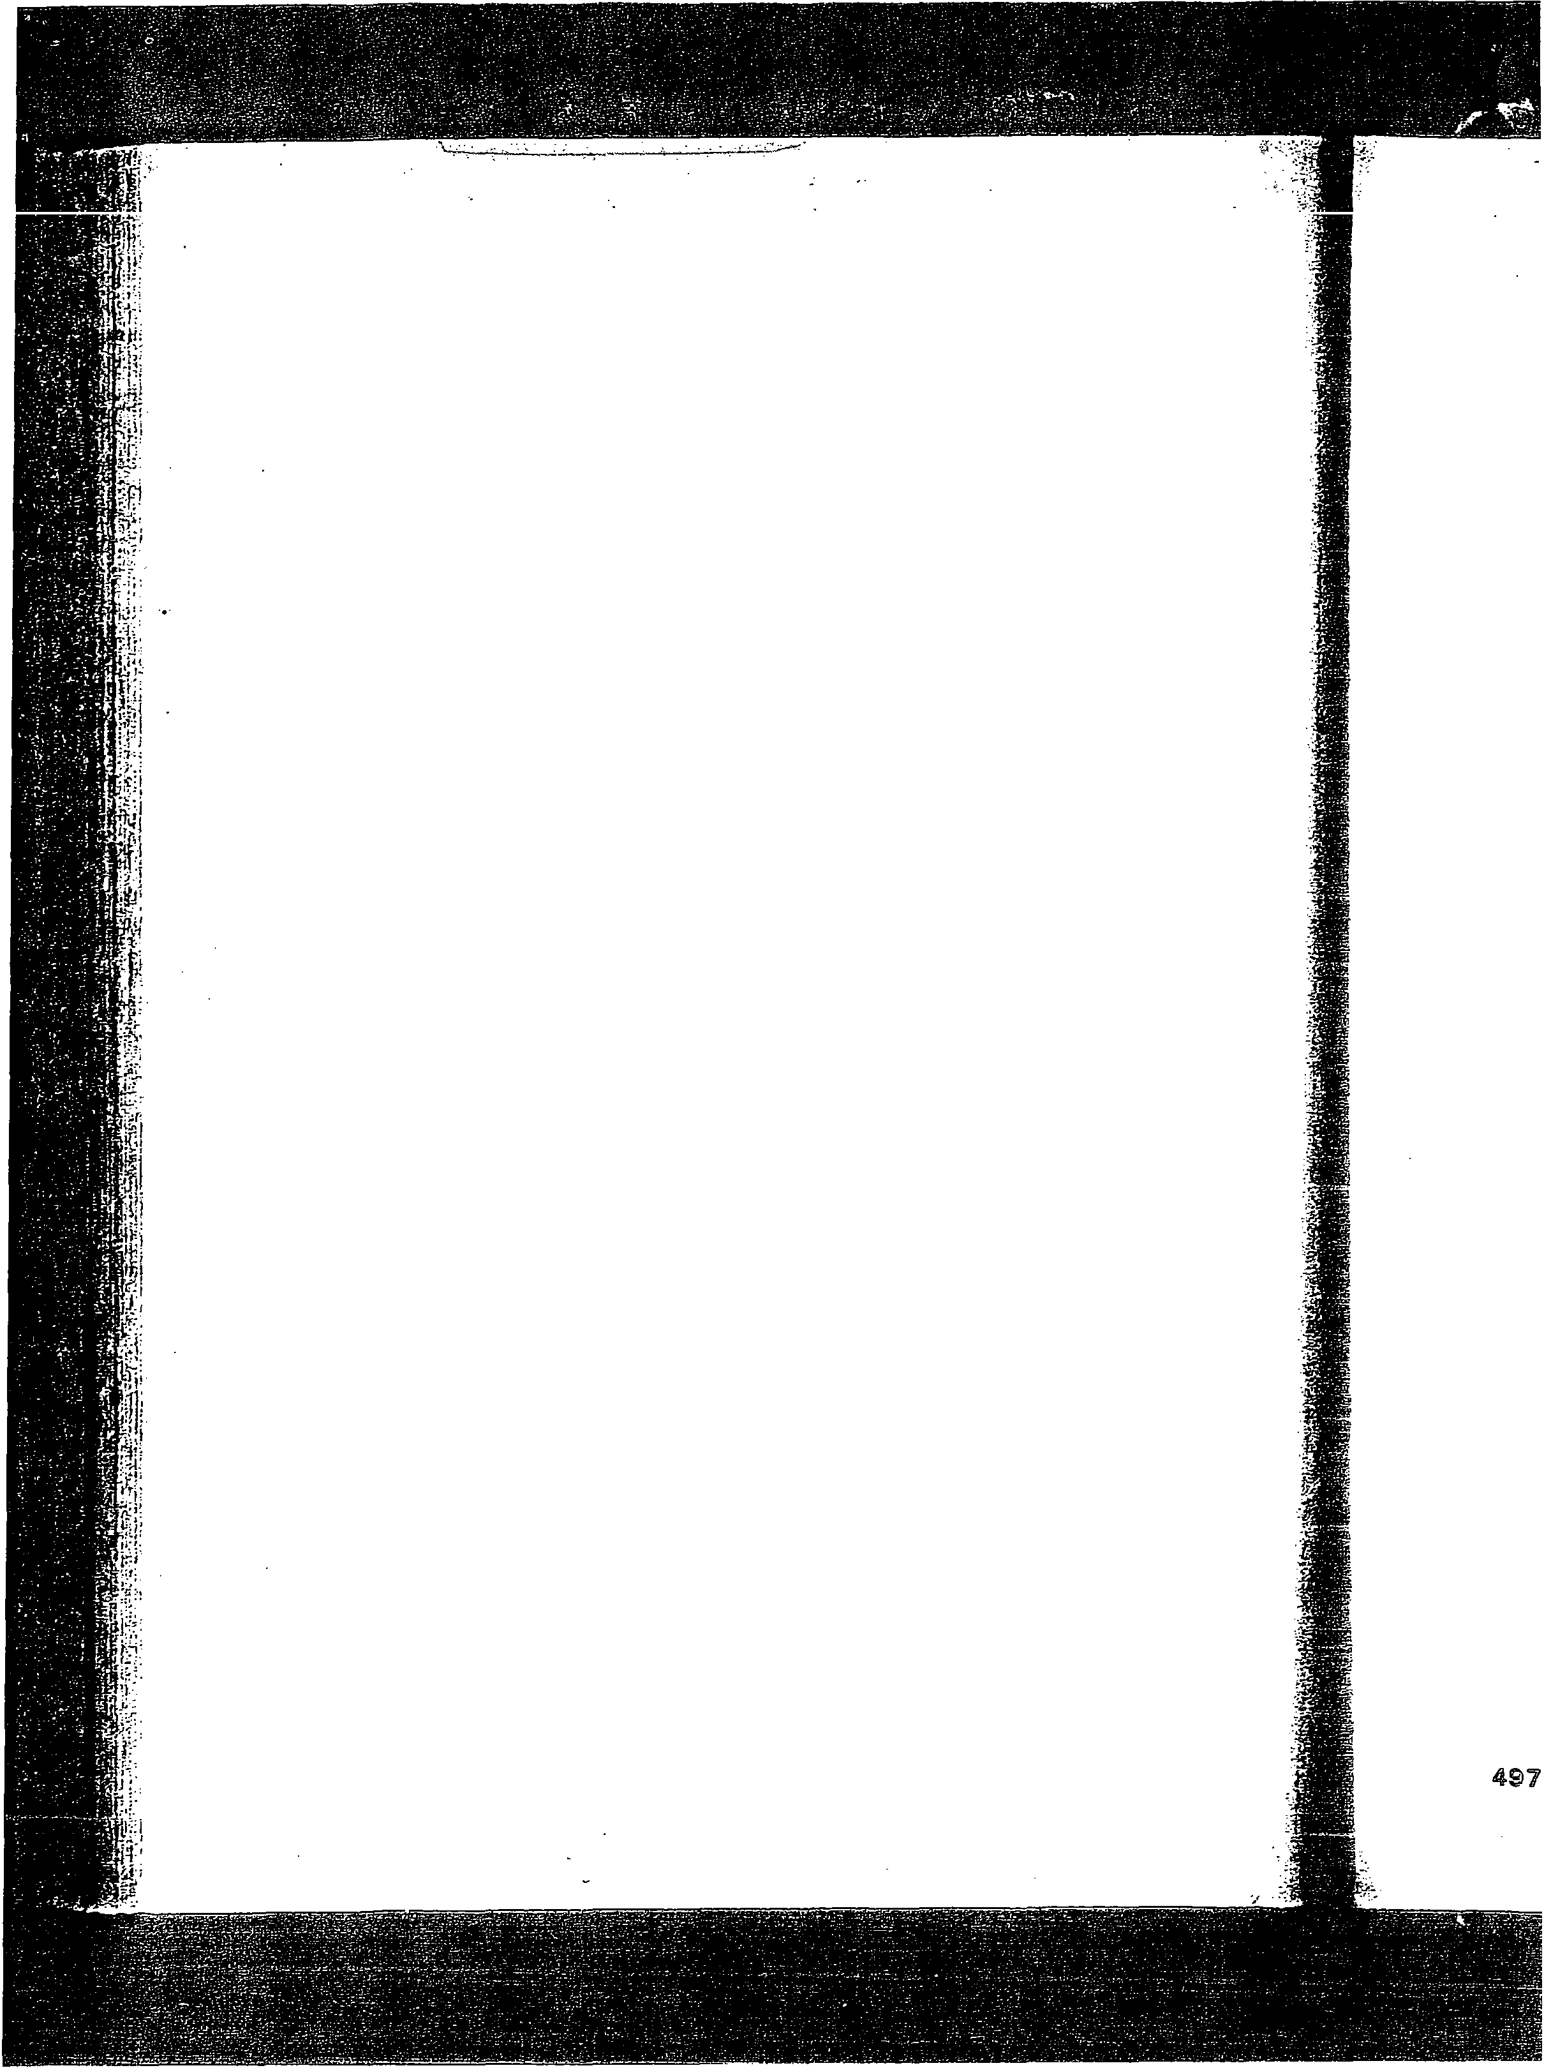
is. ''All you ·have to do to ]µce 'Dr Pepper is to try it." The now-famous ·./ trial-conflict situations that have 1:>een·dramatized over the past 2 years on TV ·
will be. contimied carrying the' copy lines, "Once you try it, you'll love the difference" and "Millions of people love the difference of Dr Pepper." In 1974, the theme became "The most original soft drink ever."
Mr. Clements has said Dr Pepper advertising has had nine objectives over
the last 10 years, and selling the product was only ninth. More important objectives, he said, were to impress Dr Pepper's own people, to reach bottlers,
to get to prospective bottlers, and to impress the financial world. Dr Pepper also, to borrow an overworked phrase, "put-its money where its mouth is." They are heavily involved in co-op adyertising, matching bottlers dollar for dollar since 1956. Though this money must be used for local advertising, in approximately 70 markets part of it is directed toward regional advertising; in which several bottlers might participate. For both local and regional cam paigns, the favored media are TV, radio, billboards, and newspapers. The advertising agency turning out the advertising that "has been acclaimed by experts and consumers as the most outstanding and effective" in Dr Pepper's history has been New York's Young & Rubicam, which developed the theme, "America's most misunderstood soft drink-but not for long." They also have a house agency, Eagle Advrtising, handling coordination and placement of ads in all other markets except New York, which is exclusively handled by Young & Rubicam.
To further develop product identity, Dr Pepper had Sandgren & Murtha, the New York industrial design firm, develop a new logo and color scheme for all their packaging. The "primary object for the change was to give-Dr Pepper greater visibility and more dominance in the marketplaces where it is offered for sale," the company said.
In 1972, Dr Pepper spent $8,847,000 for selling and advertising. "Our
primary national vehicle will be network television with the emphasis on prime time specials. And again, we're going to have more in 1974," a vice president
of advertising at Young & Rubicam said. The.specials' impression of prestige , and size "makes us appear to be an even bigger brand than we are," he explained.
Outdoor and newspaper ads backing the introduction of 48- and 32-ounce returnable resealable bottles in both single bottles and six-packs have been used to say, "You can love the difference in a big way."
Three Sugar Free Dr Pepper TV commercials have been used to support radio spots in standard, soul, and country and western versions. In addition, magazine ads using the line "one way or another, you'll love Dr. Pepper" were run in Cosmopolitan, Glamour, Redhook, and Weight Watchers magazines. Outdoor advertising was also used.
Besides cooperative advertising assistance, Dr Pepper every year meets with its bottlers the first week in October to help determine advertising budgets.
Matched by Dr Pepper, the budget is set at more or less what the bottler wants 1l to invest in his particular market, unless it exceeds what corporate Dr Pepper feels it can afford.
While the company likes to think it has 100 percent national coverage, Advertising Age in a June 18, 1973, issue gives them credit for 99 percent. Dr Pepper still has a relatively limited penetration of many large markets, . espe- · cially where it has been only recently introduced. Areas such as Chicago, •. Minneapolis, and New York do not show large market shares of Dr Pepper.

4S6 El Choice of strategy and strategic planning

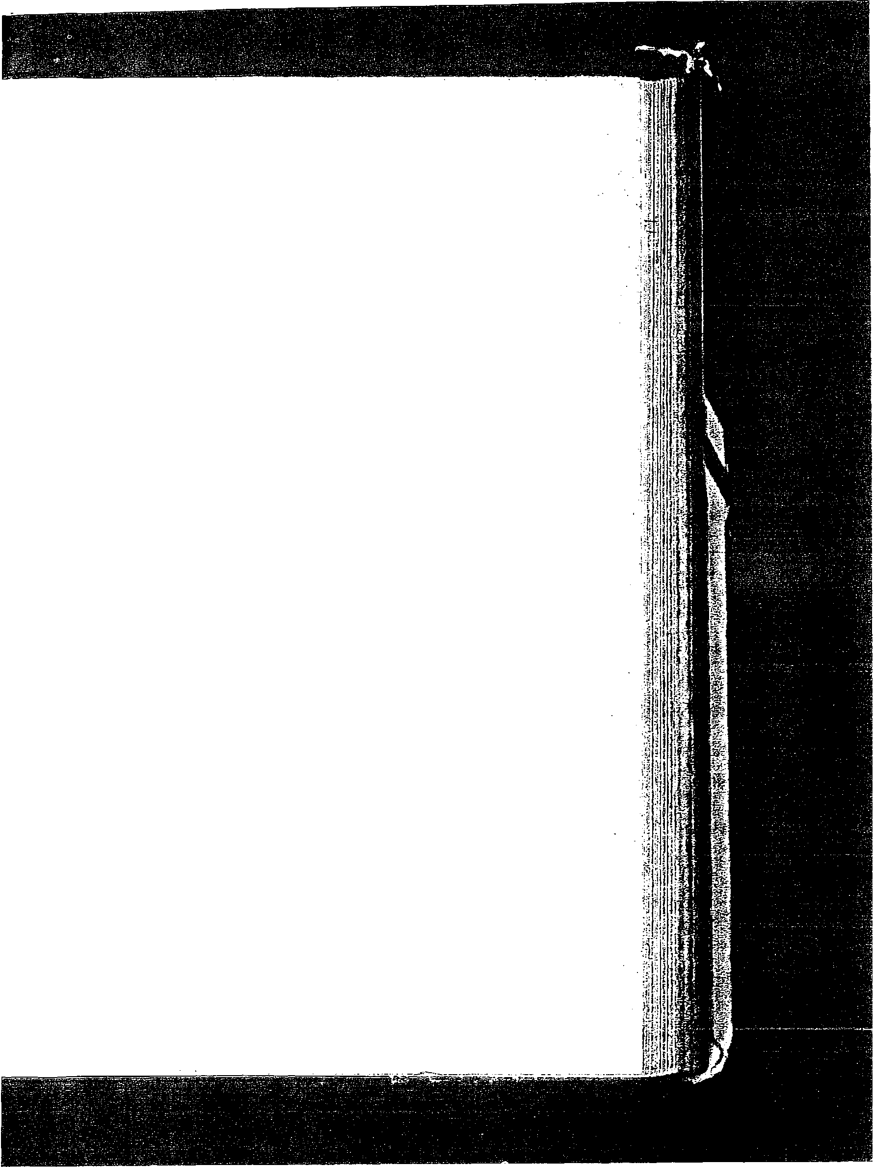
An example of Dr Pepper':S aggressiveness is invending: Mr. Clements has given special attention to it for several years. He claims PrPepper spends Inore money proportionately than any other conipany to:get_ botders to put his drink in their machines. As a result, as of 1970, Dr Pepper was iii over 100,000 machines accounting for 20 to 25 percent of-Dr Pepper's sales, only a percent­ age point behind the leader, Coca-Cola. In 1974, the company increased its vending sales by 10 percent.
Dr Pepper has responded to the threat to ecology by sponsoring antilitter campaigns such as the "Pitch In'' programs; For example, in 1971 Dr Pepper used Miss Teenage America as spokesperson among youth organizations for antilitter campaigns. The company encouraged· recycling centers and litter bags. In 1973, through the bottlers, it provided environmental kits to the schools. A kit included an environmental test· set, world ocean globe, and instruction manuals to enable students to discuss pollution and environmental problems.

Dr Pepper's operations

Before the consumer gets a chance to drink a Dr Pepper, a number of steps must be taken. First, the Dr Pepper Company purchases the ingredients. Then it produces the Dr Pepper concentrate under conditions designed to blend the formula to assure 0uniform'' and wholeome product. (See Figure 2.)
The firm even produces its own plastic containers for shipping the concen­ trate (see Figure 3). This takes place at the Dallas, Texas, headquarter,s (Figure 4). The headquarters is undergoing a major expansion at the present time. After the concentrate js manufactured, it is shipped to one of the franchised bottlers. There the concentrate which has had sweetener added to it to produce a syrup is combined with carbonated water, and thus Dr. Pepper emerges in
bottles (Figure 5) or cans (Figure 6) at the rate of 1000 per minute.
Dr Pepper is very proud of its efficient inventory management policies which recently have seen the days of inventory held drop from over 30 to close to 20 days. Selling the bottlers concentrate rather than syrup has lengthened shelf life and reduced shipping costs. Dr Pepper's concentrate is priced in the saine - range as Coca-Cola's.
Like many other soft drink firms, the company performs taste tests around the country. Commenting that he has no confidence in taste tests, Mr. Clements said, "Nine out of ten (consumers) won't like it if you tell them what it is. If you tell them it's a 'blend of natural fruit juice' instead of Dr Pepper, seven of nine will like it." He added that consumers are asked what the soft drink tastes like, and if they relate it to something good, "we've gotten through."
From a packaging standpoint,. much has changed from the time of 6­
ounce bottles. Some of the industry's success with consumers is its flexible approach to packaging. One-way containers (both cans and bottles) up to 64 ounces in size, someday soon to be 128 ounces, have answered consumers' desires for larger amounts.
Container research in the industry has been extensive. The search for opti­ mal construction materials and design has included the study of glass (with new plastic combinations), plastics (including increased amounts ofresin), and
I

497 El Dr Pepper Compa ny

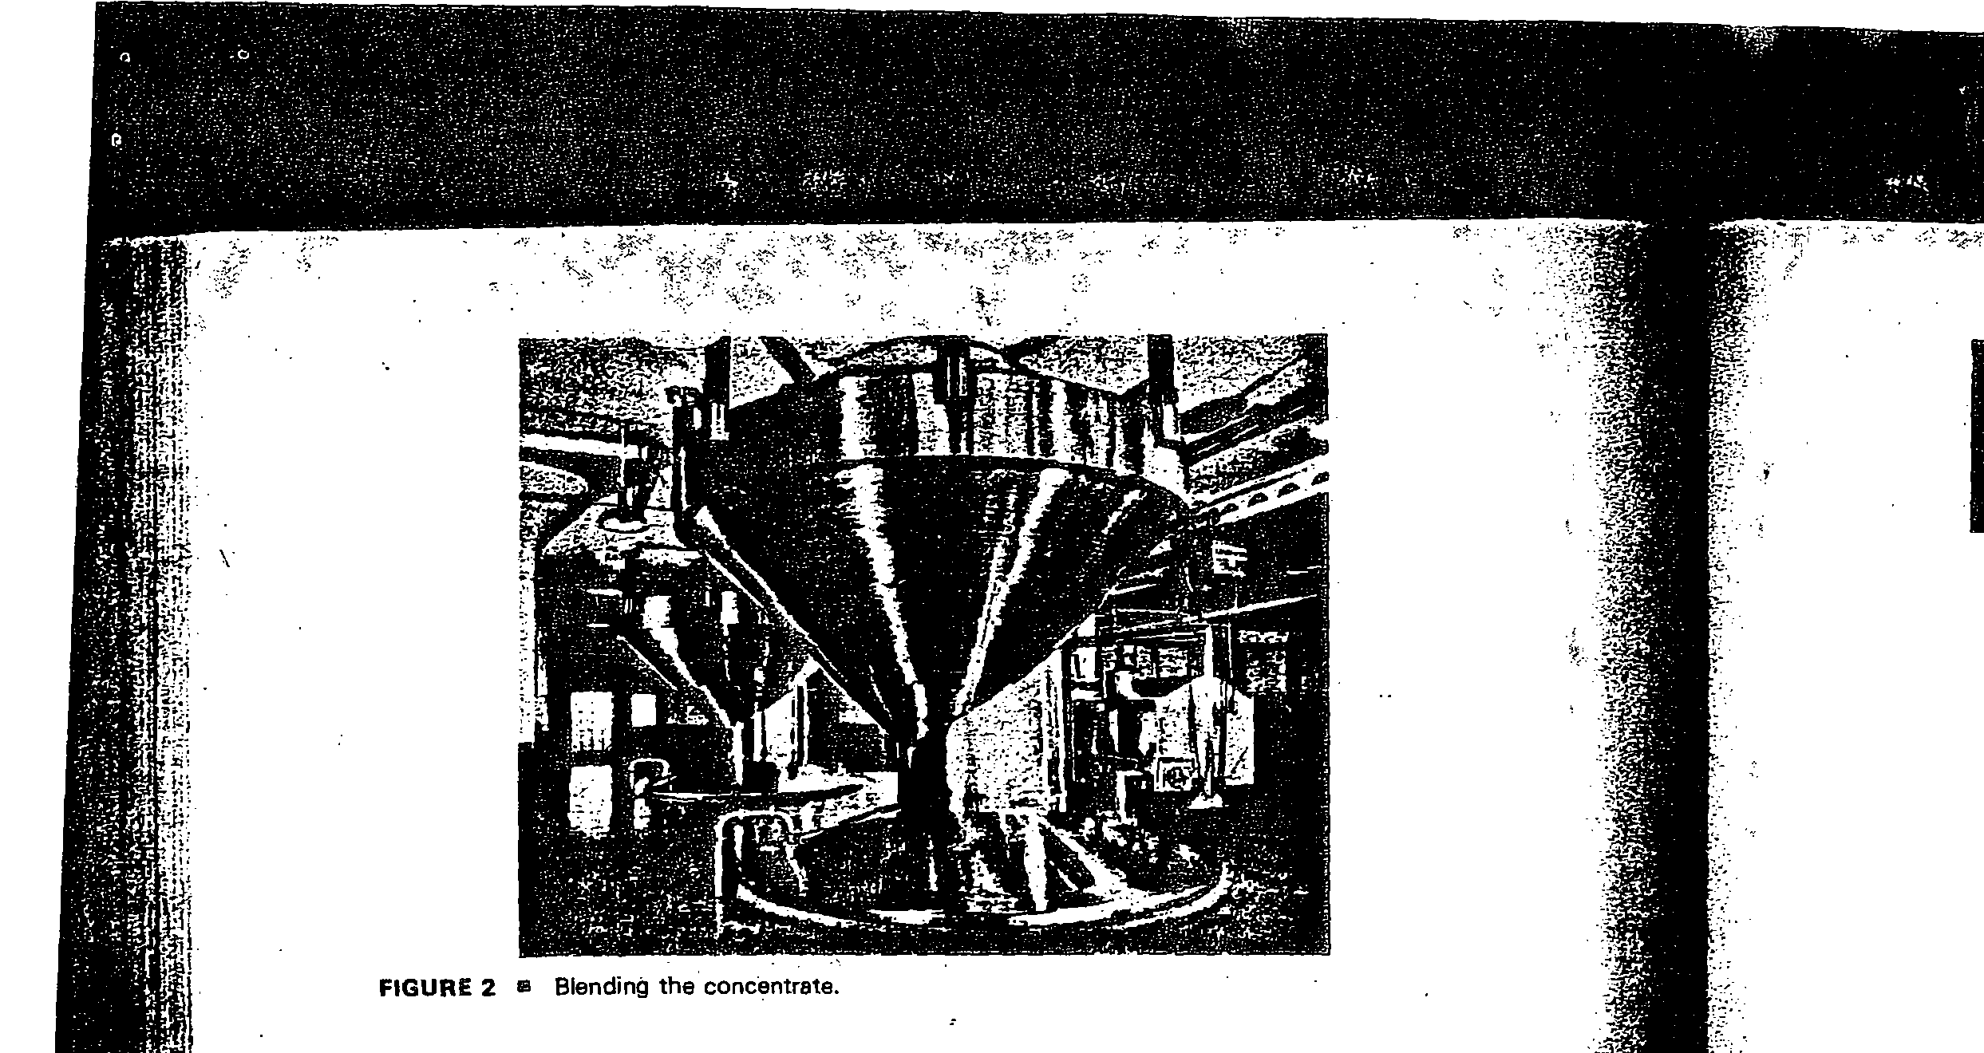
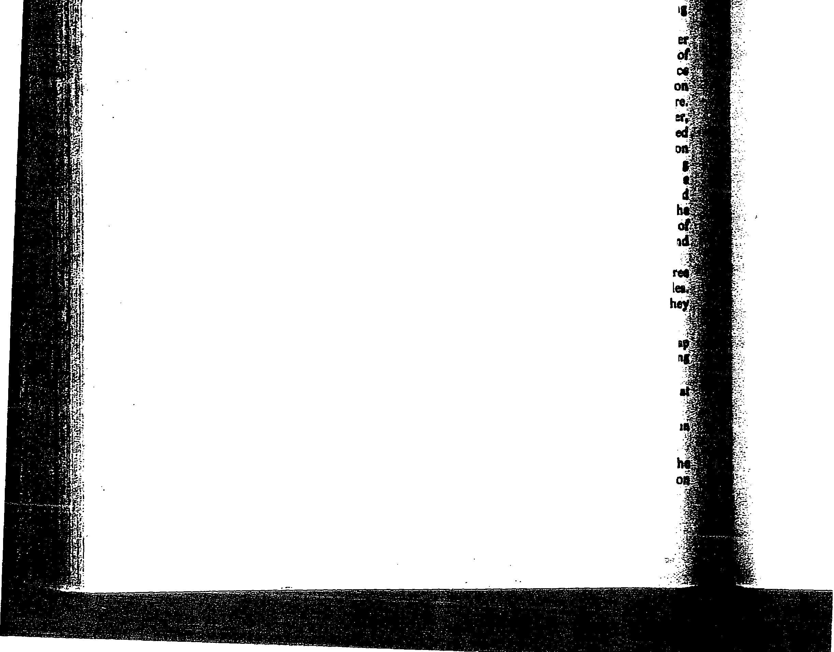
faster, .more versatile systems of mass production in packaging (from fillin1
to containerizing).
Sohio's Vistron Division, which produces the acrylonitrile copolym (Barex) resin for Pepsi bottles, and Monsanto, the supplier and converter Coke's rnethacrylonitrile styrene (Copac bottles), recently arranged to produ the first commercial 210 resin in a project yielding approximately 12 IDilli pounds annually, enough to satisfy Pepsico's plans for the immediate fuure Vistron also halved resin price to a 59- to 70-cent per pound.range. However
observers have pointed out that more resin capacity and use will be eed
to bring the price to the more competitive 30- to 40-cent range. The r .·
for the slow development in this -area and the general secrecy surroundin .. these program . aside from the newness of resin-formulating and highvoltirri . molding technology, has been the legislative mood of several states an municipalities. The last 4 years, at least in New York City, have seen t
passing of a new law taxing all·plastic containers. The banning or taxing · . one-way beverage containers is a growing possibility that makes bottlers_ an
the industry itself unsure of what the future will hold. . Automation has continued to expedite packaging. There are presently th new automated systems for basket (carrier) multipacking of beverage bottl
All three systems were designed primarily for nonreturnable bottles, but t
also can be adjusted for returnables. The new systems include: .
- Container Corporation of America's Basket Wrap, an economical hybrid of wnp; and basket rated at up to 150 six-packs per minute; installed at Pepsi-Cola Bottli Company of Pennsauken, New Jersey.
- Federal Paper Board's Jack-et-Basket, a true basket carrier with output rated . 80 plus, installed at the Coca-Cola Bottling Co., of Paterson, New Jersey.
- Mead Packaging's Mastermatic, also a true basket, that the supplier hopes will ru
100 or more per minute
While other multipacking methods steadily improved their economics, t
design and appliction of the basket carrying carton for Dr Pepper rested

498 ID Choice of strategy and strategic planning

..:::
I

II!!!
FIGURE 3 iil

s
c
(

499

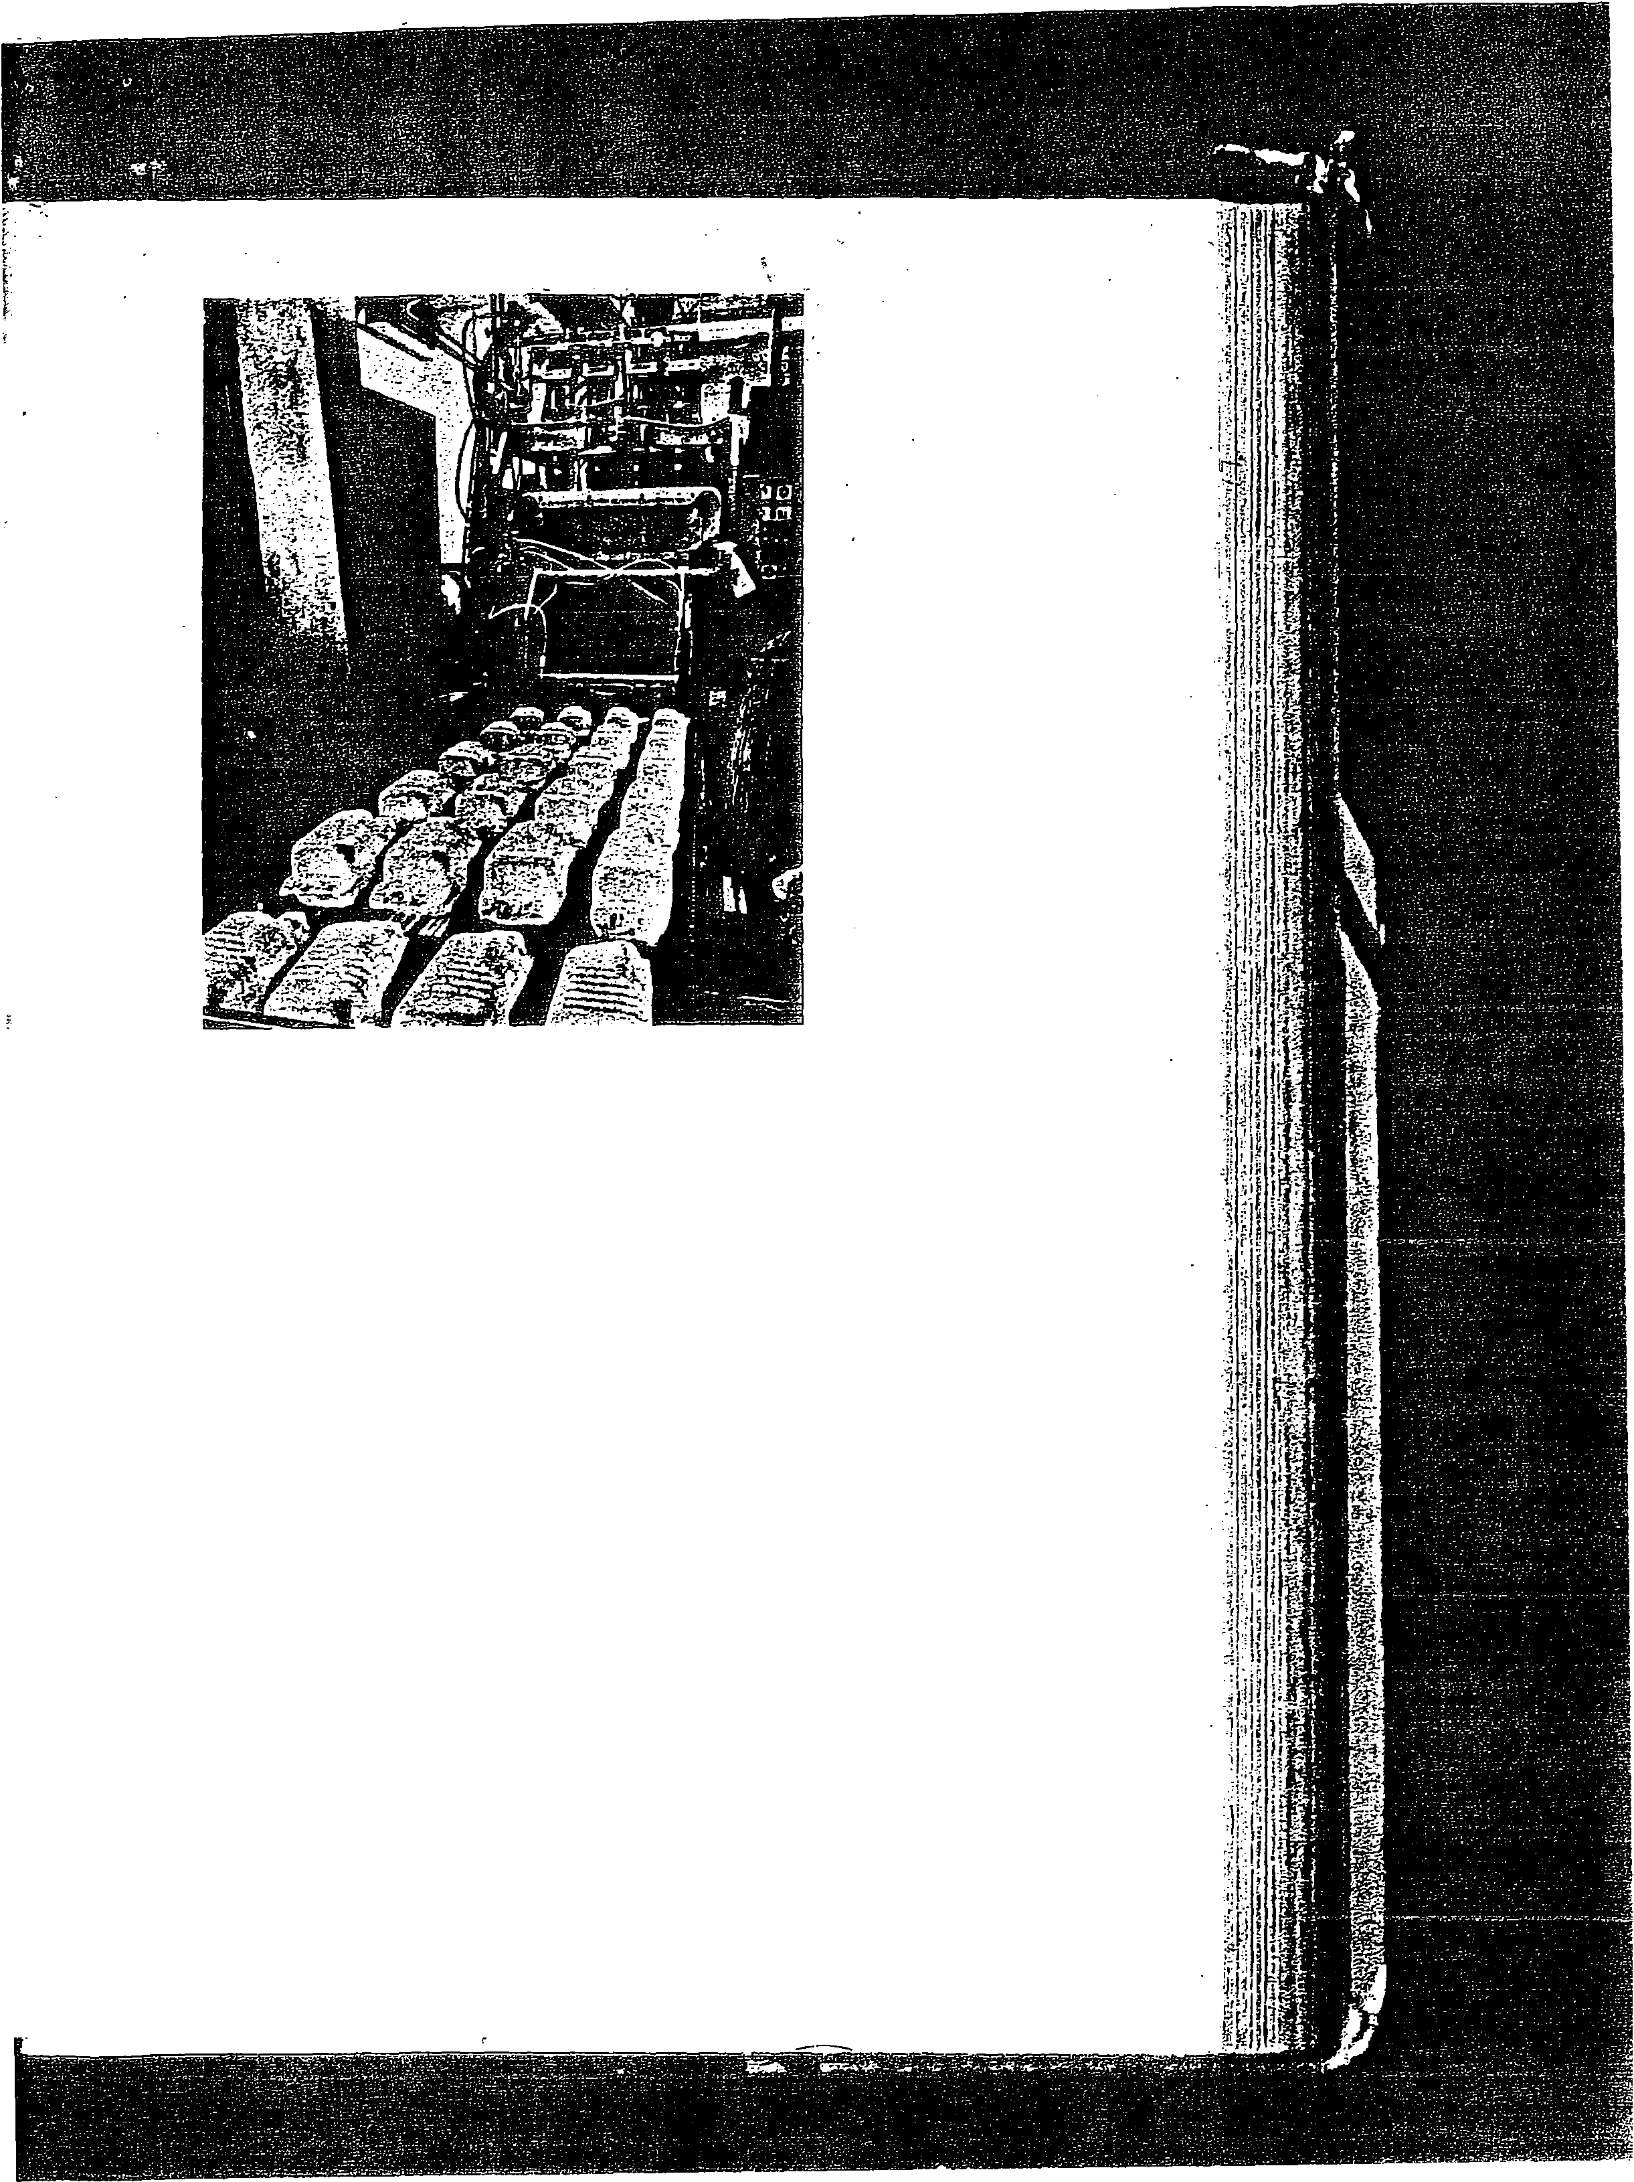

FIGURE 3 • Plastic containers used fcir shipping concentrate.

security, easy bottle removal, replacement, and carrying convenience. But coming under criticism is the basket's physical instability. Its broad expanse of promotional square)nches is said to be often wasted because the multipack is too wobbly to display well.
For large bottlers, these machines will have several advantages. First, it will
mean an end to hand setup, still surprisingly widespread for baskets. Users can now explore the economies of bulk glass instead of precased bottles. It will also mean the elimination of bottle drop and its attendant glass shock, a major step toward reducing in-plant and. in-store bottle breakage. And, for the first time, basket-carrier application is a fast, economical and competitive system. All three systems have been designed to handle the various popular bottle sizes from 7. to 16 ounces.
Another example of the increasing technology in packaging comes from the
Gulf Gate plant of Coca-Cola Bottling Co. at Houston, Texas. It has been using a high-speed, continuous-motion, prototype palletizing machine, han­ dling 26,000 cases or more per day of 12-ounce cans since August 1972. The machine is completely controlled by a solid-state programmable controller. While capable of. handling 85 cases or more per minute, the machine is operated at 60 cases per minute (cpm). At speeds of 60 cpm, the use of a solid-state programmable controller is required. Electrical cycling is too fast for conventional relays. They would quickly outrun their useful life. There is no relay failure with the machine's solid-state progra.mmable controller. Other features of the palletizer include (1) first 85-cpm machine to be operational,
(2) first high-speed machine to use programmable controller in place of a.big

0 Dr Pepper Com pa ny


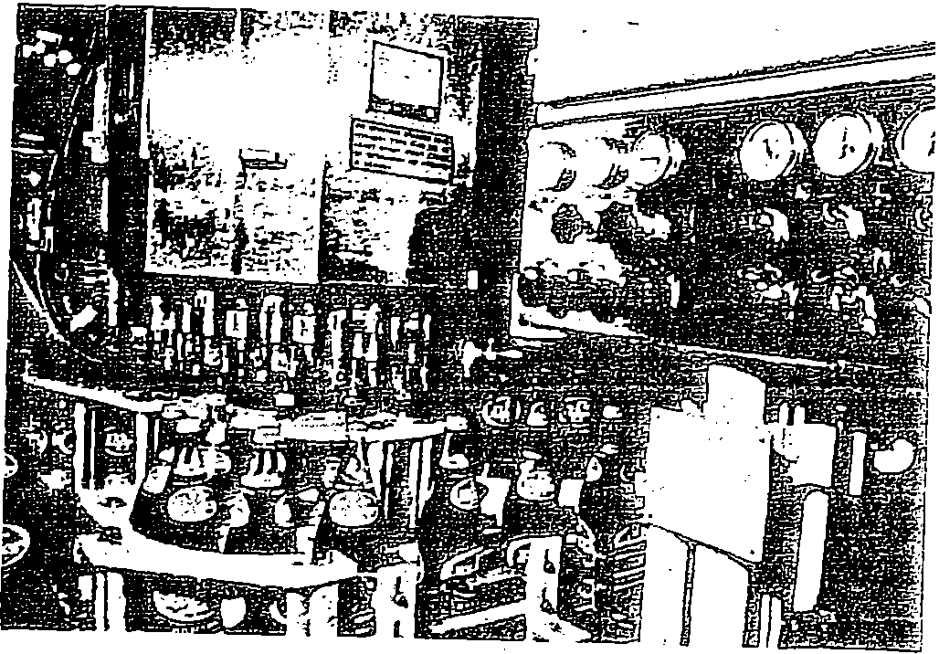
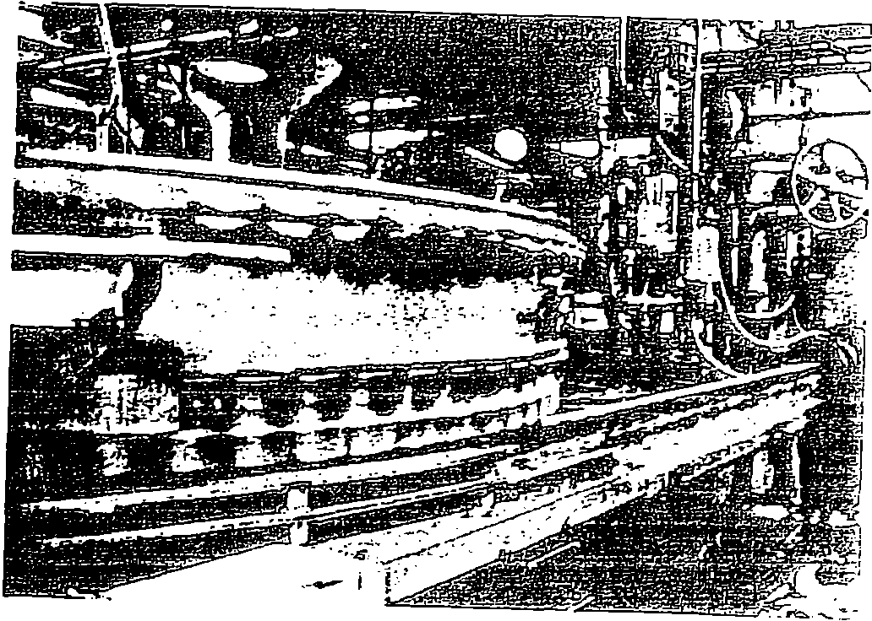

FIGURE 4 • Dallas. Texas headquarters.

FIGURE 6 • Dr Pepper in bottles. The line operates with automatic monitoring .to assure quality.

FIGURE 8 El Dr· Pepper in cans. Automatic production facilities speed operation. requiring only a few em­ ployees.

500 ei Choice of strategy and strategic planning

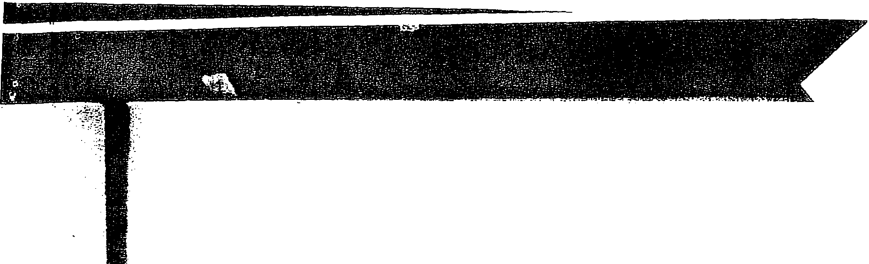
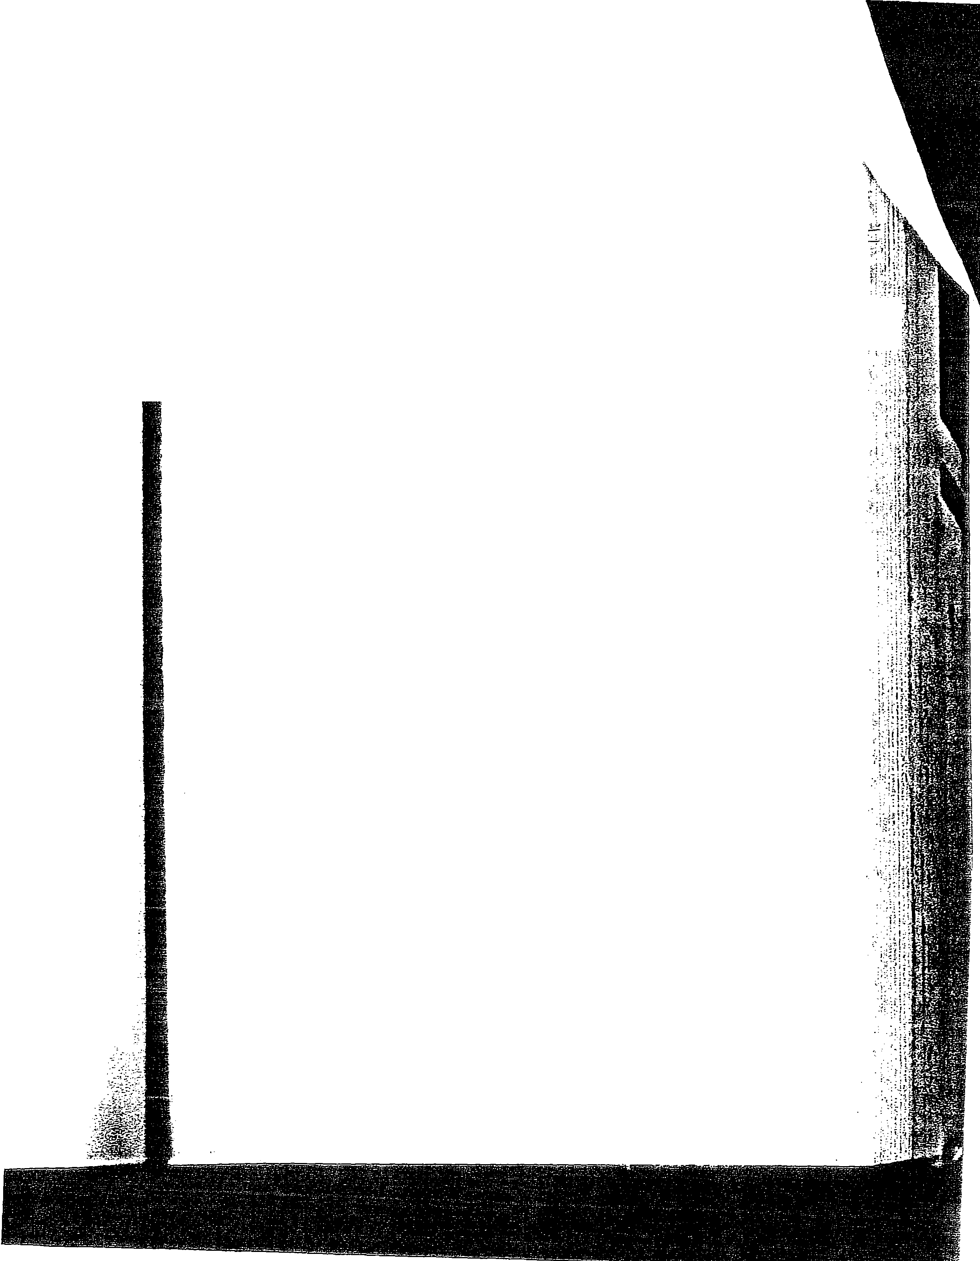

ality.

ng only a few .'i:.,.,

relay cabinet, and (3) first "continuous" motion palletizer. The programmable controller costs about much as a relay cabint. but it takes about one­ twentieth the space and is a large improvement in reliability.
as
One other recent technological development is the control of noise in the . bottling plant caused by the clatter of empty cans hitting each other on cable conveyor lines. In·some in-plant locations it has been necessary for personnel to wear ear-protective gear. Also, can-to-can contact causes nicks in the litho­ graphic covering. _
The solution to this problem came in the way of a modulated-speed, empty can conveyor system which now keeps a constant supply of cans to a 60-valve filler at the Shasta plant in Hayward, California.
Noise level along the cable conveyor line was reduced from a peak 115 decibels to 85 decibels or less by eliminating can-to-can contact. Cans travel with space between them, from depalletizer to filter infeed, to avoid denting and lithographic impairment.
Dr Pepper directly employs about 1150 people. It and its bottlers employ about 695,000 people. For its own employees, the firm offers stock option and an insured noncontributing pension plan for employees. The company expects to maintain the pension plan indefinitely, but has the reserved right to discon­ tinue it at any time. The cost of the plan amounted to $393,000 in 1971 and
$374,400 in 1970. Costs of the plan include amounts sufficient to amortize past service costs over the remaining active employment periods of the covered employees, except the additional past service cost resulting from a 1969 amendment. The amendment is applicable to employees scheduled for retire­ ment before 1979 and is being amortized over a 10-year period. The assets of the fund exceeded the actuarially computed vested benefits as of December 31, 1971.
The board can authorize stock options for key executives, normally below the market price of the stock. During 1971, for example, options to purchase 206,000 shares were outstanding, 128,000 exercisable at that time, and 26,250 shares actually were exercised.

Accounting and finance at Dr Pepper

The company has provided various 'Statements for analysis. Table 2 contains the balance sheets for 1968 through 1974. Table 3 is 1968-1974 income state­ ments. Additional data for analysis are shown in Tables 4 (changes in financial position), 5 (financial position summaries), and 6 (the financial results over the past few years).
Figure 7 presents a recent summary of distribution of revenue at Dr Pepper.
The company's stock is listed on the New York Stock Exchange, symbolized by the letters DOC. It was originally listed on NYSE in 1947. Table 7 provides the high and low prices of the stock for some recent years. Figure 8 plots the stock of the industry against the Value Line industries.
In 1974, for the first time since 1967, the soft drink industries' stocks have failed to outperform the general market for more than 3 months straight. The Value Line Composite Index, wbich ranks approximately 68 industry groups for year-ahead performance, has dropped soft drinks from 35th to 62d in the last quarter.

501 rn Or Pepper Company

?: ··,;
J1 : il
.i ·.: ;

-

TABLE 2 o CONSOLI DATED·BALANCE SHEETS

1974 1973 1972 197 1 1970 1969 1968

Assets
Current assets
Cash. certificates of deposit $ 364.1 41 $ 822.776 $ 15.935.3678 $ 11.818.371 $ 10,760.89 1 $ 8.1 57,303 $ 6,93 4.799
Marketable securities at cost 4,790.4 45 18,147.335
Receivables 9.114.983 6,679.82 4 5.606.732 4,676,760 3,879.4 18 3.977.290 2.720.350
Inventories at lower of cost (first in.
first out) or market 5.728.615 3.054.439 2.661.848 2, 155,307 1,906,629 1,757,371 2.158,87 1
Prepaid expenses 3,548,258 3.314.330 2.270.275 1,8 4 4.082 1.046,045 1,038,885 707,976

Total current assets 23,546.44 2 32.018.704 26.47 4.2 22 20.494,520 17,592.983 14.930.849 12.521.996

Marketable securities for investment 8,156,618 Investments (at cost) and notes receiv-
able 1,260.829 1,779.325 1.542.978 1.153,352 470,656 35 2.873 426,854
Property, plant. and equipment at cost 24.53 1,905 20.1 99.5 20 17.126.101 13.469,345 12,265.22 7 11.560,331 10,748,920
Less accumulated depreciation 9,1 7 1,2 48 8.902.926 7.733.1 28 5.59 4.253 5.2 49.478 4.858.193 4,490,984

Net property. plant. and equipment 15,360.657 11,296.594 9.392.973 7,875,092 7.015.7 49 6.702,138 6.257.936

Formulas. trademarks. and goodwill at cost or nominal value
2 70,910 |  | 272.910 |  | 272.9 10 | 272.9 10 | 272.9 10 | 272.910 |  | 272.910
$ 48.595.456 |  | $ 45,4 1 7 ,533 |  | $ 37.683.083 | $ 29.7-95.87 4 | $ 25.35 2.298 | $ 22.258.770 |  | $ 19.479.696

Liabilities and stock- holders' equity
Current lia bilities
Accounts payable and accrued ex-
penses | $ 4.884,550 |  | $ 6.006.509 |  | S | 4.535.029 |  | $ 3.537.896 |  | S | 2.859.1 95 | $ 2.6 15.148 |  | $ 1,801.528
Federal and state income taxes | 73,469 |  | 1.240.930 |  |  | 1,541,465 |  | 996.987 |  |  | 7 15.455 | 800.728 |  | 1.1 17.401
Total current liabilities | 4,958.019 |  | 7.2 47.4 39 |  |  | 6.076.494 |  | 4.53 4.883 |  |  | 3.57 4.650 | 3.415,876 |  | 2.9 18.929

Stockholders' equity
Common stock 7.630.73 2
6.7 17,482 5,590.078 3.862,860 3,538.009 3.3 2 4.684 3.079.029


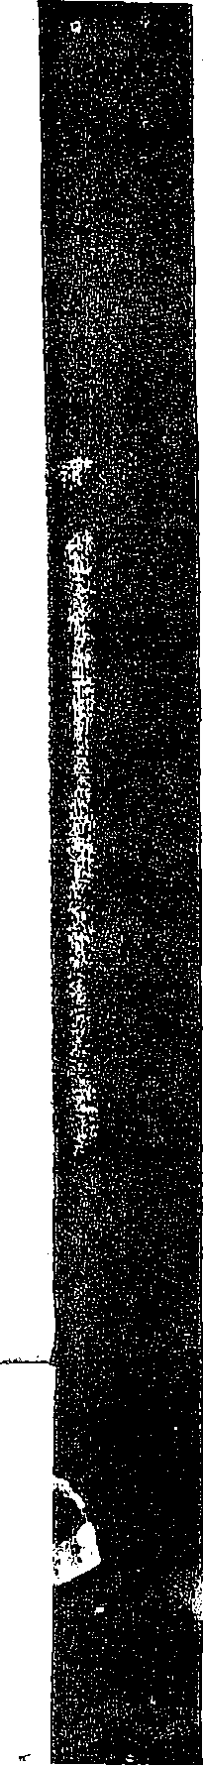
Retained earnings 36,006,705 31,452.61 2 26,016.511 2 1.398.131 18.239.639 15.518.2 10 13.481.738
43,637.437 |  | 38.170,09 4 |  | 31.606,589 |  | 25.260.991 |  | 21.7 77.648 |  | 18.842.894 |  | 16.560.767
$ 48,595.456 |  | $ 45.417,533 |  | $ 37.683.083 |  | $ 29.795.87 4 |  | $ 25.35 2.298 |  | $ 22.258.770 |  | $ 19.479.696

Total stockholders' equity

a 1972 and previous included marketable securities.

Stockholders' equnv Common stock Retained earnings
Total stockholders' equity

7,630,73:l 0,1 I , ,..1-- (J L
36.006,705 31.452.61 2
43.637.437 |  | 38.1 70,094 | 31,606.589 |  | 25.260,991 |  | 21,777,648 |  | 18,842,894 |  | 16,560, 767
$48.595.456 |  | 545.41 7,533 | $37.683.083 |  | 5 29.795.87 4 |  | $ 25.352, 298 |  | S 22.258. 770 |  | S 19,479,696

25:o,ii:s1 1

21.. . , 3, It!,.£-'1:1,U v u I ...,,..., I ...... - • -

TABLE 3 c CONSOLIDATED EARNINGS AND RETAINED EARNINGS, DECEMBER 31

 | 1974 | 1973 | 1972 | 1971 | 1970 | 1969 | 1968
Net sales | $1 28.299, 707 | $ 98,91 8.466 | $82.037.876 | $63.622,653 | $ 57.449.7 | 49 $ 49,51 4.5 | 38 $ 41,883.072
Cost of sales | 74;659,678 | 50.791,1 1 1 | 38,859.902 | 29.787,613 27.4 28,675 24,638.951 1 9,612.383
Gross profit | 53.640.029 | 48.1 27,355 | 43.1 77,974 | 33.835,040 30.021,07 4 2 4.875,587 22,270,689
Administrative. marketing, and general
expenses 36.297.1 1 1 . 31,262.480 28.343,000 21.991.585 19,835,343 15,394,624 14,027,653
Operating profit 17,342.918 16,864,875 14,834.97 4 11.843.455 10.185.731 9.480,963 8,243,036
Miscellaneous income-net 1;1 21.634 1,502,848 847.1 08 894.81 1 899.051 301.535 416.879
Earnings before income taxes 18.464.552 18.367,723 15,682.082 12.738.266 1 1.084.782 9.782.498 8.659.915
Federal and state income taxes 8,562.853 8.632.223 7.492.841 5,966.1 25 5.455,761 5.1 40.260 4.552,229
Net earnings 9.901.699 9,735,500 8,189.241 6,77 2.1 41 5,629,021 4.64 2.238 4.1 07.686
Retained earnings. beginning of year 31,452.612 26,016,51 1 21,705,823 1 8.239,639 1 5,51 8.21 0 1 3.481,738 1 1.51 1.91 8
41.354.31 .1 35.752.01 1 29.895.064 25,01 1.780 21 ,1 47.231 18.123.976 15.619.604
Dividends paid 5,347.31 1 4.299.399 3,878.553 3,61 3,649 2,907.592 2,605,766 2,137,866
Retained earnings, end of yea.r $ 36,007.000 $31.452.61 2 $ 26.01 6.51 1 $ 21,398,1 31 S 18,239,639 $ 15,518.21 0 $13;481.738

,,,._< ., / ;:
' >.";;._:

..7
:-J,::}\:??t;''. f{!}:$);J;_,

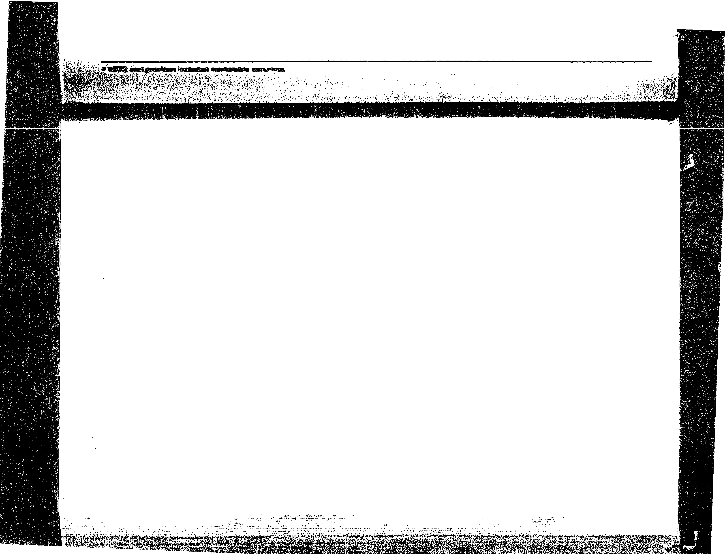
;

TABLIE 4 m CONSOLIDATED STATEMENTS OF CHANGES IN FINANCIAL POSITION, DECEMBER 31
1974 1973 1972 1971 1970 1969 1968
IF1U1nds provided
Net earnings $ 9.901,699 $ 9,7 35,500 $ 8.1 89,24 1 $6,772.1 41 $ 5,629.021 $ 4,64 2.238 $ 4".107.686
Add charge for depreciation which did
not require funds 1.985,6 29 1 .649,640 1.567.052 1.109.447 990.225 869.489 762.889
Funds derived from operations 1 1,887,328 1 1,385,140 9.756,293 7.881.588 6.61 9.246 5.51 1.727 4.870,575
Decrease in noncurrent notes receivable 73.981
Sale of common stock 913,250 1.1 27,404 1 ,667,968 324,850 213.325 245.655 356.832
1 2.800,578 12.51 2,54 4 1 1 .4 24.261 8.206.438 6,832.571 5,831.363 5,227.407

Ulses of working capital Dividends on common stock Additions to property. plant. and
equipment | 6.049,692 |  | 3.553,261 |  | 2.1 49,626 |  | 1.968,790 |  | 1,303,836 |  | 1,313.691 |  | 1.454.645
Increase in marketable securities | 8,1 56,61 8
Increase in investments and non-
current notes receivable |  |  | 236,34 7 |  | 388,278 |  | 682,695 |  | 1 17.783 |  |  |  | 175.837
 | 19.553.91 6 |  | 8,089,007 |  | 6,4 16.457 |  | 6.265.1 34 |  | 4.329.21 1 |  | 3,91 9.457 |  | 3.768,348

5.34'7.606 4.299.399 3,878.553 3.61 3,649
2.907.592 2,605,766 2. 137.866

Increase (decrease) in working cap- ital
Changes in wol'king capital Increase (decrease) in current
assets:

($ 6.232.84 2) $ 4.4 23.537 $ 5,007.804 $ 1.94 1.304 $ 2,503.360 $1,91 1.906 $ 1.459.059

Cash and marketable securities ($13.865.525) $ 3,084,74 4 $ 3,967,678
$1,057.480 $ 2,603.588

Receivables 2,435, 159 1.073.092 634.275 797,342 ( 7.872)
Inventories 2,67 4.1 76 392,591 256,099 248.678 149.258
Prepaid expenses 233.928 1.04 4,055 394.873 798.037 7,160
(8.52 2.262) 5,594,482 5,252,925 2,901.537 2,662.134

Increase (decreese) In current lie- lbiiities
Accounts payable and accrued expenses (1.1 21,959) 1,471.480
(258,309) 678.701 244.047

Federal and state income taxes (1.1 67,461) (300,535) 503.430 281.532 (85,2 73)
(2.289.420) 1.170,945 245.1 21 960.233 158,774

Increase (decrease) in working cap- ital
($ 6,232.84 2) $ 4.423.537 S 5,007,804 $ 1,941,304 $ 2,503,360


1/.rtt'( '•f;. :,µ'/ 51

TABLE !5 • FINANCIAL POSITION
Current Current Working Fixed assets Other
 | aSsets | liabilities | capital | net | assets | indebtedness | equity | per share
 | $23.546.442 | $4,958.019 | $18,588.423 | $15,360.65 7 | $9,688.357 |  | $43.637.437
 | 32.068.704 | 7,247.439 | 24.821.265 | 11.296.594 | 2.052.235 |  | 38.170,094
 | 26.474.222 | 6,076.494 | 20.397.728 | 9.392,973 | 1.815.888 |  | 31.606.589 | 1:61
 | 21.221.297 | 5,831,373 | 15.389.924 | 8.81 0.399 | 1.427.610 |  | 25.627.933 | 1.37
 | 18.449.724 | 5.279.358 | 13,170.366 | 8,055.568 | 805.022 |  | 22.030,956 | 1.18
 | 15.619.602 | 4.668.016 | 11,051.586 | 7.805.838 | 719,103 |  | 19.576.527 | 1.05
 | 13.093.309 | 3,497.143 | 9,596.166 | 6,949.627 | 717.293 |  | 17.263.086 | 0.93
 | 11.790.150 | 3,703.502 | 8.086.648 | 6,221.394 | 543,572 |  | 14.851.614 | 0.81
 | 9;322. 130 | 3.453.595 | 5,868,535 | 5.966,646 | 537.800 |  | 12.372.981 | 0.69
 | 7,896.339 | 3.604,954 | 4,291.385 | 5,973.460 | 624,866 | $189.739 | 10.699.972 | 0.60

Long-term

Stock­ holders'

Book value

0
<O
C'?
:i M
:> 0
u:>
c--i

'.') "1
'.') 0
N (")
0
<O "1
en

"1
•Years 1965 through 1972 restated to give retroactive effect to a pooling-of-interests transaction in 1973.
•Adjusted for 2-lor-1 stock split March 27. 1968. for 3-lor-1 stock split March 25. 1970, and for 2-for-1 stock split October 27, 1972.
·•veers 1965 and 1966 restated to give retroactive effect to the change during 1967 in method of accounting for returnable containers.

TABLE 6 Ii FINANCIAL RESULTS
Net Earnings hares
Net sales earnings pe_r share Dividends utstanding
$1 28,299.707 $ 9,901.699 $5,347,606 1 9 J 0§,034
98.918.466 9,735.500 4.299.39 9 .223/4 18.998.734
82.037.876 8.1 89.241 .43 3.878,553 .204/5 18.869,934
67.769.898 6.884,775 .37 3.61 3.649 .191/2 18.697.860
61.028.665 5.733,91 7 .31 2.91 6.81 2 .153/4 18,645.360
52.709.359 4.672.571 .25 2.61 8.966 .141/0 18.584.460
44.079,937 4.197.436 .23 2.14 2.866 .11:2/3 18.490.620
35.614.1 10 3.588.089 .20 1.583.555 .08:2/3 18.247,260

N

. LD
0
.....
0
0
L!'i
30.008,756 2.956.21 3 .1 7 1.381.856 .07:2/3 17.898.060
28.514.655 2.493.001 .14 1.154,876 .061/2 17.842.860
•Years 1965 through 1972 restated to give retroac_tive effect to a pooling-of-interests transaction in 1973. O Adjusted for 2-for-1 stock split March 25, 1964, and for 2-for-1 stock split March 27. 1968.
'Years 1965 and 1966 restated to give retroactive effect to the change during 1967 in method of accounting for returnable containers.

'<t
en
0
.....
TABLE 7 j

HIGH AND LOW PRICES FOR DR PEPPER'S STOCK

0
N
'<I'
o-i
Year High Low
1974 22.9 6.5
1973 30 18.7
1972 27.3 18.3
1971 40.3 22
, | OJ | 1970 | 2 4.5 | 13
 | N | 1969 | 54 | 43.2
 | N | 1968 | 55.3 | 24.3
 |  | 1967 | 52 | 30

While none of the industry's issues is rated favorable for year-ahead market
6. performance, three are still expected to perform as well as the general market.
u The three are Dr Pepper, MEI Corp. (reorganized in 1972 by the merging with
U)

Q) 01
x c
:.;;
Q) 0
E
0
two Pepsi-Cola bottlers in the Midwest), and the Seven-Up Company.
Industry earnings overall have continued to rise, but the price earnings per share have been suffering. Only in a few cases did earnings experience a decline

u in either of the last two quarters of 1973. Two companies, Coca-Cola Bottling
·=
c:
of New York and Royal Crown had declines exceeding 50 percent. The decline

!!'? "'
'°
.., u
;-o (I)
c:
! ro
of Coca-Cola Bottling of New York is attributed to acquisition indigestion, narrowing of margins, and, at Igloo Corp. (acquired in 1972), inventory ad­ justments. At Royal Crown, Phase 4 had a major hand in the decline, espe­

;'°
'
) Q)
(I)
:o-.-
U)
.£
cially in its natural citrus juice operations in Texas and Florida. Another profit

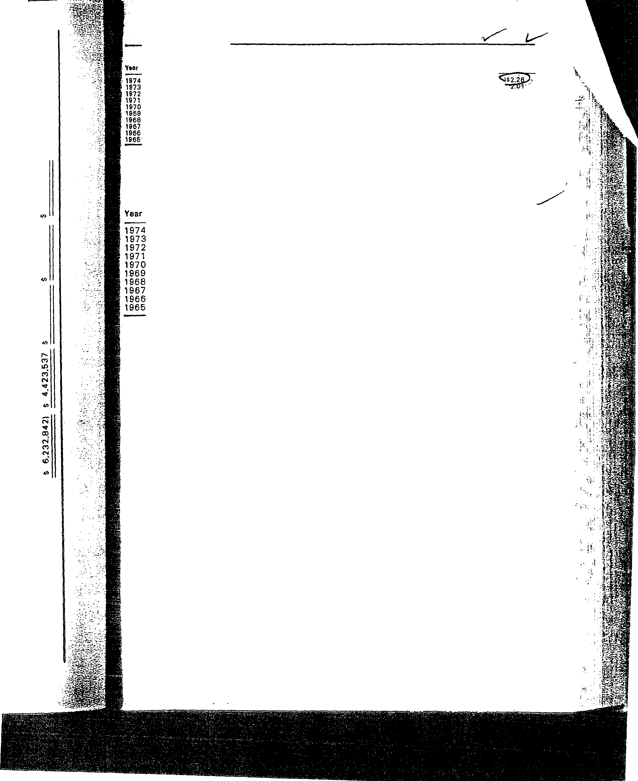

l-C,
la,
(LL

505 s Dr Pepper Company

- (b) (c)
(d)
(e)
(/)
(g)
(h)

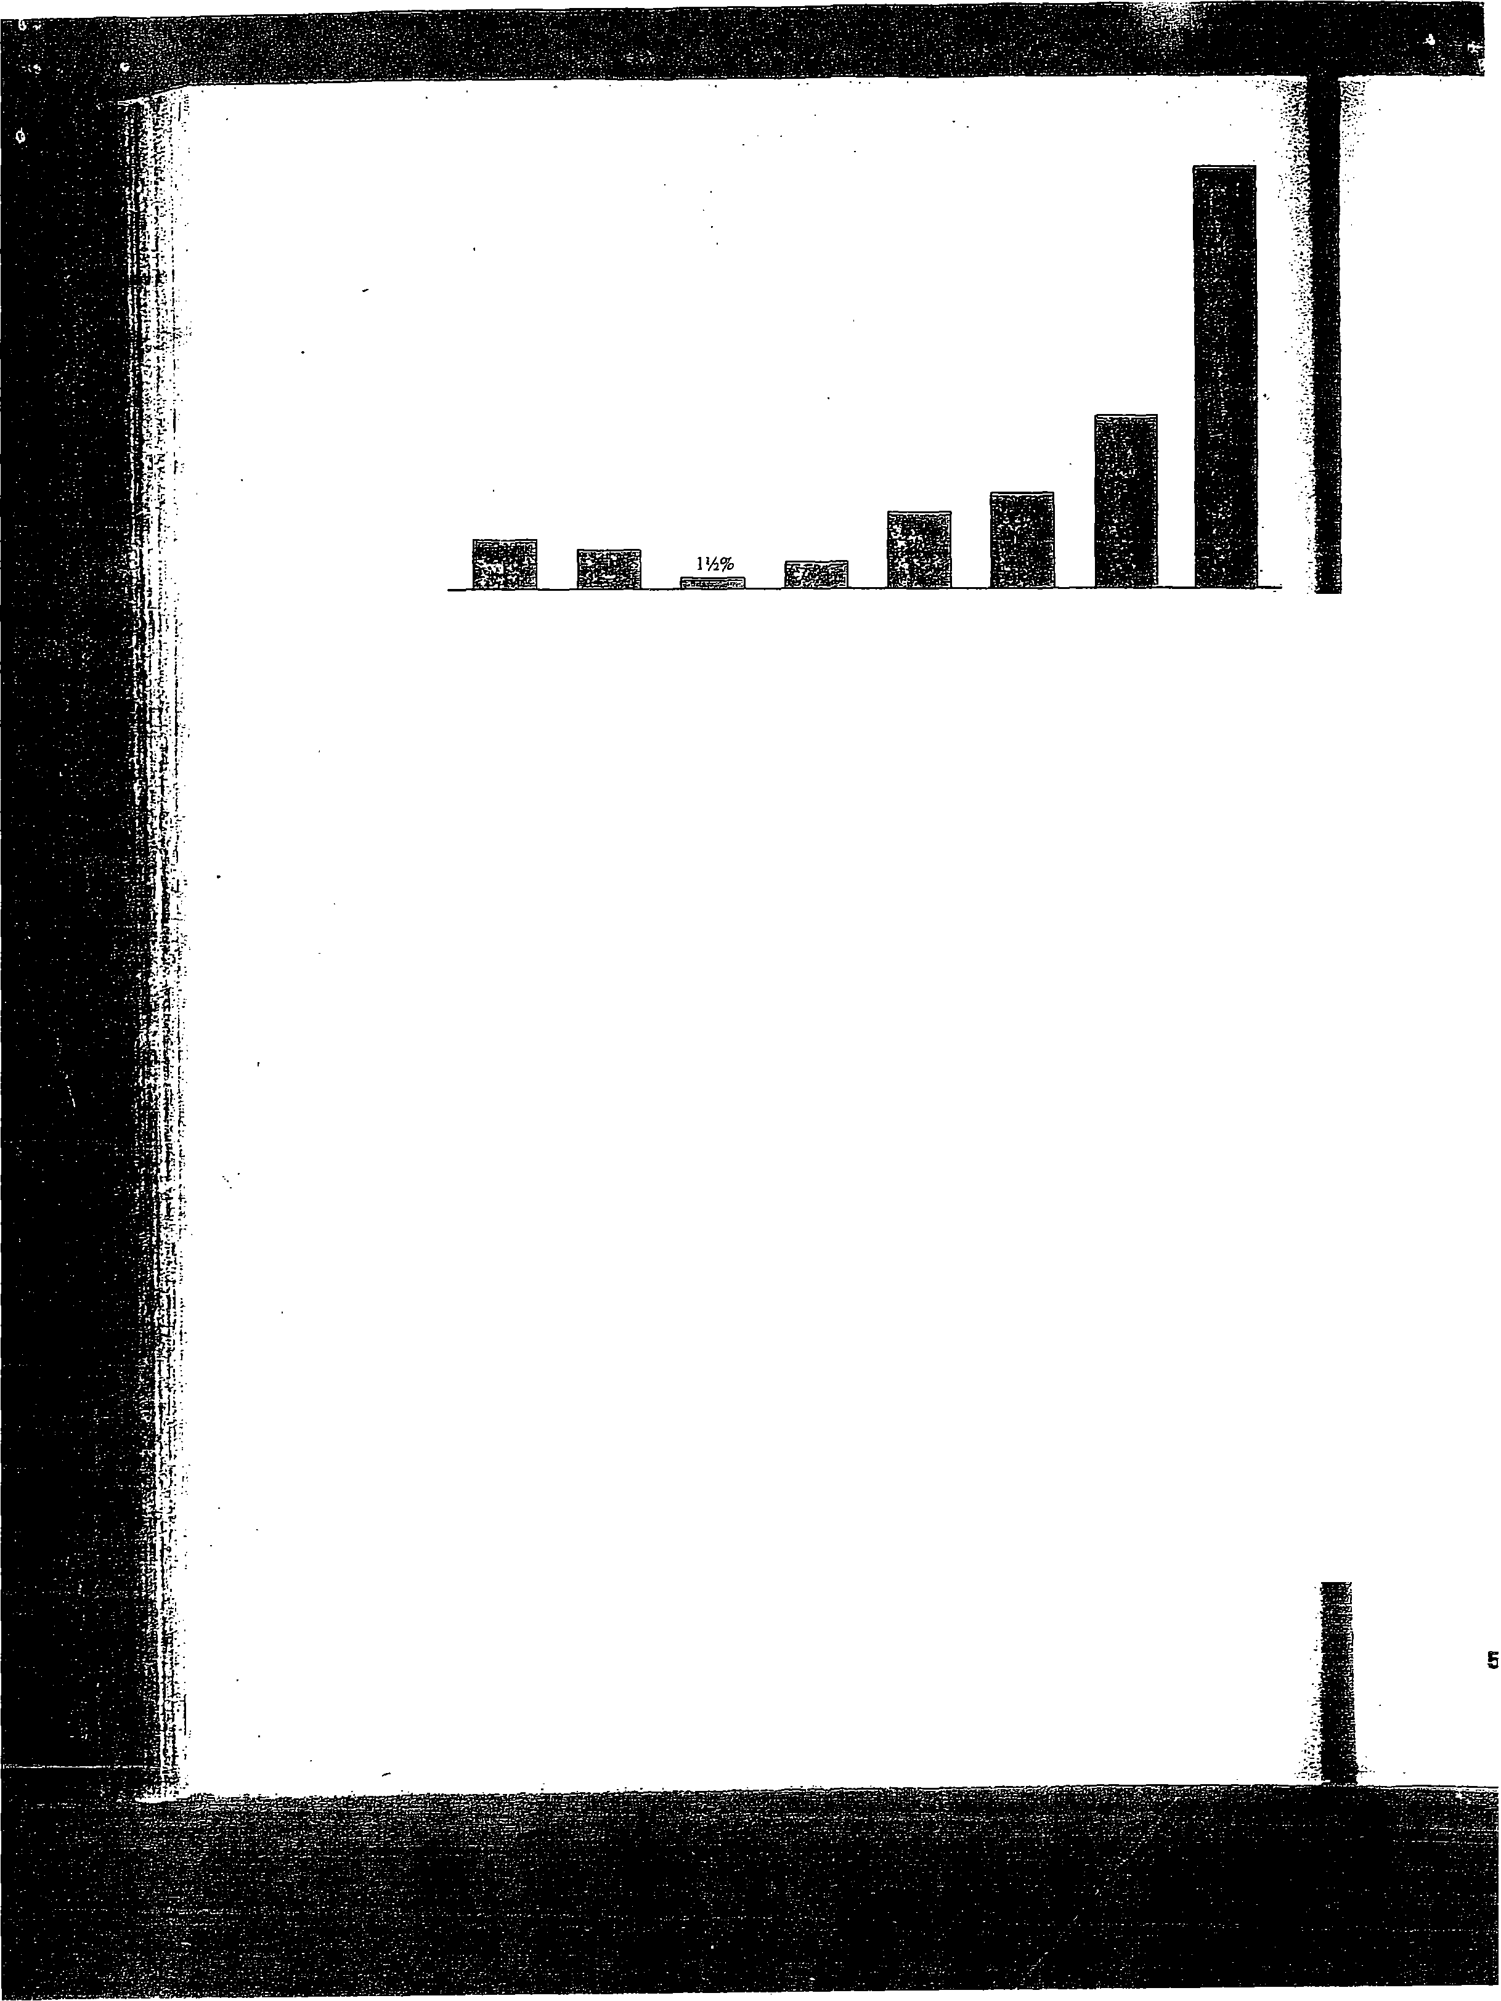
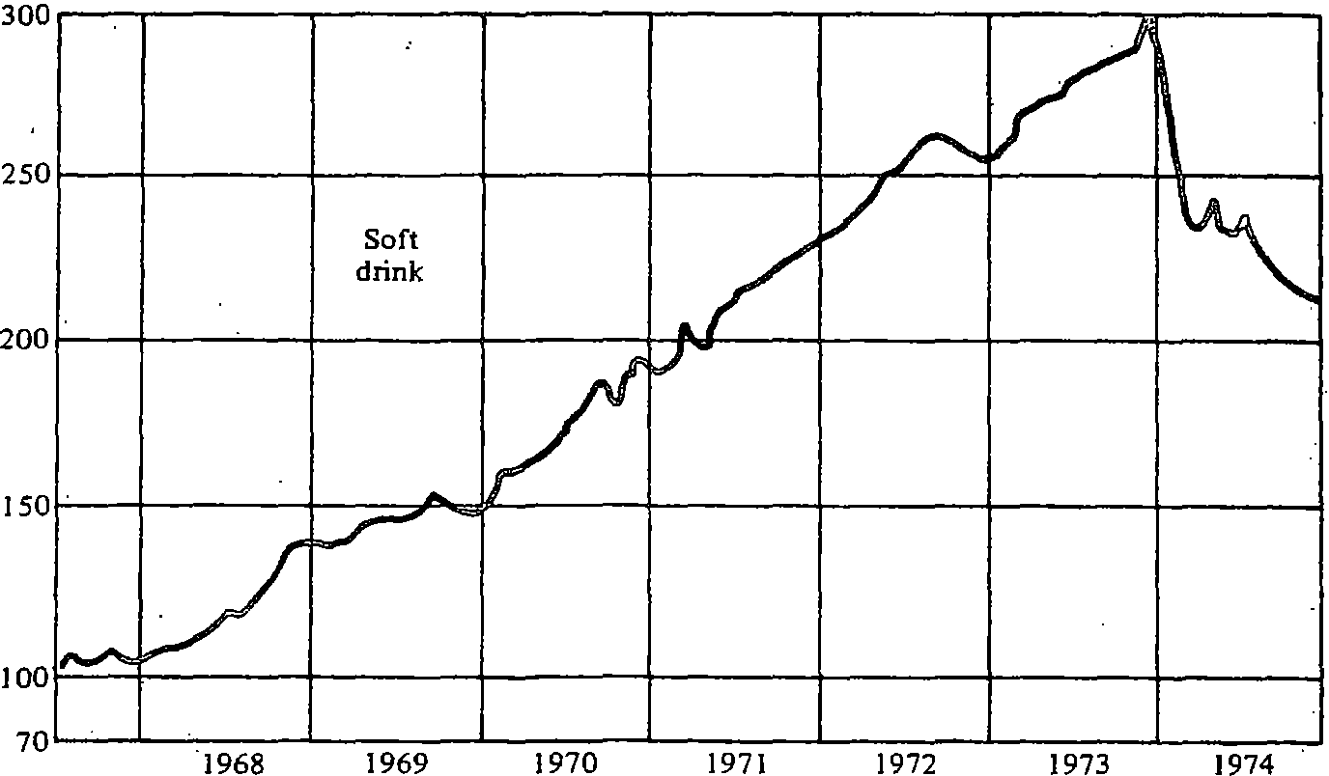
FIGURE 7 e Distribution of revenue. 1973:(e) retained in business: (b) dividends: (c) other operating expenses;
(d) depreciation ·and maintenance: (e) taxes on income; (f) payrolls; (g) promotion. advertising. and expansion; (h) raw materials and packaging.

FIGURE 8 ra Relative strength: ratio of industry to value line composite index: June 1967 equals 100.

drain was credited to the costs connected with getting the newly formulated Diet Rite Cola on its dealers' shelves.
For most companies, though, earnings are expected to keep growth uninter­ rupted, and the industry still has many years of substantial growth ahead of it, although the growth rate may have slowed in recent years.
All of Dr Pepper's subsidiaries' results (all of which are wholly owned) are on the statements in the tables provided. All material intercompany accounts, transactions, and profits have been eliminated.
The company and its subsidiaries provide for depreciation of property,

506 l@ Choice of strategy and strategic planning

