FINANCIAL ANALYSIS

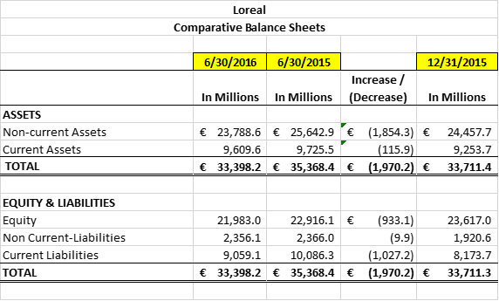
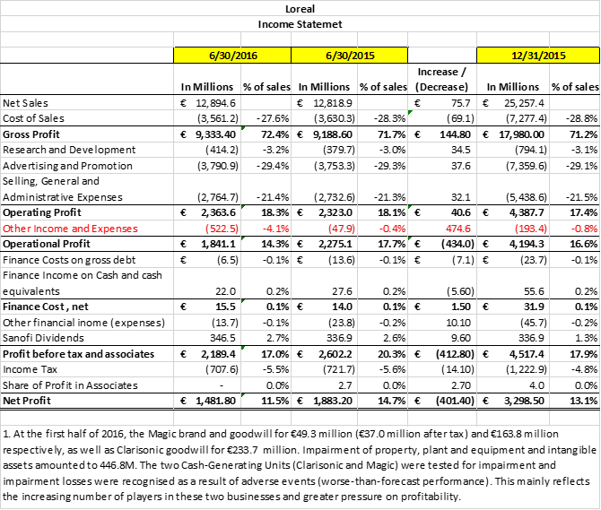
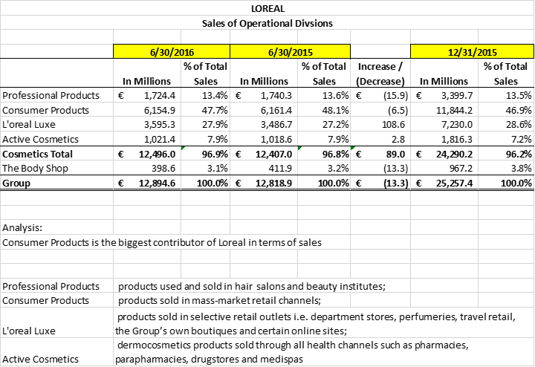
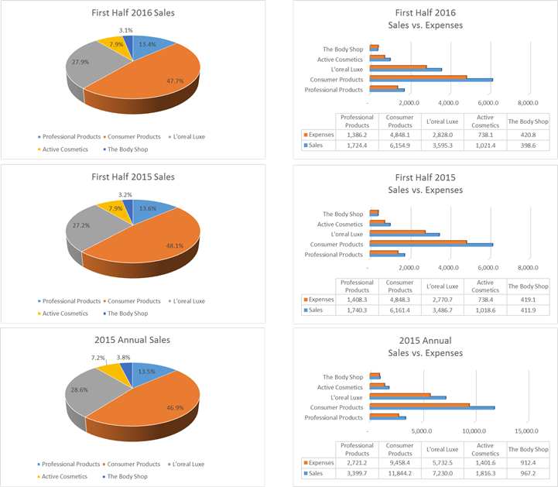
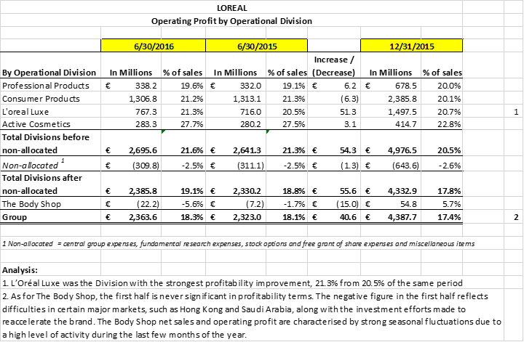
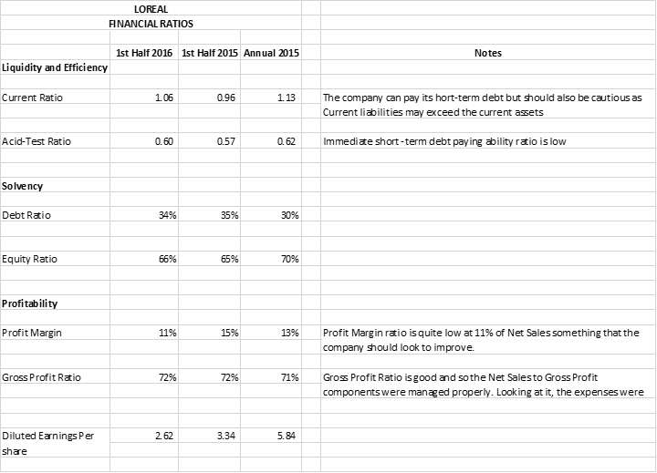
I don’t see much of a concern on Loreal’s Financial performance. But for the benefit of my financial analysis I see the following point should be taken consideration by the management:
· There were no significant increase or movement on sales.
· Expenses of all the division is high which is ranging to 80% of sales.
· For the first half of 2016, 11.5% percentage of Net Income to Net Sales is quite low. I don’t think it’s an industry standard.
· I see a concern on Loreal’s liquidity ratio as it posted a lower ratio which means Current assets may not be enough to pay for its current liabilities.
· L’Oréal Luxe was the Division with the strongest profitability improvement, 21.3% from 20.5% of the same period. I think the company can look to strengthen this division more.
· Active Cosmetics high profitability ratio should be given proper attention as this division will provide good profit at a lesser cost.
· Based on the First half of 2016 Financials, Loreal posted an impairment loss for the goodwill of Clarisonic and Magic due to worse-than-forecast performance. Loreal should be more cautious in investing and making forecast of the same. As shares may not be good as it was invested, the company may end-up into another sorry loss.

MISSION
Beauty for All - Offering all women and men worldwide the best of cosmetics innovation in terms of quality, efficacy and safety to satisfy all their desires and all their beauty needs in their infinite diversity.

STRATEGY
Universalisation - L’Oréal has chosen a unique strategy: Universalisation. It means globalisation that captures, understands and respects differences. Differences in desires, needs and traditions. To offer tailor-made beauty, and meet the aspirations of consumers in every part of the world. L’Oréal is driven by this vision of the world.

COMMITMENTS
“Sharing Beauty with All” - By 2020, … …100% of our products will have an improved environmental or social profile. …we will reduce our environmental footprint by 60%(1). …we will empower all our consumers to make sustainable consumption choices. …100% of employees will have access, everywhere in the world, to the best level of healthcare coverage and social protection, as well as training. …100% of our strategic suppliers will be participating in our supplier sustainability programme. …we will enable 100,000 people from socially and financially underprivileged communities to access work.

Step 4b) Analyze internal factors (Strengths, Weaknesses) After condcuting a thorough internal scan the next step is to use a tool such as Internal Factors Analysis Summary (IFAS) to analyze the strengths and weaknesses identified for the firm.

Internal Influences
Strengths
The on going success of the L'Oreal Group is without if not for the ingenuity of the concept of their vision as a team. L'Oreal Chairman and CEO Lindsay Owen-Jones consider passion as the key to the well-renowned accomplishment of the said Company. The primary strength of the Company is the continuing research and innovation in the interest of beauty which assures that the L'Oreal Cosmetics offers the best to their consumers. Their dedication to their continuous research makes them the leader in the growing cosmetics industry despite the competition in the market.
On the other hand the L'Oreal group also had of Strength of developing activities in the field of cosmetics as well as in the dermatological and pharmaceutical fields in order to enhance and put more concentration in their particular activities. The cosmetics activities of L'Oreal are divided in to three groups. First is the Consumer Product Division which encompasses all the brands distributed through mass-market channels, ensuring that L'Oreal quality is available to the maximum number of the consumers. The Luxury Products Division includes the prestigious international brands selectively distributed through perfumeries, department stores and duty-free shops. The Professional Products Division offers specific hair care products for use by professional hairdressers and products sold exclusively through hair salons. The Active Cosmetics Department creates and markets products for selective distribution through pharmacies and specialist health and beauty outlets. The L'Oreal Group's dermatological activities are linked with Galderma, which is basically a dermatological firm that contributes to the innovation of the L'Oreal Group's products. The pharmaceutical activities of L'Oreal are also handled by Sanofi-Aventis. These divisions and subdivisions ensure the quality that the L'Oreal Group offers to its customers. To further add to the enumerated strengths of the company, L'Oreal's advertising strategy also plays a major part to its growth. Through adapting to the culture of their target market as the main tool of their advertisement, the Company brought L'Oreal products within reach of other women from different parts of the world. (http://loreal.exteen.com)

Weaknesses
Perhaps one of the weaknesses that a big company faces is the decentralized organizational structure. This is also part of the difficulties that L'Oreal is facing. Due to the many subdivisions of the Company, there is also the difficulty in the control of L'Oreal. This slows down the production of the Company because of the need of giving reference to the other Board members and directors of the Company. L'Oreal will also have a difficulty in finding out what division is accountable for the possible pitfalls of the Company. Another weakness that L'Oreal faces is their profit. The profit margin of L'Oreal is comparably low than that of the other smaller rivals. While L'Oreal projects certain rise in digits as their profit, the result does not usually meet the expectations (Sang, 2003). Perhaps, this is also due to the high-end advertising and marketing as well as the width of the Company. Also the coordination and the control of the activities and image in the worldwide market are also viewed as a weakness in the part of L'Oreal. Due to its worldwide marketing strategy, there are also dissimilarities brought about in the campaign of L'Oreal products as to what iMac.

INTERNAL INFLUENCES
Mission and Vision - L'Oreal operates with a distinctive global vision and market approach that have all been oriented to the fast growing global personal care market whereby their core values always have lied in integrity, responsibility and respect for the people and environment and thus satisfying and empowering the consumers further and thus allowing them to become a leader in Corporate Consumer Responsibility.
Goals and objectives - L'Oreal goals and objectives have always made them outstanding in the rest in the market as it always focused its strategy on achieving internal growth which was largely influenced by the ideas of acquisitions either it being strategic or tactical it has clearly lead to the overall growth of the business.
Organisation Structure- L'Oreal has had a unique matrix structure as a result of this it has lead to effective communication throughout the whole organisation as well as developing effective market strategies and new product ideas. The matrix structure improved coordination with the rest of the departments in the organisation as well as on shared technologies and allowed information to move easily and feedback.
Employees - This has been a major influence on the organisations success as all employees are treated as assets in the company and all most all the employees have developed trusting relationships with their jobs as a result better working relations.
Decision making-Decision making tends to be decentralized in the organisation thus allowing faster decisions to be made. Fast and flexible decision making willing to take risks has led them implore onto new opportunities in the market.
Culture-L'Oreal has been built on strong values which have shaped culture and have guided the organisation throughout the life of the company whereby customer culture has always been emphasized as product safety and quality is paramount at all times and so becoming the leading beauty company .L'Oreal culture tends to cover all aspects of beauty for all consumers. The customer oriented culture has thus allowed L'Oreal to distinguish itself from competitors like P&G.
Research and Development- L'Oreal invested merely around â‚¬581 billion in 2008 as per (L'Oreal .com) so as to promote sustainable innovation and safer to products to its consumers.

SWOT Matrix & Analysis
/ Internal Environment
Strengths

Strong Brand Image, locally and Internationally

Perceived high quality standards and products

High Brand Awareness among men and women

Knowledge of different cultures and rituals worldwide: can adapt its products

Portfolio of International brands in different distribution channels (23 global
Brands, including L'Oreal Paris, Garnier, Maybelline NY, YSL Beauty, Biotherm)

Strong Research and Development departments- constant innovation

Strong advertising: through product placement, television ads, social medias,
And books.

Diversity of beauty products and services: skin care products, cosmetics, hair
Color, hair care, styling, hair-dressers. Men's line means more selling
Opportunities, and meeting the needs of more people.

Positive social responsibility image: campaign for the fight against ovarian
Cancer, partnership with WIN (women in need) to help women achieve their
Goals through workshops

Increase in operating profit from 2009 to 2010: they are doing well, despite
The economy.

Dividends have increased by 20 percent in 5 years: attractive to shareholders

Weaknesses
Internal family disputes on heritage and company control

High investment in constant innovation means high risk of failure (loss of
Money)

Their smallest cosmetic production and sales are in North America

Decentralized organizational structure: with so many brands under its name,
The company is hard to control: slowing down the production of the company

Hard to know who is accountable / responsible for problems relating to one or
Another brand of the company

Worldwide marketing strategy that adapts to the culture: blurring of the
Company image

IFAS FORMAT (TBE)

https://docs.google.com/spreadsheets/d/1G7S7zIhIU1dDocpnjFKwqkZjIGU2ikP8__mMyAk1eqc/edit#gid=0

ps: These are just research draft, me and Ryan will edit our part and build up the IFAS summary base on the material.

L’Oréal Page 282

Step 4a) Scan and Assess Internal Environment (Structure, Culture, Resources)
Determine how the organization is structured (i.e. simple, functional, divisional, SBUs, Conglomerates). Then assess the organizational culture in the organization to determine whether it is positive or negative. Then assess the organization’s resources using tools such as VRIO and Porter’s Value Chain Model.

Today’s business organizations are becoming less centralized with a greater use of cross functional work teams. The diagram illustrates the changing structural characteristics of Modern Corporations. (page 285)

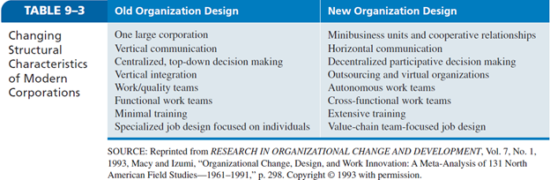

Possible Organization structure for L’Oréal:
(page 147)
Simple structure or Stage 1 has no functional or product categories and is appropriate for a small, entrepreneur-dominated company with one or two product lines that operates in a reasonably small, easily identifiable market niche. This structure doesn’t pertain to L’Oréal.

Functional structure or Stage 2 is appropriate for a medium-sized firm with several product lines in one industry. Employees tend to be specialists in the business functions that are important to that industry, such as manufacturing, marketing, finance, and human resources. This structure could be appropriate as L’ Oreal have several product lines in one industry, the great strength of a Stage II corporation lies in its concentration and specialization in one industry. Also, Stage II, the corporate strategy favors protectionism through dominance of the industry, often through vertical and horizontal growth.

Divisional structure or Stage 3 is appropriate for a large corporation with many product lines in several related industries. Employees tend to be functional specialists organized according to product/market distinctions. Stage III is typified by the corporation’s managing diverse product lines in numerous industries; it decentralizes the decision-making authority. Stage III organizations grow by diversifying their product lines and expanding to cover wider geographical areas. They move to a divisional structure with a central headquarters and decentralized operating divisions—with each division or business unit a functionally organized Stage II company.

L’Oréal organizational structure is a mix of Functional and Divisional But, L’Oréal could also be in a Decline stage (Stage 4) where it the company is in the decline, profit strategy followed by retrenchment and need structural surgery. A Revival phase may occur sometime during the Maturity or Decline stages. The corporations life cycle can be extended by managerial and product innovation. Developing new combination of existing resources to introduce new products or acquiring new resources through acquisitions can enable firms with declining performance to regain growth—so long as the action is valuable and difficult to imitate.
The table below illustrates the Organizational Life Cycle, used to determine where L’Oréal is in it Life Cycle Stage.
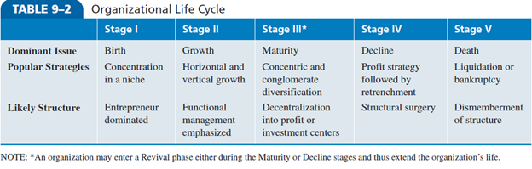

(NEED TO FIND IF THEY ARE DOWNSIZING) Possible retrenchment L’Oréal will have is downsizing as it plans elimination of positions or jobs (Textbook, Page 308). If L’Oréal plans to downsize it could
- Eliminate unnecessary work instead of making across-the-board cuts
- Contract out work that others can do cheaper
- Plan for long-run efficiencies
- Invest in the remaining employees, and
- Develop value-added jobs to balance out job elimination

Info taken from: Page 281-282, 284& 285, 308 of Wheelan and Hunger, Strategic Management and Business Policy, Fourteenth Edition

Then assess the organization’s resources using tools such as VRIO and Porter’s Value Chain Model.

Value: Yes. Does it provide customer value and competitive advantage?
L’ Oreal is constantly looking for new innovated ideas. L’Oréal has organized its Research and Innovation around six regional platforms (Europe, United States, Japan, China, Brazil, and India). In each major region of the world, these poles integrate the activities of research, "development expertise" and "market fundamentals". Their mission is also to understand the habits, needs and criteria for preferences of local populations where beauty is concerned. Thanks to this interaction between research and marketing, L’Oréal is able to offer cosmetic products that are adapted to different skin types, hair types and cultures. L’ Oreal attentively listens to consumers on every continent and on the observation of their behavior where beauty is concern. Their mission is also to understand the habits, needs and criteria for preferences of local populations where beauty is concerned. Thanks to this interaction between research and marketing, L’Oréal is able to offer cosmetic products that are adapted to different skin types, hair types and cultures. On area of concern is the long-term effect of cosmetic use, L’ Oreal is looking into organic products and natural ingredients which is expected to worth S15.98 Billion by 2020, this may seen a value for customers. But when it comes to the word “Natural” some consumers may be sceptical and don’t believe product labels are truly natural, suggesting brands will have to work harder to win them over.
The competitive advantage L’ Oreal has is by strengthening its global presence through the six regional poles - Europe, United States, Japan, China, Brazil and India - L'Oréal's Research and Innovation comes closer to its major markets, but also to the wealth of scientific knowledge of each region. Also, L’ Oreal has been named as one of the world’s most ethical companies by the Ethusphere Institute. L’ Oreal ensure that its suppliers are meeting quality and regulatory compliance, This requires industry suppliers such as logistics providers and contract manufacturers and packers to manage and comply with the myriad standards, audits, and reporting procedures established by their customers. According to L’Oreal Americas' Mark Genco, Quality Vice President, said the initiative "will provide an efficient and collaborative way to assure the quality of raw materials and components necessary for us to continue to give our consumers the positive product experience they deserve.”
http://www.packworld.com/contract-packaging/contract-packaging-news-amp-trends/pg-jj-unilever-loreal-estee-lauder-join-forces
http://www.loreal.com/group/who-we-are/awards---recognitions
(http://www.loreal.ca/en-ca/research-and-innovation/our-innovation-model)
https://www.grandviewresearch.com/press-release/global-organic-personal-care-market
http://www.cosmeticsbusiness.com/technical/article_page/Organic_beauty_evolution_in_2016/114941
Rareness: Yes & No. Do no other competitors possess it?
In considering rareness, patents and innovation sustainably is key in the highly competitive beauty industry. L’ Oreal does hold a favorable advantage as it does patent it active ingredients for beauty products. Competitors can obtain the resources or capabilities necessary in the near future but the product will be in it maturity stage.
No, because companies including L’ Oreal are investing into environmental and social benefit. The push to organic products with natural ingredients and environmentally friendly packaging is the new focus for L’ Oreal. Key competitors are also adapting to the new organic trend. There is potential for rivals to group together to share resources in order to take on L’ Oreal. Such as P & G acquisition of Clairol in 2001, giving P & G the upper hand in skin cleansers, moisturizers, and shampoos.
The

Imitability: Yes & No. Is it costly for others to imitate?
As L'Oreal is one of the world's leading cosmetics companies, the key is innovation and ability to patent R&D. L’ Oreal does have a distinctive competency where its ability to patent major active ingredients well in advance of competitors. The transparency aspect is difficult for competitors as L’ Oreal patent major active ingredients. The transferability aspect will have competitors looking for alternative ingredients sometimes finding lower quality. Due to the patent of active ingredient used to make the cosmetic products difficult to imitate.
But, No, because the skin care, makeup, fragrance and hair care businesses are characterized by intense competition throughout the world. The company competes in selected product categories against a number of multinational manufacturers (Procter & Gamble, Estee Lauder Companies Inc., Unilever, Avon, and Shisiedo). L’ Oreal skin care, makeup, fragrance and hair care businesses can be substituted. As Competitors use reverse engineering which involves taking apart a competitor’s products in order to find out how it works and what ingredient are in it. As L’ Oreal products tend to be expensive and more for families that have disposable income to spend and families looking for Luxury, The spread of counterfeit goods has become global and the range of goods subject to infringement has increased significantly. Some of the major factors that led to an increased trade in counterfeit products include growing internet usage, extension of international supply chains and more recently, the global economic downturn that led customers to look for low cost alternatives.
(http://eds.b.ebscohost.com.libproxy.auc.ca/eds/pdfviewer/pdfviewer?sid=29ea5e1e-1f6e-4c8d-a70f-1e34ab7cccec%40sessionmgr101&vid=2&hid=112)
Organization: Yes Is the firm organized to exploit the resource?
A firm must organize its management systems, processes, policies, organizational structure and culture to be able to fully realize the potential of its valuable, rare and costly to imitate resources and capabilities. Currently, L ‘Oreal

