Assignment 2 and 3
(combined)
FIN 331
Stocks and Bonds

Instructions:
Please read the instructions carefully
- Please remember the following as you work on the assignment this weekend.
- This assignment is due at 6PM Wednesday 10/12/16 (at the end of class). There will be a penalty of 10% per day for late assignments.
- You need to turn in your assignments individually by bubbling the answer choices in your scantrons.
- Write your name on the scantron (882 E). This scantron should be available at UB book store, student center, or other popular retail stores that carry office/stationary items.
- I will not accept or grade e-copies of scantrons. You will need to turn in the hardcopies.
- I will not accept handwritten assignments.
- If you submit a blank/nameless scantron you will receive ZERO even if you checked answers on the assignment.
- If you bubble more than one answer choice you will receive a zero for that question!
- Finally, no collaboration whatsoever. If I do see any evidence of collaboration each person involved will receive ZERO on the assignment.

1. SMNF is expected to pay a dividend of $2.00 per share while SOCO just paid dividends of $3.70 per share. Assume that the growth rate for both are 11.5% for ever. The rate of return for SMNF is 20% while the rate of return for SOCO is 18% Calculate Po:

A. Po for SMNF is $22 Po for SOCO is $58
B. Po for SMNF is $22 Po for SOCO is $60.9
C. Po for SMNF is $23.5 Po for SOCO is $56.923
D. Po for SMNF is $23.5 Po for SOCO is $63.5
E. None of the above.

2. A bond with a 5 percent coupon that pays interest semiannually and is priced at par will have a market price of _____ and interest payments in the amount of _____ each.

A. $1,005; $50
B. $1,050; $25
C. $1,050; $50
D. $1,000; $50
E. $1,000; $25

3. The ELL common stock pays an annual dividend of $1.90 a share and is committed to maintaining a constant dividend. How much are you willing to pay for one share of this stock if your required return is 11 percent?

A. $15.56
B. $16.67
C. $17.27
D. $18.88
E. $20.00

4. The Rose Shoppe offers 10-year, 8 percent coupon bonds with semiannual payments and a yield to maturity of 8.24 percent. What is the market price of a $1,000 face value bond?

A. $990.32
B. $983.86
C. $1,108.16
D. $1,521.75
E. $591.04

5. Antonio's offers a 10-year bond that has a coupon rate of 5 percent and semiannual payments. The face value is $1,000 and the yield to maturity is 12.6 percent. What is the current value of this bond?

A. $273.09
B. $580.92
C. $574.56
D. $605.92
E. $854.46

6. A General Co. bond has a coupon rate of 7 percent and pays interest annually. The face value is $1,000 and the current market price is $1,020.50. The bond matures in 20 years. What is the yield to maturity?

A. 6.59%
B. 6.81%
C. 7.00%
D. 7.04%
E. 7.12%

7. Webster's has a 12-year bond issue outstanding that pays a coupon rate of 6.5 percent. The bond is currently priced at $938.76 and has a par value of $1,000. Interest is paid semiannually. What is the yield to maturity?

A. 7.27%
B. 7.80%
C. 8.01%
D. 14.56%
E. 14.07%

8. Your firm offers a 20-year, semiannual coupon bond with a yield to maturity of 8.35 percent, a face value of $1,000, and a market price of $1,054. What is the coupon rate?

A. 8.91%
B. 4.46%
C. 17.64%
D. 8.82%
E. 17.82%

9. Bin Restaurant Corp stock has a market price of $18. If it has a yearly dividend of $2.50, what is your expected rate of return if you purchase the stock at its market price?
a. .072%
b. 7.2%
c. 13.89%
d. 15.15%

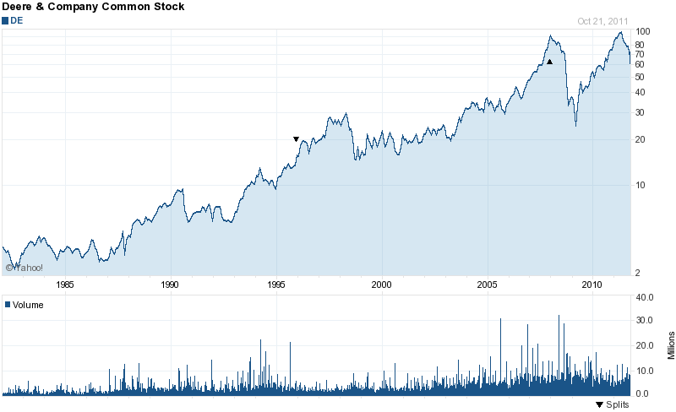

10. Your father bought 100 shares of john deere’s common stock in 1982 for $1.45. He sold it in 2011 at $72.23. What is the rate of return he earned on this investment?
- 2000%
- 3000%
- 4881%
- 5880%
- 0%

End of Assignment 2

