ABC Project Plan

Name:
Institution:
Professor;

Date:

ABC PROJECT PLAN
Alan’s Best Chocolates (ABC) is a leading company in the sales of confections and chocolates throughout the United States. The company’s products are sold from 50 stores across the country and maintain a high reputation for superior quality and taste. While the company’s sales have grown over the past ten years, the rate of growth has signiﬁcantly slowed. One key factor for this slowing rate of growth is the shift in the marketplace to purchasing chocolates and confections online. For a company to succeed, it needs to plan on how to capitalize on this online marketplace by leveraging existing technologies, industry best practices, and aggressive marketing and sales campaign to ramp up the its growth projections for the foreseeable future (Rohm, Kashyap, Brashear & Milne, 2004). The article therefore focuses on some of the ways ABC Company can indulge in e-commerce.
PRODUCTS AND SERVICES
ABC is considering a step to create an online platform from which it can sell its existing products. Until now ABC Company has only sold its products from its traditional chain of brick and mortar facilities and has been greatly limited to sales within the geographical regions where its stores are situated. By doing so, ABC Company has not been able to capitalize on the growing trend of online sales within the confections and chocolate marketplace. Through offering its products on an online platform, the company can market its products available to an entirely new market, increase revenue generation and growth projections, and also allow customers to purchase our products from their homes (Rohm, Kashyap, Brashear & Milne, 2004).

TECHNOLOGY CONSIDERATIONS
Upgraded technological capability will be mandatory for ABC to move towards offering an online marketplace from which customers can purchase our products. As we all know, customers require a simple and easy way by which to conduct online transactions, and it is imperious that all transactions are carried out in a secure manner (Figallo, 1998). The integration of our current website and the online purchasing capability will be a great developmental step. ABC Company must consider new online marketing functionality to target existing and potential customers through methods such as promotional advertisements, e-mailing lists, and loyalty discounts.
Due to lack of Information Technology experts to implement and maintain the extensive online platform needed, the company should source this service from an internet marketplace provider who can work with ABC to meet its needs within the determined budget and timeframe. With the addition of an e-commerce portal, it is anticipated that there will be an overall cost increase of between 5-10% for web server operations and maintenance costs.
PRODUCT/SERVICE MARKETPLACE
The online marketplace for confections and chocolates has been thriving for several years. In FY20xx online sales of chocolate accounted for about 20% of total chocolate sales around the globe. All of the company’s current major competitors already have an established online presence of at least 3-5 years. This serves as another major reason as to why we need to implement the e-commerce program to stay competitive in the market.
Through providing a more convenient means of purchasing our products online, it is anticipated that we will retain its current customers while carrying out an online marketing campaign for more new customers as well. The company will distribute online purchases via direct shipping from the nearest stores.
MARKETING STRATEGY
Rohm, Kashyap, Brashear and Milne (2004) suggested that in order for a company to be successful, it must differentiate itself from competitors to appeal to customers in the online marketplace . To achieve this, the company will utilize its practice of personalizing its product packaging that it currently offers in-store customers. ABC will implement a customer e-mailing list to send sales advertisements, product promotions, and other special offerings to customers who register.
Additionally, the company will offer referral incentives to customers who refer our products to family and friends to provide additional incentives. In addition to that, ABC’s current marketing and sales staff will require special training in online marketing and sales practices. The training service will need to be contracted to a training provider as part of our startup costs and schedule.
ORGANIZATION AND STAFFING
Though the ABC Company online sales campaign is not anticipated to signiﬁcantly impact on the organizational structure of the company, several stafﬁng additions are required to successfully implement the online sales campaign. Among them include the online Sales Manager and the online Marketing Manager.
SCHEDULE
The following is a high level program of the vital steps for this initiative:
Jan 1, 2015: Initiate Project
February l, 2015: Project kickoff meeting
March l, 2015: Complete the design of online sales site
April 1, 2015: Complete testing of online sales site
June 1, 2015: Complete the beta testing trials of the online sales site
July 2, 2015: Go live with site launch
After the approval of this project a detailed schedule will be made by the assigned project team to include all deliverables and tasks.
FINANCIAL PROJECTIONS
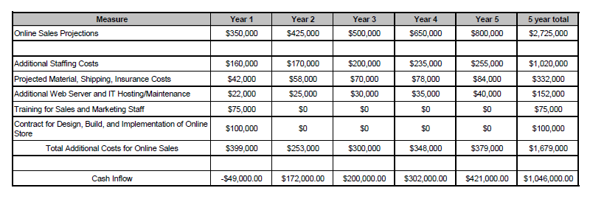

FINDINGS AND RECOMMENDATIONS
It is recommended that ABC Company approves the online sales initiative and starts project initiation. This initiative will be very beneﬁcial to the company and has a high probability of success. Key ﬁndings include:
Technology: -Will utilize current technology which lowers project risk
- E-commerce infrastructure will be contracted out to vendor which allows ABC Company to share risk
-Once in place this technology is simple to operate and maintain for a relatively low-cost
Marketing: -This initiative will allow ABC Company to reach many target groups electronically at a low cost
-ABC Company can expand customer base beyond the geographic areas where stores are currently located.
-The marketplace for online confection and chocolate sales is in a steady state of growth.
-ABC can distinguish itself from its competitors and will utilize incentive programs to target new customers.
Organizational: -Minimal increases to stafﬁng will be required due to lack of changes to organizational structure
-No new capital investments are required
Financial: -Break even point will occur early in the second year of operation
-Five-year projections show online sales accounting for about 25% of total sales.
-ABC Company will be in a position to seize greater market share through maintaining both an in-store and online presence.

References
Rohm, A. J., Kashyap, V., Brashear, T. G., & Milne, G. R. (2004). The use of online marketplaces for competitive advantage: a Latin American perspective. Journal of Business & Industrial Marketing, 19(6), 372-385.
Figallo, C. (1998). Hosting Web communities: Building relationships, increasing customer loyalty, and maintaining a competitive edge.

