Take any natural number n. If n is even, divide it by 2 to get n / 2. If n is odd, multiply it by 3 and add 1 to obtain 3n + 1. Repeat the process (which has been called "Half Or Triple Plus One", or HOTPO[6]) indefinitely. The conjecture is that no matter what number you start with, you will always eventually reach 1. The property has also been called oneness.
Create a project called Program1. Add a C source file to the project named program1.c. Your program should create a table of numbers providing information about the number of steps that a particular number takes in order to reach the number 1 in the sequence described above. Your program should create the table by first asking the user to enter a starting integer > 1 and less than 1000 (ONE THOUSAND) and then an ending number that is greater than their starting number and less than 10000 (TEN THOUSAND). For every integer in between, and including the start and end points, your program should compute the number of steps it takes to reach the number 1 and display it beside the original number. A sample run with the starting point of 2 and the ending point of 99 is given below:
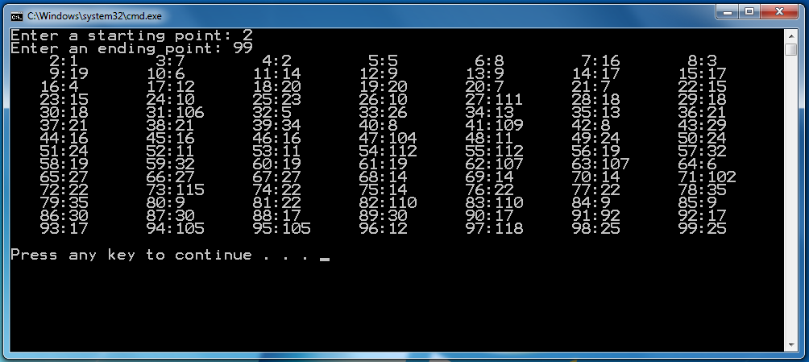
COMP 91.101 (201, 202, 204) Program 1 F15 - Dr. Lin
Your program should print a maximum of 7 columns per line where each column follows the following format rules: The first number is printed right justified in 5 spaces then a colon is printed then the number of steps is written as a left justified number in 5 spaces. The end result is that we get columns centered on the colon character as shown in the screenshot.
You should make use of functions to make your code easy to read.
At the top of your program you should have a comment section that follows the below format:
/***********************************************
Purpose: <Insert a short description of what
your program does here.>
***********************************************/

