Midterm
Respond to each question in essay format. Each response should be a minimum of 150 words.
- Sub-optimizing goals can create systemic issues within an organization. Explain how this might occur. Keep this short. Think of it as an elevator speech that your might need to provide to an executive – 1 to 2 very precise but not pedantic paragraphs.
- Explain the role of data in requirements development. Explain which requirements categories need data and what types of data would be necessary.
- Look at the attached diagram. What would the impact be of automating step (A)? What would the ROI be? Explain where you would look for data to support this change and define the exact ROI.

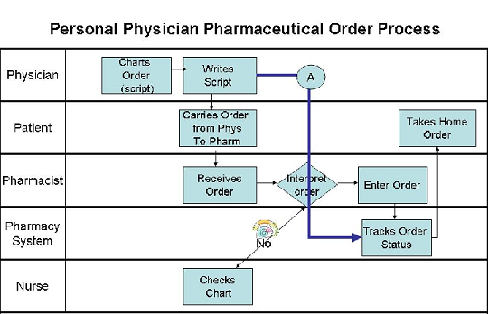

4. Why is designing an effective organizational structure vital to the success of an organization?
5. Look at the attached Entity Matrix. Will that class be enough to change physician behavior so that physicians will enter their own patient orders into a computer system? What clues do you see to support your decision? If something more is needed, suggest what else may be needed. Explain your reasoning.

