Carefully read the following Balance Sheet.
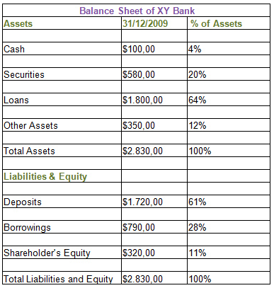
After carefully reading all the available information, prepare a two page (double-spaced) essay describing the consulting firm and answer the following questions:
- A bank balance sheet is different from that of a typical company. Explain the differences.
- Looking at the percentages, comment on the Assets and Liabilities of the above Balance Sheet. Why do bank managers prefer Loans over Securities? Why is cash only 4%?
Cite references to material that you use in preparing the essay.

