- Richard
SundayMay 21 at 7:33am
Manage Discussion Entry
We read this week about factors that put the “mix” in mixed method research. Zohrabi (2013) points out the efficacy of closed-ended questionnaires when used for gathering quantitative data, while open-ended questionnaires work better for generating qualitative data. We begin to see the necessity for carefully analyzing and structuring the questions we develop for our research instrument. The process becomes more involved and requires even greater analysis when a mix of open and closed-ended questions is employed.
As a research instrument, questionnaires demonstrate a great range of value. Their ease of use is a notable factor, and respondents who can remain anonymous are likely to share more detailed and reliable information. They are also efficient in terms of both cost and time. Tricks of the trade, in developing questionnaires, include designing questions to minimize misinterpretation, and wording the questions in ways that don’t direct the responses.
Zohrabi, M. (2013). Mixed method research: Instruments, validity, reliability and reporting findings. Theory and Practice in Language Studies, 3(2), 254-262. doi:10.4304/tpls.3.2.254-262.

Walter
TuesdayMay 23 at 4:52pm
Manage Discussion Entry
INDEX
Financial indexes are tracked daily to determine the change from day to day. The S&P 500 or the NASDAQ Composite, shows the relative value of a selected group of stocks and bonds that make up the index. Other financial indexes can be sector specific and show a statistical aggregate that measures change. Below is the S&P 500 for one year.
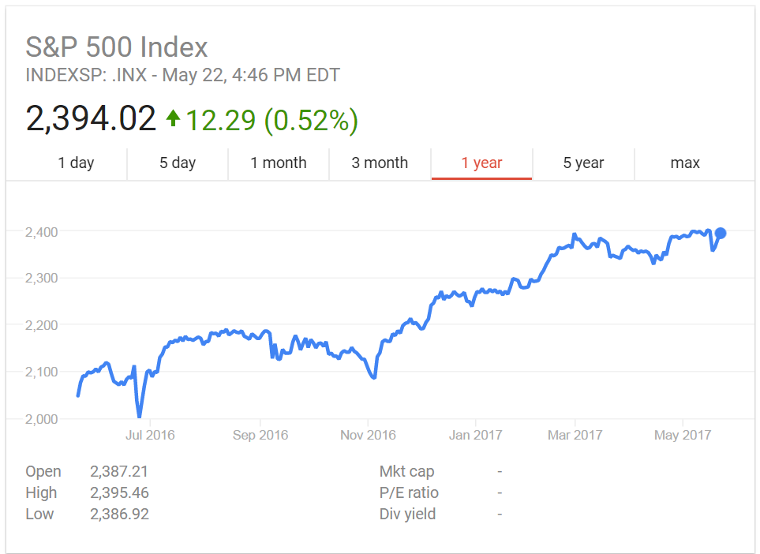
http://www.investopedia.com/terms/i/index.asp (Links to an external site.)Links to an external site.
http://www.investinganswers.com/financial-dictionary/stock-market/index-971 (Links to an external site.)Links to an external site.

SCALE
A five point Likert scale is used to collect student feedback data for my institutions’ End Of Course. There are 13 questions in two groups (Course and Instructor) on the survey that is launched from a link in the Learning Management System to SurveyMonkey. This is not a force choice scale as there is a neutral option (Allen and Seamen, 2007). The weighted survey results are aggregated and can be filtered for a particular micro view. A sample is below.
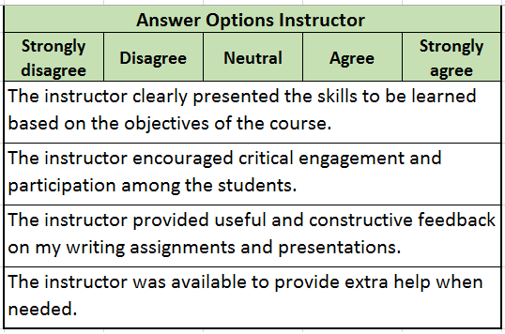
Examples of Likert scale category groups appear in Table 1. (Allen and Seamen, 2007)
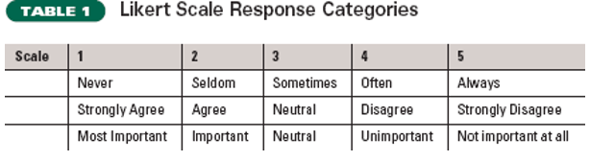
Allen, E., and Seaman, C. (2007). Likert scales and data analyses. Quality Progress; Milwaukee40.7 (Jul 2007): 64-65. Retrieved May 11, 2017 from http://asq.org/quality-progress/2007/07/statistics/likert-scales-and-data-analyses.html

TOPOLOGY
For topology, data collection is or a grid. The use of a research question with a single dependent variable or more than one independent variable would be used. Quantitative analysis using multiple regression requires the variables to be number values (Richarme, 2002). The results of multiple regression will present the data in a topology grid. An alternative is to use Excel to collect data and then use the Pivot table function to create a topology grid for data presentation. Below is an example of a simple matrix topology from a sample for predictions to actual.
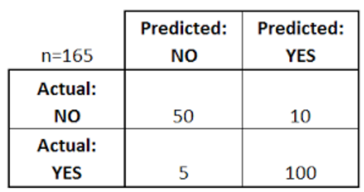
Richarme, M. (2002). Eleven multivariate analysis techniques: key tools in your marketing research survival kit. Decision Analyst, Inc. Retrieved May 22, 2017, from https://www.decisionanalyst.com/whitepapers/multivariate/

QUESTIONNAIRE
Questionnaires can be structured with closed questions if data collection is for a quantitative study or unstructured with open ended questions to provide the respondent greater freedom to answer in their own words (Questionnaire, 2017). An unstructured questionnaire from the Middle States Commission on Higher Education (MSCHE) was selected. This MSCHE questionnaire requested information on my institution’s 150% graduations rate for first-time full-time students for cohort years 2004 to 2010.
Following is the four question open-ended questionnaire. In addition to the narrative, 5 charts and 4 graphs were submitted in 3 attachments.


Learning and Teaching Services – Questionnaire. (2017). The University of Sheffield
Western Bank Sheffield, S10 2TN UK. Retrieved May 22, 2017 from: https://www.sheffield.ac.uk/lets/strategy/resources/evaluate/general/methods-collection/questionnaire (Links to an external site.)Links to an external site.

Edited by on May 23 at 4:54pm
ReplyReply to Comment

Collapse SubdiscussionRichard

Richard
TuesdayMay 23 at 7:36pm
Manage Discussion Entry
Walt provides us with some insight into the range of scales and indices used as research instruments. As we’ve discussed, researchers are charged with the search for finding the right tool for the job at hand. We’re probably all most familiar with the scale named after Robert Likert, who developed it in 1932.
Research on the use of adapted Likert scales seems to be in agreement that large sample sizes tend to enhance the validity of projects that employ them. As with any research instrument, the data generated from Likert scales depends on thoughtful and sincere input by respondents.
Cases are noted where respondents check the same number value for every question. In K-12 applications of Likert-like scales, I’ve witnessed the “Christmas Tree” effect, where respondents use the numbered choices to create patterns or designs with the selections they make. Some research suggests that respondents will choose the middle value of a scale to be non-committal in their responses. As you can imagine, “non-committal” doesn’t provide much value to the researcher. Our discussion will address some of the ways to deal with pros and cons involved with the use of scales.

Collapse SubdiscussionBrian

Brian
YesterdayMay 24 at 5:34am
Manage Discussion Entry
Walt,
After the Module 6 discussion, I thought for sure you were going to pull the BLS indexes that Babbie (n.d.) links to in the footer. However, your selection of the stock market was good because now that I think of it that's where I most frequently hear that term applied. It was also a good reminder that if I had any extra money, I should be investing it. Which makes me wonder to what extent an index should encourage a change in action? I suppose the depends on the variables at play, right?
More importantly, how did your institution have a 150% graduation rate?
Reference
Babbie, E. (n.d.). Chapter 6: Indexes, scales, and typologies. Retrieved from http://ebabbie.net/resource/practice/06/prev.html (Links to an external site.)Links to an external site.
ReplyReply to Comment

Collapse SubdiscussionWalter

Walter
YesterdayMay 24 at 10:30am
Manage Discussion Entry
Hi Brian,
I am glad you asked (smile)!
The Integrated Postsecondary Education Data System’s (IPEDS) graduation rates are the calculated percentages of students who graduate or complete their program within a specified timeframe. Graduation rates are important to a variety of audiences. IPEDS is under the National Center for Education Statistics, Institute of Education Sciences – US Department of Educations. IPEDS data are collected at the institution level, not at the student level. IPEDS graduation rates (GR) are reflective of full-time, first-time, degree-/certificate-seeking students who started and finished at the same institution.
The IPEDS graduation rate is calculated as:
GR = the number of students who completed their program within a specific percentage of normal time to completion divided by the number of students in the entering cohort (adjusted).
The normal time increments are:
      - 4 years – 100%
      - 6 years – 150% (Maximum time for students on Federal Financial Aid)
      - 8 years – 200%
There rates and published by all institutions that received Federal funding under three main federal government passed legislative acts to collect graduation rates for specific groups, including:
      - Student Athlete Right-to Know and Campus Security Act (1990)
      - Student Right-to-Know Act (1997, 1999)
      - Higher Education Act (HEA), as amended (2008)
Here is a chart – A picture is worth a 1000 words. All of this information is cited from (IPEDS, 2016).
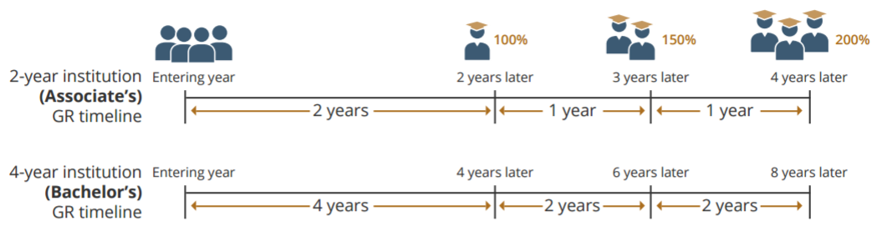
IPEDS, (2016). Graduation rates. Publication No. 2017046 p. 4. NCES. Retrieved May 24, 2017, from https://nces.ed.gov/pubs2017/2017046.pdf (Links to an external site.)Links to an external site.
Edited by Walter Person on May 24 at 10:34am
ReplyReply to Comment

Brian
YesterdayMay 24 at 5:25am
Manage Discussion Entry
Scale:
Scales ask respondents to rate a specific quality along a spectrum of intensity. Likert scales given in a restaurant after dining may ask a patron to rate his happiness with the service on a scale of 1-5. In a reading and writing seminar, I used a semantic differential scale with different news sources where students had to do some historiography and research to rate if the source was more liberal or conservative learning.
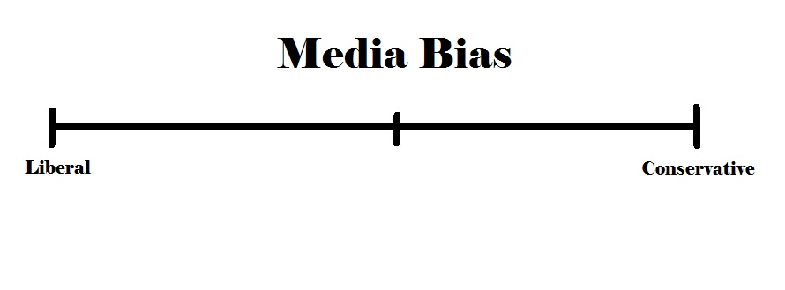
Index:
An index is a composite of data from multiple sources for a certain variable that can be measured through time. Having just watched the documentary, Before the Flood, I have climate change on the mind, so decided an index of related factors would be appropriate. With data of depleting sea ice taken from multiple sources and compiled together, one can then plot and track change over time.
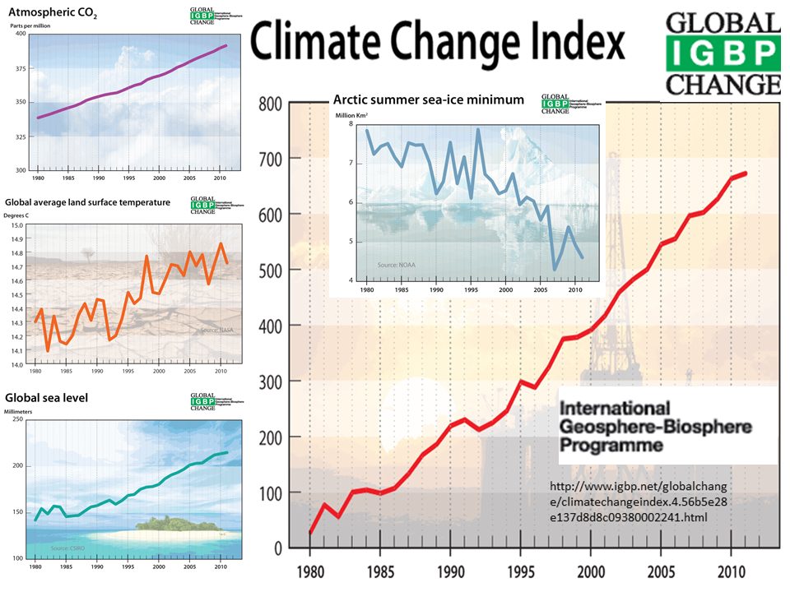
Climate Change Index. (n.d.). Retrieved May 22, 2017, from https://www.climateemergencyinstitute.com/uploads/IGBP_climate_change_index.png

Typology:
Typologies are multidimensional research measures that allows for the reporting of several variables at the same time. The grid below reflects a quick convenience sample of co-workers after noting some complain about not liking pineapple in dishes in the school cafeteria. While debating the deliciousness of the fruit, we got into a talk about how people either love or hate cilantro. The typology grid below gives a quick glance as to the categories each participant (n=11) falls in to.
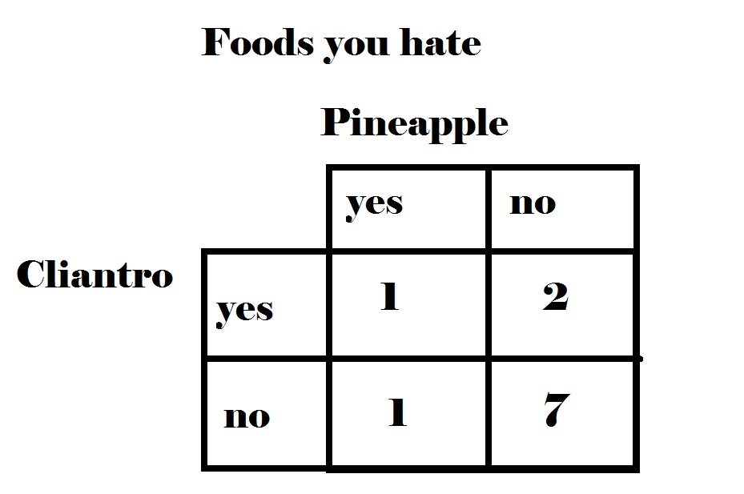

Questionnaire:
Questionnaires are printed sets of questions that allows for the gathering of usually qualitative data through open ended answers. This differs from surveys which often use questions with set responses or categories usually to gather quantitative data. Below is a screenshot from the Proust Questionnaire which Vanity Fair has published many celebrity’s answers to. Can anyone guess the famous musical artist who gave these responses? Scroll down slowly so you don’t have the answer spoiled by the citation.
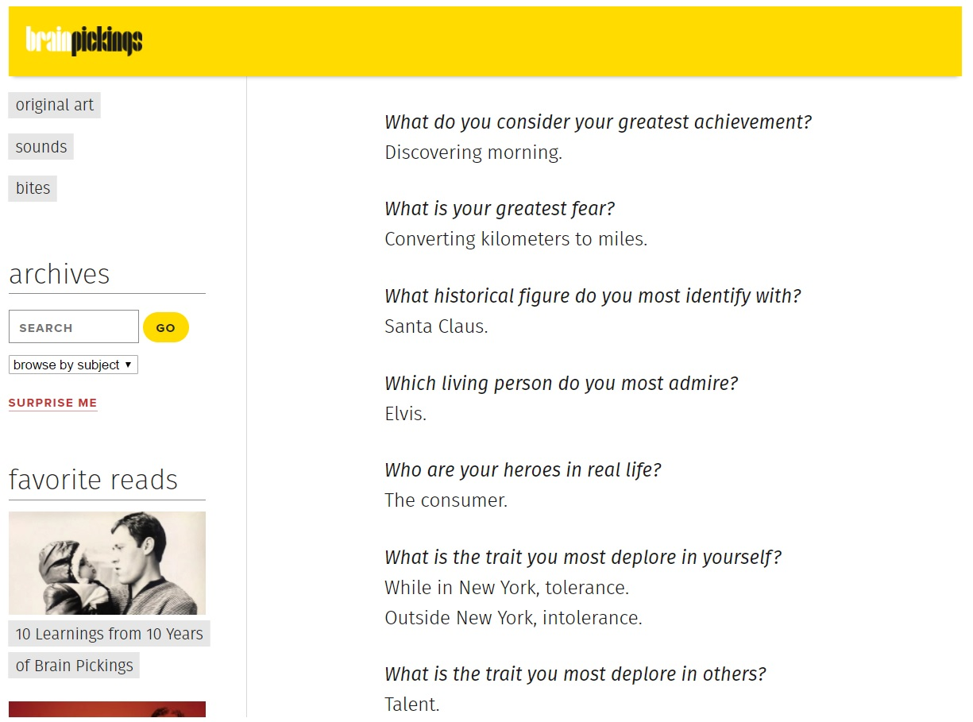

Popova, M. (2016, September 04). David Bowie Answers the Famous Proust Questionnaire. Retrieved May 24, 2017, from https://www.brainpickings.org/2014/07/10/david-bowie-proust-questionnaire-vanity-fair/

ReplyReply to Comment

Collapse SubdiscussionMark

Mark
YesterdayMay 24 at 5:47pm
Manage Discussion Entry
In research, scales are used to measure concepts that are qualitative and correlate them with quantitative values. Each of the questions or statements that describe a phenomenon are given certain weight depending on their strength to measure the phenomenon. After the responses are given, a single number is obtained and based on that value, it is either highly indicative of the phenomenon or moderately indicative of the phenomenon, or somewhere in between.
In this example for post-operative nausea and vomiting (PONV) listed below, various values are assigned to different degrees of symptoms of PONV and then added to obtain a single score which indicates significant PONV.
Q1. Have you vomited or had dry-retching*?
0 No
1 Once
2 Twice
3 Three or more times
Q2. Have you experienced a feeling of nausea (“an unsettled feeling in the stomach and slight urge to vomit”)? If yes, has your feeling of nausea interfered with activities of daily living, such as being able to get out of bed, being able to move about freely in bed, being able to walk normally, or eating and drinking?
0 Not at all
1 Sometimes
2 Often or most of the time
3 All of the time.
To calculate the PONV Impact Scale score, add the numerical responses to questions 1 and 2. A PONV Impact Scale score of ≥5 defines clinically important PONV.
*count distinct episodes: several vomits or retching events occurring over a short time frame, say 5 min, should be counted as one vomiting/dry-retching episode; multiple episodes require distinct time periods without vomiting/dry-retching.
Myles, P. S., & Wengritzy, R. (2012). Simplified postoperative nausea and vomiting impact scale for audit and post-discharge review. British Journal of Anaesthesia, 108(3), 423-429. http://dx.doi.org/10.1093/bja/aer505 (Links to an external site.)Links to an external site.
“An index is a composite score that is based upon multiple nominal level indicators” with the composite score being the added score of all the responses by the subject (http://www.soc.iastate.edu/class/202/powerpoint/indexscalesandtypologies.pdf) (Links to an external site.)Links to an external site.. Below is an index for fire safety that is used in the operating room:
Surgical site above the xiphoid process………Yes=1 No=0
Open oxygen source via nasal cannula………. Yes=1 No=0
Use of ignition source, electrocautery or laser. Yes=1 No=0
Depending on the responses of the three conditions, they are added up with a total from 0 to 3, which correlate to:
3= High risk for fire, 2= Low risk for fire with potential for high risk, 1=Low risk for fire and 0= No risk for fire

Mathias, J. M. (2006). Scoring fire risk for surgical patients. OR Manager, 22(1), 1-3.

Typologies are multi-dimensional measurements of several many possible answers to several various variables. Below is from a study using typology to assess users of scientific research:
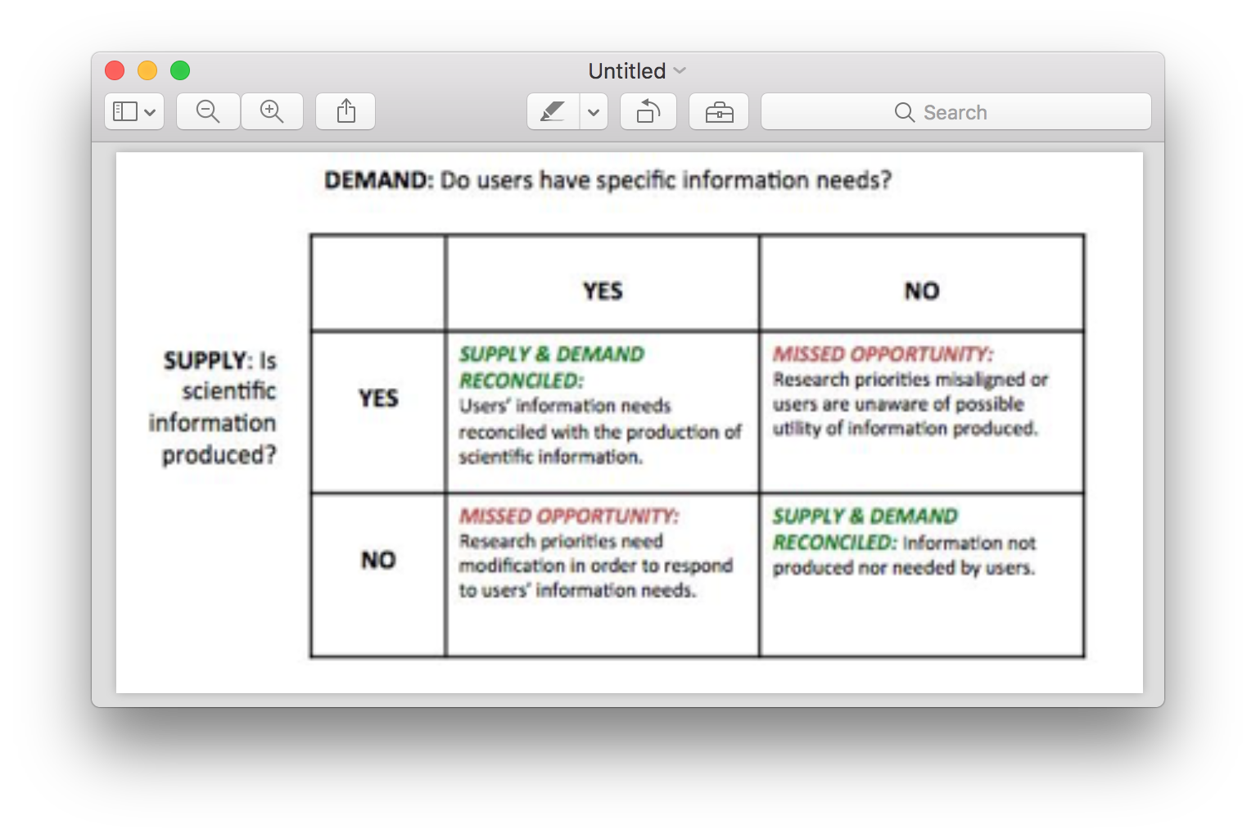

McNie, E. C., Parris, A., & Sarewitz, D. (2015). A typology for assessing the role of users in scientific research. Retrieved from Consortium for Science, Policy and Outcomes: http://cspo.org/research/user-inspired-research/a-typology-for-assessing-the-role-of-users-in-scientific-research/ (Links to an external site.)Links to an external site.
Questionnaires are very practical tools for research and can be easily distributed and they can be set up with open ended questions which require the respondent to provide more than a short word or two answer. This is helpful when you want to really qualify what the respondent is feeling but is hard to quantify and put a certain number to it. Also, closed end questions are usually single word answers and are easy to quantify when crunching the statistics but may not be insightful to what the respondent is meaning when he answers the question. Below is a questionnaire about exchange students’ experiences visiting other countries, with both open ended and closed ended questions:
  - Age _____________
  - Sex Male Female
  - Homecountry _____________________________________________________________
  - Mother tongue _________________________________________________________
  - What do you study in the host country? In which department/departments? ________________________________________________________________
  - How long are you going to stay in the host country?__________ months
  - Why did you decide to come to the host country as an exchange student? ____________________________________________________________________________
  - What has surprised you most about the host country? _____________________________________________________________________________
  - What have you enjoyed most about the host country? ___________________________________________________________________________
  - What have you enjoyed least about the host country? ____________________________________________________________________________
(http://www.euro-mobil.org/english/FragebkEN.pdf) (Links to an external site.)Links to an external site.

References
Mathias, J. M. (2006). Scoring fire risk for surgical patients. OR Manager, 22(1), 1-3.
McNie, E. C., Parris, A., & Sarewitz, D. (2015). A typology for assessing the role of users in scientific research. Retrieved from Consortium for Science, Policy and Outcomes: http://cspo.org/research/user-inspired-research/a-typology-for-assessing-the-role-of-users-in-scientific-research/
Myles, P. S., & Wengritzy, R. (2012). Simplified postoperative nausea and vomiting impact scale for audit and post-discharge review. British Journal of Anaesthesia, 108(3), 423-429. http://dx.doi.org/10.1093/bja/aer505

Edited by Mark Henning on May 24 at 5:50pm
ReplyReply to Comment

Collapse SubdiscussionWalter

Walter
YesterdayMay 24 at 8:25pm
Manage Discussion Entry
Hi Mark,
The first four questions of the survey you selected contained demographic variables. These characteristics or descriptors help determine if the sample is representative of the population and provide a picture of the respondents (Kaur, 2013). In addition, with a large sample (n), the responses can be filtered by the demographic variables. In your example this would be age, gender, home country and mother tongue. Results for the remaining questions could be compared by the four demographic variables. In this survey, there may be associations between positive responses and age groups or gender. This methodology could provide data collection for several research questions in a study on exchange students’ experiences visiting other countries.
Walt
Kaur, P. (2013). Variables in research. Indian Journal of Research and Reports in Medical Sciences, Vol-3, No.4, Oct – Dec. Retrieved May 24, 2017 from: http://www.ijrrms.com/pdf/2013/jul-sep2013/IJRRMS%20Vol.3%20(4)_10.pdf (Links to an external site.)Links to an external site.

Reply

