CASE 9-1 Aero Marine Logistics
Aero Marine Logistics (AML) was incorporated as a private limited company in South Delhi in the year 1996. The promoters of AML are two professionals who had gathered 15 years of experience working for Tata Steel (one of the biggest and oldest companies in India) in the field of shipping, customs clearance, forwarding, and transportation. Over the last five years, AML has been successful in building an infrastructure and pool of experienced personnel to handle the entire gamut of logistics. In fact, it was one of the first companies to offer door-to-door delivery. It considers itself the specialist in customized solutions and services—a concept that is still unheard of in the transportation industry in the rural belts of northern India. AML handles the entire package of logistics for all its customers. Some of the services they offer include the following:
- • Import consolidation. AML has a well-spread network of offices and trade connections in the United States, Europe, the Far East, and the Middle East to render import consolidation by both air and sea to any part of India. It promises a personalized prompt service with value for cost.
- • Door-to-door services. AML is fully equipped to deliver door to door, which includes cargo pickup from the supplier’s warehouse, warehousing prior to customs clearance, complete customs clearance of exports from overseas, and freight booking with airlines/shipping lines to receive cargo in India. It also undertakes local customs clearance and transportation to deliver to the door of the customer.
- • Exports. AML has expertise in handling exports of various kinds of cargo by ocean and by airfreight. It ensures the timely movement of cargo at the most competitive rates. It takes care of both the complete export documentation formalities and the physical movement of cargo.
- • Consultancy on customs and logistics. AML is well equipped with professionals to guide customers regarding various modes of transportation and to help customers to optimize utilization of space and save on freight. It acts as liaison with different authorities like the RBI (Reserve Bank of India), Port Authority of India, India Civil Aviation Regulatory Body, TEXPROCIL (The Cotton Textiles Export Promotion Council of India), DGFT (Directorate General of Foreign Trade), and so forth, on behalf of clients for various permissions and quotas related to import and export of cargo. This could perhaps be classified as its most valuable service, which it hopes will build up its brand image. The red tape, bureaucracy, lack of work ethic, and corruption preclude anyone lacking either clout or established relationship channels (with babus, or permanent government employees, notorious for their apathy toward fulfilling job duties and with a penchant for bribe taking) to do business in India.
To enable it to offer these services, AML has partnered with various associates all over the globe to render forwarding services to all its customers. It has a covered warehouse space of 1,000 square meters and has the ability to arrange for additional space. It has its own two 407 Tata trucks for pickup and delivery of small consignments. It has dedicated a fleet of five lowbed trailers for pickup and delivery of containers. All the field personnel have been provided with two-wheelers for faster conveyance between various points of work.
AML has grown rapidly and recently established an online presence whereby clients can place orders online and check the status of their cargo. So far the increase in sales from the online presence has not been much. Most of AML’s clients are spread out in rural areas, and except for customers in Delhi, most do not have access to the Internet.
Today AML is handling an average of 200-plus TEUs (20-foot container equivalents) of imports and exports every month between Delhi and Mumbai (Bombay), which is the nearest big port (a distance of 1,407 kilometers). (See Exhibit 9-A.) Luckily, most containers are used for traffic in both directions; moving empties is unproductive. Main items for export are bathroom fittings and spares, machine spares and agricultural equipment, machine spares and chemicals, scientific equipment, medical equipment spares and chemicals, food processing machinery, furniture and kitchen equipment, and interiors. Main items for import are automobile engines and spares, cotton yarn, food products, electronics, televisions and components, rice, stone for stone crafting, and so on.
Recently, one of the AML partners, Mr. S. Singh, was approached by the chairman of Freshfoods, Mr. R. Maan, with a promise of a huge potential volume (150,000 kilograms per month) for importing frozen mushrooms from Europe if AML would build up its Indian infrastructure to handle such volumes. Freshfoods is the biggest regional exporter/importer of food products in North India. It was founded 20 years ago by a collective of farmers wanting to find markets for their surplus produce of exotic and non-native foods (like avocados and strawberries) that did not have much local demand except for five-star hotels catering to mostly foreign tourists. The shift in eating habits in recent years had prompted Mr. Maan to promote mushrooms as a daily food item in a major way. To keep the price of imported mushrooms comparable with locally grown food items, huge quantities would have to be transacted to make use of economies of scale.
Mr. Singh realized that the first order from Mr. Maan was an experiment and that further orders would depend on whether the product caught on or not. AML needed to bet on a huge surge in demand for frozen mushrooms in the region if it wanted to be part of this new trend from the very beginning. Singh’s partner—Mr. Kumar—is wary of investing heavily on the basis of this one order. After some bargaining, Mr. Mann agreed that Freshfoods would ship approximately 150,000 kilograms of mushrooms per month for 12 months and will pay US$.20 per kilogram of mushrooms.
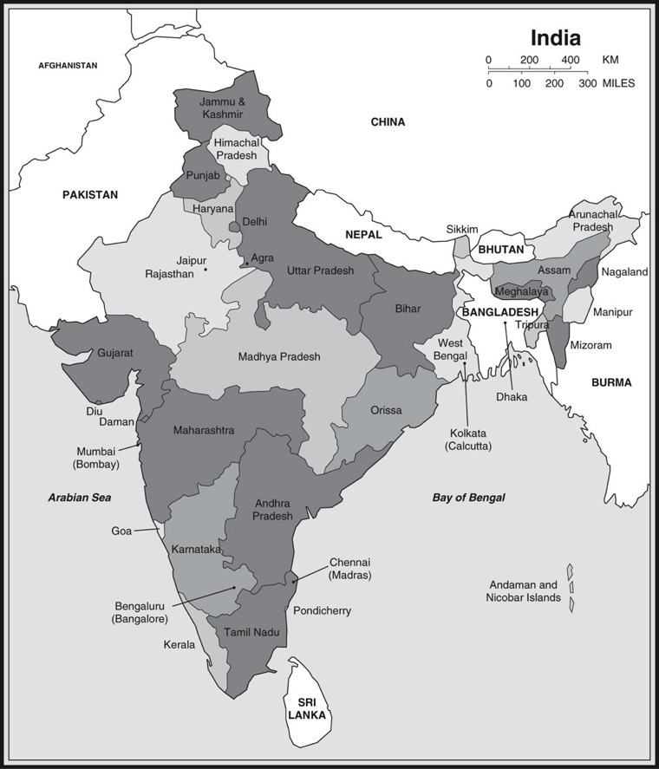

If AML decided to handle this product, it would need to add some equipment to its flatbed trailers to provide power to the refrigeration units on the containers. This is a one-time cost of Rs 9 lakhs (Rs 1 lakh = US$2,222). With temperatures soaring to 50 degrees Celsius (and the hot wind calledloo—notorious for deaths associated with heat waves) for most of the long, hot summer, the energy costs of meeting special conditions could be prohibitive. AML expects them to total about Rs 3 lakhs on an annual basis.
Mr. Singh then made inquiries to his rail carrier about the costs of leasing refrigerated containers. He was disappointed to learn that leasing was almost impossible. The container-leasing companies wanted exorbitant rates because there was no backhaul traffic requiring refrigerated equipment and because some areas in North India were too isolated if they needed to send a worker to service malfunctioning equipment. The container-leasing company did, however, offer to sell used refrigerated 20-foot containers for Rs 7 lakhs apiece and would agree to service them for one year at an additional cost of Rs 1 lakh per container. The used containers could be expected to lastanother five years. In a meeting involving Mr. Singh, Mr. Maan, and Mr. Veejay, a carrier representative, it was decided that ten 20-foot containers would be sufficient to handle the projected volume of mushrooms. Each container would make one round-trip each month. The cost of ocean freight expense from Amsterdam to Mumbai is US$1,700 for a single 20-foot container. The cost of land transportation per single 20-foot container from Mumbai to Delhi is US$300. Return costs for empty containers from Delhi to Mumbai to Amsterdam are half as much, although about 10 percent of the time another cargo can be found that will cover the costs of return transport.
As the meeting broke up, Mr. Veejay said that the mushrooms were not a very dense cargo and that Mr. Singh could be using 40-foot refrigerated containers, which held twice as much as a 20-foot container, though handling costs were less than twice as much. The cost of ocean freight from Amsterdam to Mumbai is US$2,600 for a single 40-foot container. The cost of transportation per single 40-foot container from Mumbai to Delhi is US$500. Return costs from Delhi to Mumbai to Amsterdam are half as much, although about 10 percent of the time another cargo can be found that will cover the costs of return transport. Mr. Veejay felt that the 40-foot containers would need to be purchased. Five would be needed, with each making one round-trip per month. Containers were only
available new, and the cost would be Rs 15 lakhs apiece. Maintenance anywhere was guaranteed for the first year, and the containers had an estimated life of 10 years.

