Go to the Strategic Business Insights website.
Take the VALS Survey. Have the results sent to you by email. The results are sent in a Microsoft® Word document showing your primary and secondary VALS segments.
Go to the Nielsen website.
Explore the Nielsen Segmentation Methodology, the featured and other segments, and then click on Zip Code Lookup. Enter your Zip Code and the code provided and click Enter. A map showing your geographic area will pop up along with information on the distribution of people by age, race/ethnicity, marital status, and presence of children. On the left will be three options: PRIZM, P$CYCLE, and ConneXions (three segmentation techniques based on Zip Codes, Wealth, and Connectivity).
Click on PRIZM to view the list of primary segments for your geographic area. Into which of these segments would you place yourself and why?
Write a 1,400-word segmentation analysis that includes the following:
- Summarize your results.
- Summarize what you learned about these segmentation methodologies.
- Compare your results showing your buying behaviors with what you know of organizational buying behaviors.
- How do consumer behaviors differ from organizational behaviors?
- Examine the dimensions of the consumer segments as well as organizational segments.
Cite a minimum of two scholarly sources.
Format your paper consistent with APA guidelines.
Click the Assignment Files tab to submit your assignment.

Primary
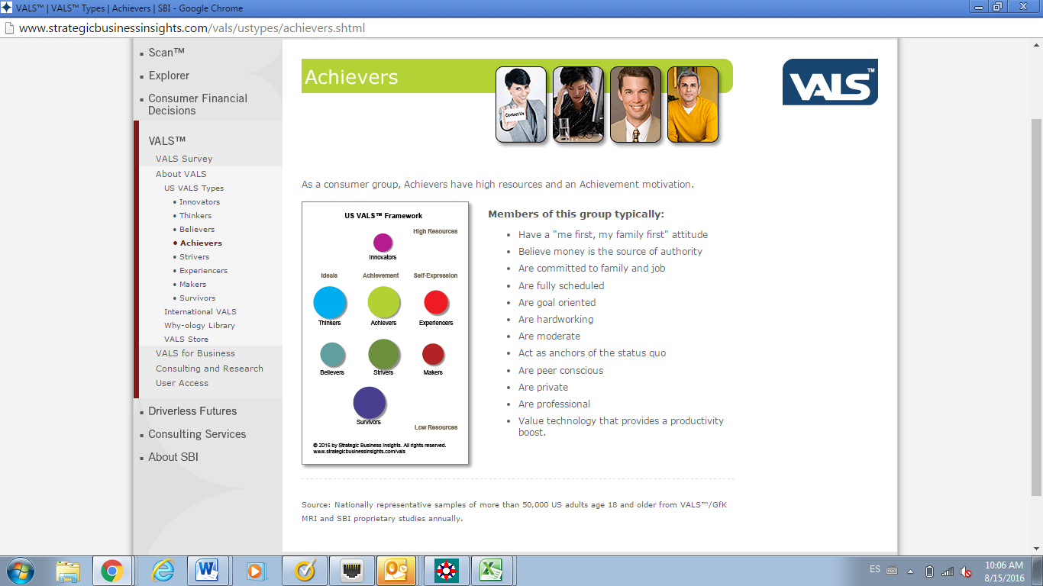
-Secondary
