Introduction
A program is a particular software package; this software package is consisted of majorly coded instructions which are meant to automatically perform particular tasks as per the commands made by the coded instructions. A wide Area Network (WAN) is a communication platform to which individuals within and out of a particular organization can share information through the use of the interconnections made. The network created in the organization is aimed at simplify the tasks to which the organization involves itself in.
This project article describes the process to which the Wide Area Network is created and the importance it has over other forms of networks. The case study to which the project article is based on is process of developing a payroll program to which a particular large organization in the US will use to ease the process of making payments to its employees. The payroll is basically the list containing the name of employees and the amount of salaries and wages they are to be paid within the intervals of payment as described in their contracts with their employers.
The article also describes the process to which these large organizations develop comprehensive methods and implement strategies which enable these organizations have efficient methods of not only making payrolls and payments but also communicating effectively which each other. Development of a program is relatively demanding an organization is required to create a program that is reliable; the project discusses the appropriate methodology to which the program’s architecture should be developed as well as the necessities to which a program developer is required to have.
A good program developer is the one who in the first place considers assembling the requirements to which he or she might need in the task this programmer is to develop. In this case, the payroll program requirements are to be listed to ease the process of developing it. Development of the payroll program is procedural; it involves different steps to which a particular individual is required to follow to ensure that he or she creates a quality product. The requirements of developing a good program are the hardware as well as any necessary equipment to which a programmer will need in the process of creating the software.
The programmer requires basically a computer, the language to which the program is to be written in, how the language should be technically structured and expressed; the design structure of the program should also be stated by the organization. This infers that the program to be developed has to meet the specifications and requirements of the organization and should be in line to serve the purpose that it is to serve comprehensively (Mahajan, Shukla, & Soni3, January 2015). Design description of the program is a very important aspect to which a programmer is required to give, design description is a design strategy which ensures that the programmer develops a good program, the description is always represented in pseudo codes.
As stated earlier on, software development is procedural it involves a series of steps to which a particular programmer is required to follow. These steps include; probability study, gathering requirements, specifying the requirements of the software, and validating the software (Marek, March 29, 1996). During the probability of feasibility test or study, the programmer is given the descriptions in which the stated software should have as well as the functions in which this software is to perform.
In the second phase of developing software, the requirements of this software are gathered. The programmer takes up the responsibility of ensuring that the requirements for software to be developed are availed. In this phase the software developer takes up opinions from the probable users of the software and from the organization on the features to which the software should contain.
The third step of software development is the specification of the software’s requirements; the requirements of developing the software should be collected from suppliers. This step describes the process in which the software to be created will interact with its interface to the user, the hardware in which it is created in, the operation speed to which the software is required to operate, its portability as well as the process in which information is to be recovered in case the software crashes (Jørgensen & Moløkken, April 2006). This specification step ensures that the programmer states the limitations of the software as well as its advantages; this will ensure that the functionality of the software is improved.
The final step of developing software is the validation process, in this step the software is analyzed if it has meet the specifications of the client the validation of the software involves evaluating the legality of the software, and if the software has met the legal requirements. The strategies of creating the software are assessed if they can be essentially implemented, if the created software is complete, if there is presence of software ambiguity, and if the created software is indeed valid as described by the software’s domain. The diagram below describes the summarized process of developing software.
Software Requirement and Specification
Requirements’ Negotiation
Gathering Requirements
Organizing Requirements

The development of good software involves effective use of technology; in this case the software to be developed is software that will ensure that effective payrolls are created to ensure that payment of employees is effective.it the recent past there has been massive advancement in technology, this infers that the technology used in programming is advanced as well. The Programming technologies used are Lucene and Node.js.
Lucene is used in creating sense in unstructured texts, this is important in ensuring that analysis of gathering information for a structured program. This technology is written in Java and efficiently analyzes and parses free text. Node.js is an important technological advancement in programming, in this case the software or program to be developed is a payroll program, the program to be created requires data to be disseminated faster and to a large recipient volume, Node.js has these features and has therefore eased the process of creating more efficient programs (Neil, 2014).
The architecture of the software to be created has to meet the specifications of the client, in that the payroll app should ensure that its features create a comprehensive methodology to which the users will be paid with ease. The architecture of the software should ensure it should cater for a wide area network; this is to ensure that it is efficient enough for use by many users. The diagrams below show the structure in which a good payroll program should take as well as how the software in should be created with communication hardware to create an effective interaction with the users.
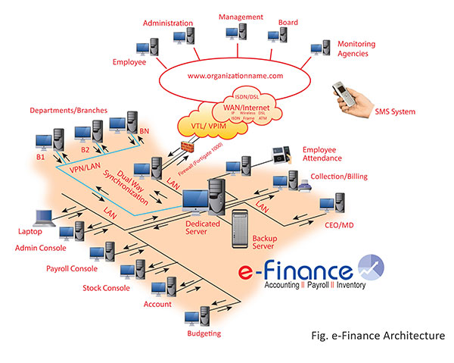 (15De)
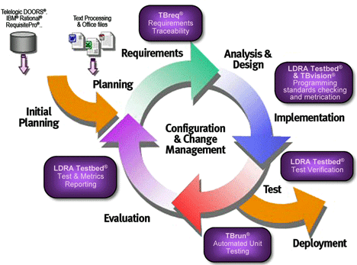 (15De1)

Adoption of new technologies come with new challenges, potential challenges that come with adopting this software is the violation of users’ culture, inefficiency in the case of software crushing and delayed payment if the system fails.
Conclusion
As described in this article, development of reliable software involves creating a detailed methodology to which a developer of software will use as a guiding tool to during software development. A wide area network is also an important tool within and out of an organization; it ensures that individuals within an organization communicate with ease.

References
(n.d.). Retrieved December 20, 2015, from http://efinance.ezone.com.np/_/images/e-finance-system-architecture.jpg
(n.d.). Retrieved December 20, 2015, from http://edablog.com/primages/2009/LDRA-Security-Critical.gif
Jørgensen, M., & Moløkken, K. (April 2006). “How Large Are Software Cost Overruns? Information Systems and Software Technology, 297-301.
Mahajan, K., Shukla, S., & Soni3, N. (January 2015). A Review of Computerized Payroll System. International Journal of Advanced Research in Computer and Communication Engineering Vol. 4, Issue 1, 67-70.
Marek, J. D. ( March 29, 1996). TECHNOLOGY USE IN COMPUTER PROGRAMMING COURSES. In Second Annual University of Pittsburgh Teaching Excellence Conference: Technology in Teaching. Pittsburgh.
Neil, C. A. (2014, June 4). 4 technologies that changed software development. Retrieved December 20, 2015, from GCN: https://gcn.com/articles/2014/06/05/top-software-development-technologies.aspx

