Mayberry Satellite Campus
Michael Boddie
NTC/362
Dean Mc Intyre
May 15,2017

Network Extension
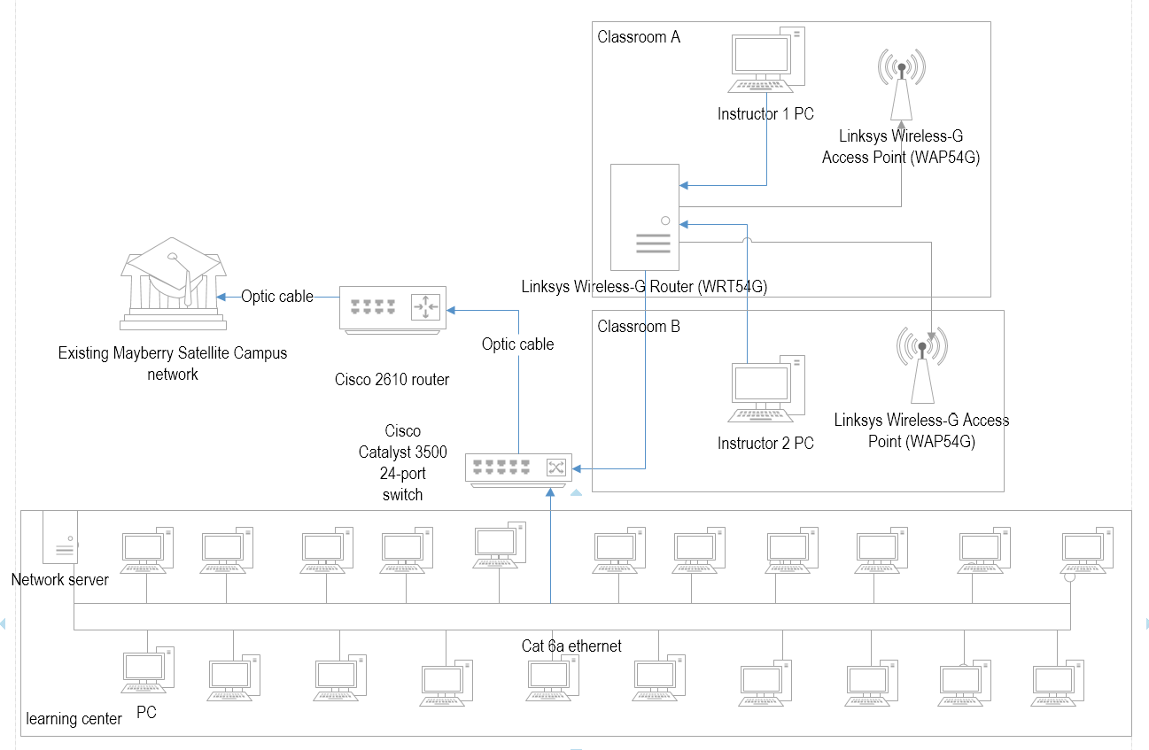
Routing details
There would be a wireless access point in each of the two classes. I would recommend the Linksys Wireless-G Access Point (WAP54G). This would provide the connection of the workstations in each class. There would be one wireless router that would provide connection to the network
Since the wireless routers would be connected to a main router, then it is recommended that the routing protocol should be changed. This would ensure that they do not collide because two routers may have the same default settings. For instance, both may have a default of 92.168.1.1. But one can be changed to 192.168.2.1.
All the traffic in each class would be routed to the access point which in turn would be routed to the wireless router. (There would be a private network of 192.168.2.1). The router would then connect to a switch in the learning center where it would route its traffic.
For easy management, I would recommend that the network should be fragmented into 3 sub-nets; one subnet for the one classroom, one for the other class and the remaining for the learning center. For the classes, the instructor’s PC would be the supervising or serving computer for the subnet in each class. The dynamic IP address should be limited up to a given range that would cater for the probable number of students at a go.
Connection.
Linksys Wireless-G Access Point (WAP54G) would broadcast wirelessly and enable the assignment of dynamic IP addresses to the mobile PC of students in the classrooms. Each classroom would contain a WAP54G access point. Each would be connected to the central router (Linksys Wireless-G Router) that would be located in one of the class that is nearer the learning center. The connection between the access point and this router would be through a Cat 6a Ethernet cables. I recommend this category of cable because it supports a faster transmission speed of up to 10 GB/s. The instructor’s PCs would be connected to the wireless router directly. Since the wireless router would be located in one classroom, then there would be two long Ethernet cables – which may pass in a bus latchet along the wall – connecting to the other room. The Wireless-G Router would in turn connect to the Cisco Catalyst 3500 24-port switch which would be located in the learning center room. This new switch would connect all the PCs in the learning center through cat 6a cables under bus topology. There would be a network server to manage all the connections in this extended subnetwork. Cisco Catalyst 3500 switch has the ability to be configured to act as DHCP server for the two classroom wireless network. This switch would connect to a router that would in turn route all the subnetwork traffic to the main existing network before the extension. The access to public or ISP network would be from the main network which would be routed to the new extension up to the access points so that the students would have internet access.
Supervisor’s PC recommendation
10/100/1000 Ethernet NIC has limitations for network PC especially those used for server and administration purposes. The supervisor’s PC would musty be used for administration of the network in each classroom, hence they would require a better NIC. I recommend the Rosewill Gigabit PCI Network Adapter because it’s usable for connecting multiple VLANS or subnet as in the case of this new extension of the network. Since the supervisors would mostly deal with sharing software and other network resources, Gigabit PCI Network Adapter would be applicable because it supports transfer of legacy software between virtualized environments. (TechGuru. 2016). I would recommend a higher storage capacity of up to 1 Terabyte of hard disk capacity because the instructor’s computer would use a lot of memory space in saving the network resources and software for serving the students. Even though replacing the instructor’s computers computer with special network server PCs, modifying the existing computers with Intel Core i5 processors would be a better solution because such computers have a fine speed.

References
TechGuru. (2016). Best PCI Gigabit Ethernet Network Interface Cards (NIC). Retrieved May 15 2017 from https://nerdtechy.com/best-pcie-gigabit-ethernet-network-cards

