Fabrication of Solar Operated Heating and
Cooling System Using Thermo-Electric Module
Prof. Vivek R. Gandhewar^{*1}, Miss. Priti G. Bhadake^{#2}, Mr. Mukesh P. Mangtani^{#3}
*1 Associate Professor, #2, 3 Scholar B.E. (4th year/ Mech.),
1, 2, 3 JDIET, Yavatmal, (M.S.), India

Abstract: In the recent years, we all are facing electricity crisis. It’s time to harness the renewable energy resources of the nature. Our project utilizes the solar energy to run a heating and cooling system. In this project we have fabricated a thermoelectric system using solar energy. It is an eco-friendly project, made by using thermoelectric module. The project supports both heating and cooling. The project has various applications like, military or aerospace, medical and pharmaceutical equipment etc. Thus it proves to be very helpful.

Key Words: RAPS, Thermo-Electric Module, Heat sink, PV-Utility.
I. INTRODUCTION
The current tendency of the first world is to look at renewable energy resources as a source of energy. This is done for the following two reasons; firstly, the lower quality of life due to air pollution; and, secondly, due to the pressure of the ever increasing world population puts on our natural energy resources. From these two facts comes the realization that the natural energy resources available will not last indefinitely. Therefore, the ideal solution would be to use some type of renewable energy resource to provide these houses with energy without an expensive electrical grid connection [1]. One solution is a RAPS (Remote Area Power Supply) using an alternative form of energy. A study done by the University of Cape Town's Energy Development Research Centre came up with interesting facts that can be used to support the application of PV systems to Third World housing. The thermoelectric cooler it will utilize the power from the PV panels when the battery is fully charged, and at night, will use a small amount of power to maintain the temperature in the cooler box. In. other words, if the battery of the system is fully charged, and there is no appliance to absorb the power generated from the PV panel, it would be wasted, resulting in a 'poor efficiency factor for the whole PV system [2]. The cooler box integrated in a RAPS would allow for a very efficient system utilizing all the excess generated power from the sun.

II. LITERATURE REVIEW
As we know that, the physical principles upon which modern thermoelectric coolers are based actually date back to the early 1800's, although commercial thermoelectric (TE) modules were not available until almost 1960. The first important discovery relating to thermoelectricity occurred in 1821 when a German scientist, Thomas Seebeck, found that an electric current would flow continuously in a closed circuit made up of two dissimilar metals provided that the junctions of the metals were maintained at two different temperatures [3]. Seebeck did not actually comprehend the scientific basis for his discovery, however, and falsely assumed that flowing heat produced the same effect as flowing electric current. In 1834, a French watchmaker and part time physicist, Jean Peltier, while investigating the "Seebeck Effect," found that there was an opposite phenomenon whereby thermal energy could be absorbed at one dissimilar metal junction and discharged at the other junction when an electric current flowed within the closed circuit. And it is the fundamental principal behind a thermo-electric system [4].
And the theory existed in 1911; the materials available were not suitable for effective cooling. Metals have good electrical conduction but good thermal conductivity as well. This allowed for a very low COP (co-efficient of performance) of 1% due to the thermal conductivity of the metal from the hot side to the cold side of the TEC It was only since the 1950's with the discovery of semiconductors, that the COP was increased. Semiconductors had the same electrical conductivity as metals but much lower thermal conductivity [5]. This provided for a much improved COP of 20%. Typical material composition is alloys of the elements Bi, Cd, Sb, Te, Se and Zn. The standard alloy used today in manufacturing is the type.
Using different metals produced cooling devices that had very poor co-efficient of performances (COP). This was because materials with high temperature conduction co-efficient were used partly because of excessive temperature conduction between the hot side and the cold side of the thermo-electric heat exchanger. Since the discovery of semiconductors, the co-efficient of performance of the TEC was drastically improved since materials could be used with low temperature conduction co-efficient but by doping it, the semiconductor could be made to conduct, exerting electrical conduction properties found in metal.

III. CONSTRUCTION
Here this system heat or cool the product using thermo-electricmodule.the constru-ction set up for this system require following parts 1.Solar panel 2.Charge controller
3.Battery 4.Fins,thermister
5.Exaust fan,circuit kit
6.Thermoelectric module.
7.Metal (aluminium box,sheets)

A. Solar Panel
The direct conversion of solar energy is carried out into electrical energy by means of the photovoltaic effect i.e. the conversion of light or other electro magnetic radiation into electricity.Heat can be converted directly into electrical energy by solar cell,more generally a photovoltaic cell.
The solar panel use in this fabrication having an input capacity 16v and output capacity 21v.

B. Charge Controller
The charge controller is a simple,efficient and precise controller designed to operate with the charge source such as solar panels and wind generator to prevent overcharge.
Output drive current-1.0 Amps.

C. Battery
The battery is an electrochemical device for converting chemical energy into electrical energy. The main purpose of the battery is to provide a supply of current for operating the cranking motor and other electrical units. Capcity of battery-12v.

D. Thermoelectric Module
A typical thermoelectric module is composed of two ceramic substrates that serve as a foundation and electrical insulation for P-type and N-type Bismuth Telluride dice that are connected electrically in series and thermally in parallel between the ceramics. The ceramics also serve as insulation between the modules internal electrical elements and a heat sink that must be in contact with the hot side as well as an object against the cold side surface. Electrically conductive materials, usually copper pads attached to the ceramics, maintain the electrical connections inside the module. Solder is most commonly used at the connection joints to enhance the electrical connections and hold the module together [6]. Most modules have and even number of P-type and Ntype dice and one of each sharing an electrical interconnection is known as, "a couple." [6]. While both P-type and N-type materials are alloys of Bismuth and Tellurium, both have different free electron densities at the same temperature. P-type dice are composed of material having a deficiency of electrons while N-type has an excess of electrons. As current (Amperage) flows up and down through the module it attempts to establish a new equilibrium within the materials. The current treats the P-type material as a hot junction needing to be cooled and the N-type as a cold junction needing to be heated. Since the material is actually at the same temperature, the result is that the hot side becomes hotter while the cold side becomes colder. The direction of the current will determine if a particular die will cool down or heat up. In short, reversing the polarity will switch the hot and cold sides [7].
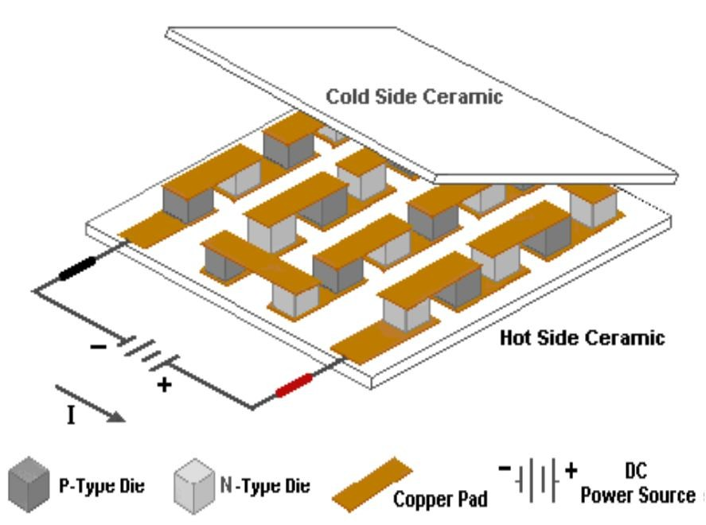
Figure 1: Internal construction of thermo- electric module
(adapted from ADVANCED THERMOELECTRIC · One Tara Boulevard · Nashua, NH 03062 · USA)[6]

IV. OPERATING PRINCIPLE OF THE THERMO-ELECTRIC MODULE
The TEM operating principle is based on the Peltier effect. The Peltier effect is a temperature difference created by applying a voltage between two electrodes connected to a sample of semiconductor material. One of the TEM sides is cooling and the other side is heating.
When a TE module is used, you must support heat rejection from its hot side. If the temperature on the hot side is like the ambient temperature, then we can get the temperature on the cold side that is lower (tens of Kelvin degrees). The degree of the cooling is depended from the current value that is leaking through a thermoelectric module.
In a thermo-electric heat exchanger the electrons acts as the heat carrier. The heat pumping action is therefore function of the quantity of electrons crossing over the p-n junction [8].

Heat Absorbed
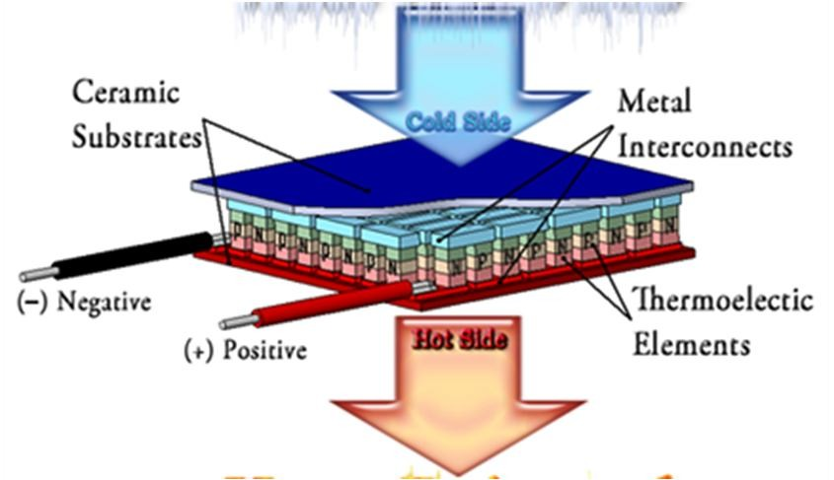
Heat Rejected
Figure 2: Operating principle of thermo-electric module (adapted from scientific and production firm module -ISO 9001)

V. WORKING OF THERMOELECTRIC

MODULE
Thermoelectric modules are solid-state heat pumps that operate on the Peltier effect (see definitions). A thermoelectric module consists of an array of p- and n-type semiconductor elements that are heavily doped with electrical carriers. The elements are arranged into array that is electrically connected in series but thermally connected in parallel. This array is then affixed to two ceramic substrates, one on each side of the elements (see figure below). Let's examine how the heat transfer occurs as electrons flow through one pair of p- and n-type elements (often referred to as a "couple") within the thermoelectric module:
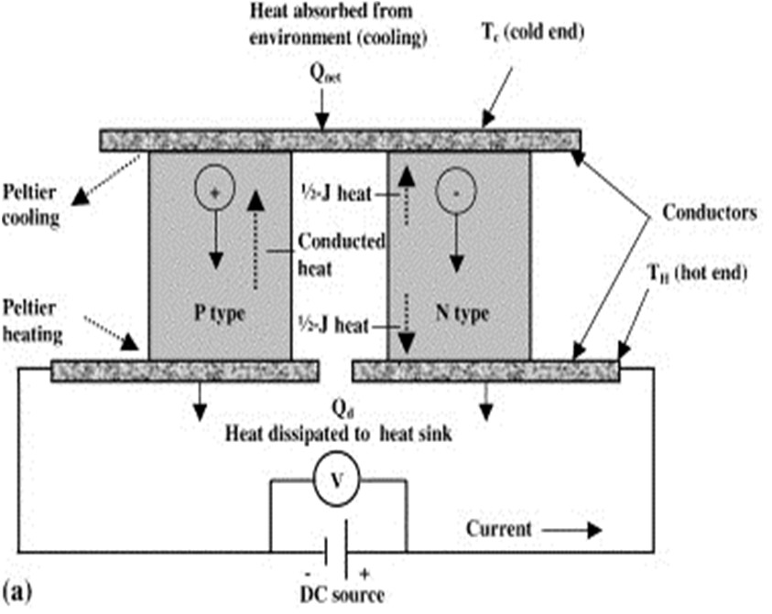
Figure 3: Schematic diagram of thermoelectric cooling [12]

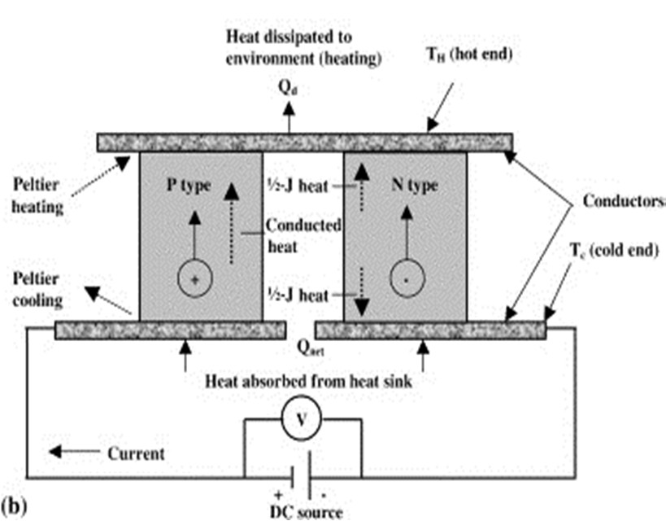

Figure 4: Schematic diagram of thermoelectric heating [12]

The p-type semiconductor is doped with certain atoms that have fewer electrons than necessary to complete the atomic bonds within the crystal lattice. When a voltage is applied, there is a tendency for conduction electrons to complete the atomic bonds. When conduction electrons do this, they leave “holes” which essentially are atoms within the crystal lattice that now have local positive charges. Electrons are then continually dropping in and being bumped out of the holes and moving on to the next available hole [8]. In effect, it is the holes that are acting as the electrical carriers.
Now, electrons move much more easily in the copper conductors but not so easily in the semiconductors. When electrons leave the p-type and enter into the copper on the cold-side, holes are created in the p-type as the electrons jump out to a higher energy level to match the energy level of the electrons already moving in the copper. The extra energy to create these holes comes by absorbing heat. Meanwhile, the newly created holes travel downwards to the copper on the hot side. Electrons from the hot-side copper move into the p-type and drop into the holes, releasing the excess energy in the form of heat.
The n-type semiconductor is doped with atoms that provide more electrons than necessary to complete the atomic bonds within the crystal lattice. When a voltage is applied, these extra electrons are easily moved into the conduction band. However, additional energy is required to get the n-type electrons to match the energy level of the incoming electrons from the cold-side copper. The extra energy comes by absorbing heat. Finally, when the electrons leave the hot-side of the n-type, they once again can move freely in the copper. They drop down to a lower energy level, and release heat in the process.

A. Technical Specification
Thermoelectric modules withstand potentially detrimental environmental conditions operating without failure under the low temperature point being equal to 285 K (12°C) and the high temperature point being equal to 328 K (+55°C). Thermoelectric modules successfully meet the below specified conditions without failure: sinusoidal vibration, 10-50 Hertz, with vibroacceleration amplitude up to 20 m/s² (2g). Unsealed thermoelectric modules withstand high humidity conditions with the RH level up to 88 % and 298 ° K (25°C) without any failure in operation. Thermoelectric modules withstand single mechanical shock with the peak shock acceleration being equal to 20G (200 m/s²) and 2-4 msecCollision Momentum without any failure [9].

B. Insulation Resistance Requirements
Insulation resistance of thermoelectric modules between the electrodes and outer surfaces of the ceramic plates is no less 20 M Ohms at the test DC voltage of 100 Volts under such standard climatic conditions as 25 ± 10°C, 45-80 % RH and 84-106, 7 KPa atmospheric pressure [9].

C. Reliability
Reliability is one of the major criterions of thermoelectric module (TEM) selection. TEMs are considered to be highly reliable components due to their solid-state construction. However premature TEM failure roots in soldered joints degradation which is primarily caused by the following factors: Improper operation and faulty mounting of TEM's leads to catastrophic electrical or mechanical failure; Continuous exposure to an elevated temperature results in TEM's is overheating. It is important that the modules are installed in full accordance with these general instructions to minimize the possibility of premature TEM failure. If you choose the right TEM or calculate/ design a thermoelectric cooling assembly, please take into account TEM's operating temperature, which is TEM's hot side temperature [10]. This is highly important since if the TEM is exposed to the higher temperature range, this will result in degradation changes in semiconductor material parameters and subsequent TEM's failure. We manufacture TEMs with the operating temperature of 80° C or 150°C. The latter are marked with HT symbol. According to the tests' results, the Mean Time between Failures (MTBFs) for TEMs is in excess of 200,000 hours at ambient room temperature. It is recommended, however, to design thermoelectric cooling assemblies in such a way as to provide the maximum heat dissipation from the TEM hot side to minimize the possibility of premature TEM failure [11].

VI. ADVANTAGES
Thermoelectric cooling devices and systems are believed to be as good as compressor- or absorber based refrigerators. However we believe that thermoelectric cooling offers a number of advantages over traditional refrigeration methods, namely:

- Solid state heat pumps have no moving parts,
- No Freon’s or other liquid or gaseous refrigerants required,
- Noiseless operation,
- Compact size and light weight makes TEMs well suited for miniature coolers,
- High reliability - We guarantee 200,000 hours of no failures,
- Precise temperature control,
- Relatively low cost and high effectiveness,
- Operation in any orientation,
- Easy to clean aluminum interior,
- Eco-friendly C-pentane, CFC free insulation.

VII. DISADVANTAGE
C.O.P. is less as compared to conventional refrigeration system.

VIII. LIMITATION
Our project is based on solar energy, thus solar energy is very necessary for the working of our project. But in rainy season it cannot be possible to charge battery from solar .this is the limitation of our project but this problem can be solved by giving direct current supply.

XI. APPLICATIONS OF SYSTEMS
- It can be uses as remote place where electric supply is not available.
- In restaurants /hotels
- At public places
- Laboratory, scientific instruments, computers and video cameras.
- Medical and pharmaceutical equipment.
- Military applications.

X. CONCLUSION
Thus our project concludes that solar energy systems must be implemented to overcome increasing electricity crisis. In this work, a portable solar operated system unit was fabricated and tested for the cooling and heating purpose. The system was designed based on the principle of a thermoelectric module to create a hot side and cold side. The cold side of the thermoelectric module was utilized for cooling purposes whereas the rejected heat from the hot side of the module was eliminated using heat sinks and fans. And hot side of the thermo electrical module was utilized for heating purpose. In order to utilize renewable energy, solar energy was integrated to power the thermoelectric module in order to drive the system. Furthermore, the solar thermoelectric cooling and heating system avoids any unnecessary electrical hazards and proves to be environment friendly.

REFERENCES
- Angrist, S.W., 1971. Direct Energy Conversion (Allyn and Bacon, Inc., Boston, MA,)
- Field Rl. Photovoltaic / Thermoelectric Refrigerator for
Medicine Storage for Developing Countries. Sol Energy 1980; 25(5):4457..
- Omega.(n.d.)The thermocouple. Retrieved October 10, 2010, from http:// www.omega.com/temperature/z/ pdf/z021-032.pdf [4] International Journal of Engineering (IJE), Volume (5): Issue (1): 2011, Riffat SB. Xiaolima Thermo-Electric: A Review of Present and Potential Applications. Applied Thermal Engg.
2003:23:913– 35.
- Dai Yj, Wang Rz, Ni L. Expr. Investigation on A ThermoElectric Refrigerator Driven By Solar Cells. Renew Energy 2003; 28:949–59.
- Advance Thermoelectric. One Tara Boulevard.Nashu,NH03062.Us.
- Abdul - Wahab, S.A., A. Elkamel, A.M. Al - Damkhi, I.A. Al - Habsi, H. Al - Rubai'ey, A. Al - Battashi, A. Al -Tamimi, K. Al-Mamari and M. Chutani, 2009. Omani Bedouins' readiness to accept solar thermoelectric refrigeration systems. International J. Energy Technology and Policy, 7: 127-136.
- Bansal PK, Martin A, Comparative Study of Vapour Compression, Thermoelectric and Absorption Refrigerator-Rs. Int J Energy Res 2000; 24(2):93-107.
- D. Vashaee, And A. Shakouri, “Electronic and Thermoelectric Transport in Semiconductor and Metallic Super lattices,” Journal of Applied Physics, Vol. 95, No.3, pp. 12331245, February 2004.
- Solar Concentrator for Combined Heat and Thermoelectric Power Generation. Energy Conversion & Management 2000; 41: 737-756.
- P. Ancey, M. Gshwind, New Concept of Integrated Peltier Cooling Device for the Preventive Detection of Water
Condensation”, Sensors and Actuators B 26-27 (1995) Pp. 303-307.
- En.Wikipedia.Org/Thermo Electric Effect.

