Inventory Process Management and Control
WALMART’S INVENTORY PROCESS MANAGEMENT PLAN
Luther Jones
6/12/16

Table of contents

Chapter 1. Executive Summary 3
Chapter 2. Overview of Inventory Management Process 5
Chapter 3. SWOT Analysis 6
3.1. Strengths 6
3.2. Weaknesses 6
3.3. Opportunities 6
3.4. Threats 7
Chapter 4. Effectiveness plan 8
Chapter 5. Reporting tools 10
Chapter 6. Execution plan 11
Chapter 7. Contingency plan 12

Chapter 1. Executive Summary

With nearly 500.000-million-dollar revenue in 2015, over 27000 million dollar annual profits and 2.2 million employees, Walmart has positioned itself as the first company in the FORTUNE 500 Company. It is undoubtedly among the biggest companies in the General Merchandising industry and definitely the most important company in the Retailing sector.

In April 2013, Walmart executives acknowledged that the company had problems related to the inventory management, and that they had lost nearly 3 billion dollars in 2013 due to out of stock merchandise. Even while this out of stock episode had been attributed both to the casual combination of bad weather conditions, higher than expected taxes and economically challenged customers, an adequate inventory process control would theoretically have avoided this situation.

Thus, the main aim of this report is to provide with the suitable inventory management control process that would ensure that such situation will not repeat again in the future. It will deal with different management aspects such as SWOT analysis, the evaluation of the current situation, and the establishment of the required effectiveness, execution and contingency plans to ensure an optimum inventory process control.

Figure 1 shows the schematic diagram of how the board of directors of Walmart is organized. Such horizontal structure enables a fast coordination within the different departments, thus ensuring an easy communication between them, necessary for the implementation of such an ambitious inventory management plan in a big company.
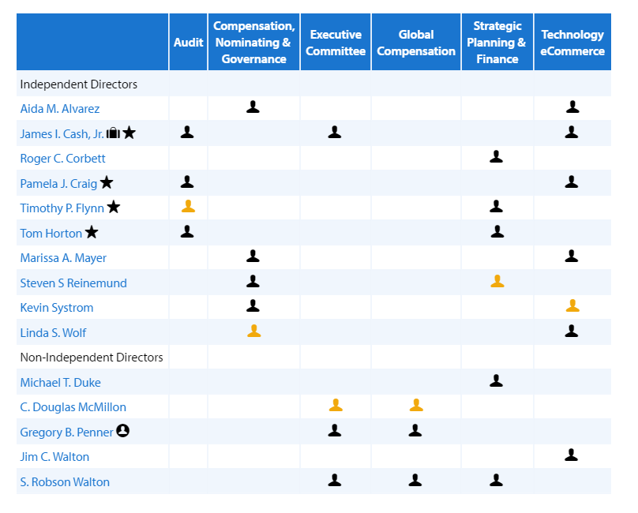
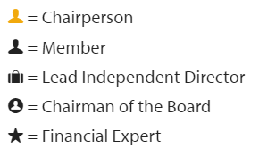

Figure 1. Organization of the board of directors in Walmart

Chapter 2. Overview of Inventory Management Process

The entire Walmart organization is committed to a business model that diminishes the costs of managing the supply chain (e.g. transport, storage…) to enable its customers to save money. This has been accomplished by a successful supply chain management focused on:
- Working directly with manufacturers, avoiding intermediary costs
- Providing the customer with the goods they want when and where they want them
- Developing cost structures to offer their customers low everyday pricing
- Enhancing the competitive advantage gained over its competitors.

Currently, the inventory organization in Walmart is based on two basic principles:
- Vendor Managed Inventory (VMI), according to which manufacturers cooperating with Walmart as vendors are responsible of managing their own products in Walmart’s network of warehouses. Thus, Walmart focuses on establishing strategic partnerships with any vendor able of ensuring the high product demand at the lowest price possible. Such partnership is based in that Walmart will guarantee the successful vendors with long term high volume of sales.
- Cross – docking, this implies that the direct transfer of products from inbound to outbound truck trailers or vice versa avoiding the intermediate storage step. This practice significantly reduces transportation costs and time and inventory holding costs.

Chapter 3. SWOT Analysis
(TBD)

3.1. Strengths
- Wide range of products
- Embraces cost leadership strategy and approach
- Highly competent regarding use of information systems
- Large scale of transactions and operations
- High efficiency in supply chain

3.2. Weaknesses
- High employee turnover
- Reduced differentiation of their products
- Negative Publicity
- High number of labor related lawsuits

3.3. Opportunities
- Acceptance of own labor products
- Exploration of online markets
- Exploring other emerging markets
- Healthy eating is on the trend

3.4. Threats
- Aggressive competition from brick and mortar and other online competitors
- Healthy lifestyle trend
- Rising prices in commodities
- Increased resistance from the local communities

Chapter 4. Effectiveness plan
Wal-Mart stores have several opportunities for growth. In the SWOT analysis, the following opportunities emerged. Expansion of retail market growth in emerging markets, the store recorded an expansion of its operations in the markets outside the US (Kneer, 2009). The business expanded its operations in china Brazil and India. The second opportunity identified was the rise in acceptance of own label products. The sales of private label products have increased by over 40% in the last ten years (Kneer, 2009). The third growth opportunity is the trend towards healthy eating. This trend has resulted in higher demand for more grocery products. Therefore, Wal-Mart has an opportunity to expand its grocery and earn more income from the sales.
Effectiveness plan
The opportunity areas identified in week two are of significant importance to the management of the store, and as such, it is important to put in place measures that will see the exploitation of these potentialities. The global trend in rising demand for grocery products is one of the essential areas that the management needs to focus on. This opportunity means that expansion of production in the demand area is not only necessary but also urgent. To meet the rising demands the management needs to come up with a clear policy that will dwell on ensuring that there are no excess demands in the market. One way of ensuring this is through the establishment of new enterprises in various parts of the world. The new branches will supplement the older ones in terms of supplying the groceries.
New units will require an additional stocking, and this calls for an increase in production of the grocery products. Being the largest retail supplier in the world, Wal-Mart requires increasing its stock almost to double standards that will be able to meet the growing demand, especially in grocery products. The management needs also to come up with a distribution strategy that targets consumers in various parts. This will involve doing an analysis to see which area has a high customer base. The store will then undertake to carry out an outdoor supply mechanism to target many consumers. This is achievable by transporting the groceries to these areas and selling them directly to consumers. This will increase sales and at the same time reaching out to new consumers of Wal-Mart products.
A follow-up exercise is necessary to track and evaluate the performance of the new strategies to find out if they are meeting the required goals.

Chapter 5. Reporting tools
In the measurement of metrics on the process and control, several broads will be required in order to facilitate the efficient measuring process. The amount of the products in ought to be calculated and determined in weight for the purpose of determining the mass. The quality in terms of density should be determined to ensure that the required amount is obtained. The value of the product is measured to evaluate the quantity and the quality.
Good measuring machines are essential for the measuring process. However, the knowledge in the use of the machines is essential. The measurement process requires a great level of accuracy in the approximations made. Each and every measure of the products requires accuracy.

Chapter 6. Execution plan
The execution of the production should be done with respect of the various processes involved and the inputs. The analysis of the inputs and the out puts ought to be realistic. The output should be greater than the input for the process to be a success.
The execution process is to be made by the top management and the stakeholders. The staff to handle the finances and the development matters of the system should involved in the implementation of the plans. Decision made to gear the productivity should be made by the members responsible and those having control of the production.
However, the employees working within the investment plan at the production sections should not be involved in the execution process. Their work should remain the doing the will to the management towards the achievement of set objectives.

Chapter 7. Contingency plan
An investment process requires the define approach towards the realization of the development and efficiency in the system. The investments options and processes require effective plans to develop the whole process.
Any given investment plan should be made to adopt the available conditions. With the conditions put into practice the investment process is likely to be successful. No given investment option should be made with a view of realizing profits only without considering the available and trending conditions.

