Nuns With Guns: The Strange Day-to-Day Struggles Between Bankers and Regulators

Lenders are awash in new regulations, and growing armies of rule enforcers are forcing striking changes on banks’ internal cultures

‘The regulatory environment is completely different than it was five years ago,’ says Greg Imm, chief compliance officer at M&T Bank Corp., here in his Buffalo, N.Y., offices, ‘and you can accept it and move on, or fight it and lose.’ PHOTO: MIKE BRADLEY FOR THE WALL STREET JOURNAL
By
KIRSTEN GRIND and

EMILY GLAZER
Updated May 30, 2016 10:39 p.m. ET
252 COMMENTS
SAN DIEGO—Among the new federal banking regulations there is one that financial wonks call “TRID,” the TILA-Respa Integrated Disclosure rule.
Attendees at a recent training school here for bank compliance staff, who must learn and enforce such rules, said they deciphered TRID’s true meaning: “The reason I drink.”
The sobering reality of banking in 2016 is that lenders are awash in new regulations, and growing armies of rule-interpreters and enforcers—for good or ill—are bringing striking changes to banks’ internal cultures.
The 2010 Dodd-Frank law, passed in the wake of the financial crisis and designed to prevent another, is one of the most complex pieces of legislation ever. At more than 22,200 pages of rules, it is equivalent to roughly 15 copies of “War and Peace” and covers matters from how much capital banks must set aside to how they can advertise.

What Is a Bank?

A series exploring the existential crisis facing banks in 2016
Guide to the series and full story list

- The Strange Day-to-Day Struggles Between Bankers and Regulators
- The Most Powerful Man in Banking
- For Community Banks, the Best and Worst of Times
- Banks' Embrace of Jumbo Mortgages Means Fewer Loans for Blacks, Hispanics
- As Banking Evolves, ‘Fintech’ Emerges From the Branch
- What Customers Want From Their Banks: Ease
- Bair: Today’s Bank: Necessity, Mystery, Whipping Boy
Those rules and others have spawned a regulatory apparatus that is the fastest-growing component of the financial sector, with banks hiring tens of thousands of new staff whose job is to keep their employers right with the new regime. Federal agencies have dispatched thousands of their own minders to set watch at banks.
The regulatory tightening has helped change the profile of a big bank in the postcrisis era. It now looks more like a utility, subject to complex rules about how it can do business and answering to government watchers whose careers depend on enforcing those rules with vigor.
“The regulatory environment is completely different than it was five years ago,” said Greg Imm, chief compliance officer at M&T BankCorp. in Buffalo, N.Y., “and you can accept it and move on, or fight it and lose.”
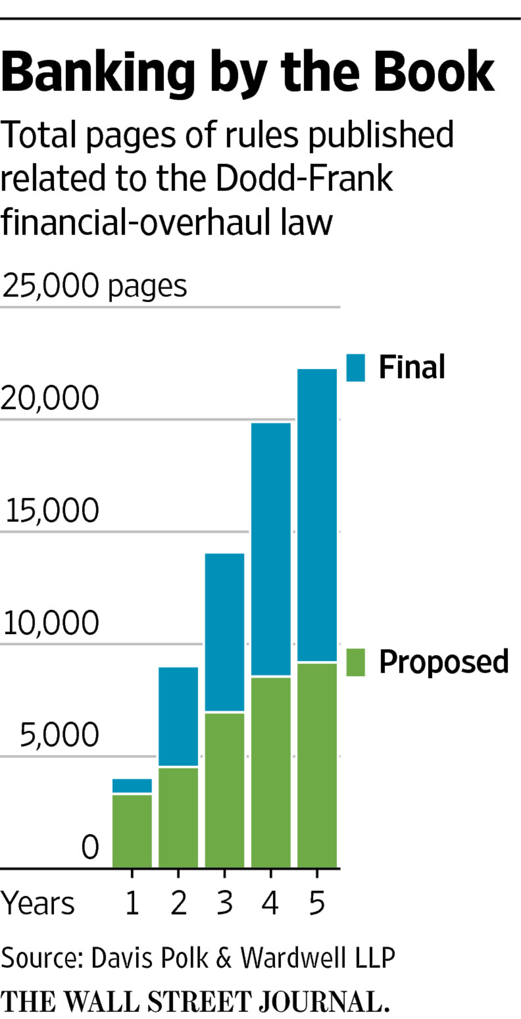
While the 2008 meltdown still inspires spirited debates about where to draw the regulatory line, there is general agreement that lack of oversight by regulators and banks contributed to the debacle and consequent government bailout. By some measures, the banking system is safer than it was.
At the same time, there are trade-offs. Banks pulled back from financing areas ranging from student lending to certain types of mortgages. They no longer make bets with their own money, known as proprietary trading, and have collectively ceased working with hundreds of thousands of individual or company accounts.
The heightened regulatory environment led 46% of banks to pare back their offerings for loan accounts, deposit accounts or other services, according to an American Bankers Association survey of compliance officers last year.
It is also costly. The six largest U.S. banks by assets in 2013 together spent at least $70.2 billion that year on regulatory compliance, up from $34.7 billion in 2007, according to the most recent study by policy-analysis firm Federal Financial Analytics Inc., which said costs have continued to mount since then.

WHAT IS A BANK: WSJ PRO

For additional stories in the "What Is a Bank" series, see WSJ Pro Financial Regulation (separate subscription required) WSJ PRO ONLY
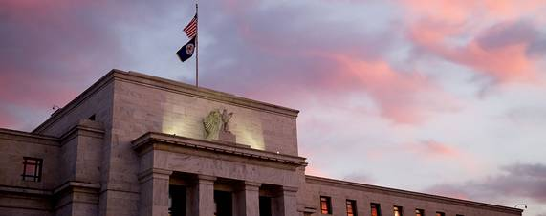
- Why Banks’ Appetite for Jumbo Mortgages Is Growing
- Fed’s Tarullo: Time to Reassess Postcrisis Rules
- Timeline: Tarullo’s Path to Becoming Fed’s Regulatory Point Man
- ‘Granular’ Rules Choke Smaller Banks, Trade Group Says
- Breaking Up Is Hard to Do, Even for Big Banks
- Why Some Bank Compliance Executives Are Throwing in the Towel
- WSJ Pro Financial Regulation homepage
Wells Fargo & Co. Chief Executive John Stumpf in an interview with an industry group last year said “one of the real benefits of our regulatory system is a strong, well-capitalized transparent financial services industry.” Still, he said: “We need balance, and our nation’s leaders have to understand some of the unintended consequences of regulation, which ultimately hurt consumers.”
Bank traders now know compliance officers and regulators are combing through chat rooms looking for signs of collusion and watching to make sure market bets don’t include excess risk. Teams inside banks are devoted to ensuring that mortgage officers are making proper disclosures to borrowers and that advertising offering “free checking” isn’t proven false by the fine print. Compliance employees often walk bank executives through rules and explain potential customer impact.
Bigger banks face on-site regulators sent by branches of the Federal Reserve, the Federal Deposit Insurance Corp. and the Office of the Comptroller of the Currency. More than a dozen other agencies regularly send staff to conduct exams or ask questions.
The dynamic can be maddening for all sides, with regulators, internal compliance executives and employees operating like rival tribes, according to interviews with more than three dozen current and former employees who have worked on these issues inside the country’s banks and regulatory agencies.
At a Barclays PLC town hall after Dodd-Frank rules began to go in place, bank compliance executives shared images of how each group thinks of the other, said someone familiar with the meeting. To represent bankers, compliance executives showed an image of the Wild West: cowboys on horses with guns.

MORE
- The Existential Crisis That Is Stalking Banks
- Banks Retreat from Global Ambitions
- How a Bank Makes Money: Tracking Citigroup
On the other side, to show how bankers view compliance officials, the executives revealed a picture of nuns carrying guns, an indicator that the group was seen as ultraconservative but still dangerous. Barclays declined to comment.
Each side needs the other, said Dan Gallagher, Securities and Exchange Commissioner until October 2015, and now president of regulatory consultancy Patomak Global Partners LLC, who has criticized what he calls a “crazy quilt” of regulation.
“The industry is more than ever yearning for guidance and interaction,” he said. And “after the crisis, the regulators had a lot of egg on their face as much as the firms,” he said, so “the government needs the compliance people in place. They’re part of the oversight system.”

‘Fire warden’
William Dudley, president of the Federal Reserve Bank of New York, testified in 2014 before Congress about what he sees as the role of his people: “I think of it more like a fire warden makes sure that the institution is run well so that it’s not going to catch on fire and burn down.”
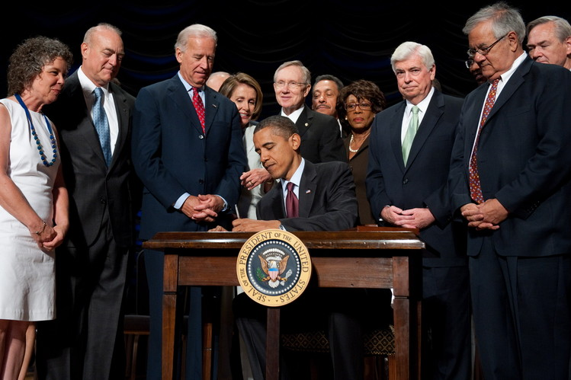
President Barack Obama signed the 2010 Dodd-Frank law, one of the most complex pieces of legislation ever passed, designed to prevent repeat of the 2008 financial meltdown. PHOTO: SAUL LOEB/AFP/GETTY IMAGES
Bank executives largely avoid publicly voicing frustrations with the regulatory regime, and most wouldn’t comment on the record for this article. In April 2015, Citigroup Inc.Chief Financial Officer John Gerspach said on an earnings call: “The cost associated with regulatory and compliance efforts has continued to increase. It’s consumed a fairly significant portion of the efficiency savings that we’ve been generating in the business.”
At J.P. Morgan, the nation’s largest bank by assets, the head count associated with what it calls “controls,” which includes many compliance-related staff, has grown to 43,000 in 2015 from 24,000 in 2011.
Colonial Savings in Fort Worth, Texas, with eight branches, had three to four people in its compliance department two years ago, said Richard Harvey Jr., its chief compliance officer. It now has 14, and “it’s very tough to find good compliance help.”
Before the crisis, bankers could make decisions more autonomously, said people on all sides. Most viewed compliance officers and regulators as sounding boards. A banker could run into a regulator at a Starbucks and chat informally about lending.
Now, formal and informal rifts are defining features of life in a bank. At one midsize bank in the Western U.S., a compliance officer was reprimanded after complaining about an individual regulator to a colleague in the bathroom, only to find out the regulator had been in a stall. The bank’s compliance department now sends a firmwide email before each sensitive regulatory exam, warning employees to watch what they say in shared areas, including bathrooms, said a person familiar with the emails.
Compliance employees serve as middlemen between the regulatory agencies and bank staff, fielding data requests and overseeing exams. They also help test products and services to make sure their banks are following rules and aren’t taking unacceptable risk.
That go-between role, some compliance employees said, makes them feel like hallway monitors. A compliance officer at a large bank said that when he approaches employees’ offices or cubicles to discuss issues, they usually drop what they are doing, close computer screens and hang up phones.
“They’ll get a headache look on their face and rub their temples,” he said. “It’s not like I’m hated but they know if I show up, there’s a problem.”
At large banks including Bank of America Corp., Citigroup, J.P. Morgan and Wells Fargo & Co. there are as many as 200 examiners on site from different agencies at all times, a number that has swelled by at least 20% over the past several years, bank executives said.
Those outsiders can create predicaments, such as where to seat officials from rival agencies. At J.P. Morgan, New York Fed and OCC staff a few years ago sat on one floor. J.P. Morgan had to separate the groups in part because of infighting, said people familiar with the episode. One set of examiners, they said, didn’t want the other to know what they were working on. Both regulatory groups were also expanding their teams and needed more space, they said.
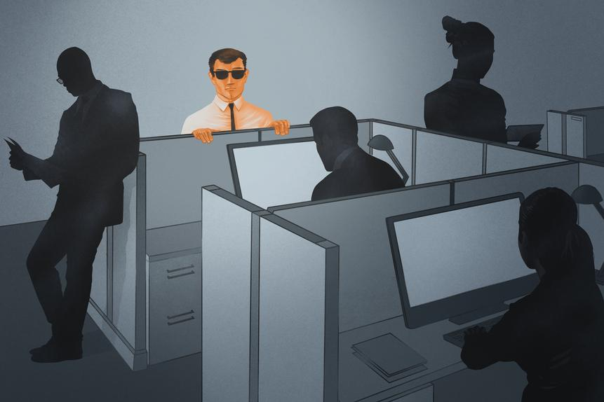ENLARGE
ILLUSTRATION: PAUL ANTONSON FOR THE WALL STREET JOURNAL

No happy hours
Navigating personal interactions can be a challenge, said Irene Guzman, a compliance officer at International Bank of Commerce in Texas. She describes regulators as “pleasant.”
Employees know, though, they can’t fraternize with regulators: no lunches, no happy hours, no dinners. If you see them at a restaurant, she said, “you can wave.”
Many rules are designed to prevent “regulatory capture,” in which regulators can get too cozy with bankers they work near. There used to be few regulators working on-site at banks, and interactions were sparse. After the crisis, on-site examiner roles ballooned across the industry. More recently, some are beginning to pull back on-site examiners in favor of teams looking at multiple firms and conducting regular visits.
Interactions between compliance officers and regulators have become much more formal since the crisis. Before, compliance executives could bump into a regulator in the hall and ask about an exam. Now, the two groups host formal meetings to discuss any issue, with prepared agendas and both sides documenting what is said.
At Wells Fargo and J.P. Morgan, in-house regulators have bank email addresses spelling out “EXAMINER” or “CONTRACTOR” to reduce chances employees mistake them for colleagues. J.P. Morgan sometimes scripts out what employees will say before they speak with regulators, said a person familiar with the interactions.
One former Consumer Financial Protection Bureau deputy said he frequently gave his examiners pep talks before sending them into banks, reminding them to “never let it be personal” and not to go in “with a chip on your shoulders.”
CFPB spokesman Samuel Gilford said the agency “works closely with our fellow state and federal regulators to ensure that consumer protections are applied consistently across markets.”
Regulators sometimes struggle to decipher new rules the same way compliance officers do. Mike Maher, chief compliance officer for Wells Fargo’s consumer-lending group until last year, recalls a monthslong discussion between the bank and regulators over whether it should let customers pay ahead on mortgages. And if they did, would the bank consider borrowers delinquent if they later missed a month?
The regulators, themselves unsure of the rules, were hesitant to take a position or provide guidance. “There are no written rules sometimes” about how to interpret the law, said Mr. Maher. “You’re in this space of ‘what is fair?’ ”
It isn’t uncommon for regulators from different agencies to issue conflicting opinions, said some bank employees. Mr. Imm of M&T, who was Fifth Third Bancorp’s chief compliance officer until 2014, said one of that bank’s regulators requested an exam; two weeks later, another agency requested the same. The agencies came back with different results. After Mr. Imm informed them, they conferred and returned with the same result. Fifth Third declined to comment.
Some of the new corps of watchers get training at operations like the one in San Diego, hosted by the American Bankers Association, where attendees were greeted with a 300-page instruction manual. About 200 students trooped into a room each morning at a DoubleTree hotel, leaving only for snack breaks and lunch.
Attendees learned procedures ranging from properly overseeing an ATM transaction to how to speak with regulators. They learned about new rules such as the October 2015 TILA-Respa rule, for Truth in Lending Act and Real Estate Settlement Procedures Act. Also called “Know Before You Owe,” it requires more-integrated disclosure forms for consumers at the time of application and settlement.
Instructors made light of the tension between banks and regulators, performing a skit parodying the Wizard of Oz during one class. A male instructor dressed as Dorothy wondered why one of her regulators hadn’t told her something.
“Oh you gullible, innocent girl!” replied an instructor dressed as the Wizard. “Don’t you know there’s no such thing as a good regulator?”

