SAMPLING MEAN:

DEFINITION:

The term sampling mean is a statistical term used to describe the properties of statistical distributions. In statistical terms, the sample mean from a group of observations is an estimate of the population mean. Given a sample of size n, consider n independent random variables X₁, X₂... X_{n}, each corresponding to one randomly selected observation. Each of these variables has the distribution of the population, with mean and standard deviation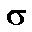. The sample mean is defined to be 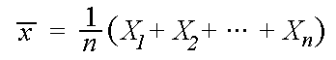

WHAT IT IS USED FOR:

It is also used to measure central tendency of the numbers in a database. It can also be said that it is nothing more than a balance point between the number and the low numbers.

HOW TO CALCULATE IT:

To calculate this, just add up all the numbers, then divide by how many numbers there are.
Example: what is the mean of 2, 7, and 9?
Add the numbers: 2 + 7 + 9 = 18
Divide by how many numbers (i.e., we added 3 numbers): 18 ÷ 3 = 6
So the Mean is 6
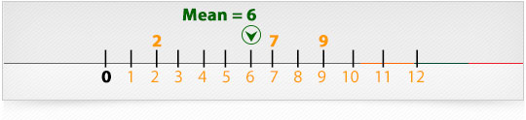

SAMPLE VARIANCE:

DEFINITION:

The sample variance, s², is used to calculate how varied a sample is. A sample is a select number of items taken from a population. For example, if you are measuring American people’s weights, it wouldn’t be feasible (from either a time or a monetary standpoint) for you to measure the weights of every person in the population. The solution is to take a sample of the population, say 1000 people, and use that sample size to estimate the actual weights of the whole population.

WHAT IT IS USED FOR:

The sample variance helps you to figure out the spread out in the data you have collected or are going to analyze. In statistical terminology, it can be defined as the average of the squared differences from the mean.

HOW TO CALCULATE IT:

Given below are steps of how a sample variance is calculated:
- Determine the mean
- Then for each number: subtract the Mean and square the result
- Then work out the mean of those squared differences.
To work out the mean, add up all the values then divide by the number of data points.
First add up all the values from the previous step.
But how do we say "add them all up" in mathematics? We use the Roman letter Sigma: Σ
The handy Sigma Notation says to sum up as many terms as we want.

- Next we need to divide by the number of data points, which is simply done by multiplying by "1/N":
Statistically it can be stated by the following:
- 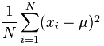
- This value is the variance

EXAMPLE:

Sam has 20 Rose Bushes.
The number of flowers on each bush is
9, 2, 5, 4, 12, 7, 8, 11, 9, 3, 7, 4, 12, 5, 4, 10, 9, 6, 9, 4
Work out the sample variance

Step 1. Work out the mean
In the formula above, μ (the Greek letter "mu") is the mean of all our values.
For this example, the data points are: 9, 2, 5, 4, 12, 7, 8, 11, 9, 3, 7, 4, 12, 5, 4, 10, 9, 6, 9, 4
The mean is:
(9+2+5+4+12+7+8+11+9+3+7+4+12+5+4+10+9+6+9+4) / 20 = 140/20 = 7
So:
μ = 7

Step 2. Then for each number: subtract the Mean and square the result
This is the part of the formula that says:
So what is x_{i}? They are the individual x values 9, 2, 5, 4, 12, 7, etc...
In other words x₁ = 9, x₂ = 2, x₃ = 5, etc.
So it says "for each value, subtract the mean and square the result", like this
Example (continued):
(9 - 7)² = (2)² = 4
(2 - 7)² = (-5)² = 25
(5 - 7)² = (-2)² = 4
(4 - 7)² = (-3)² = 9
(12 - 7)² = (5)² = 25
(7 - 7)² = (0)² = 0
(8 - 7)² = (1)² = 1
We need to do this for all the numbers

Step 3. Then work out the mean of those squared differences.
To work out the mean, add up all the values then divide by how many.
First add up all the values from the previous step.

= 4+25+4+9+25+0+1+16+4+16+0+9+25+4+9+9+4+1+4+9 = 178
But that isn't the mean yet, we need to divide by how many, which is simply done by multiplying by "1/N":
Mean of squared differences = (1/20) × 178 = 8.9
This value is called the variance.

STANDARD DEVIAITON:

DEFINITION:
This descriptor shows how much variation or dispersion from the average exists.
The symbol for Standard Deviation is σ (the Greek letter sigma).

It is calculated using:
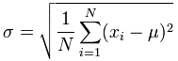
In case of a sample the ‘N’ in this formula is replaced by n-1.

WHAT IT IS USED FOR:
It is used to determine the expected value. A low standard deviation indicates that the data points tend to be very close to the mean (also called expected value); a high standard deviation indicates that the data points are spread out over a large range of values.

HOW TO CALCULATE IT:

To determine the standard deviation, you need to take the square root of the variance.

EXAMPLE PROBLEM:
Let’s look at the previous problem and compute the standard deviation. The standard deviation as mentioned earlier is nothing more than the measure of dispersion (spread). It can be calculated by taking the square root of the variance. In case of the previous problem where the variance was 8.9, its corresponding standard deviation would be the square root of 8.9 which is 2.983

σ = √(8.9) = 2.983...

HYPOTHESES TESTING:
DEFINITION:

Hypothesis testing is a topic at the heart of statistics. This technique belongs to a realm known as inferential statistics. Researchers from all sorts of different areas, such as psychology, marketing, and medicine, formulate hypotheses or claims about a population being studied.

WHAT IT IS USED FOR:

Hypothesis testing is used to determine the validity of these claims. Carefully designed statistical experiments obtain sample data from the population. The data is in turn used to test the accuracy of a hypothesis concerning a population. Hypothesis tests are based upon the field of mathematics known as probability. Probability gives us a way to quantify how likely it is for an event to occur. The underlying assumption for all inferential statistics deals with rare events, which is why probability is used so extensively. The rare event rule states that if an assumption is made and the probability of a certain observed event is very small, then the assumption is most likely incorrect.
The basic idea here is that we test a claim by distinguishing between two different things:
- An event that easily occurs by chance
- An event that is highly unlikely to occur by chance.
If a highly unlikely event occurs, then we explain this by stating that a rare event really did take place, or that the assumption we started with was not true.
HOW TO USE THE TEST FOR DECISION MAKING PURPOSES:
1. Formulate the null hypothesis (commonly, that the observations are the result of pure chance) and the alternative hypothesis (commonly, that the observations show a real effect combined with a component of chance variation).
2. Identify a test statistic that can be used to assess the truth of the null hypothesis.
3. Compute the P-value, which is the probability that a test statistic at least as significant as the one observed would be obtained assuming that the null hypothesis were true. The smaller the -value, the stronger the evidence against the null hypothesis.
4. Compare the -value to an acceptable significance value (sometimes called an alpha value). If , that the observed effect is statistically significant, the null hypothesis is ruled out, and the alternative hypothesis is valid.
EXAMPLE OF HYPOTHESIS TESTING (TWO-TAIL TEST)
If you are told that the mean weight of 3rd graders is 85 pounds with a standard deviation of 20 pounds, and you find that the mean weight of a group of 22 students is 95 pounds, do you question that that group of students is a group of third graders?
- The z-score is ((x-bar) - µ)/(*sigma*/(n^.5)); the numerator is the difference between the observed and hypothesized mean, the denominator rescales the unit of measurement to standard deviation units. (95-85)/(20/(22^.5)) = 2.3452.
- The z-score 2.35 corresponds to the probability .9906, which leaves .0094 in the tail beyond. Since one could have been as far below 85, the probability of such a large or larger z-score is .0188. This is the p-value. Note that for these two tailed tests we are using the absolute value of the z-score.

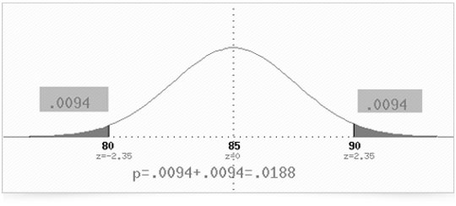
- Because .0188 < .05, we reject the hypothesis (which we shall call the null hypothesis) at the 5% significance level; if the null hypothesis were true, we would get such a large z-score less than 5% of the time. Because .0188 > .01, we fail to reject the null hypothesis at the 1% level; if the null hypothesis were true, we would get such a large z-score more than 1% of the time.

DECISION TREE:
DEFINITION:
A schematic tree-shaped diagram used to determine a course of action or show a statistical probability. Each branch of the decision tree represents a possible decision or occurrence. The tree structure shows how one choice leads to the next, and the use of branches indicates that each option is mutually exclusive.
WHAT IT IS USED FOR:
A decision tree can be used to clarify and find an answer to a complex problem. The structure allows users to take a problem with multiple possible solutions and display it in a simple, easy-to-understand format that shows the relationship between different events or decisions. The furthest branches on the tree represent possible end results.
HOW TO APPLY IT:
  - As a starting point for the decision tree, draw a small square around the center of the left side of the paper. If the description is too large to fit the square, use legends by including a number in the tree and referencing the number to the description either at the bottom of the page or in another page.
  - Draw out lines (forks) to the right of the square box. Draw one line each for each possible solution to the issue, and describe the solution along the line. Keep the lines as far apart as possible to expand the tree later.
  - Illustrate the results or the outcomes of the solution at the end of each line. If the outcome is uncertain, draw a circle (chance node). If the outcome leads to another issue, draw a square (decision node). If the issue is resolved with the solution, draw a triangle (end node). Describe the outcome above the square or circle, or use legends, as appropriate.
  - Repeat steps 2 through 4 for each new square at the end of the solution lines, and so on until there are no more squares, and all lines have either a circle or blank ending.
  - The circles that represent uncertainty remain as they are. A good practice is to assign a probability value, or the chance of such an outcome happening.
Since it is difficult to predict at onset the number of lines and sub-lines each solution generates, the decision tree might require one or more redraws, owing to paucity of space to illustrate or represent options and/or sub-options at certain spaces.
It is a good idea to challenge and review all squares and circles for possible overlooked solutions before finalizing the draft.
EXAMPLE:
Your company is considering whether it should tender for two contracts (MS1 and MS2) on offer from a government department for the supply of certain components. The company has three options:
- tender for MS1 only; or
- tender for MS2 only; or
- tender for both MS1 and MS2.
If tenders are to be submitted, the company will incur additional costs. These costs will have to be entirely recouped from the contract price. The risk, of course, is that if a tender is unsuccessful, the company will have made a loss.
The cost of tendering for contract MS1 only is $50,000. The component supply cost if the tender is successful would be $18,000.
The cost of tendering for contract MS2 only is $14,000. The component supply cost if the tender is successful would be $12,000.
The cost of tendering for both contracts MS1 and MS2 is $55,000. The component supply cost if the tender is successful would be $24,000.
For each contract, possible tender prices have been determined. In addition, subjective assessments have been made of the probability of getting the contract with a particular tender price as shown below. Note here that the company can only submit one tender and cannot, for example, submit two tenders (at different prices) for the same contract.
Option Possible Probability
tender of getting
prices ($) contract

MS1 only 130,000 0.20
115,000 0.85

MS2 only 70,000 0.15
65,000 0.80
60,000 0.95

MS1 and MS2 190,000 0.05
140,000 0.65
In the event that the company tenders for both MS1 and MS2 it will either win both contracts (at the price shown above) or no contract at all.
- What do you suggest the company should do and why?
- What are the downside and the upside of your suggested course of action?
- A consultant has approached your company with an offer that in return for $20,000 in cash, she will ensure that if you tender $60,000 for contract MS2, only your tender is guaranteed to be successful. Should you accept her offer or not and why?

Solution
The decision tree for the problem is shown below.
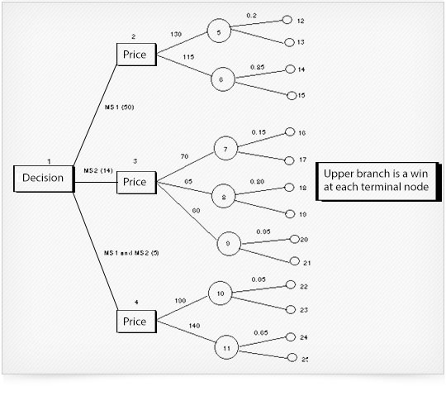
Below we carry out step 1 of the decision tree solution procedure which (for this example) involves working out the total profit for each of the paths from the initial node to the terminal node (all figures in $'000).

Step 1
- path to terminal node 12, we tender for MS1 only (cost 50), at a price of 130, and win the contract, so incurring component supply costs of 18, total profit 130-50-18 = 62
- path to terminal node 13, we tender for MS1 only (cost 50), at a price of 130, and lose the contract, total profit -50
- path to terminal node 14, we tender for MS1 only (cost 50), at a price of 115, and win the contract, so incurring component supply costs of 18, total profit 115-50-18 = 47
- path to terminal node 15, we tender for MS1 only (cost 50), at a price of 115, and lose the contract, total profit -50
- path to terminal node 16, we tender for MS2 only (cost 14), at a price of 70, and win the contract, so incurring component supply costs of 12, total profit 70-14-12 = 44
- path to terminal node 17, we tender for MS2 only (cost 14), at a price of 70, and lose the contract, total profit -14
- path to terminal node 18, we tender for MS2 only (cost 14), at a price of 65, and win the contract, so incurring component supply costs of 12, total profit 65-14-12 = 39
- path to terminal node 19, we tender for MS2 only (cost 14), at a price of 65, and lose the contract, total profit -14
- path to terminal node 20, we tender for MS2 only (cost 14), at a price of 60, and win the contract, so incurring component supply costs of 12, total profit 60-14-12 = 34
- path to terminal node 21, we tender for MS2 only (cost 14), at a price of 60, and lose the contract, total profit -14
- path to terminal node 22, we tender for MS1 and MS2 (cost 55), at a price of 190, and win the contract, so incurring component supply costs of 24, total profit 190-55- 24=111
- path to terminal node 23, we tender for MS1 and MS2 (cost 55), at a price of 190, and lose the contract, total profit -55
- path to terminal node 24, we tender for MS1 and MS2 (cost 55), at a price of 140, and win the contract, so incurring component supply costs of 24, total profit 140-55- 24=61
- path to terminal node 25, we tender for MS1 and MS2 (cost 55), at a price of 140, and lose the contract, total profit -55
Hence we can arrive at the table below indicating for each branch the total profit involved in that branch from the initial node to the terminal node.
Terminal node Total profit $'000
12 62
13 -50
14 47
15 -50
16 44
17 -14
18 39
19 -14
20 34
21 -14
22 111
23 -55
24 61
25 -55
We can now carry out the second step of the decision tree solution procedure where we work from the right-hand side of the diagram back to the left-hand side.

Step 2
- For chance node 5 the EMV is 0.2(62) + 0.8(-50) = -27.6
- For chance node 6 the EMV is 0.85(47) + 0.15(-50) = 32.45
Hence the best decision at decision node 2 is to tender at a price of 115 (EMV=32.45).
- For chance node 7 the EMV is 0.15(44) + 0.85(-14) = -5.3
- For chance node 8 the EMV is 0.80(39) + 0.20(-14) = 28.4
- For chance node 9 the EMV is 0.95(34) + 0.05(-14) = 31.6
Hence the best decision at decision node 3 is to tender at a price of 60 (EMV=31.6).
- For chance node 10 the EMV is 0.05(111) + 0.95(-55) = -46.7
- For chance node 11 the EMV is 0.65(61) + 0.35(-55) = 20.4
Hence the best decision at decision node 4 is to tender at a price of 140 (EMV=20.4).
Hence at decision node 1 we have three alternatives:
- tender for MS1 only EMV=32.45
- tender for MS2 only EMV=31.6
- tender for both MS1 and MS2 EMV = 20.4
Hence the best decision is to tender for MS1 only (at a price of 115) as it has the highest expected monetary value of 32.45 ($'000).

INFLUENCE OF SAMPLE SIZE:
DEFINITION:
Sample size is one of the four interrelated features of a study design that can influence the detection of significant differences, relationships, or interactions. Generally, these survey designs try to minimize both alpha error (finding a difference that does not actually exist in the population) and beta error (failing to find a difference that actually exists in the population).

WHAT IT IS USED FOR:

The sample size used in a study is determined based on the expense of data collection and the need to have sufficient statistical power.

HOW TO USE IT:

We already know that the margin of error is 1.96 times the standard error and that the standard error is sq.rt ^p(1􀀀^p)/n. In general, the formula is ME = z sq.rt ^p(1-^p)/n
where
*ME is the desired margin of error
*z is the z-score, e.g., 1.645 for a 90% confidence interval, 1.96 for a 90% confidence interval, 2.58 for a 99% confidence interval
_ ^p is our prior judgment of the correct value of p.
_ n is the sample size (to be found)

EXAMPLE:

If ^p =0.3 and Z=1.96 and ME =0.025 then the necessary sample size is:

ME= Z sq.rt (^p*1-^p)/n

0.025 = 1:96 sq.rt (0.3*0.7)/n

n=1291 or 1300 students

POPULATION MEAN:

DEFINITION:

The population mean is the mean of a numerical set that includes all the numbers within the entire group.

WHAT IT IS USED FOR:

In most cases, the population mean is unknown and the sample mean is used for validation purposes. However, if we want to calculate the population mean, we will have to construct the confidence interval. This can be achieved by the following steps:

HOW TO USE IT:
- The sample statistic is the sample mean x¯
- The standard error of the mean is s/sq.rt n where s is the standard deviation of individual data values.
- The multiplier, denoted by t*, is found using the t-table in the appendix of the book. It's a simple table. There are columns for .90, .95, .98, and .99 confidence. Use the row for df = n − 1.
- Thus the formula for a confidence interval for the mean is x¯±t∗ (s/sq.rt n)

EXAMPLE:

In a class survey, students are asked if they are sleep deprived or not and also are asked how much they sleep per night. Summary statistics for the n = 22 students who said they are sleep deprived are:
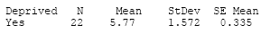
- Thus n = 22, x¯ = 5.77, s = 1.572, and standard error of the mean = 1.572/sq.rt 22=0.335
- A confidence interval for the mean amount of sleep per night is 5.77 ± t* (0.335) for the population that feels sleep deprived.
- Go to the t-table in the appendix of the book and use the df = 22 – 1 = 21 row. For 95% confidence the value of t* = 2.08.
- A 95% confidence interval for μ is 5.77 ± (2.08) (0.335), which is 5.77 ± 0.70, or 5.07 to 6.7
- Interpretation: With 95% confidence we estimate the population mean to be between 5.07 and 6.47 hours per night.

RANDOM SAMPLING
Random sampling is a sampling technique where we select a group of subjects (a sample) for study from a larger group (a population). Each individual is chosen entirely by chance and each member of the population has a known, but possibly non-equal, chance of being included in the sample.
By using random sampling, the likelihood of bias is reduced.
WHEN RANDOM SAMPLING IS USED:

Random sampling is used when the researcher knows little about the population.

THE STEPS ASSOCIATED WITH RANDOM SAMPLING:

- Define the population
- Choose your sample size
- List the population
- Assign numbers to the units
- Find random numbers
- Select your sample

EXAMPLE:

In a study, 10,000 students will be invited to take part in the research study. The selection was limited to 200 randomly selected students. In this case, this would mean selecting 200 random numbers from the random number table. Imagine the first three numbers from the random number table were:
0011 | (the 11th student from the numbered list of 10,000 students)
9292 | (the 9,292nd student from the list)
2001 | (the 2,001st student from the list)
We would select the 11th, 9,292nd, and 2,001st students from our list to be part of the sample. We keep doing this until we have all 200 students that we want in our sample.

SAMPLING DISTRIBUTION:
DEFINITION:
The sampling distribution is a theoretical distribution of a sample statistic. There is a different sampling distribution for each sample statistic. Each sampling distribution is characterized by parameters, two of which are and. The latter is called the standard error.
WHAT IT IS USED FOR:
It is used for making probability statements in inferential statistics.
HOW IS SAMPLING DISTRIBUTION USED?
Step 1: Obtain a simple random sample of size n.
Step 2: Compute the sample mean.
Step 3: Assuming we are sampling from a finite population, repeat Steps 1 and 2 until all simple random samples of size n have been obtained.
EXAMPLE OF SAMPLING DISTRIBUTION:

THE SAMPLE DISTRIBUTION
The sample distribution is the distribution resulting from the collection of actual data. A major characteristic of a sample is that it contains a finite (countable) number of scores, the number of scores represented by the letter N. For example, suppose that the following data were collected:
32 | 35 | 42 | 33 | 36 | 38 | 37 | 33 | 38 | 36 | 35 | 34 | 37 | 40 | 38 | 36 | 35 | 31 | 37 | 36 | 33
36 | 39 | 40 | 33 | 30 | 35 | 37 | 39 | 32 | 39 | 37 | 35 | 36 | 39 | 33 | 31 | 40 | 37 | 34 | 34 | 37
These numbers constitute a sample distribution. Using the procedures discussed in the chapter on frequency distributions, the following relative frequency polygon can be constructed to picture this data:
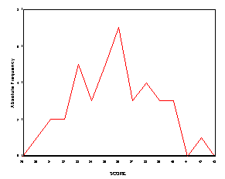
SAMPLING ERROR:
DEFINITION:
The error that arises as a result of taking a sample from a population rather than using the whole population.
WHAT IT IS USED FOR:
It is used to detect the difference between the sample and the true, but unknown value of population parameter.
HOW TO USE IT/CALCULATE IT:
- Determine the level of confidence followed by the critical values
- Calculate the sample standard deviation
- Calculate the margin of error using
E = Critical value * sample standard deviation/sq.rt of sample size
EXAMPLE:
- What is the margin of error for a simple random sample of 900 people at a 95% level of confidence? The sample standard deviation is 2.
By use of the table we have a critical value of 1.96, and so the margin of error is 1.96/(2 √ 900 = 0.03267, or about 3.3%.
- What is the margin of error for a simple random sample of 1600 people at a 95% level of confidence and a sample standard deviation of 2?
At the same level of confidence as the first example, increasing the sample size to 1600 gives us a margin of error of 0.0245, or about 2.5%.
This shows that by increasing the sample size, the margin of error decreases.

PROBABILITY:

DEFINITION:

Probability is the chance that something will happen — how likely it is that some event will occur.
WHAT IT IS USED FOR:
Probability is used in various areas, such as assessing risks in medical treatment, forecasting weather, what to sell at a discount and when to sell it, determining car insurance rates, determining future commercial and manufacturing construction, in developing other real estate, in municipal planning for such things as placing new roads, and in financial planning at home and in the business world.
HOW TO CALCUATE IT:
1. Count the number of all distinctive and equally likely outcomes of the experiment. Let that be n.
2. Count the number of distinctive outcomes that represent the occurrence of the event in question. Let that be n_{e}.
3. Calculate the result of the division n_{e}/n. That is the probability of the event.

EXAMPLE:

Find the probability of getting an even number after rolling a die.

  - Event: Getting an even number
  - Steps above:
    - Distinctive outcomes: 1, 2, 3, 4, 5, 6 are all the outcomes, their count n=6
    - Outcomes representing the event: 2, 4, 6 are all the even numbers you can get, their count n_{e}=3
    - Probability: P = n_{e}/n = 3/6 = 0.5 or 1/2

POWER CURVE:

DEFINITION:

Power curves illustrate the effect on power of varying the alternate hypothesis.

WHAT IT IS USED FOR:

The curve illustrates how a sample of observations with a defined variance is quite powerful in correctly rejecting the null hypothesis (for example, if m₀=8) when the true mean is less than 6 or greater than 10. The curve also illustrates that the test is not powerful — it may not reject the null hypothesis even when the true mean differs from m_{0 —} when the difference is small. This is also extensively used in testing the relationship between power and sample size.

HOW IT IS USED:

See example below.

EXAMPLE:

If the researcher learns from literature that the population follows a normal distribution with mean of 100 and variance of 100 under the null hypothesis and he/she expects the mean to be greater than 105 or less than 95 under the null hypothesis and he/she wants the test to be significant at 95% level, the resulting power function would be:
Power=1-Φ[1.96-(105-100)/(10/n)]+Φ[-1.96-(95-100)/(10/n)], which is,
Power=1-Φ[1.96-n/2]+Φ[-1.96+n/2].
That function shows a relationship between power and sample size. For each level of sample size, there is a corresponding sample size. For example, if n=20, the corresponding power level would be about 0.97, or, if the power level is 0.95, the corresponding sample size would be 16.

PROBABILITY DISTRIBUTION:

DEFINITION:

A statistical function that describes all the possible values and likelihoods that a random variable can take within a given range. At times it is presented in the form of a table or an equation that links the outcome of a statistical experiment with its probability of occurrences.

HOW IT IS USED:

It establishes a range that will be between the minimum and maximum statistically possible values, but where the possible values are likely to be plotted on the probability distribution depends on a number of factors, including the distribution mean, standard deviation, skewness, and kurtosis.

HOW TO USE IT:

- Identify the event
- Create a table showing the possibility of its occurrence

EXAMPLE:
An example will make clear the relationship between random variables and probability distributions. Suppose you flip a coin two times. This simple statistical experiment can have four possible outcomes: HH, HT, TH, and TT. Now, let the variable X represent the number of Heads that result from this experiment. The variable X can take on the values 0, 1, or 2. In this example, X is a random variable because its value is determined by the outcome of a statistical experiment.
A probability distribution is a table or an equation that links each outcome of a statistical experiment with its probability of occurrence. Consider the coin flip experiment described above. The table below, which associates each outcome with its probability, is an example of a probability distribution.
Number of heads | Probability
0 | 0.25
1 | 0.50
2 | 0.25
The above table represents the probability distribution of the random variable X.

EXPECTED VALUE OF SAMPLE INFORMATION:
DEFINITION:
In decision theory, the expected value of sample information is the expected increase in utility that you could obtain from gaining access to a sample of additional observations before making a decision.

WHAT IS IT USED FOR?

Calculate the Expected Monetary Value (EMV) of each alternative action.

HOW TO USE IT/CALCULATE IT?

1. Determine the optimal decision and its expected return for the possible outcomes of the sample using the posterior probabilities for the states of nature
2. Calculate the values of the optimal returns
3. Subtract the EV of the optimal decision obtained without using the sample information from the amount determined in step (2)

EXAMPLE:

The expected value of sample information is computed as follows:

Suppose you were going to make an investment into only one of three investment vehicles: stock, mutual fund, or certificate of deposit (CD). Further suppose that the market has a 50% chance of increasing, a 30% chance of staying even, and a 20% chance of decreasing. If the market increases, the stock investment will earn $1500 and the mutual fund will earn $900. If the market stays even, the stock investment will earn $300 and the mutual fund will earn $600. If the market decreases, the stock investment will lose $800 and the mutual fund will lose $200. The certificate of deposit will earn $500 independent of the market's fluctuation.
Question:
What is the expected value of perfect information?
Solution:
Expectation for each vehicle:
The maximum of these expectations is the stock vehicle. Not knowing which direction the market will go (only knowing the probability of the directions), we expect to make the most money with the stock vehicle.
Thus,
On the other hand, consider if we did know ahead of time which way the market would turn. Given the knowledge of the direction of the market, we would (potentially) make a different investment vehicle decision.
Expectation for maximizing profit given the state of the market:
That is, given each market direction, we choose the investment vehicle that maximizes the profit.
Hence,
Conclusion:
Knowing the direction the market will go (i.e., having perfect information) is worth $350.

EXPECTED VALUE OF SAMPLE INFORMATION:
DEFINITION:
In decision theory, the expected value of sample information (EVSI) is the expected increase in utility that you could obtain from gaining access to a sample of additional observations before
making a decision.

WHAT IT IS USED FOR:

EVSI attempts to estimate what this improvement would be before seeing actual sample data; hence, EVSI is a form of what is known as preposterior analysis.
HOW IT IS CALCULATED:
See example below:
EXAMPLE:
Thompson Lumber Company is trying to decide whether to expand its product line by manufacturing and marketing a new product which is “backyard storage sheds.” The courses of action that may be chosen include:
- Large plant to manufacture storage shed
- Small plant to manufacture storage shed
- Build no plant at all
THOMSON LUMBER COMPANY
ALTERNATIVES FAVORABLE MARKET UNFAVORABLE MARKET
Construct a Large Plant $200,000 $-180,000
Construct a Small Plant $100,000 $-20,000
Do Nothing $0 $0
ANALYSIS
ALTERNATIVES FAVORABLE MARKET UNFAVORABLE MARKET EMV COMPUTED
Construct a large plant $200,000 $-180,000 (0.5)(200,000)+(0.5)(-180,000)=$10,000
Construct a small plant $100,000 $-20,000 (0.5)(100,000)+(0.5)(-20,000)=$40,000
Do Nothing $0 $0 $0

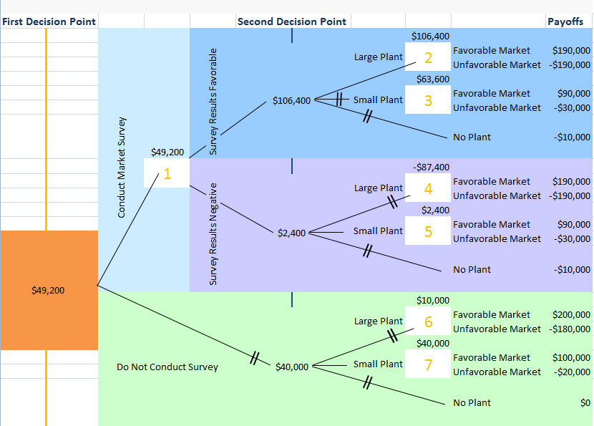

EVSI = Expected value of best decision with sample information (assuming no cost to gather it)-Expected value of best decision without sample information
Decision Tree Solution

EVSI = $49,200 - $40,000 = $9,200
And since the EVPI was previously calculated to be $60,000,
Thompson would be willing to pay up to $9,200 for this test information, with an efficiency of (9200/60000)*100 = 15.3%

SIGNIFICANCE LEVELS:

DEFINITION:

It is a property of the distribution of a test statistic. Significance is a statistical term that tells how sure you are that a difference or relationship exists.

WHAT IT IS USED FOR:

The significance level of a test is the probability that the test statistic will reject the null hypothesis when the [hypothesis] is true.

STEPS USED IN ANALYSIS:

Decide on the critical alpha level you will use (i.e., the error rate you are willing to accept).
Conduct the research.
Calculate the statistic.
Compare the statistic to a critical value obtained from a table.

EXAMPLE
Null Hypothesis: m =64
Alternative Hypothesis: m>64
Test data:
X=64 (mean_
s=3.15(sample standard deviation)
m=64 (Population mean)
a=0.05 (significance level)
For this example, the test statistic is:
t _{n-1} = `x - m
s /Ö n
Check to see if you really understand why it is a t-value and not a z-value.
Now substitute the given values and get a value for t

t _{n-1} = 66 - 64
3.15/ Ö25
t _{n-1} = 2
0.53
t _{n-1} = 3.77

P-value
p-value = P( t > 3.77 )

So the p-value is smaller than 0.0005, in symbols p-value < 0.0005
Note: When you have a “not equal to” alternative hypothesis, you have to multiply by two as you have only found half of the p-value.
Decision
Well, we have to decide whether to reject or not reject the Null Hypothesis.
If the p-value bigger than 0.05 then do not reject the Null Hypothesis
If the p-value smaller than 0.05 then reject the Null Hypothesis

TYPE I AND TYPE II ERRORS:

DEFINITION:

Type I & Type II Error
The first kind of error that is possible involves the rejection of a null hypothesis that is actually true. This kind of error is called a type I error, and is sometimes called an error of the first kind.
The other kind of error that is possible occurs when we do not reject a null hypothesis that is false. This sort of error is called a type II error, and is also referred to as an error of the second kind.
WHAT IT IS USED FOR:
It is not used for anything. It is basically a classification of an error.
HOW IT IS USED IN CALCULATIONS:
See example below:
EXAMPLE (TYPE I ERROR)
If the cholesterol level of healthy men is normally distributed with a mean of 180 and a standard deviation of 20, and men with cholesterol levels over 225 are diagnosed as not healthy, what is the probability of a type one error?
z=(225-180)/20=2.25; the corresponding tail area is .0122, which is the probability of a type I error.
If the cholesterol level of healthy men is normally distributed with a mean of 180 and a standard deviation of 20, at what level (in excess of 180) should men be diagnosed as not healthy if you want the probability of a type one error to be 2%?
2% in the tail corresponds to a z-score of 2.05; 2.05 × 20 = 41; 180 + 41 = 221.
EXAMPLE (TYPE II ERROR)
If men predisposed to heart disease have a mean cholesterol level of 300 with a standard deviation of 30, but only men with a cholesterol level over 225 are diagnosed as predisposed to heart disease, what is the probability of a type II error? (The null hypothesis is that a person is not predisposed to heart disease.)
z=(225-300)/30=-2.5 which corresponds to a tail area of .0062, which is the probability of a type II error (*beta*).
If men predisposed to heart disease have a mean cholesterol level of 300 with a standard deviation of 30, above what cholesterol level should you diagnose men as predisposed to heart disease if you want the probability of a type II error to be 1%? (The null hypothesis is that a person is not predisposed to heart disease.)
1% in the tail corresponds to a z-score of 2.33 (or -2.33); -2.33 × 30 = -70; 300 - 70 = 230.

