MBA 520 Module Six Forecasting Model Questions

The questions that follow and the article Comparing the Accuracy and Explainability of Dividend, Free Cash Flow, and Abnormal Earnings Equity Value Estimates will inform your completion of milestone III. An understanding of the models in this assignment will assist you in hypothesizing the incremental impact of a new investment project for the company. The understanding of these models will contribute to your ability to look toward the future when considering the direction of an organization.

Prompt
Once you have read the article “Comparing the Accuracy and Explainability of Dividend, Free Cash Flow, and Abnormal Earnings Equity Value Estimates” and Chapters 6 and 7 of your text, review and complete the questions below. Use the article and your text to inform your responses to the questions below.

Assignment Questions:

1. For models 2, 2a, and 2b:

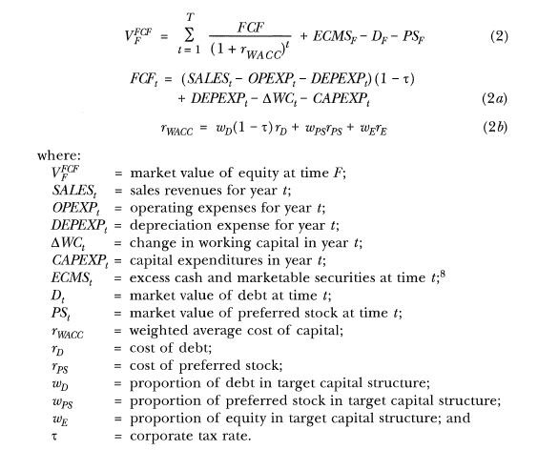

- What is the best way to minimize the weighted average cost of capital?
- What is the effect of the weighted average cost of capital on the market value?

2. For models 3, 3a, and 3b:

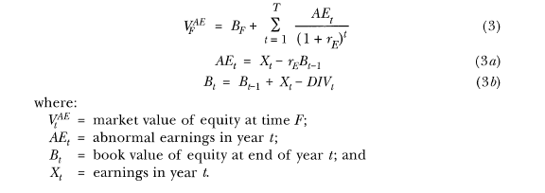
- What is the relationship between book value of equity and time t-1 and the market value of the equity?

3. Discuss model 4 and expand on the importance and the meaning of the market risk premium.

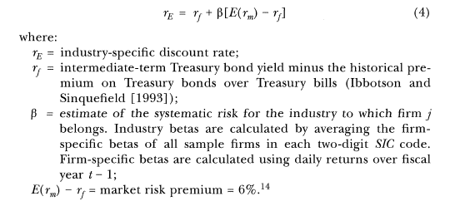

4. In your own words, what are the main conclusions for this article, and what could be improved upon in its analysis?

