1: (Analyzing the cash flow Statement) Goggle, Inc. is an Internet firm that has experienced a period of very rapid growth in revenues over the period 2007-2010. The cash flow statements for Goggle, Inc. spanning the period are below. Choose the best answer for the following question using the information found in these statements:

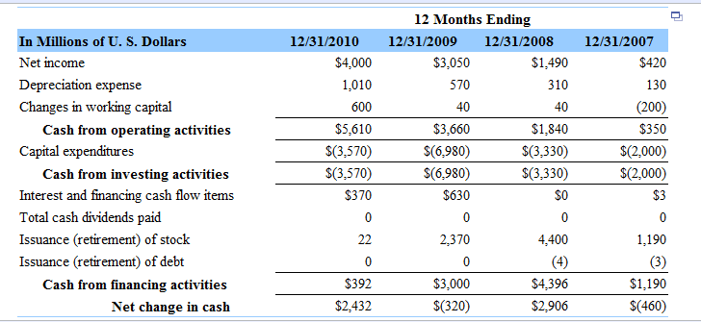

What years did Goggle generate positive cash flow from its operations?

Goggle has generated positive cash flow from its operations during the years 2007, 2008, and 2010.

Goggle has generated positive cash flow from its operations during the years 2008, 2009, and 2010.

Goggle has generated positive cash flow from its operations during the years 2007, 2008, 2009, and 2010.

Goggle has generated positive cash flow from its operations during the years 2007, 2009, and
2010.

2:
(Analyzing the cash flow Statement) Goggle, Inc. is an Internet firm that has experienced a period of very rapid growth in revenues over the period 2007-2010. The cash flow statements for Goggle, Inc. spanning the period are below. Choose the best answer for the following question using the information found in these statements:

Describe Goggle's main source of financing in the financial markets over the period.

Google's main source of financing in the financial markets over the period was the issuance of common stock for the amount of $985 million.

Google's main source of financing in the financial markets over the period was the issuance of debt for the amount of $10 million.

Google's main source of financing in the financial markets over the period was the issuance of common stock for the amount of $8,034.

Google's main source of financing in the financial markets over the period was the issuance of debt for the amount of $985 million.

3: (Analyzing the cash flow Statement) Goggle, Inc. is an Internet firm that has experienced a period of very rapid growth in revenues over the period 2007-2010. The cash flow statements for Goggle, Inc. spanning the period are below.

Based solely on the cash flow statements for 2007 through 2010, select the best choice below, that describes the major activities of Goggle's management team over the period.

Googles management team has been investing heavily in working capital and financing them with the issuance of stocks and internally generated funds.

Google's management team has been investing heavily in capital expenditures and financing them with the issuance of stocks and internally generated funds.

Google's management team has been spending heavily in paying cash dividends and financing them with the issuance of stocks and internally generated funds.

Google's management team has been investing heavily in capital expenditures and financing them with the issuance of debt and internally generated funds.

4: (Analyzing the cash flow Statement) Goggle, Inc. is an Internet firm that has experienced a period of very rapid growth in revenues over the period 2007-2010. The cash flow statements for Goggle, Inc. spanning the period are below. Choose the best answer for the following question using the information found in these statements:

Cash Flow Statement

How much did Goggle invest in new capital expenditures over the period? (Round to the nearest integer.)

The amount that Google invested in new capital expenditures over the period is $15,930 million.

The amount that Google invested in new capital expenditures over the period is $14,710 million.

The amount that Google invested in new capital expenditures over the period is $16,290 million.

The amount that Google invested in new capital expenditures over the period is $11,030 million.

5: (DuPont analysis) Dearborn Supplies has total sales of $200 million, assets of $109 million, a return on equity of 30 percent, and a net profit margin of 7.6 percent. What is the firm's debt ratio?

6: (Bond valuation) The 8-year $1,000 par bonds of Vail Inc. pay 11 percent interest. The market's required yield to maturity on a comparable-risk bond is 7 percent. The current market price for the bond is $1,130.
What is your yield to maturity on the Vail bonds given the current market price of the bonds? (Round to two decimal places.)

What should be the value of the Vail bonds given the yield to maturity on a comparable risk bond? (Round to the nearest cent.)

Should you purchase the bond at the current market price?

7: (Review of financial statements) Prepare a balance sheet and income statement for the Warner Company from the scrambled list of items found here in order to answer the question below. The statements do not need to be submitted, only your response to the question.

Financial Statement

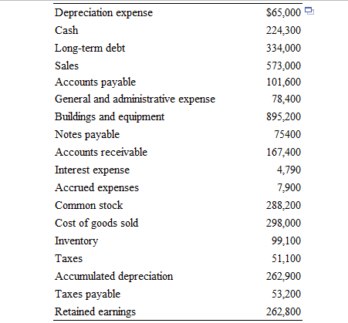

What can you say about the firm's financial condition based on the prepared financial statements?

8: (Expected rate of return and risk) Syntex, Inc. is considering an investment in one of two common stocks. Given the information that follows, which investment is better, based on the risk (as measured by the standard deviation) and return? (Round to two decimal places.)
Expected Rate of Return

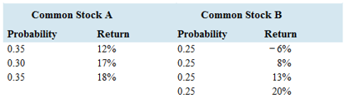

Given the information in the table, what is the expected rate of return for stock A?

What is the standard deviation of stock A?

What is the expected rate of return for stock B?

Based on the risk (as measured by the standard deviation) and return of each stock which investment is better?

9: (Common stock valuation) The common stock of NCP paid $1.21 in dividends last year. Dividends are expected to grow at an annual rate of 5.40 percent for an indefinite number of years.
If your required rate of return is 8.30 percent, what is the value of the stock for you?
Should you make the investment?

10: (Individual or component costs of capital) Compute the cost of capital for the firm for the following:

A bond that has a $1,000 par value (face value) and a contract or coupon interest rate of 10.8 percent. Interest payments are $54.00 and are paid semiannually. The bonds have a current market value of $1,130 and will mature in 10 years. The firm's marginal tax rate is 34 percent.

A new common stock issue that paid a $1.77 dividend last year. The firm's dividends are expected to continue to grow at 7.4 percent per year, forever. The price of the firm's common stock is now $27.61.

A preferred stock that sells for $141, pays a dividend of 9.5 percent, and has a $100 par value.

A bond selling to yield 11.4 percent where the firm's tax rate is 34 percent.

11: (Cost of debt) Sincere Stationery Corporation needs to raise $531,000 to improve its manufacturing plant. It has decide to issue a $1,000 par value bond with an annual coupon rate of 10.1 percent with interest paid semiannually and a 15-year maturity. Investors require a rate of return of 7.7 percent.

A: Compute the market value of the bonds.

B: How many bonds will the firm have to issue to receive the needed funds?

C: What is the firm's after-tax cost of debt if the firm's tax rate is 34 percent?

12: (Individual or component costs of capital) Your firm is considering a new investment proposal and would like to calculate its weighted average cost of capital. To help in this, compute the cost of capital for the firm for the following:
A: A bond that has a $1,000 par value (face value) and a contract or coupon interest rate of 11.9 percent that is paid semiannually. The bond is currently setting for a price of $1,129 and will mature in 10 years. The firm's tax rate is 34 percent. If the firm's bonds are not frequently traded, how would you go about determining a cost of debt for this company?

B: A new common stock issue that paid a $1.74 dividend last year. The par value of the stock is $16, and the firm's dividends per share have grown at a rate of 8.7 percent per year. This growth rate is expected to continue into the foreseeable future. The price of this stock is now $27.88.

C: A preferred stock paying a 9.3 percent dividend on a $120 par value. The preferred shares are currently setting for $153.18.

D: A bond setting to yield 13.9 percent for the purchaser of the bond. The borrowing firm faces a tax rate of 34 percent.

13: (Weighted average cost of capital) The target capital structure for Jowers Manufacturing is 52 percent common stock, 12 percent preferred stock, and 36 percent debt. If the cost of common equity for the firm is 20.8 percent, the cost of preferred stock is 12.5 percent, and the before-tax cost of debt is 10.4 percent, what is Jowers' cost of capital? The firm's tax rate is 34 percent.

