Re-Organization and Layoff: Solutions

William Phister, Kerry Grunwald, Michael Mayberry, Tyler Shipe, Chris Wren

PHL/320
May 3, 2016
Eric Belmar
Re-Organization and Layoff: Solutions
Companies grow into a great business and employ thousands of personal. Management shares ideas and plans for expansion to set goals to improve profitability. Unfortunately, the market can fall short causing a ripple effect that every employee will feel. To save the company thousands of dollars, some will perform employment layoffs to stay in business. Over the last twenty years, U.S. based companies have increased layoffs by an astounding four hundred and seventy percent, at one point reaching almost two million (Figure 1, Harvard Business Review, 2013). Losing a job puts a threat to the very own livelihood to the employee. With careful planning, lower management can organize an operation with low to no extra cost to the company. Regarding the extent of the situation, management needs the training to facilitate a layoff. Having a better-equipped and intelligent management will have a better result for the company operation. It will give the employee reassurance that management cares and understand the situation. In addition, the company can focus on motivation and productivity among the remaining employees and utilize critical thinking strategies to develop new ideas for the enterprise.
Re-Organization
An alternative solution to terminating an employee, either temporarily or permanently is to explore the possibility of reassigning the duties of the employee to a new location or a department that is currently expanding. This method would allow the company to focus on a plethora of business developments due to the workforce, the efficiency of the company would potentially increase from the reorganization of employees. Policies like this would boost worker morale, by means of showing that the company recognizes difficulties the employees face, like an overabundance of work, and address them professionally. Furthermore, employees know management will attempt to keep them as long as possible, in any capacity, so long as the company is financially able to maintain the individual’s employment. Regarding the company’s financial stability, utilizing this policy may relieve specific expenses, for example, workers with at least 12 consecutive months of continuous employment also qualify for severance pay under the Canadian Labour Code (Employment and Social Development Canada, 2016). Another benefit would be the avoidance in the cost of starting the hiring process again in the future. Restructuring the role of an employee can potentially help fuel the growth of the company as well as boost the morale of the workforce.
Training
When alternative measures fail and the need to dismiss an employee is absolute, management needs to be properly coached and trained in company specific termination procedures. Allowing managers the time to engage collectively regarding the releasing of employees will permit management to reduce the negative impacts, post-layoff. As stated by Stever Robbins (2009), President of venturecoach.com and CEO of Stever Robbins, INC., described in the Harvard Business Review (HBR) “Most people are loyal first to their manager, then to their company” (para. 6). Managers will need to shift discussion from the termination to the individuals future, managers encompassing this ability will direct the former employees focus from the company to the individual. While the individual is going through a very difficult time, their first line supervisor can help with directing questions about resources and benefits that will be available during the transition process. The delivery of the message should be in a private setting, with the administrator of the meeting prepared to answer crucial questions that led to the release of the individual. Most importantly, “Managers instead should handle layoffs with honesty, sensitivity and open communication” says Bridget Murray (p. 50, 2002), of the American Psychological Association’s Monitor on Psychology. Murray (2002) also states that keeping “employees informed and show that they care about them, ex-employees more often stay loyal and sympathetic to the company” (p. 50, 2002).
Team Collaboration
Group collaboration is essential to critical thinking with identifying the best possible solutions to problems or issues. Cooperation amongst team members, especially those with varying specialties and educational backgrounds, brings outside perspectives and opinions that may have been overlooked if problem solving independently. Teamwork enhances the understanding of the core issues and brings new perspectives to the analysis of potential strategies. It ensures the final solution identified has been thought through carefully and has a high level of commitment and consensus within the group.
Barriers
In this example, the team relied exclusively on technology to collaborate and identify two possible solutions to the problem presented. Relying exclusively on technology to problem solve was the main barrier the team had to overcome to be successful. The team faced the typical technical challenges such as not replying all to emails, and the on-line website timing out. There were other types of communication gaps created by using the technology medium because it interfered with the emotional transmission of the message. Face-to-face collaboration is typically more effective compared to technology-mediated collaboration because of its ability to transmit physical gestures and other non-verbal cues that technology cannot. The inability to communicate non-verbal cues can have an impact on emotional and social aspects, such as trust, that need to be cared for when working and collaborating in a group setting (Andres & Akon, 2010). The group had to over communicate, seek clarification, and reconfirm intentions in order to overcome this barrier created by technology.
Conclusion
The need for layoffs has increased exponentially over the course of the last twenty years, management teams across the world have been ill prepared in dealing with the overwhelming number of employees being forced out of work. Restructuring companies or training managers on how to properly handle these situations may relieve the additional stress of terminating an employee or losing a career. Managers who understand the reasons behind the layoffs will better communicate to those who are losing their employment. In a fast-paced global economy, companies are forced to make riskier decisions at a quicker pace; these decisions have the ability to negatively affect thousands of employee’s lives. Business leaders need to understand critical-thinking processes and professional communication tools in order to help alleviate additional stresses in the workplace. Whether the company chooses to utilize the restructuring method or terminating employees, the decision will have a lasting impact on the remaining workforce.

Figures
Figure 1
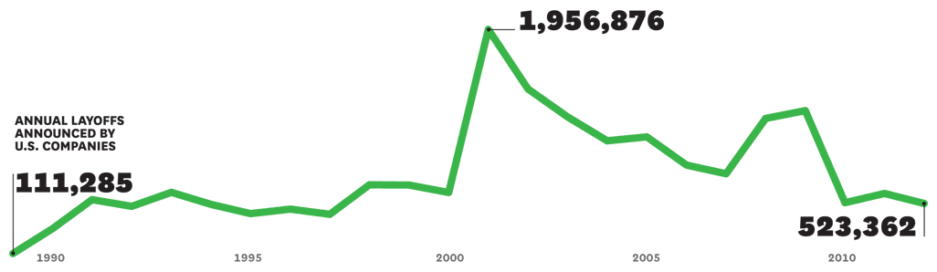

References
Andres, H. P., & Akan, O. H. (2010). Assessing Team Learning in Technology-Mediated Collaboration: An Experimental Study. Journal of Educational Technology Systems, 38(4), 473-487.
Bridget Murray. (2002). Psychologists help companies traverse the minefields of layoffs. Monitor on Psychology, 33(4), 50.
Employment and Social Development Canada. (2010). Federal labour standards. Termination, layoff or dismissal. Retrieved from http://www.esdc.gc.ca/en/jobs/workplace/employment_standards/labour/termination.page
Harvard Business Review. (2013). [Line graph showing the number of annual layoffs announced by U.S. companies] Honeywell’s CEO on how he avoided layoffs. Retrieved from https://hbr.org/resources/images/article_assets/hbr/1306/R1306A_A_LG.gif
Stever Robbins. (2009). Harvard business review. How to handle layoffs. Retrieved from
https://hbr.org/2009/03/how-to-communicate-layoffs

