EcoCar3 Marketing Campaign


Integrated Project Plan Report

Table of Contents
- Project Overview
  - Purpose, Scope and Objectives, and Business Case
    - Scope
    - Statement of Work (SOW)
    - Business Case
  - Project Deliverables
  - Project Organization
  - Work Breakdown Structure (WBS)
    - Personnel Table
  - Responsibility Assignment Matrix
- Risk Assessment
  - Risk Identification
  - Qualitative Risk Assessment
  - Quantitative Risk Assessment Matrix
    - Summary Quantitative Risk Assessment
  - Risk Mitigation Strategies
- Project Schedule
  - Activity Duration Estimates
  - Gantt Chart
  - Activity Network
  - Resource Allocation
    - Resource Allocation Time Table
- Project Budget
  - Project Resources
  - Other Costs
  - Cost Estimates
  - Time phased Budget
- Project Close-out
  - Close Cost Accounts
  - Lessons Learned

- Project Overview

  - Purpose, Scope and Objectives, and Business Case
The purpose of this project is to overall increase attendance at the EcoCar3 event in both the audience and student participants, and increase awareness of the event through social networking.
    - Scope
EcoCar3 is an organization that hosts a collegiate competition in which students will redesign a Chevrolet Camaro to reduce environmental impact. Up to 17 team members made up of some of the greatest minds ASU has to offer compete to offer innovative ideas on how to meet engineering, environmental, and economic goals. Although the EcoCar3 program can be a great opportunity for ASU students, due to poor advertising and marketing, not enough students sign up for classes. The social presence of the project is also quite limited. A majority of the advertising for the EcoCar3 team is targeted at the Polytechnic Campus. When events come up, the team will make a temporary flier blast on the campus and a short description of the event on the ASU Facebook page. These updates come on an irregular basis through the PolyGram and the same issues can be seen through the printing and distribution of the event fliers. When the event finishes there is no action taken to check whether our marketing campaign has accomplished it duty.
- Majority of advertising and marketing targeted at Poly campus
- Regularly updating the EcoCar3 ASU Facebook page
- Irregular updates to PolyGram
- Irregular printing and distribution of flyers

    - Overview of the Project
Many students majoring in engineering, business, communication, graphic information technology, entrepreneurship, and journalism can take a great deal out of this program but because marketing and advertising has been focused on the ASU Polytechnic campus, we believe that a large pool of candidates are unaware of what the project is or unaware about how to sign up. ASU has gathered a team to specifically increase the social presence across all ASU campuses as well as social media presence. Currently the most routine place for news, the EcoCar3 ASU Facebook page has under 500 likes.
    - Constraints
      - Budget - Given a stipend of $250 per month until the end of the Spring 2016 semester.
      - Space - Can’t take photos of the Engineers computers. We will not have enough to do TV or radio ads.
      - Time - Three months/ Spring 2016 semester
      - Regulatory - We must adhere to the ASU code of conduct. Follow the branding guide of ASU
    - Statement of Work (SOW)
Team membership allows students to earn credit toward their degrees and gain hands-on experience engineering, managing and creating communications content in an automotive industry like setting.
      - Key Milestones
Table 1.1
Milestone/ Event | Date
Complete Student Target Report | Feb. 23 2016
Manager approve first campaign | Mar. 3 2016
Finish First Media Campaign | Mar. 14 2016

Table 1.1: Cont.
Managerial approved Sec Campaign | Mar. 21 2016
Finish Second Media Campaign | Mar. 22, 2016
Managerial Approved Last Campaign | April 8, 2016
Complete Media Project | April 25, 2016

      - Resource Requirements
        - Computers/phones/camera
        - Social media account privilege
      - Risks and Concerns
        - Environmental Risk
          - None, our campaign will focus a majority of its advertising through online social media.
        - Client expectation risk
          - None, the platform that we will be advertising on is already a social norm.
        - Competitive Risks
          - None
        - Risks in project development
          - Delays in site development, old team members shown.
        - Project Constraints
          - Time
            - Project Deadline (3 Months from 2/2016)
            - Group members schedule (Time to meet outside of class)
          - Cost
            - Budget ($250 per month)
- Acceptance criteria
  - Increase of social media presence
  - Have a surplus of unused media
  - Increase mailing list signup
  - Scheduled media releases
- Estimated Time and Costs
  - Estimated time to complete project work
    - Estimated beginning of May, 2016
  - Estimated costs to complete project work
    - Estimated ($750 in next 3 months)
  - Anticipated ongoing costs
    - Business Case
It’s evident through quick verbal surveys around the campus that there are few students that know about the opportunities that EcoCar3 has to offer. We are participating in this project to overall increase awareness of the competition while simultaneously increasing student participation in the competition.
  - Project Deliverables
During the course of this project, we have set key deliverables that, if met, show that the project is on the right course.
  - Incoming students are briefed on current EcoCar3 media status
  - Updated social networks, media, and ads
  - Increase presence at Polytech
  - Redesigned EcoCar3 website that is implemented with ASU
  - Redesigned award system for events (Raffle, Door prizes, etc.)

  - Project Organization
The ASU Ecocar3 team is comprised of multidisciplinary studies which include students from many different departments coming together to work on this project as a whole. The table listed below this shows the people needed to work together as team leaders to get it done. This graph is broken down from faculty advisers to team leaders needed to take charge in making sure the tasks are done on time. This map can also help you find the person you are looking for based on what role they play in the EcoCar3 competition.
Figure 1.1
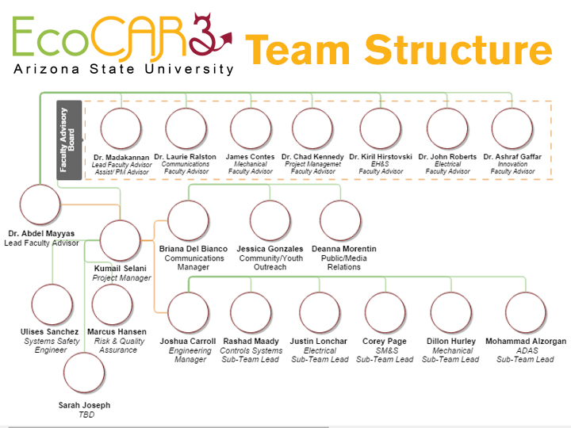

  - Work Breakdown Structure (WBS)
Figure 1.1 below lists incoming students that are selected to be a part of the EcoCar3 media team are briefed on EcoCar3’s media status. Advisors from each campus are then interviewed to select a demographic that would be interested in EcoCar3. A proposal is developed with either newer ideas or current working ideas that benefit EcoCar3’s marketing. Once the proposal is accepted then the process that's been implemented starts. After the signup we collect the data and use that information during our next proposal. The process repeats a third time and we make a final report for management.
Table 1.2
Description | WBS | Code
EcoCar3 Media Project |  | 1.0
Establish Current EcoCar3 Media Content |  | 1.1
Gather Current Team / Media | 1.1.1
Sort Media | 1.1.2
Identify Current Plan | 1.1.3
Create Target Student Report |  | 1.2
Interview current EcoCar3 Students | 1.2.1
Ask poly advisor for target students | 1.2.2
ask Tempe advisor for target students | 1.2.3
ask west advisor for target student | 1.2.4
ask Downtown advisor for target student | 1.2.5
Complete target report | 1.2.6
Media Concentration Report |  | 1.3
Question media team | 1.3.1
Figure out what is working | 1.3.2
Evaluate possible marketing areas | 1.3.3
Prepare Media Proposal |  | 1.4
Develop Cost & Pitch | 1.4.1
Complete Plan | 1.4.2
Management Approval | 1.4.3
Update media team on new plan |  | 1.5
Advise team | 1.5.1
Reassign project assignments to members | 1.5.2
Create Media to Implement |  | 1.6

Table 1.2: Cont.
Create Physical | 1.6.1
Gather pictures | 1.6.2
Create Videos | 1.6.3
Roll First Media Campaign |  | 1.7
Retrieve Sign up Data |  | 1.8
Process data | 1.8.1
End First Media Campaign | 1.8.2
Report back to Management |  | 1.9
Create .doc and summary of Activities | 1.9.1
First media Assignment Complete | 1.9.2
Plan Second Media Campaign |  | 2.0
Discuss & assess previous campaign | 2.0.1
Q&A w/ Team members for ideas | 2.0.2
Weigh Individual Proposals | 2.0.3
Vote | 2.0.4
Bring Proposal to Management | 2.0.5
Second Media Proposal Accepted |  | 2.1
Assign Individual Assignments | 2.1.1
Create Media to Implement |  | 2.2
Create Physical | 2.2.1
Gather pictures | 2.2.2
Create Videos | 2.2.3
Roll out Second Media Campaign |  | 2.3
Retrieve Sign Up Data |  | 2.4
Process Data | 2.4.1
Second Campaign Finished | 2.4.2
Report to Management |  | 2.5
Create .doc and summary of Activities | 2.5.1
Second Media Assignment Complete | 2.5.2
Plan Last Media Campaign |  | 2.6
Discuss & assess previous campaign | 2.6.1
Q&A w/ Team members for ideas | 2.6.2
Weigh Individual Proposals | 2.6.3
Table1.2: Cont.
Vote | 2.6.3
Bring Proposal to Management | 2.6.5
Last Campaign Proposal Accepted |  | 2.7
Assign Individual Assignments | 2.7.1
Create Media to Implement |  | 2.8
Create Physical | 2.8.1
Gather pictures | 2.8.2
Create Videos | 2.8.3
Roll out Last Media Campaign |  | 2.9
Retrieve Sign Up Data |  | 3.0
Process data | 3.0.1
Last Campaign Finished | 3.0.2
Report Results to Management |  | 3.1
Create .doc and summary of Activities | 3.1.1
Last Media Assignment Complete | 3.1.2

    - Personnel Table
The personnel Table 1.2 represents the organizational structure of the central people who hold important roles in this project. It gives a general view of personnel and their involvement in the project. This will also coincide with the responsibility assignment matrix that is created in the next section.
Table 1.3
Name | Department | Title
Dr. Abdel Mayyas | Administrator | Lead Faculty Advisor
Dr. Laurie Ralston | Communications | Faculty Advisor
Kumail Selani | Communications | Project Manager
Vishal Pandey | Administrator | Co-Manager
Briana Del Bianco | Communications | Manager
Suzy do Deizer | Team Member | Photographer
Manny Padilla | Team Member | Online Social Media
Kevin Riley | Team Member | Physical Media
  - Responsibility Assigned Matrix
Table 1.3 below is the Responsibility Assignment Matrix (RAM) to inform readers about the significant members of the team and their roles during crucial parts of the project. The figure below is the matrix created for the EcoCar3 media campaign project. This RAM identifies the lead of each section of the project, their support and who to notify when their task is complete and in need of a review. This tool has the important role of clarifying to the team about who to questions if and when inquires do occur.
Table 1.4
 | Dr. Abdel Mayyas | Dr. Laurie Ralston | Kumail Selani | Vishal Pandey | Briana Del Bianco | Suzy de Keizer | Manny Padilla | Kevin Riley
1.1 | 🌕 |  | 🌕 | 🔔 |  | 🌟 | 🌕 | 🌕
1.2 | 🔺 | 🌕 |  |  | 🔔 | 🌕 | 🌕 | 🌟
1.3 |  | 🔺 | 🔔 | 🌕 | 🔔 |  | 🌟 | 🌕
1.4 | 🌕 | 🔺 |  |  | 🌕 |  | 🌟 | 🌕
1.5 | 🌕 | 🔺 | 🌕 |  |  | 🌟
1.6 |  | 🔺 |  | 🌕 |  |  |  | 🌟
1.7 |  |  | 🔔 |  | 🔺 | 🌕 | 🌟
1.8 | 🌕 |  | 🌕 |  | 🔺 |  |  | 🌟
1.9 | 🔺 | 🔺 |  |  | 🌕 |  | 🌟
2.0 |  | 🔺 | 🔔 | 🌕 |  |  | 🌕 | 🌟
2.1 | 🔺 |  | 🔔 | 🌕 | 🌕 | 🌟
2.2 |  | 🔺 |  |  |  | 🌟 | 🌕
2.3 |  |  |  | 🌕 | 🔔 |  | 🌟
2.4 | 🔔 | 🔺 |  |  |  | 🌟 |  | 🌕
2.5 | 🔺 |  |  | 🌕 | 🔺 |  |  | 🌟

Table 1.4: Cont.
2.6 |  | 🔺 |  |  | 🌕 |  | 🌕 | 🌟
2.7 | 🔔 |  |  |  | 🌕 | 🌟 |  | 🌕
2.8 | 🔔 |  | 🔔 | 🌕 |  | 🌕 |  | 🌟
2,9 |  | 🔺 |  |  |  | 🌟 |  | 🌕
3.0 | 🔺 | 🔺 |  | 🔔 | 🔺 | 🌕 | 🌟 | 🌕
Key:
Support - 🌕; People who has knowledge or have been assigned to support responsible party.
Notification - 🔔; People who need to be updated of the progress.
Approval - 🔺; People accountable for signing off on tasks or work.
Responsible - 🌟; People responsible for the execution of task or work.
- Risk Assessment
  - Risk Identification
Risk assessment is an important aspect of project management because it takes into account the possible negative events that occur during the lifetime of a project. Risk assessment is done early in the project to be effective by identifying possible problems before they occur. In Table 2.1 below the risks for the EcoCar3 project are listed with corresponding codes. As an important element in the overall project, this can save time and increase performance when problems happen. In this section, we’re identifying the following risks:
Table 2.1 Risk Identification List - Risks are identified by an alpha code
Code | Risk
A | HDD fail; loss of data (pictures, video, etc.)
B | Social media website and apps go down, EcoCar3 website down
C | EcoCar3 website is hacked
D | Fail to increase student turnout
E | Event cancelled/postponed
F | Weather destroying physical advertising
G | Late posts/announcement of event
H | Media conflicts with ASU policies and procedures
I | Absenteeism
Table 2.1: Cont.
K | Student’s worker overwhelmed by class workload
L | EcoCar3 website not regularly updated

  - Qualitative Risk Assessment
In Figure 2.1 below is a Table that is a visual representation of the risk associated with our project through a quantitative approach.. The matrix reflects all the identified project risks and have prioritized them according to the likelihood of occurrence with the potency of the consequences. These two criteria will offer a sense of impact on the project were the risks happen to occur.
 |  | Consequences
 |  | Low | Medium | High
Likelihood | High | L
Likelihood | Medium | I | K | B, C, D, H
Likelihood | Low | J | E, G | A , F
Likelihood | Figure 2.1 – Quantitative Risk Assessment Matrix  Risks are evaluated by their likelihood and consequences

  - Quantitative Risk Assessment Matrix
In the Tables below, the EcoCar3 project is calculating the risk factor using a qualitative approach through two calculated Tables. Probability of failure is displayed in Table 2.2 and Consequence of Failure in Table 2.3. These tables take into consideration multiple categories to create an overall risk factor. A common rule of thumb when discussing the overall risk factor are scores below .30 are considered “low risk,” projects scoring between .30 and .70 are “medium risk,” and projects scoring over .70 are “high risk.” The overall risk factor will be determined for all listed risks. Below is an example using risk H, Media conflicts with ASU policies and procedures to create the probability of failure and consequence of failure creating the overall risk factor.
Table 2.2 Probability of Failure Table - Calculating the probability of failure
Probability of Failure(P_{f})
Score | Maturity | Complexity | Dependency
Low (0.1)
Minor (0.3) | 0.3 | 0.3
Moderate (0.5) |  |  | 0.5
Significant (0.7) |  |  |  | Average P_{f}
Major (0.9) |  |  |  | 0.36666667

Table 2.3 Consequence of Failure Table - Calculating the consequences of failure determining the overall risk factor
Consequence of Failure(C_{f})
Score | Cost | Schedule | Reliability | Performance
Low (0.1) | 0.1
Minor (0.3) |  |  |  | 0.3
Moderate (0.5) |  | 0.5 | 0.5
Significant (0.7)
Major (0.9) |  |  |  |  | Average C_{f}
Overall Risk Factor (H): .59 |  |  |  |  | 0.35

    - Summary Quantitative Risk Assessment
Using the calculations above and the scheme for calculating overall risk factor, this approach is duplicated for the rest of risk resulting in a useful Table determining the risk factor in order to better prepare for problems that may arise in our project's lifetime. In the Table 2.4 below, the calculated risk factors are displayed
Table 2.4 Risk Factor Summary - The Table is displayed using the risk factor calculations for each individual risk.
Code | Risk | Risk Factor
A | HDD fail; loss of data (pictures, video, etc.) | 0.77
B | Social media website and apps go down, EcoCar3 website down | 0.62
C | EcoCar3 website is hacked | 0.50
D | Fail to increase student turnout | 0.67
E | Event cancelled/postponed | 0.63
F | Weather destroying physical advertising | 0.54
G | Late posts/announcement of event | 0.25

Table 2.4: Cont.
H | Media conflicts with ASU policies and procedures | 0.59
I | Absenteeism | 0.77
J | Administrative resignation | 0.82
K | Student’s worker overwhelmed by class workload | 0.66
L | EcoCar3 website not regularly updated | 0.53
  - Risk Mitigation Strategies
In the Table (Table 2.5) below it is shown a method of Mitigation of potential risks that might happen over time while working on the Eco-car team this semester. This will highlight from both The Probability of failure and also from the Consequences of failure. In the probability of failure we talk about how some of these changes can directly affect the whole team more than other would. In Consequences of failure we will look at how budget and time will affect the project.
Table 2.5 - Risks are organized by their severity and are coupled by a mitigation strategy.
Risk Mitigation Strategies
High Risk | Mitigation Strategy
HDD fail; loss of data (pictures, video, etc.) | Insure that most of the data is backed up either using a hard drive or through the cloud.
Absenteeism | Address organization chart for responsibility
Administrative resignation | Have an up to date chart for back up administration
Medium Risk | Mitigation Strategy
Social media website and apps go down, EcoCar3 website down | Alternative Physical advertising plan devised
Media conflicts with ASU policies and procedures | Confirm that a second pair of eyes have looked over the media before publication
EcoCar3 website is hacked | Perpetual log of media work
Fail to increase student turnout | Have past project surveys ready to analyze
Event cancelled/postponed | Create alternative advertising plan for possible postponed events in advanced
Weather destroying physical advertising | Create 25% more than necessary ad’s
Student’s worker overwhelmed by class workload | Active conversation with students
EcoCar3 website not regularly updated | Active conversation with students
Low Risk | Mitigation Strategy
Late posts/announcement of event | Scheduled posts/ Calendar assignments

- Project Schedule
  - Activity Duration Estimates
In the table below we have listed out all the activities that have listed for the whole project/semester. It would should the description of what the project is and also the time the project should be completed in. The table below it would show the time most likely the projects should last or the amount of days it should be completed. We have also added the Optimistic view to show that the project might be finished before or on time. We also have the Pessimistic view showing more days added making sure that if anything does happen we will have it covered in the max amount of days needed for everything to be created. I doubt any of our project will last more than the Likely days needed to finish.
Table 3.1 - Activity duration estimate
Activity | Description | Resource | Optimistic | Likely | Pessimistic | Per Time
A | Establish Current EcoCar3 Media Content | Management | 20 | 30 | 35 | 27
B | Create Target Student Report | Team Leaders | 2 | 2 | 4 | 2
C | Media Concentration Report | Side Groups | 2 | 3 | 5 | 2.5
D | Prepare Media Proposal | Team Leaders/Group | 1 | 1 | 3 | 1
E | Update media team on new plan | Team Leaders/Group | 4 | 7 | 9 | 7
F | Create Media to Implement | Side Groups | 1 | 1 | 3 | 1.5
G | Retrieve Sign up Data | Team Leaders | 2 | 3 | 5 | 2.5
H | Report back to Management | Team/Full Management | 4 | 6 | 9 | 4
I | Plan Second Media Campaign | Team Leaders/Group | 2 | 2 | 4 | 2
J | Second Media Proposal Accepted | Management | 5 | 5 | 8 | 4
K | Create Media to Implement | Team Leaders/Group | 3 | 4 | 7 | 3
L | Retrieve Sign Up Data | Team Leaders | 3 | 3 | 4 | 2
M | Report to Management | Team/Full Management | 4 | 5 | 6 | 3
N | Plan Last Media Campaign | Team Leaders/Group | 5 | 6 | 8 | 5
O | Last Campaign Proposal Accepted | Team/Full Management | 6 | 8 | 10 | 7
P | Create Media to Implement | Team Leaders/Group | 2 | 3 | 5 | 4
Q | Retrieve Sign Up Data | Team Leaders | 4 | 5 | 7 | 3
R | Report Results to Management | Team/Full Management | 4 | 5 | 7 | 4

  - Gantt Chart
The Gantt chart is used to estimate the time that is needed to complete our EcoCar3 Marketing campaigns. In the table 3.1 below, you will see our condensed schedule with the main tasks displayed with their estimate start and end dates as well as their predecessor tasks. Milestones will only be visible through a separate file. Below the condensed table is a visual representation of the timeline. The critical path is also displayed with the light red color. The estimate completion time for our project is 52 days over 3 months.
Table 3.1 - Condensed projected time table
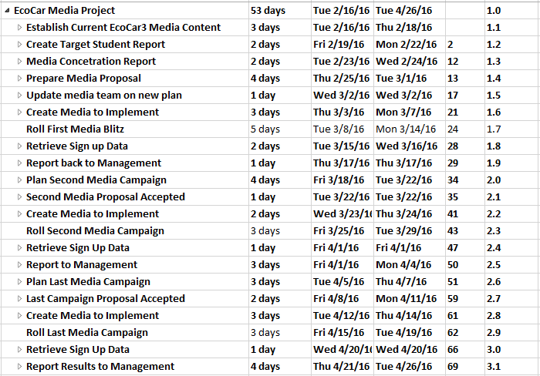

Figure 3.1 - Gantt chart graph of project schedule.
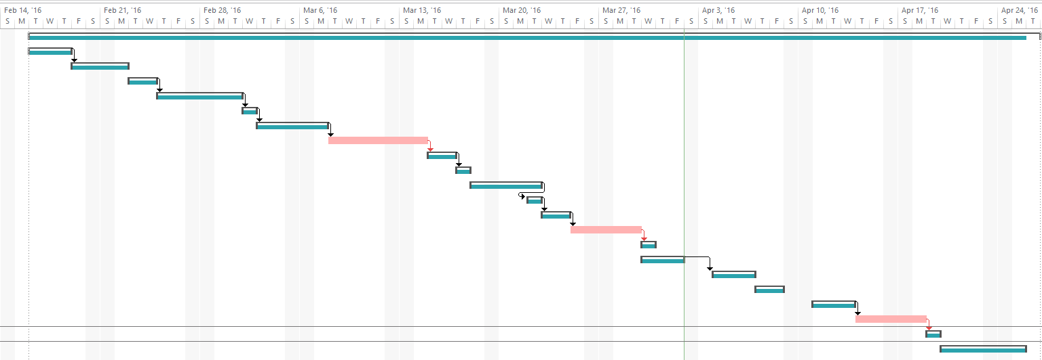

  - Activity Network
In the figures below, a portion of the EcoCar3 activity network is displayed. In order to view the complete chart, reference the complete file. Figures 3.3a and Figure 3.3b will provide a more detailed critical path based on our previous Figure 3.1. The figures below display a detailed critical path in red while those items that are not in the critical path are colored blue. Due to the expansion of this network, it is best to view it through the attached MS project file.

Figure 3.3a – EcoCar3 marketing project begins by establishing attainable targets and informing new recruits on goals and procedures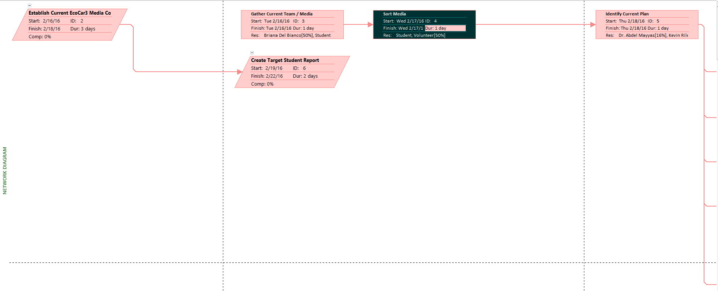

Figure 3.3b – EcoCar3 will evaluate necessary information by asking advising. This is part of the critical path for optimal work. At the end of this figure, a task that is not part of the critical path is displayed in blue.
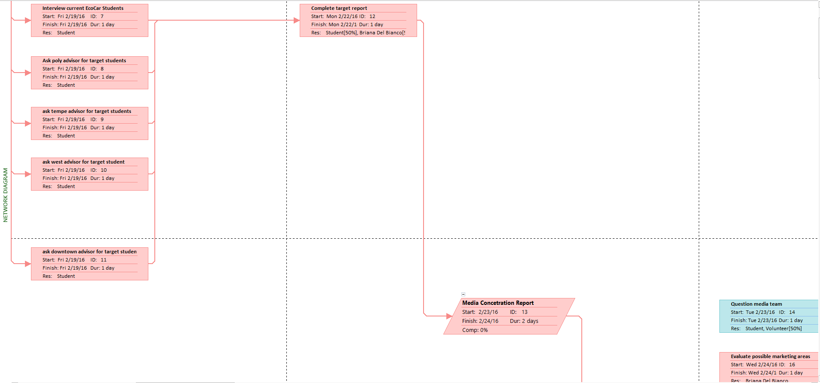
  - Resource Allocation
The resource allocation in Table 3.4 below, displays the minimal necessary time for individuals involved in the EcoCar3 project. It displays the necessary time investment needed to accomplish our EcoCar3 marketing campaign goals. Our objective for creating Table 3.4 is to assure that individuals are working within their bounds and on schedule. After assessing the workload, all over allocations for team members have been adjusted and reconfigured to allow flexibility. Allocation will allow team members to plan their expected contributions to the project while at the same time having a reference sheet to help keep track of their team members.
Table 3.4 - Expected contribution hours for key members of EcoCar3 Project
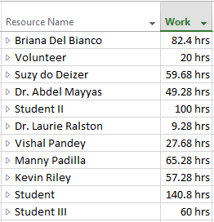
    - Resource Allocation Time Table
Accompanying Table 3.4 will be the expected time table for contributing members with the corresponding date which they will be expected to work. In Tables 3.5a and 3.5b the expected contribution is tracked from start to finish with expected contributors.
Table 3.5a - Expected Hours Feb 16 to Mar 18
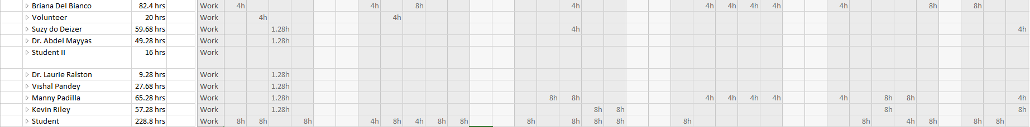

Table 3.5b - Expected Hours Mar 20th to April 22nd
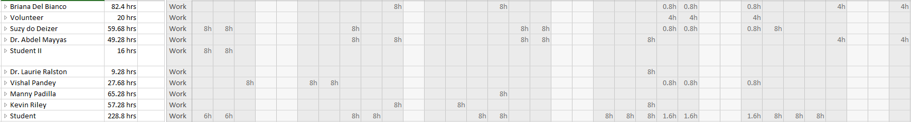
- Project Budget
  - Project Resources
Table 4.1 shows a preliminary total labor cost budget. This project allocates the work the media team with it’s 10 main members, whose direct labor costs are to be charged against the project without a personal time charge included. There is also a rotating base of volunteer students that will not be paid because of their volunteer status. This will not be included into the table below.

Table 4.1 - Labor Cost Table - Main staff and expected cost of project.
Name | Department | Title | Salary | Hr. Rate | Fully Loaded (40%) | Time Needed (Hr) | Duration  (Weeks) | Total Associated Cost
Laurie Ralston | Staff | Faculty Advisor | $60k | $21.00 | $29.40 | 25 | 12 | $5,880.00
Briana Del Bianco | Management | Project Manager | $10k | $16.00 | $22.40 | 25 | 12 | $4,480.00
Sarah Johnston | Press | Press |  | $10.50 | $14.70 | 4 | 12 | $470.40
Suzy de Keizer | Media | Photography |  | $12.00 | $16.80 | 5 | 12 | $672.00
Paige Beringer | Event | Event planner |  | $10.50 | $14.70 | 4 | 12 | $470.40
Kevin Riley | Media | Media Kit |  | $10.50 | $14.70 | 4 | 12 | $470.40
Manny Padilla | Web | Web Development |  | $13.00 | $18.20 | 6 | 12 | $873.60
Jessy Gonzales | Event | ASU |  | $10.50 | $14.70 | 4 | 12 | $470.40
Cody Larkin | Media | Video Editor |  | $12.00 | $16.80 | 5 | 12 | $672.00
  - Other Costs
Supplies: Physical Advertising material - $1000. This is taking into consideration stipend that is given to the media group for the total duration of the project. Paper, flyers, banners, food. The supplies taken into consideration are those that are needed for our outdoor meet and greets with students.
Trips: $10,000 Students will need to travel back and forth with the EcoCar3 team in order to take pictures and interview with engineering team. (This money takes into consideration the cost of the whole team, not only the media team.)
  - Cost Estimates
Ballpark: The ballpark estimates are going to be based on students who are traveling with the EcoCar3 team. This is due to not knowing how many events the team will be attending and how many members of the media team are needed to attend and cover the event. Also, ASU has allotted a $10,000 budget that pertains to the entire EcoCar3 team.
Comparative: The comparative estimates are definitely what the supplies costs are. Based on past events ASU has held, there is no impacting change on what it would cost to purchase supplies.
Feasibility: There currently isn’t a feasibility estimate. To date, the media team has no projects incorporated into the budget.
Definitive: The definitive estimate is going to be Staff and Managerial salaries. Based on the information in Table 4.1, the total needed to cover the Staff and Managerial salaries is estimated at $13,786.87
  - Time Phased Budget
The Table 4.2 displays the time-phased budget which will have the total budget for the project categorized by the month. This combines the project activity as well as the anticipated schedule in which the budget will be expended. This allows the project team to match its schedule with the budget and identify the milestones for both schedule performance and project expenses.

Table 4.2 – Time Phased Budget Displays the expected budget cost for each milestone
Description | February | March | April | Total
Establish Current EcoCar3 Media Content | $90 |  |  | $90
Gather Current Team / Media | $50 |  |  | $50
Sort Media | $75 |  |  | $75
Identify Current Plan | $80 |  |  | $80
Create Target Student Report | $125 |  |  | $125
Interview current EcoCar3 Students | $110 |  |  | $110
Ask poly advisor for target students | $0 |  |  | $0
ask Tempe advisor for target students | $25 |  |  | $25
ask west advisor for target student | $55 |  |  | $55
ask Downtown advisor for target student | $20 |  |  | $20
Complete target report | $40 |  |  | $40
Media Concentration Report | $115 |  |  | $115
Question media team | $140 |  |  | $140
Figure out what is working | $50 |  |  | $50
Evaluate possible marketing areas | $55 |  |  | $55
Prepare Media Proposal | $250 |  |  | $250
Develop Cost & Pitch | $100 |  |  | $100
Complete Plan | $85 |  |  | $85
Management Approval | $40 |  |  | $40
Update media team on new plan | $35 |  |  | $35
Advise team | $20 |  |  | $20
Reassign project assignments to members | $10 |  |  | $10
Create Media to Implement | $95 |  |  | $95
Create Physical | $115 |  |  | $115
Gather pictures | $100 |  |  | $100
Create Videos | $120 |  |  | $120
Roll First Media Campaign | $500 |  |  | $500
Retrieve Sign up Data |  | $95 |  | $95
Process data |  | $80 |  | $80
End First Media Campaign |  | $100 |  | $100
Report back to Management |  | $100 |  | $100
Create .doc and summary of Activities |  | $135 |  | $135
First media Assignment Complete |  | $35 |  | $35
Plan Second Media Campaign |  | $200 |  | $200
Discuss & assess previous campaign |  | $135 |  | $135
Q&A w/ Team members for ideas |  | $55 |  | $55
Weigh Individual Proposals |  | $60 |  | $60
Vote |  | $45 |  | $45
Bring Proposal to Management |  | $90 |  | $90
Second Media Proposal Accepted |  | $200 |  | $200
Table 4.2: Cont.
Assign Individual Assignments |  | $145 |  | $145
Create Media to Implement |  | $215 |  | $215
Create Physical |  | $115 |  | $115
Gather pictures |  | $150 |  | $150
Create Videos |  | $135 |  | $135
Roll out Second Media Campaign |  | $510 |  | $510
Retrieve Sign Up Data |  |  | $95 | $95
Process Data |  |  | $80 | $80
Second Campaign Finished |  |  | $110 | $110
Report to Management |  |  | $100 | $100
Create .doc and summary of Activities |  |  | $135 | $135
Second Media Assignment Complete |  |  | $25 | $25
Plan Last Media Campaign |  |  | $200 | $200
Discuss & assess previous campaign |  |  | $135 | $135
Q&A w/ Team members for ideas |  |  | $65 | $65
Weigh Individual Proposals |  |  | $70 | $70
Vote |  |  | $55 | $55
Bring Proposal to Management |  |  | $80 | $80
Last Campaign Proposal Accepted |  |  | $180 | $180
Assign Individual Assignments |  |  | $145 | $145
Create Media to Implement |  |  | $215 | $215
Create Physical |  |  | $115 | $115
Gather pictures |  |  | $135 | $135
Create Videos |  |  | $150 | $150
Roll out Last Media Campaign |  |  | $510 | $510
Retrieve Sign Up Data |  |  | $25 | $25
Process data |  |  | $30 | $30
Last Campaign Finished |  |  | $10 | $10
Report Results to Management |  |  | $50 | $50
Create .doc and summary of Activities |  |  | $25 | $25
Last Media Assignment Complete |  |  | $10 | $10
Monthly Total | $2,500 | $2,600 | $2,750 | $7,850
Cumulative Total | $2,500 | $5,100 | $7,850

- Project Close-out
This section will have our close-out information including work completed and/or soon-to-be completed. We will have all of our close-out documentation, notices, warranties, contracts and charges.
  - Close cost-accounts

  - Lessons Learned
We learned that there is an ongoing issue with the rotating door of students as they become less invested in the project as time goes on. This caused miscommunication and a waste of time because we would have to invest more time into training individuals. Volunteers and students would have to be reeducated with what is happening in the project which feels like a waste of time. We should make a documented file with our progress so we can introduce newcomers to the data.

