Please find attached to this document three articles on LinkedIn in China. Please write a concise essay in response to the questions below, by using the theoretical framework and perspectives of the course readings and lecture notes. You are welcome to use additional materials beyond the assigned articles in support of your arguments.
The standard for the paper is as follows: 12-point Times New Roman font, 1-inch margin, double-spaced, page-numbered, maximum 10 pages in length and saved as a Word document (no PDF). References and any exhibits/appendices you deem necessary do not count against the page limit.
The deadline for submission is May 7, 11:59 pm. Please send me an electronic version by email.

Questions:
1) Please identify the risk situation for LinkedIn during its expansion to China in 2014.
2) Please review what steps have been taken by LinkedIn to address the risk, and present your critical analysis of them.
3) Please assess the current situation with LinkedIn in China, in light of the Microsoft acquisition deal.

Attachments/Articles:
1) “To Reach China, LinkedIn Plays by Local Rules.” By PAUL MOZUR and Vindu Goel. The New York Times. October 5, 2014.
2) “How LinkedIn Cracked the Chinese Market.” By Katie Benner. Bloomberg BusinessWeek. October 30, 2014.
3) “For LinkedIn China, Microsoft Deal Is a Complicated Connection.” By Alyssa Abkowitz. The Wall Street Journal. June 23, 2016

To Reach China, LinkedIn Plays by Local Rules
By PAUL MOZUR and VINDU GOEL
OCT. 5, 2014
The New York Times
Smartphone-using commuters in Beijing. Western social media are often blocked in China. Credit Andy Wong/Associated Press
HONG KONG — For American technology companies from Microsoft to Facebook to Google, China is a difficult, even impossible, place to operate.
But one company, the social network LinkedIn, has found a way to do business — by being willing to compromise on the free expression that is the backbone of life on the Western Internet.
LinkedIn’s experience provides a blueprint, and perhaps a cautionary lesson, for Silicon Valley as it tries to crack the vast Chinese market. Other American tech companies are watching with great interest, wondering whether LinkedIn will find an equilibrium between free speech and Chinese law that it can live with.
“Over the next five years, things will continue to progress in a positive fashion over there, so it’s important to be there today,” said Kerry Rice, an Internet analyst at Needham, a brokerage firm. “If LinkedIn figures out how to navigate the operating environment in China, clearly other companies will try to imitate that.”

Related Coverage

LinkedIn Goes to ChinaFEB. 24, 2014
LinkedIn’s global English-language site has attracted four million Chinese members without gaining much attention from the Chinese government. But the company wanted to reach more of China’s estimated 140 million professional workers, and so in February it introduced a Chinese-language version.
The Chinese-language site has attracted about a million new members and seems to have the tacit approval of the government. It is functioning without blockages even though the authorities have cracked down on other Internet services, including Instagram and Yahoo, in reaction to the pro-democracy protests in Hong Kong.
The secret to LinkedIn’s seeming success? Aside from its willingness to play by Chinese rules on expression, the company has relinquished 7 percent of its local operation to two well-connected Chinese venture capital firms. Having such a relationship with homegrown firms is crucial for foreign web companies seeking to operate in China, experts say.
“The government needs to know who they can call, and as a foreign company you need to know before your site gets shut down so you have a chance to do something about it,” said Duncan Clark, founder of BDA China, a consulting firm that advises foreign companies on China’s tech sector. “That’s worth a lot, to have that channel.”
A spokesman for LinkedIn, Hani Durzy, said the company opened a Chinese-language site because of its “belief that the creation of economic opportunity can have a profound impact on the lives of Chinese individuals, much as it has elsewhere in the world.”
“While we strongly support freedom of expression,” he added, “we recognized when we launched that we would need to adhere to the requirements of the Chinese government in order to operate in China. So the decision to proceed in China was one that we weighed heavily.”
On the Chinese- and English-language sites in China, the company censors content that the authorities consider politically sensitive, using a combination of software algorithms and human reviewers. People whose posts are blocked get an emailed form letter advising them that a posted item contains “content prohibited in China” and “will not be seen by LinkedIn members located in China.”
LinkedIn also does not provide Chinese-language users certain important tools — like the ability to create or join groups or to post long essays — that allow people elsewhere to have public discussions and form communities.
Although LinkedIn’s strategy has given it access to Chinese speakers, analysts say it poses risks for the company’s reputation and growth strategy.
Like many American tech companies, LinkedIn, which is based in Mountain View, Calif., has promoted itself as dedicated to free-market principles. Too much censorship could cause users to flee.
What’s more, if LinkedIn’s business grows larger in China, that could give the government more leverage to make demands about what type of content is permissible globally.
The company has already stumbled a bit in its entry into the Chinese market. It angered some non-Chinese customers, who found that posts they made in English while in China were blocked globally as part of the company’s effort to protect its Chinese users from anything that could attract unwanted government scrutiny. LinkedIn moved to loosen its policy last month, allowing posts blocked in China to be seen elsewhere.
Some also say LinkedIn has not communicated clearly how and why it is censoring content.
For example, Bill Bishop, a media commentator and tech investor in China, said content he posted about China from a connection in the United States was blocked by the service. When he inquired why, the company inaccurately responded that it was because he had posted the item from China, when the real problem was that he had listed China as his work location.
Other tech companies have weighed the risks of trying to satisfy the Chinese government and taken a different approach.
Google, which once acceded to China’s demands to censor content in the country, noisily reversed course in 2010, moving to deliver uncensored results to Chinese users from servers in Hong Kong and souring its relationship with the authorities to this day.
Twitter has been blocked in China for years and says it will not censor posts because to do so would “sacrifice the principles of the platform,” according to Colin Crowell, the company’s vice president for global public policy.
Vine, a short-video service owned by Twitter, operates freely in China without “any special arrangement,” Mr. Crowell said.
Although Facebook — the world’s largest social network, with about 1.3 billion monthly users worldwide — is blocked in China, it hasn’t given up on getting in the country. But it is trying to use commerce to pry open the door, selling ads to Chinese companies and government organizations that want to reach consumers outside China.
Facebook is also studying the experience of Instagram, its separately operated photo-sharing app, which is growing quickly with only occasional blockages by the Chinese government.
“We think this is an exciting opportunity,” Dan Neary, the company’s vice president for Asia and the Pacific, said in a statement.
Analysts say LinkedIn is well positioned to be acceptable to Beijing because it can argue that it makes the employment market more efficient, ultimately spurring the economy. China’s Internet regulators often argue that the main goal of development of the Internet should be to bolster economic growth.
China’s closed markets have given a huge head start to four homegrown companies, which dominate the Internet there: Alibaba in e-commerce, Baidu in search, Tencent in video gaming and instant messaging and Sina in social networking.
LinkedIn itself faces competition from local rivals like Zhaopin and 51Jobs.com, which both have more users than it does in China.
LinkedIn’s partnership with two local players — China Broadband Capital and a Chinese affiliate of Sequoia Capital, an American venture capital firm — has helped it manage its relationship with government officials.
C.B.C. was founded by Edward Tian, a well-connected investor and former entrepreneur who once ran a telecommunications company with the son of a former Chinese president, Jiang Zemin. The company has helped bring at least one other Silicon Valley company, Evernote, into China.
“There have been a lot of problems with companies like Facebook and Twitter,” said Kevin Wang, a C.B.C. spokesman. “We think one of the key reasons is the lack of communication, even the absence of communication, between these companies and the Chinese government.”
The local partners have a strong incentive to help LinkedIn succeed. Under the partnership agreement, they can buy an additional 21 percent of the joint venture for $20 million if certain conditions are met.
LinkedIn does retain control of the venture, securing the bulk of the profit as well as the risk.
Under Chinese law, the joint venture will eventually need to obtain an Internet content provider’s license to keep operating. The license has some benefits, but also some downsides; once granted, the company will be required to store information about its Chinese users in China.
Doing so would make it much easier for the government to demand information on, say, dissidents who use the service — a conundrum that tripped up Yahoo nearly a decade ago and prompted that company to essentially pull out of the country.
Despite the challenges, LinkedIn is optimistic about its efforts in China.
“In the end, the most important consideration for us was providing an opportunity for millions of Chinese professionals to significantly expand their economic opportunities,” said Mr. Durzy, the LinkedIn spokesman. “We want to get it right in China, so we will continue to listen and learn."
Paul Mozur reported from Hong Kong and Vindu Goel from San Francisco.
A version of this article appears in print on October 6, 2014, on page A1 of the New York edition with the headline: To Reach China, LinkedIn Plays by Local Rules. Order Reprints|Today's Paper|Subscribe

https://www.bloomberg.com/view/articles/2014-10-30/how-linkedin-cracked-the-chinese-market

How LinkedIn Cracked the Chinese Market
Bloomberg BusinessWeek
Oct 30, 2014 9:08 AM EDT
By Katie Benner
When I first began teaching English in Beijing almost 15 years ago, I also worked as a copy editor for a few Chinese newspapers. Lots of my students and colleagues dreamed of becoming teachers, entrepreneurs, bankers and consultants. (Yes, you heard that right, some people yearn to be consultants.) They wanted to wield business cards with brands such as Deloitte, Goldman Sachs and Pepsi. So they toiled over adverbs and thought about life outside of state-run companies.
Without fail they asked for introductions to my American business connections, and they were crestfallen when I couldn't help. They wanted desperately to network, and this in an era when a digital, 300-million-strong professional network named LinkedIn didn't yet span the globe. There was just me and other random foreigners who were sometimes in China because we couldn't get jobs at Goldman either.
There was, and is -- as the consultants would say -- lots of pent up demand for LinkedIn in China.
Now LinkedIn is the first U.S. company to enjoy Internet success in China. The country is at the center of one of the professional networking site's fastest growing regions and represents one of its biggest opportunities. While LinkedIn has only 5 million members in China (if you combine its English and Chinese language sites) the country is home to more than 100 million professionals who are potential future members.
Last quarter, LinkedIn's chief executive officer, Jeff Weiner, mentioned the positive effect that China has had on his company's bottom line. Fueled by China, LinkedIn's revenue from its Asia Pacific division grew 64 percent last quarter, faster than from its operations in any other part of the world. Investors hope to see that growth continue when the company reports earnings today, and in the future.
Most discussions of LinkedIn's success inevitably focus on the fact that the company cooperates with the Chinese government and censors content from its Chinese users -- a discussion that intensified when LinkedIn started blocking some of its users' posts earlier this year. (Other companies, including my employer, Bloomberg LP, have also had to navigate these hurdles.)
Some critics have made much of the fact that LinkedIn tries to paint its so-called "professional content" -- stories about management techniques and earnings and best practices that it features alongside resumes and job postings -- as uncontroversial. Therefore, the argument goes, there isn't much on the site to warrant the attention of censors.
Here's the thing, though: Content isn't the core reason LinkedIn has made strides in China. It's been successful there because it's the only foreign Internet company that offers something that a Chinese rival just can't replicate -- a direct connection between the world's biggest companies, the world's most respected universities, and bazillions of networking-starved Chinese who want to use the site's services.
LinkedIn is a window onto, and in some cases a passport to, the middle class, white-collar professional world that Chinese citizens have craved ever since they traded in their Mao suits for Levis in the 1980s.
The tremendous growth of the middle class is one of the most significant economic and social changes to hit China, and the government has tried to nurture it in order to preserve economic and social stability. That has meant, among other things, fostering connections between foreign universities and select multinational companies. It's meant creating a tier of home grown professional services companies, often founded by or stocked with people who studied and worked at premiere foreign institutions.
The world is watching to see how LinkedIn deals with censorship and the Chinese government. But that's not the only way to gauge why it's been successful at courting Chinese users and dodging Chinese hardliners. LinkedIn meets the aspirational needs of a generation hungry for opportunity and simply copying its content strategy won't translate into duplicating its success.
It's not only foreign companies that have a hard time mimicking LinkedIn in China. Homegrown Chinese companies face the same dilemma. Tencent, Weibo, Renren and Alibaba can replace Facebook, Google, Twitter and Amazon; but none of them can yet replicate LinkedIn.
This column does not necessarily reflect the opinion of Bloomberg View's editorial board or Bloomberg LP, its owners and investors.
To contact the editor on this story:
Timothy L O'Brien at tobrien46@bloomberg.net

http://www.wsj.com/articles/for-linkedin-china-microsoft-deal-is-a-complicated-connection-1466684276

For LinkedIn China, Microsoft Deal Is a Complicated Connection

Professional networking site has found success in China, where its new owner has faced challenges
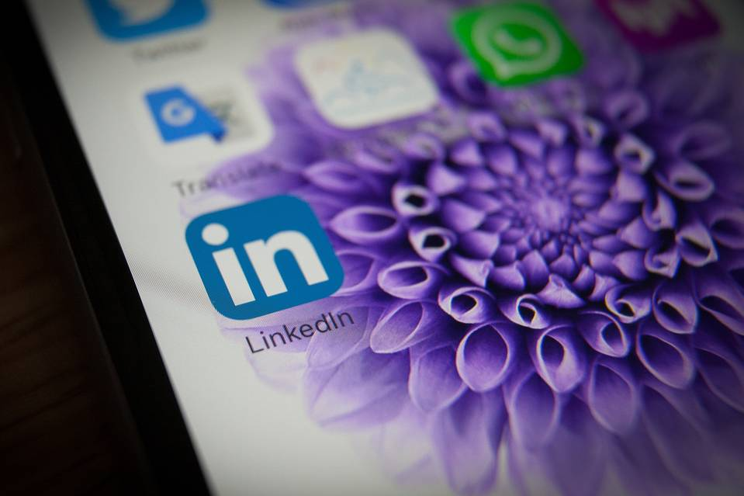
Microsoft bought LinkedIn for $26 billion this month. Photo: Zuma Press

By Alyssa Abkowitz
The Wall Street Journal
Updated June 23, 2016 11:01 a.m. ET
BEIJING—Western technology companies have long struggled to figure out how to operate in China, home to the world’s biggest internet and smartphone markets but ruled by an authoritarian government. Yet LinkedIn Corp. LNKD -0.07 % is an exception.
To enter the country, LinkedIn in 2014 made a rare concession for a U.S. social-networking company when it agreed to abide by local censorship rules. The company adjusted its business strategy to fit Chinese preferences, joining hands with Chinese firms China Broadband Capital and Sequoia China.
Now, though, some China technology observers are raising concerns that Microsoft Corp. MSFT 0.73 % ’s plan to acquire LinkedIn for $26 billion, announced last week, could interfere with the professional social network’s progress in the country.
China’s Great Firewall fences off the internet to many of the world’s tech titans, and foreign competitors complain about protectionist government policies that they say crimp their business. Alphabet Inc. GOOGL 1.42 % ’s Google pulled out in 2010 after declining to censor results on its search engine. Facebook Inc. FB 0.74 % and Twitter Inc. TWTR -1.94 % are blocked. Microsoft and Qualcomm Inc. QCOM 0.22 % have faced headwinds in China such as antitrust probes and espionage accusations.
Meanwhile, human-rights advocates have criticized LinkedIn for censoring articles about anniversaries of the 1989 crackdown on Tiananmen Square protesters or the detention of human-rights lawyers.
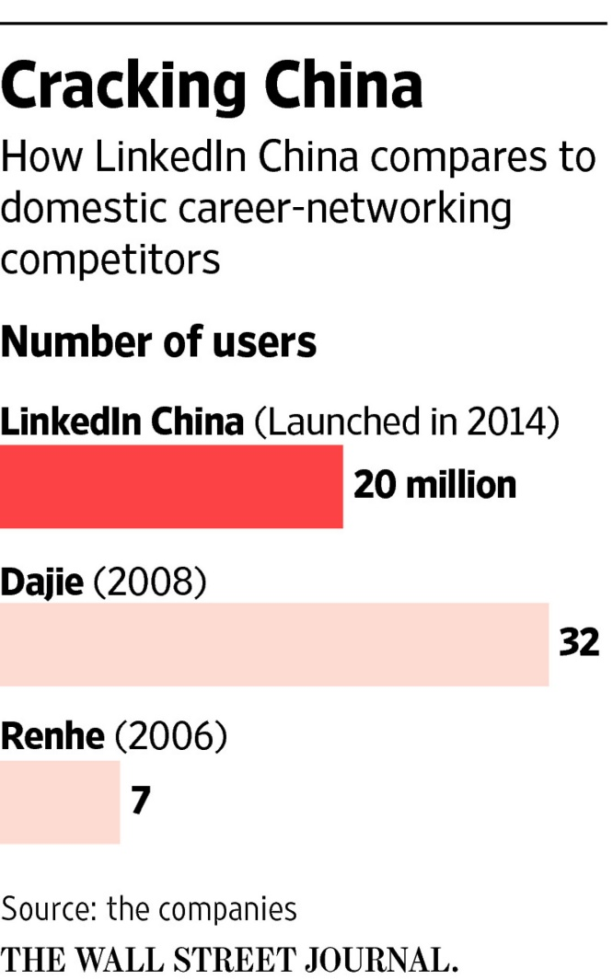
Still, LinkedIn’s alliances and strategy concessions worked to help establish the company’s China business. Since LinkedIn’s entry, its membership in China has grown more than fivefold to 20 million users.
“They have realized in order to be successful in China you cannot take a business model from the West and cut and paste it and expect it to work,” said Edward Tse, chief executive of global strategy consulting firm Gao Feng Advisory Co.
But Microsoft’s deal to buy LinkedIn might create a hitch for the social network in China. “LinkedIn could somehow be hampered by that relationship,” said Travis Wu, a vice president at Forrester Research in Beijing who previously worked at Microsoft. “It was seen as independent, but now it’s part of a big machine and if the machine has issues with the government it could affect them.”
A Microsoft spokesman reiterated what the company said in its statement announcing the LinkedIn acquisition: “LinkedIn will retain its distinct brand, culture and independence,” in all geographies, including China.
LinkedIn declined to comment about how the acquisition would affect the company’s operations in China.
Microsoft’s deal for LinkedIn comes as the Chinese government cracks down on content provided by foreign companies that have expanded in China during the past few years, such as Apple Inc. AAPL 0.54 % and Walt Disney Co. DIS 0.24 % China wants to prop up its own homegrown technology outfits, a move that has already hurt companies like Microsoft.
“If you give a Chinese competitor a window to say, ‘Look at this foreign company, they’re not following the rules,’ they’re going to be called out,” said Ben Cavender, principal of China Market Research Group in Shanghai.
To that end, LinkedIn China, which now has about 200 employees at offices in Beijing and Shanghai, decided shortly after arriving in the country in 2014 to globally restrict sensitive content coming from China. It revised that policy in September 2014 so that information deemed sensitive was blocked only to users inside of China.
Censorship is done by LinkedIn employees and algorithms that trawl the site for sensitive content, a person familiar with the matter said.
China is LinkedIn’s fastest-growing market. Company co-founder Reid Hoffman has made frequent trips to the country to seek favor with the government and potential users. Many of those trips have involved events at which Mr. Hoffman and other tech executives share success stories with Chinese entrepreneurs.
LinkedIn has become a go-to site in China for attracting talent from overseas or finding Chinese employees with global experience. Last year it launched a local adaptation of LinkedIn, called Chitu or “Red Rabbit”—named after a war horse during the Han dynasty—aimed at China’s younger generation of workers.

LinkedIn China
- Founded: 2014
- Joint venture with Sequoia China and China Broadband Capital
- Number of employees: more than 200
- Location of offices: Beijing; Shanghai
- LinkedIn China president: Derek Shen, former Google China executive.
“Ultimately, our goal is to help create economic opportunities for millions of Chinese professionals,” LinkedIn China President Derek Shen said.
Isabella Chen, greater China manager for wine trader Les Grands Chais de France, checks her LinkedIn app daily to read wine news and updates posted by her 81 connections. The 27-year-old former public-relations manager said she was approached for her current job through the career-networking site.
“There’s no international networking on Chinese job boards,” she said. Professional networking websites such as Dajie and Renhe offer forums within China. “There are more opportunities on LinkedIn to find a global company,” she added.
Still, LinkedIn China faces tough local competition. The user base of the company’s Chitu app is still short of its full potential, said Mr. Wu of Forrester Research.
LinkedIn hasn’t disclosed the number of users on the Chitu platform, which was meant to bring younger Chinese who might not speak English into the fold through local features such as happy animal cartoons and people posting selfies.
“It’s still early days, but we are very encouraged by the momentum we see,” Mr. Shen said.
Part of the problem Chitu faces is that China’s younger demographic uses social-media apps such as Tencent Holdings Ltd. TCEHY 0.49 % ’s WeChat for personal and professional conversations. While WeChat users can import their LinkedIn contacts, it is much easier for them to scan a person’s QR code or create a group chat within the WeChat app, instead of connecting via a separate platform, analysts say.
“The app logo looks cute, but function-wise it’s a bit disappointing,” said Fiona Wang, a 27-year-old public-relations consultant from Beijing. “Contacts or potential opportunities I can get from LinkedIn, so it hasn’t given me any real reasons to use it.”
—Lilian Lin contributed to this article.

