Literature on Obesity

Introduction
Obesity has become a serious problem in the United States. As a health issue, it has continually put people at risks of associated opportunistic health disorders, especially among children. It has been identified as one cause of a poor, unhealthy population. In recent years, the prevalence among the population has been reported to decline (McFarlane, 2009). However, the number and the level of obesity among preschool-aged children are still high. In a study conducted recently, it was established from a sample population that children between the age of 5 and 19 were obese, and 70% tested positive for one or more opportunistic diseases.
Obese people are more likely to be pre-diabetic. This is a condition where the level of glucose in the blood indicates a high-risk level of developing diabetes. Another condition diagnosed with obese children and adolescents is the high risk of developing joint and sleep apnea problems. Another issue related to obesity it is likely to have social and psychological problems like poor self-esteem and stigmatization.
Obesity has affected children across all classes, but it is more dominant among children from the middle and low classes. The health department has moved in to minimize the cases of type-2-diabetes, stroke, heart disease, several types of cancer, and osteoarthritis. It has also been established that 80% of obese children and adolescents will be obese at adults, exposing them to the above health risks. The aim of this paper is to analyze the literature behind obesity.
Obesity Overview
Obesity has been considered as one of the current issues affecting people. Social health scientists have been working on the methods of reducing the increasing rates of obesity, but the fight has born little results. There are many causes of obesity among children and adolescents. First, hereditary factors are among the greatest elements analyzed as a source for obesity. A few types of research discovered that the level of BMI between 25 and 40% of obesity cases are inheritable (Van, 2012).
Therefore, the genetic element represents a negligible percentage of childhood obesity, less than 5% (Sweeting, 2008). Hence, genetics can assume a part in the advancement of obesity but it is not the reason for the emotional increment in childhood obesity. The statistics on childhood and teenage obesity are shown in the figure below.
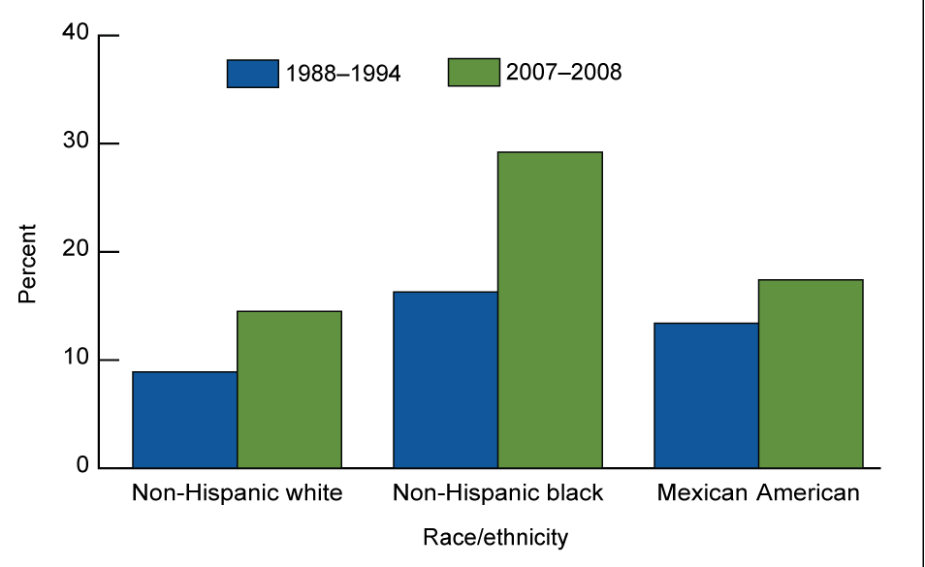
Obesity prevalence trends among children and adolescent aged 12-19 years
The living conditions have additionally been connected with the rise in instances of obesity. The food accessibility and the inclinations of relatives can affect the types of food that a person consumes. Others, like the family's living situation, such as inactive or physically dynamic, have been linked with the cases of obesity (Rudolph, 2013).
High consumption of fast food has been linked with obesity in the current era. Numerous families, particularly those with both parents employed far from home, settle on fast food restaurants. The selection of these fast foods is also facilitated by the sense that most kids like fast food. In the US today, there are more than 300,000 fast food outlets. These fast food restaurants provide an easy avenue to access fast food.
For instance, classic Americans chuck down four plates of French fries and three burgers every week. This is just a small example of the actual problem. However, it must be noted that most fast food has a high amount of calories with little health qualities (O'Dea & Wilson, 2006). As such, the excess energy from these foods are stored as fat on body linings, muscles, and along blood veins. This must be noted as a health hazard.
Many parents with obese children consider it as just baby fat. However, if they continue to be obese throughout their adolescent years, then there is likelihood that they will be obese as adults. This may cause detrimental health problems such as hypertension, dyslipidemia, and noninsulin-dependent diabetes mellitus. Challenges developed when a child is obese latter turn to be diseases at adulthood. The health problems transferred by being obese include heart diseases, gallbladder issues, diabetes, cancer, sleep apnoea, and osteoarthritis.
The American Obesity Association pointed out that children and teenagers with obesity are 12.6 times more likely to have high amounts of fasting insulin, which is a threat for type-2 diabetes (O'Dea and Wilson, 2006). When a person develops this condition, it becomes difficult to control other opportunistic diseases related to the contracted disease. When eventually one is put under medication, the survival chances start to decline due to medicinal side effects. Having a large weight may also cause bone and joint problems facilitate by the lack of strength. The American Obesity Association says that children grow bone and sinews, which might not be adequately strong to hold excess weight.
Reilly (2005) an author of other obesity journals, indicated that obese girls and young women are at a higher risk of experiencing negative socio-demographic encounters. Women are more likely to develop psychological and social problems whenever they have an abnormal condition as compared to men. As such, obese women have a likelihood to develop challenges propagated by obesity due to their psychological torture.
Annually, since the advancement of technology and availability of televisions in almost all homes in the United States, obesity has been rising steadily. With more channels, interesting programs, and video games, most children after schools and during holidays opt just to sit and watch these programs. The parents do not schedule them for exercise or a daily chore, which becomes a chance to develop obesity.
According to the CDC, obesity has more than doubled from 15% in 1980 to 31% in 2000 (Sharma, 2006). This rise can be tied to the technological developments during this period. As a simple example, many times people choose the elevator over stairs for even as small as ten steps. This scenario spells a problem and demonstrates how lazy people have become in the technologically advancing world. Further, children cannot undertake few activities, since most of them, including the most basic chores have been automated. As such, there are no provisions where people especially children can work to maintain proper body development.
Unfortunately, people often fail to see the real problem or only turn their head to the solutions. When a person becomes obese many health factors are put at risk. Obese children and teenagers have a higher possibility of developing health issues like heart disease, diabetes, cancer, stroke, sleep apnea, and osteoarthritis. Sadly, these are just a few of the long list of health troubles. However, obesity does not always have to be the result. It should be a personal initiative to schedule exercises in a daily or frequent activities.
Recommendations
Obesity in today’s society needs to be tackled with urgency. It has been identified as one of the health peril associated with several wellbeing dangers. There are sociological ties related to obesity and is dispassionately characterized by body weight list that appears to be extremely constrained. However, there might be space for sociological examination into how social elements affect the view of weight within families.
There has been identified a striking difference between gender and the variables of obesity as it has been reported. To achieve an obese free society, it is important to analyze the conceivable causes in the look for sustainable solutions. The level of these causes also varies, and the approach would be different with unique solutions.
Studies have set the change of social life as the major approach to minimizing obese cases. Further, the approach towards obese people should be such that there is no rebuking or being sluggish towards them as there is likelihood of lowering their self-esteem. Programs should be created by specialists to attempt and obstruct the main causes of childhood obesity. This exertion should be facilitated by all stakeholders. Since there are different causes of childhood obesity, it should be managed by the entire society.

Conclusively, the people need to schedule diets that are more beneficial and ensure that there are adequate physical exercises all the time. The media, advertisers, parents, and schools need to assume their roles through the advancement of physical action and adhering to a proper diet, and not have garbage food and computer games as promptly accessible to the kids.

References
Adegboye, A. R. A., Andersen, L. B., Froberg, K., Sardinha, L. B., & Heitmann, B. L. March 08, (2010). Linking definition of childhood and adolescent obesity to current health outcomes. International Journal of Pediatric Obesity, 5, 2, 130-142.
Baur, L. A., Hazelton, B., & Shrewsbury, V. A. (January 01, 2011). Assessment and management of obesity in childhood and adolescence. Nature Reviews. Gastroenterology & Hepatology, 8, 11, 635-45.
Burrell, S., Alexander, S., & Baur, L. A. (July 01, 2011). The management of obesity in childhood and adolescence. Modern Medicine: The Journal of Clinical Medicine, 36, 7, 16.
McFarlane, J., Scott, H., Robertson, V., Gleeson, C., Vanderkroft, D., & Wilson, K. (2009). General practitioner and paediatrician self-reported capacity for the diagnosis and management of childhood and adolescent overweight and obesity. Nutrition & Dietetics. 66, 176-185.
Murray, R., & Battista, M. (January 01, 2009). Managing the risk of childhood overweight and obesity in primary care practice. Current Problems in Pediatric and Adolescent Health Care, 39, 6, 146-65.
O'Dea, J. A., & Wilson, R. (January 01, 2006). Socio-cognitive and nutritional factors associated with body mass index in children and adolescents: possibilities for childhood obesity prevention. Health Education Research, 21, 6, 796-805.
Reilly, J. J. (January 01, 2005). Physical activity and obesity in childhood and adolescence. Lancet (london, England), 366, 9482, 23-29.
Rudolph, L., Caplan, J., Ben-Moshe, K., & Dillon, L. (2013). Health in All Policies: A guide for
state and local governments. American Public Health Association.
Sharma, M. (August 01, 2006). School-based interventions for childhood and adolescent obesity. Obesity Reviews, 7, 3, 261-269.
Sweeting, H. N. (January 01, 2008). Gendered dimensions of obesity in childhood and adolescence. Nutrition Journal, 7.
Van, . M. M. T. (May 01, 2012). Obesity in childhood and adolescence : editorial. South African Medical Journal, 102, 5, 289.

