1. Discuss the Constant Growth Model of stock valuation. Include in your discussion the advantages, disadvantages and assumptions of the model.

2. Discuss the following questions regarding the valuation equations for bonds and for common stocks, which are listed below:

(1) What are in common in the valuation equations for bonds and for common stocks?

(2) What are the differences between the valuation equation for bonds and that for common stocks?

(3) Why can’t we use the valuation equation for bonds to valuate the common stocks?
Valuation equation for bonds:
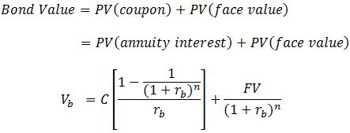

Valuation equation for common stocks:
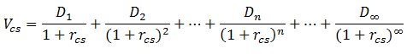
3. Provide examples of how manufacturers work with retailers to jointly plan and implement the four
Ps.
4.What is digital forensics? Describe various steps in digital forensics. Check additional readings session 12 for this.

View a CSI episode and discuss the similarities between digital forensics and CSI (CSI shows can be violent, if that bothers you do not watch the episode).

5. What are biometrics and Automatic Speech Recognition (ASR) and
how is it used in a business environment? Give examples where
they can be used for security purposes.
6. How target figured out a girl was pregnant..

Read the article and discuss in 2x2 matrix (legal vs ethical). Did BI analysis created privacy violation?
http://www.forbes.com/sites#/sites/kashmirhill/2012/02/16/how-target-figured-out-a-teen-girl-was-pregnant-before-her-father-did/

