Topic: Income Inequality in Inner City Detroit
Business Proposal: New Housing Development/ Real Estate Venture Near Start-Up Companies
1.) Introduction
2.) Decline of Detroit (Automobile, Manufacturing, Recesssion, Bankruptcy)
Anatomy of Detroit’s Decline:
http://www.nytimes.com/interactive/2013/08/17/us/detroit-decline.html?_r=0

3.) Business Proposal (Real Estate, Decreasing Income Inequality, Increasing Population)
https://www.citylab.com/equity/2017/02/detroits-recovery-the-lass-is-half-full-at-most/517194/
Renaissance Zone info:
http://www.degc.org/data/uploads/RZ%202011.pdf
Renaissance Zone approval: http://www.dbusiness.com/daily-news/Annual-2015/Michigan-Approves-Next-Michigan-Renaissance-Zone-Designations-for-Detroit/
Detroit Houses and Residents:
http://www.city-data.com/housing/houses-Detroit-Michigan.html
Detroit Income, wages, and earnings:
http://www.city-data.com/income/income-Detroit-Michigan.html
Detroit Crime rate:
http://www.city-data.com/crime/crime-Detroit-Michigan.html
Tax Incentives for new business:
http://www.degc.org/site-selectors/incentives-and-financing
4.) Comparison with Other Businesses (Already existing investments and start-ups)
Austen, Ben. “The Post-Post Apocalyptic Detroit.” The New York Times Magazine. July 11, 2014.
https://www.nytimes.com/2014/07/13/magazine/the-post-post-apocalyptic-detroit.html?mcubz=1
• “...city’s population has sunk to 700,000 from a peak of close to two million, and almost a third of its vast housing stock sits vacant. But this means that property costs have dropped to the point that barriers to ownership...are absurdly low.”
• Capitalists coming in trying to rebuild city = private sector taking over public sector responsiblities such as investments into police forces, security, courthouses, jails
• Detroit real estate investors commited to reviving neigbourhoods
• bungalows in middling neighbourhoods near border of the suburbs = bought land for extremely low prices, renovate them, and them resell or rent them out for profits
• Detroit Economic Growth Corporation enabled 10 entrepreneurs to start pop-up businesses and matched them with artists to design their spaces
• attempt to create retail destination
• included Bakery (Good Cakes and Bakes), Furniture Business, Restuarants, bars
• plans for future retail shops = revival of Avenue of Fashion (retail corridor)
• surrounding residential blocks have median household income of $56,000 to fund retial business nearby
• “TechTown” = a technology incubator in Midtown Detroit (technology incubator helps new start up companies to develop and provide serveices such as management training or office space)= creation of 85 companies = tech industry beginning to flourish
• Microsoft = plans to create office in Detroit
• data driven companies (young people in the tech industry)
• Billionaire Dan Gilbert = large investor into Detroit after Bankruptcy in 2013
• has purchases and leased over 60 properties, most in downtown Detroit
• owner of Quicken Loans = business in down town detroit = dealing largely with real estate mortgages
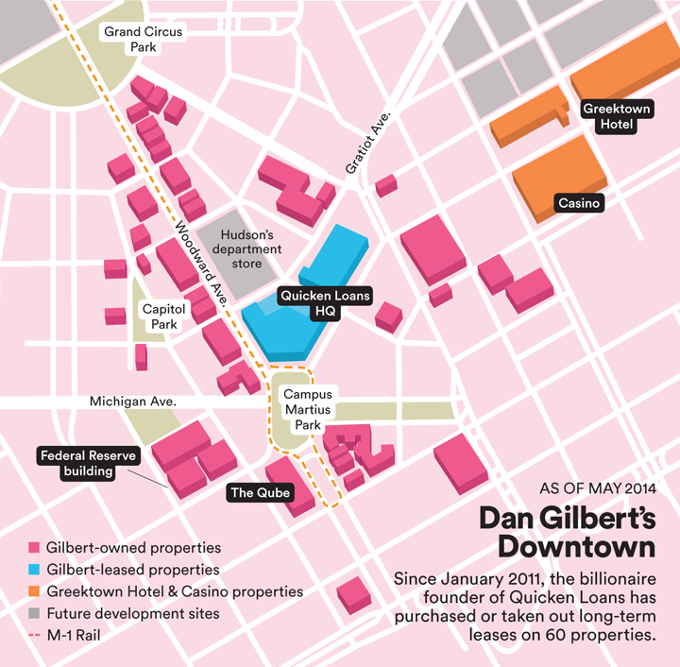
Simoes, Mariana and Max Rosenberg. “The 23 Coolest Small Businesses In Detroit.” Business Insider. April 18, 2013.
http://www.businessinsider.com/the-coolest-businesses-in-detroit-2013-4?op=1/#troit-bike-city-6
• Website business (Are You A Human), mobile app (Glyph), instagram tool (Hashgram), gadget company (iRule) = tech start ups
• bicycle company, bike collective (AutoBike) (Detroit Bike City)
• Restuarant (The Batata Shop), Bar (Green Dot Stables), Bed and Breakfast (Honor and Folly)
• online retailer for school and office supplies (Chalkfly), coffee shop and arts space, print shop
• crafts stored (City Bird), furniture store (Hugh), Wallpaper Store
• PonyRide = collective that leases out space to local artists and entrepreneurs
• Real Estate Firms
Guzman, Zack. “Billionaire Dan Gilbert’s mission to rebuild Detroit as hub of ‘muscles and brains’” CNBC. October 17, 2016.
http://www.cnbc.com/2016/10/17/billionaire-dan-gilberts-mission-to-rebuild-detroit-as-a-hub-of-muscles-and-brains.html
• businessman Gilbert invested $2 billion into Detroit after it’s decline in order to revitalize it
• sees it as a hotspot for technolggy and entrepreneurs
• relocated his businesses from the Detroit suburbs to downtown Detroit (bringing along 15,000 employees)
Tabron, Tosha. “The Road to Rebuiding Detroit.” Forbes. JPMorgan Chase. May 19, 2015.
https://www.forbes.com/sites/jpmorganchase/2017/04/13/seth-priebatsch-of-levelup-on-transparency-big-companies-and-company-culture/#126bf23c6ce3
• trying to revamp entertainment district = new Red Wings arena
• further downtown old worn down buildings torn down to make room for new housing for those with new tech start ups
• JPMorgan Chase & Co. announced commitment of $100 million in Detroit in May 2014
• acting as a partner in human resources, technology, finance and business
5.) Conclusion

Introduction:
- Greeting
- Member Introduction
- Topic Introduction
- Outline of presentation

Decline of Detroit:
- Current state of Detroit
- Reasons for decline
  - Reliance on automobile industry
  - Racial discrimination
  - Corruption in leadership
  - Inefficient transportation system

Business Proposal:
- Introduction of business proposal
  - Increase of low cost housing

