ASSIGNMENT_3

Note: Read Chapter’s 4 and 5 with examples and complete the assignment.

- (Triangle-Printing Program) Write a program that prints the following patterns separately, one below the other. Use for loops to generate the patterns. All asterisks (*) should be printed by a single printf statement of the form printf("%s", "*"); (this causes the asterisks to print side by side). [Hint: The last two patterns require that each line begin with an appropriate number of blanks. Nested loops can be used. The outer loop iterates row number of times and the inner loop iterates column number of times.]

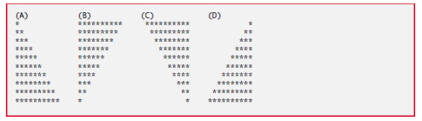

- (Even or Odd) Write a program that inputs a series of integers (at least 3) using a loop and passes them one at a time to function isEven, which uses the remainder operator to determine whether an integer is even. The function should take an integer argument and return 1 if the integer is even and 0 otherwise. Below is a sample output

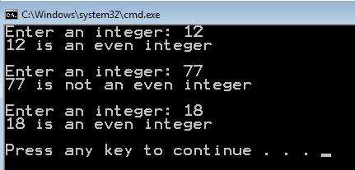

Maximum Points: 20
Due Date: 11:59 PM, March 13th, 2016
Submission: Submit your source code to Blackboard.

