Question 1
The following C program asks the user for two input null-terminated strings, each stored in uninitialized 100-byte buffer, and compares them. The program then shows the alphabetical order of both strings, by reporting whether the first is less than the second, the second is less than the first, or both are equal.

#include <stdio.h>

int main()
{
// Two strings, 100 bytes allocated for each
char s1[100];
char s2[100];

// Read string 1
printf("Enter string 1: ");
scanf("%s", s1);
// Read string 2
printf("Enter string 2: ");
scanf("%s", s2);
// Compare them
int index = 0;
while (1)
{
// Load characters from s1 and s2
char c1 = s1[index];
char c2 = s2[index];

// Current character is greater for s1
if (c1 > c2)
{
printf("s1 > s2\n");
break;
}

// Current character is greater for s2
if (c1 < c2)
{
printf("s1 < s2\n");
break;
}

// End of strings reached
if (c1 == 0)
{
printf("The strings are equal\n");
break;
}

// Compare next character
index++;
}
}

a) (4 pt.) Write a full MIPS program that provides the exact same output as the reference C code, including all messages shown to the user. Submit your program in a file named q1.s on Blackboard.

b) (1 pt.) Run the program on MARS three times, each time providing different combinations of strings that lead to different answers. Show the simulator output in each case

Question 2
The following C code shows the proposed algorithm. The string is traversed with two indices, called old_index and new_index, where the latter always takes a value less or equal to the former. When a non-space character is found, the character at position old_index is copied to position new_index, and both indices are incremented. When a space is found, the current character is not copied, and only old_index is incremented. The algorithm stops when a null character is found.
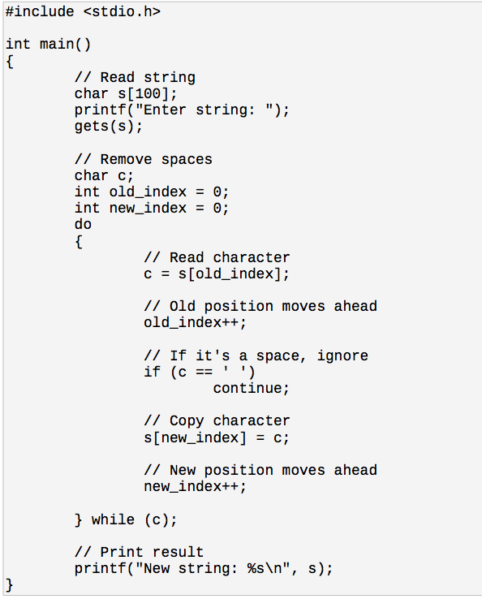

a) Write the full MIPS program that mimics the behavior of this C program and submit it in a file named q2.s.
b) Run it on MARS and show the output of the simulation. Make sure to enter a string containing spaces to demonstrate the correct functionality of the algorithm.

