- (9pts) Eco Friendly Designs has decided to open an office in Pleasantville, CA. They plan to be here for a while and rented more space to support future expansion. This includes an outdoor patio where their employees can eat lunch. The new manager, Mr. Ingo, has hired you to install cabling and related equipment to connect every computer to a 100BaseT (Fast Ethernet) wired Ethernet LAN. Because their competitor, Designs by Friendly has moved in next door (at the top of the floor plan), Mr. Ingo wants only a wired network. He has explicitly told you not to support wireless.

He has provided the floor plan of the office shown below.
Create a plan that includes as a minimum:
  - A list of all equipment required, including that for the equipment (telecommunications) room. Assume every computer already has the appropriate NIC card.

  - Identify where shared printers might be placed.

  - On the plan, identify the location of the telecom room. Also, show the runs and drops (keep cable lengths under 90 meters and specify whether they will be in the ceiling, the walls, in a raceway outside the walls or across the floor.) Assume there is a dropped ceiling and estimate distances if necessary.

  - Capability for growth. Eco Friendly Designs has 10 employees and a 5year lease. Their product is in hot demand in a growing industry. They expect to hire while at this site and You should be able to add several more computers and upgrade the LAN without changing or adding equipment.

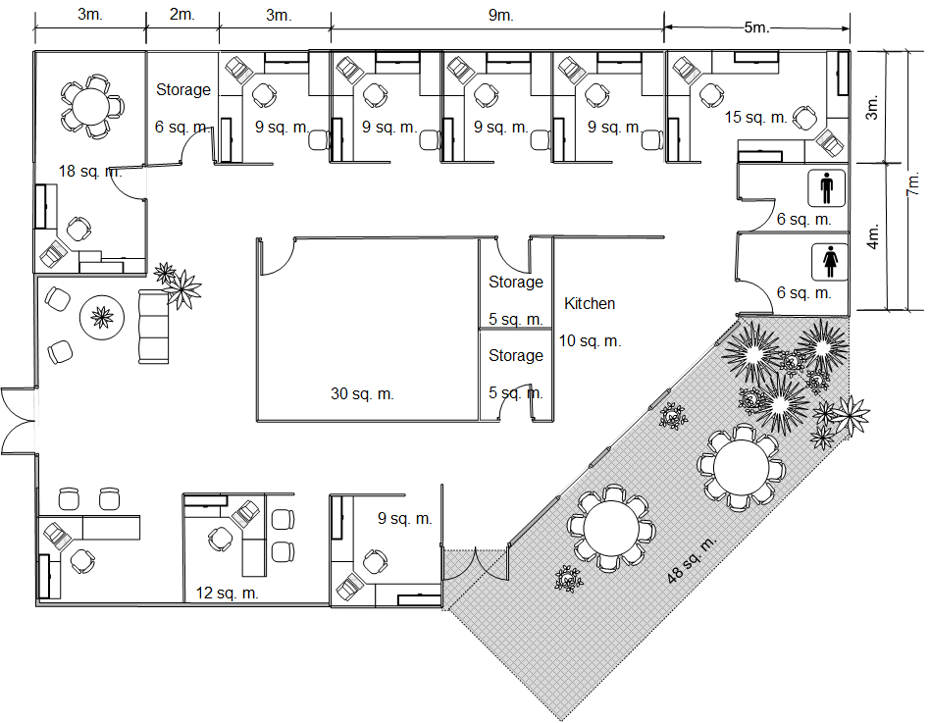
This is a solid wall with offices on the other side for another company.
- (9pts) Mr. Ingo is worried about industrial espionage from their competitors that moved in next door and upstairs. Since he felt you had done such wonderful work with the network installation you proposed in the previous example he has contacted you to add a security system to monitor their patio and lobby areas. The new security system will need to incorporate many remote video cameras (you determine how many). Live video feeds will require Gigabit Ethernet speeds and should be accessible to Mr. Ingo’s and the system administrator’s networked PCs which will run the security application software.

Evaluate the network you designed. Your customer is concerned about cost and what the live feed will do to the network performance. His third concern is “down time” with this installation.

While answering the questions below, make any necessary assumptions about your client’s network and be sure to state those assumptions.
  - Do you recommend using UTP or fiber? Why?

  - Exactly which Ethernet do you recommend? (1000BaseT, 1000BaseCX, 1000BaseSX, or 1000BaseLX)

  - What equipment must be upgraded? On the plan, identify the location of any new equipment. (Consider the equipment room, the cabling and the work areas.) Also think about whether all systems need to have access to the surveillance software.

- (9pts) Mr Ingo of Eco Friendly Design has need of your services again. He has been told by a number of employees they would like to do their work on the patio on sunny days. He has asked you to research their wireless network options.
Review the floor plan from the previous question and consider the following needs in your recommendation.
- The network should be able to support up to 15 computers and frequent visitors.
- The network must be secure against unauthorized wireless access, but allow authorized visitors to join with minimal configuration
- The network should use current, widely available industry-standard technology
- What 802.11 standard would you recommend? Why?

- What equipment will be necessary? On the plan, identify the location of any new equipment.

- How would you provide security? Would you make any special suggestions considering the surrounding competition? Why?

- (9pts) You have a 12GB video you want to upload to YouTube.
  - How long does it take to transmit this image over a 100Mbps modem?
  - How long does it take to transmit this video over a 100GMbps LAN?

- (8pts) A 802.11 wireless station wishes to send a frame to a machine in another BSS via a wireless distribution system.
  - What are the ToDS and FromDS bits and the 4 address fields on the sending machine?

  - What are the ToDS and FromDS bits and the 4 address fields sent from the sending machine’s BSS and going to the receiving machine’s BSS.

- (6pts) Suppose Alice calls tech support to report that she started up her Windows machine, log’s in but cannot access the printer. List the next set of steps you should attempt. For each step specify what to do if it succeeds and if it does not succeed.

Extra Credit
- (2pts) An Ethernet frame contains 440 bytes of data. Calculate the percentage of the frame that is overhead (do not include the preamble in the frame).

- (2pts) A medium has a high frequency of 65MHz and a bandwidth of 85MHz. What is the low frequency?

