_______________________________________________________________________
CSC253 ADVANCED C# ProGRAMMING
_______________________________________________________________________

LAB 07 STRINGS AND CHARACTERS

Objectives
In this lab assignment, students will learn:
- To create immutable character-string objects of class String
- To use string methods to manipulate strings
- To create mutable character-string objects of class StringBuilder
- To manipulate mutable character-string objects of class StringBuilder

Goals
In this lab assignment, students will demonstrate the abilities to:
- Create immutable character-string objects of class String
- Use string methods to manipulate strings
- Create mutable character-string objects of class StringBuilder
- Manipulate mutable character-string objects of class StringBuilder

Description

Program 1
This program is about StringBuilder. Create a C# Windows application that has the following GUI:
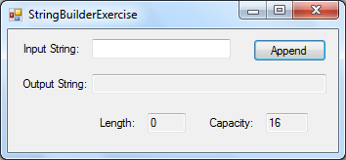
When the program starts, create a StringBuilder object with an empty string. The user can type a string in a textbox. Every time the user clicks the Append button, the text in the “Input String” textbox will be appended to the end of the string associated with the StringBuilder object. Display this string, its length and its capacity. The following is an example:
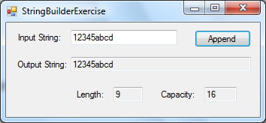
Suppose the user clicks the Append button again, the output string becomes longer and the length and capacity both change:
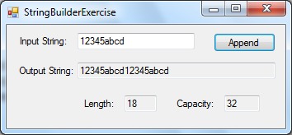
Suppose the user types +++ in the “Input string” textbox and clicks the Append button, +++ will be added to the output string:
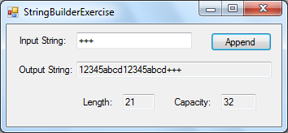
This program allows us to see how the length and the capacity change as the string gets longer and longer.

Program 2
Create a C# Windows application that reads a five-character string from the user and produces all of its substrings. For a five-character string, there are five 1-chracter substrings, four 2-character substrings, three 3-character substrings, two 4-character substrings and one 5-character substring.
The following is the GUI of this program:
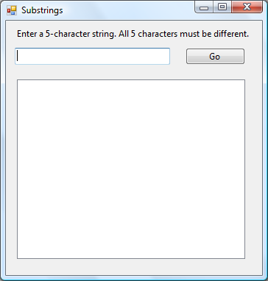
The user clicks the Go button after he has entered the string. The program first checks the string’s length. If it is not exactly 5-character long, a message box will pop up telling the user that the string must have exactly 5 characters:
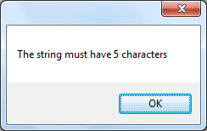
If the string entered is exactly 5-character long, the program will check whether the five characters are all different. If some of the characters are the same, the program will use a message box to display an error message:
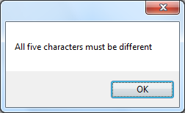
Uppercase and lowercase letter are considered the same letter. For example, uppercase ‘P’ and lowercase ‘p’ are considered the same letter and cannot coexist in the string.
If all five characters are different, the program will display all possible substrings in a listbox:
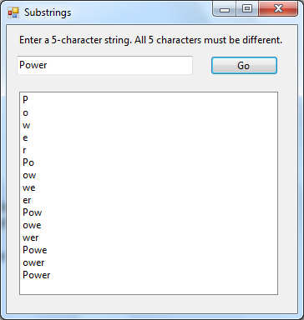

Grading rubrics

Program 1:
Category | High Proficiency | Medium Proficiency | Low Proficiency
Creating GUI [10 pts] | Correctly creating GUI [10 pts] | Minor problems in GUI [5-9 pts] | Major problems in GUI [0-4 pts]
Creating and using StringBuilder object [15 pts] | Correctly creating and using StringBuilder object [15 pts] | Minor problems in creating and using StringBuilder object [8-14 pts] | Major problems in creating and using StringBuilder object [0-7 pts]
Program compilation and test runs [15 pts] | Program compiles and runs correctly [15 pts] | Program compiles but does not generate correct output [8-14 pts] | Program fails to compile [0-7 pts]

Program 2:
Category | High Proficiency | Medium Proficiency | Low Proficiency
Creating GUI [10 pts] | Correctly creating GUI [10 pts] | Minor problems in GUI [5-9 pts] | Major problems in GUI [0-4 pts]
Checking length and characters of the string [15 pts] | Correctly Checking length and characters of the string [15 pts] | Minor problems in checking length and characters of the string [8-14 pts] | Major problems in checking length and characters of the string [0-7 pts]
Creating substrings of the input string [15 pts] | Correctly creating substrings of the input string [15 pts] | Minor problems in creating substrings of the input string [8-14 pts] | Major problems in creating substrings of the input string [0-7 pts]
Program compilation and test runs [20 pts] | Program compiles and runs correctly [20 pts] | Program compiles but does not generate correct output [10-19 pts] | Program fails to compile [0-9 pts]

