Relevant Concepts: Branching and Loop structure

Problem 1: Develop a C program that a) lets a user enter value of n, b) sums all positive numbers from 100 – 499 (inclusive) that are divisible by n and display the sum, and c) display total numbers from 100 – 499 (inclusive) that are divisible by n.

Sample code execution #1: Red entered by a user
Enter value of n: 10

There are 40 values between 100-499 that are divisible by 10
Sum of numbers between 100-499 that are divisible by 10 is 11800

Press any key to continue . . .
Sample code execution #2: Red entered by a user
Enter value of n: 23

There are 17 values between 100-499 that are divisible by 23
Sum of numbers between 100-499 that are divisible by 23 is 5083

Press any key to continue . . .
More Test cases: 1) n = 540 (answer: 0 value and sum = 0)
2) n = 1 (answer: 400 values and sum = 119800)
3) n = 7 (answer: 57 values and sum = 17157)
Problem 2: Develop a C program that lets a user enter only a number between 1 and 9 and display the following output. Your program should make sure that a user enters only a positive number between 1 and 9. See sample code execution below.
Hint: nested loops should be used.
Sample Code execution #2:
Note: -5, 0, 8 are entered by a user

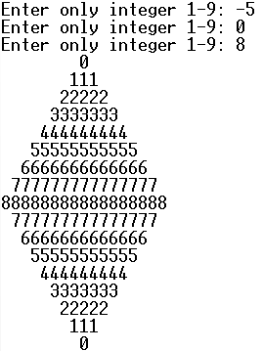

Sample Code execution #1:
Note: 10, -1, 32, -10, 3 are entered by a user

