MGT-805 Integrated Case Study
In this course, you will interact with Part II of a multi-year, integrated case study experience. This part of the case study focuses on organizational structure issues and related ethical decisions.

The Case
Purple Cloud was founded 15 years ago and has grown from a start-up security company to a small, but well-respected competitor in the rapidly growing security sector. The founder, A. Nathan Tecnoti, is a visionary leader who forecasted the need to develop robust software products that protected both individuals and companies. As the Internet grew, so did Tecnoti’s business. He could innovate rapidly, but Tecnoti could not keep up with the ever-changing technologies and was often out-maneuvered by larger companies who had larger and more proficient technical staffs and marketing budgets. Tecnoti began seeking a way to accelerate product development so that he could increase market share and take advantage of new market opportunities. It is for this reason that Tecnoti developed an acquisition strategy to rapidly acquire companies that offered promising security technologies.
Invoking that strategy, Tecnoti recently acquired ABCTech from its founders, Thunder Thompson (CEO) and Chris Christianson (COO). Video press coverage of this event can be viewed at https://lc.gcumedia.com/mgt805/business-acquisition-press-release-video/v1.1/. ABCTech was created in Thompson’s garage while he continued to work for a large computer programming organization. Although their specialty is application design, they understand the importance of safe data. As cybercrimes increased over the past few years, Thompson and Christianson came up with an idea that would change data and personal security. With just a few dollars in their pockets raised from family and friend investments as well as using the maximum amount available on some credit cards, the duo set out to build the necessary architecture that would provide them the opportunity to become the next technology magnates. As they got closer to an end-product, they started marketing their product and were surprised how sales were growing each month as they headed for a quarter million dollars in revenue their first year. Being programmers by day and new entrepreneurs by night, Thompson and Christianson quickly learned there was much they did not know about business. So when the opportunity was presented, they readily accepted the offer to be acquired by Purple Cloud.
The ABCTech product acquired by Purple Cloud is completely different than any other software security application offered in the market. The product offers an elegant solution that is implemented with a single update to the user's computer operating system thereby bypassing the need to distribute daily updates to address new security threats. The simplicity of the solution circumvents both the necessity to acquire capital to build or acquire extensive infrastructure and the requisite addition of high-priced support staff. If implemented rapidly and with precision, Purple Cloud has the opportunity via this acquisition to catapult itself to become a dominant market leader with unprecedented revenue growth and dramatic profits. However, for this plan to succeed, Tecnoti needs to carefully integrate ABCTech’s executives and support staff. If they do not assimilate into Purple Cloud and help implement the technology, the investment and market leadership opportunity will be lost.

Questions to Consider
- Describe the post-acquisition organizational structure of Purple Cloud. What do you notice? Is this structure influencing Purple Cloud’s financials? Why or why not?
- Should Purple Cloud restructure its organization? Why or why not? Defend your position by establishing a theoretical foundation that includes information regarding the propensity for success of an acquisition using current (within the last three years) or foundational references.
- What ethical considerations arise in a restructuring process? Is there an ethical way to restructure? Defend your position by establishing a theoretical foundation using current (within the last three years) or foundational references.

Background Information
Mission, Vision, Core Values
 | Purple Cloud | ABCTech
Mission | Purple Cloud exists to provide quality protection products to ensure client online security. | ABCTech exists to create an affordable computer security product for every person.
Vision | Safe movement in the cloud for all applications. | A world protected from cybercrime and personal security breaches.
Core Values | - Security  - Honesty  - Reliability  - Teamwork  - Efficiency | - Honesty  - Integrity  - Diversity  - Agility  - Safety

Competitive Analysis
With 15 years of experience in the rapidly growing security sector, Purple Cloud’s product technology monitors the Internet for security bugs and then distributes software updates to mitigate the risk. Unfortunately, Purple Cloud’s product technology and pricing is a "me too" product that is virtually identical to other products marketed by larger, more established companies.
The market for data security is an established market led by several well-known and dominant companies that focus both on the consumer and business markets. Vendor reputation and brand perception influence customer purchase decisions to a greater extent than product cost. To continually promote brand safety, dominant companies expend a significant portion of their budgets on advertising and marketing expenditures.
Dominant companies offer single-user licenses, enterprise contracts, and even customized safety applications. They have built large, expensive technical infrastructures enabling them to distribute daily security updates as needed. These companies have national and international presence and are well respected. They are financially profitable and are perceived by their customers as offering products that provide great value.
Purple Cloud recently acquired ABCTech’s product, which is completely different than any other software security application offered in the market. ABCTech’s product solution is implemented with a single update to the user's computer operating system thereby bypassing the need to distribute daily updates to address new security threats. The simplicity of the solution circumvents both the necessity to acquire capital to build or acquire extensive infrastructure and the requisite addition of high-priced support staff. Purple Cloud now has the potential to compete with well-established companies within this sector. To succeed, Purple Cloud needs to determine whether to update the organizational structure with the selective addition of key staff from the acquired company, adjust product development strategy, and/or re-align support staff all within the context of closely monitoring and controlling expenses.

Member Biographies

Purple Cloud

A. Nathan Tecnoti, Founder and CEO
Tecnoti is a visionary. He started his company to help protect the privacy of individuals and small companies. With this focus, he has built a successful small business. However, with just $50M in revenue, he is often out-maneuvered by larger companies who have the marketing resources and technology to block his expansion into this market. Andrew’s experience with previous organizations allowed him to establish quick responses to market situations, improve customer relevance, and create better partnerships in the digital industry, especially in cloud-based models.
With a B.S. in business and an M.S in information technology, Tecnoti brings to the company significant experience working globally as well as a strong IT background. In addition, Tecnoti has extensive experience in the industry prior to Purple Cloud where he worked in the roles of senior vice president of technology for two other large corporations. He was responsible for growth, marketing, and the companies’ office operations. Tecnoti also has experience in licensing of software and managing sales in the United States and Europe for previous corporations.
Maria Preston, Chief Operational Officer
Maria Preston is responsible for driving profitable growth and creating operational excellence. She has an excellent track record of innovation and creating excellence in the operational division. Preston oversees the national and global supply chain of the company. Her innovative approach to problem solving has put her at the top of her industry in her previous organizations and now with Purple Cloud where she is charges with innovating operational processes for maximum efficiency.
Preston’s previous experience shows she has held leadership roles in IT and manufacturing. She has worked with a variety of companies in Silicon Valley and is known for creating partnerships that reshape and create cross-functionality for the organization. Preston holds a B.A. in economics and an M.B.A. in business administration.
Willie Taylor, Chief Financial Officer (CFO)
Willie Taylor comes to Purple Cloud with an abundance of experience in the financial strategy and operations of IT companies. He is tasked with creating value for shareholders, upholding a balanced portfolio, and leading the growth initiatives of the company. He believes integrity is critical in creating a successful financial strategy.
Taylor's previous experience comes from working in business, technology, operations, and finance for companies in Silicon Valley. He has had experience partnering with organizations to focus on long-range strategic planning, forecasting, and working with budgets as high as $50M. Taylor has a B.S. in finance and an M.S. in business with a specialization in finance. He also has extensive experience in mergers and acquisitions, financial planning, and profit and loss.

ABCTech
Thunder Thompson, CEO and Co-Founder
Thompson is co-founder of ABCTech. As the CEO of ABCTech, Thompson focuses on the company’s growth and technology strategy. Thompson has a B.S. degree in computer programming and a passion for creating safe data products and applications. He brings more than 10 years of experience in enterprise IT software, data analytics, security, and knowledge of cybercrime. Thompson also has experience in technical operations and cloud and data platforms. He is new to being an entrepreneur, but is excited at the prospects of making a difference in the technology world with his company’s safe data products. Thompson believes in ABCTech’s vision: A world protected from cybercrime and personal security breaches.
Chris Christianson, COO and Co-Founder
Christianson is the co-founder and COO of ABCTech. He is also the company’s chief marketing officer. Christianson is responsible for growing the company’s revenue. He has 12 years of experience in HTML, Java, Python coding, and product development, and is trained in software development, product development, and product marketing. Christianson holds a B.S. degree in computer programming and has certification in marketing and product development. He too is new to entrepreneurship, but has a passion to see ABCTech and its products succeed. Christianson believes the company can achieve its mission: To create an affordable security product for every person.
John Smith, Chief Financial Officer (CFO)
John Smith has extensive experience in financial planning and analysis through working with teams on financial analysis, business plan development, and corporate benchmarking. In his previous company, Smith held leadership positions focusing on supply chain management, finance, and operations. He has a B.S. in finance and accounting and an M.S. in accounting. Smith also has experience in the information technology and technology strategy areas, which allows him to prudently manage the cash flow and investment needs of the company.
Herbert VanderLugt, Marketing Director
Hebert VanderLugt has extensive experience in marketing. Before joining ABCTech, he worked in Silicon Valley as head of marketing operations for a large tech firm. VanderLugt has a B.A. in business as well as an M.B.A from a prestigious business school. He is also fluent both in writing code and in website design. These skills complement his understanding of ABCTech and its marketing needs within the tech industry.
Joan-Marie Taylor, Sales Manager
Joan-Marie Taylor heads up the sales operations for ABCTech. She has extensive experience in the tech industry in marketing, sales, and product design. Taylor worked in key leadership positions at other tech companies that allowed her to design and sell products for the company. She also has extensive experience in customer service and individual training regarding technical applications. Taylor holds a B.S. degree in business and an M.S. in business with a specialization in sales and marketing.
Tom Englewood, Director of Customer and Techical Support
Tom Englewood provides oversite of all the customer support and technology issues for ABCTech. He has both a B.S. and M.S. in computer science. Englewood brings 30 years of experience in the field of technology and customer service both at the university level and in the corporate setting. He has experience in enterprise applications, teaching, research and learning, user support information security, infrastructure, and communications.

Organizational Charts
ABCTech Pre-Acquisition Structure
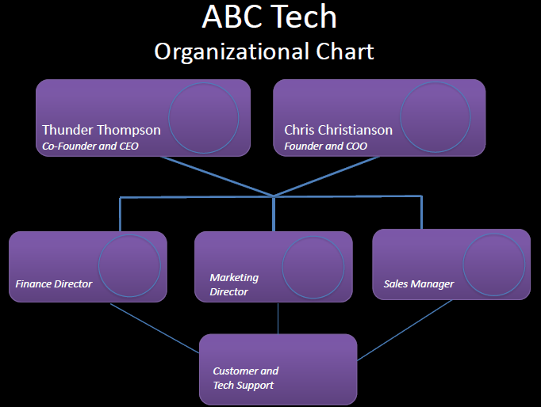

Purple Cloud Post-Acquisition Structure
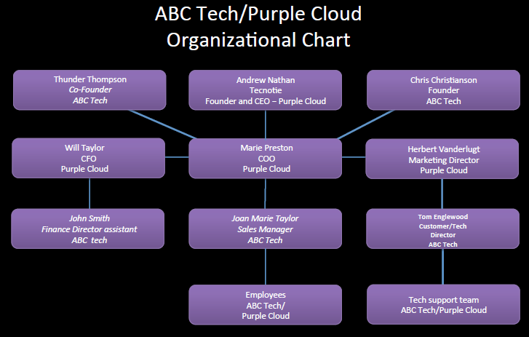

Financial Statements
Purple Cloud Income Statement

Purple Cloud Balance Sheet

