Interpreting the historical trend in increase/decrease of population per continent
Trends
Population size clearly increases and decreases at differing rates in differing continents. However, Growth in population is the long-standing trend on all continents from Latin America to Africa etc; same case applies to individual states. Over the past decade, the global population saw its greatest increase in known history, rising from about 1.6 billion in 1900 to over 6 billion.
This type of increase in population can be associated with a number of factors, such as low motality rates in many countries in the diffrenet continents, this is a s a result of things like by improved medical advances and sanitation and as well as massive food production that is associated with green technology. In early 2000, The UN estimated that world's population to having an annul growth rate of 1.14%= 75 million persons. This was down from a peak in the past decade (1980s) of peak of 88 million. By early 2000, the world had approximately 10 ten times as many people as there had been in 1700. In all continents, the population growth rate has been steadily declining from its peak of 2.19% in 1970s, However population growth remains high in; Sub Saharan Africa, Latin America, the Middle East.
There has been a decline in population growth in some continents like Europe mainly because of low fertility rates. In years 2010 for example countries like Japan and many others in Europe began encountering negative population growth as a result of sub replacement fertility rates. United Nations In the year 2006 stated that the rate of population growth was visibly diminishing due to an ongoing global demographic transition.
In the event that the trend is encouraged that it is possible that the rate of growth may diminish to zero by 2050.
In conclusion the slowdown to the near-global decline in fertility rates which is measured against the average number of children born to a woman over her lifetime including continets sucgh as Asia and even in Africa, where the rates remain the highes.The fall is however being offset by high numbers of children are born countries or where populations are already large. From the data in the excel file, we can clearly see that , nine countries will account for half the world’s population growth between now and the next few decades These countries incl;ude; Nigeria, Pakistan, India, Tazania, Ethiopia, Democratic Republic of Congo, The US, uganda and even Indeonesia.(Haub, Carl, 2011).

A prediction on how the population would vary in the next decade. How did you arrive at this conclusion?
We can use an alternative scenario is given by the statistician Jorgen Randers. Randers argues that traditional projections insufficiently take into account the downward impact of global urbanization on fertility. Randers' "most likely scenario" reveals a peak in the world population in the early 2040s at about 8.1 billion people, followed by decline.
Secondly, using the exponential smoothing model in our excel file , we can observe that in the next decade there will be rapid population growth in a number of continents like Asia and Africa and mild growth rate in Europe and Latin America in the next decade.
From above two perspectives we can conclude that; Despite the fact that there is a continued slowdown in the rate of population growth, the world cannot run away from the fact that it is number of people in the globe will rise from the current 7.3 billion today to 8.7 billion in the next decade
10 years ago, the world population was growing by 1.24% annually; today, the percentage has dropped to 1.18% which is roughly 83 million people a year. This has meant that the overall growth rate, peaked in the late 1960s, has all along been falling steadily since the 1970s.
There is a probability of almost 80% that the population of the world will be between 8.4 and 8.6 billion in 2030, between 9.4 and 10 billion in 2050 and between 10 and 12.5 billion in 2100 if we go per the forecasts.
In the next five deaceds or so as per the forecast,, six countries that include, India, China, Indeonesia, Pakistan, Nigeria and the US, we expectb a population of approximately above 300 million persons .

Africa alone is expected to drive more than half of the world’s population growth over the next 30 years. It can be forecasted that during this period the population of 28 of the continent’s countries is expected to double. We can clearlty observe from the forecast that a country like Nigerai in the next four to five decades the population will easily surpass that of the US. What this measn is that the West African nation will most likely be world’s third most populous country in the world.( Randers, Jorgen ,2012).
In the event that the current birth rates trends persist, the n clearly a continent such as Africa, which from an economic point of view contains 27 of the world’s 48 least developed countries, will be the onlycontinent that will be still experiencing substantial population growth in the next five decades or so. Consequently, its share of the global population is forecast to rise to 25% in 2050 and 39% by 2100. Asia on the other hand will see its population grwoth fall to 54% in the next five decades to about 44% in the next 8-10 decades.

Converting area chart into a line chart in Excel, and add forecasted values.

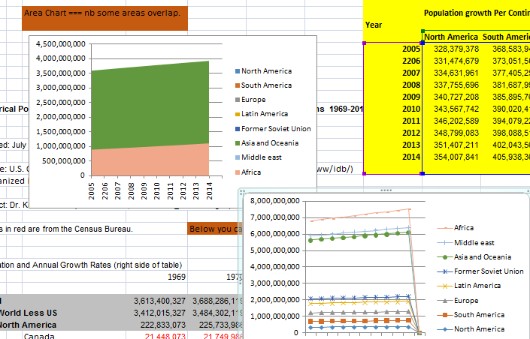

How Excel creates a forecast. The steps involved.
Exponential smoothing is an effective forecasting method similar to the weighted moving average forecasting technique.
Forecast for the next period is equal to forecast for this period plus a fraction of the difference between actual demand and forecast in this period.
F_{t+1} = F_{t}+α(A_{t}-F_{t})

Forecast for this period and the actual demand for this period are used to solve for the forecasting of the next period. Alternatively one can rearrange the exponential smoothing formula is by multiplying alpha by actual demand (A_{t}) and alpha minus 1 by F_{t}. Thus numerically, the exponential formula is:

  - F_{t +1}= (1-α) F_{t}+ αA

Steps in excel
1First, let's take a look at our time series.
2On the Data tab, click Data Analysis
3. Select Exponential Smoothing and click OK.
4Click in the Input Range box and select the range B2:M2.
5. Click in the Damping factor box and type 0.9. Literature often talks about the smoothing constant α (alpha). The value (1- α) is called the damping factor.
6. Click in the Output Range box and select cell B3.
7. Click OK.
8 Plot a graph of these values.

Excel data analysis properties or chart types that could be used to demonstrate your data findings.
One can use the following other charts to try and demonstrate the data findings;
Pie charts
Pie Charts are known for displaying only one series of data. Excel uses the series identifier as the chart title (e.g. population) and displays the values for that series as proportional slices of a pie.
Column Charts
They effectively shows the comparison of one or more series of data points. But the Clustered Column Chart is especially useful in comparing multiple data series.
In a Column Chart, the vertical axis (Y-axis) always displays numeric values, and the horizontal axis (X-axis) displays time or other category.
Excel has designed the chart in this manner because the number of time segments (4) is greater than the number of series (3). Whichever has the highest quantity will be placed on the horizontal axis (X-axis).
Line Charts
The Line Chart is especially effective in displaying trends. In a Line Chart, the vertical axis (Y-axis) always displays numeric values and the horizontal axis (X-axis) displays time or other category.
We selected the Line with Markers chart for our single series chart at left. You may choose each Line Chart type with or without markers. Markers are circles, squares, triangles, or other shapes which mark the data points. Excel displays a unique marker - different shape and/or color - for each data series.

Scatter Diagrams.
The purpose of a Scatter Chart is to observe how the values of two series compares over time or other category. According to Scatter Plots (U. of Illinois), "Scatter plots are similar to line graphs in that they use horizontal and vertical axes to plot data points. However, they have a very specific purpose. Scatter plots show how much one variable is affected by another. The relationship between two variables is called their correlation." The series pair has a Positive Correlation if they increase similarly and a Negative Correlation if they both decrease in like manner. Otherwise, they have No Correlation.

References
Randers, Jorgen (2012). 2052: A Global Forecast for the Next Forty Years. Vermont: Chelsea Green Publishing. p. 62.
Haub, Carl (October 2011). "How Many People Have Ever Lived on Earth?". Population Reference Bureau. Retrieved April 29, 2013
World Population to 2300" (PDF). New York: United Nations Department of Economic and Social Affairs: Population Division. 2004: 3, 14.

