TAXATION of COLLEGE SPORTS

On October 2, 2006, U.S. House Ways and Means Committee chairman Bill Thomas sent National Collegiate Athletic Association (NCAA) president Myles Brand a long letter questioning why the NCAA and intercollegiate athletics should be able to retain their plethora of tax privileges. Thomas pointedly inquired how the hypercommercialized activities of Division I athletics supported the tax-exempt educational mission of U.S. colleges and universities. This chapter seeks to understand this issue, both from the perspective of tax law and from that of public policy.
Before one can meaningfully answer the question of why intercollegiate athletics should have tax privileges, it is necessary to understand what those privileges are as well as the legal basis for them. There are three principle areas of tax privileges for college sports:

  - The ability for donors to deduct 80% of “contributions” to athletic departments that are required for them to be able to purchase season’s tickets to either football or men’s basketball games
  - The ability of college sports programs to issue facility bonds, which has tax-exempt interest to the holders
  - The ability to avoid taxation on activities that are unrelated to the purpose of the tax exemption held by U.S. colleges and universities

These tax privileges are based on a broader tax exemption that is afforded U.S. colleges and universities. The exemption, in turn, is based for public universities on the assumption that the state is providing a service that may otherwise have to be produced by the federal government and for private universities on the assumption that education is a public good whose development promotes the general welfare and functioning of our democratic government. Public universities, as state enterprises, are automatically exempt, while private universities fall under the 501(c)(3) category that provides exemption for charitable, nonprofit organizations. In 1976 the U.S. Congress passed an amendment to 501(c)(3) that explicitly classified the promotion of amateur sports as a charitable activity. Hence, the NCAA was able to obtain 501(c)(3) status and therefore is covered by the tax exemption, as are private universities and colleges. According to Internal Revenue Service (IRS) code, however, both public and private nonprofit universities are explicitly made subject to unrelated business income taxation (UBIT); and, as we shall see, some key questions in connection to the UBIT arise about the relationship of intercollegiate athletics to the educational mission of universities that form the basis for the frequently heard call for college sports to be taxed

DEDUCTIBILITY FOR DONATIONS
Let us now consider the three tax privileges that benefit intercollegiate athletics. Most of the 124 schools in the Football Bowl Subdivision (FBS, formerly D I-A) in 2013 require their supporters and fans to make a sizable donation to the athletic department in order to be able to purchase season’s tickets to the home games of the school’s football or basketball team. One of the first schools to do this was the University of Texas in the early 1980s.
However, in 1984, Texas got some bad news from the IRS. The IRS ruled that since these “donations” to the university were a payment for purchasing part of a ticket for their personal enjoyment, they would not be deductible (as a gift to a charitable organization). Fortunately for the Texas athletic department, it had some powerful friends. In particular, its alumnus U.S. representative Jake Pickle happened to be a member of the House Ways and Means Committee. He wrote a bill, cosponsored by U.S. senator from Louisiana Russell Long, that stipulated 100% of the preticket “contributions” was tax deductible for fans buying tickets to the University of Texas and Louisiana State University football games (Dexheimer, 2007; Eichelberger & Babcock, 2012). Other schools quickly picked up on the favoritism and lobbied for the provision to be made general. In 1988, the U.S. Congress obliged, passing a bill that made 80% of all such ticket “donations” deductible for all universities (Gaul, 2012).
When Congress passed this deductibility provision, it was estimated that it would cost the U.S. Treasury $0.5 million annually. In 2012 Bloomberg News made open-record requests of FBS schools, but only 34 of the 120 FBS schools at the time responded with data on the donations collected in order to purchase season’s tickets. Ohio State University collected the most, with $38.7 million, followed by LSU with $38.0 million and Texas with $33.9 million, and the 34 schools together collected $467.2 million. At 80% deductibility, this amounted to $373.8 million; and, at a top tax rate of 39.6%, this amounted to individual tax savings (or cost to the federal government) of $148 million.
And this sum refers to only 34 schools. There are 124 FBS schools and 340 Division I schools (Eichelberger & Babcock, 2012).
It seems reasonable to view these upfront “contributions” as similar to permanent seat licenses (PSLs) that are sold by professional sports teams. PSL are essentially the first part of a two-part tariff to purchase a season’s ticket: the total market price of the ticket is the prorated PSL (or “contribution”) plus the nominal ticket price. For any given total market ticket price, university athletic departments can increase their ticket revenue by increasing the first part of the tariff and lowering the second part. By raising the first part, the net (after tax) ticket price to the fan is lower and, hence, the university can sell more tickets or charge a higher final price. There is no conceivable economic or efficiency justification for the federal government to sacrifice tax revenues in order to subsidize the purchase of season tickets (almost entirely by higher-income individuals) for big-time college sporting events. To the extent that there are ancillary benefits from such a policy, these could be obtained through a more direct approach.

ISSUANCE OF TAX-EXEMPT BONDS FOR FACILITY CONSTRUCTION
Athletic departments in either public or nonprofit, private universities are able, through their schools, to finance facility construction or renovation through the issuance of bonds, the interest on which is tax-exempt to its holders. Bond buyers are generally high-income individuals. Consider the following example. If a bond buyer, in the highest 39.6% tax bracket, buys a nonexempt corporate bond, with, say, a 7% interest rate, the net (after tax) interest rate is 4.23%. For a tax-exempt bond to be competitive with this corporate bond, the interest would have to be only 4.23% (or lower, given that there may also be an exemption from state income tax.) In this example, a bond to finance the construction or renovation of a college football stadium would save 2.72%, which on a $200 million bond, amounts to a $5.44 million annual saving on the bond’s debt service, or a yearly federal subsidy to the stadium of $5.44 million.
Since 1995, U.S. universities have spent more than $30 billion on sports facilities. Many observers believe there is an arms’ race among schools, wherein the forces of competition push these expenditures on modernized structures, replete with luxury boxes, club seating, signage boards, restaurants, and more. The federal subsidy encourages this lavish spending.
Given that a university’s tax-exempt status is meant to underwrite its central purpose of education, there is a legitimate question of whether the hypercommercialized business of big-time intercollegiate athletics is sufficiently related to this central purpose to justify extending the exemption to the construction of sports stadiums, arenas, training facilities, and tutoring buildings for athletes.
In his 2006 letter to the U.S. Congress, NCAA president Myles Brand wrote: “Athletics facilities, state-of-the-art or otherwise, are necessary for the support of the activity for which there is a tax exemption. These facilities, often paid for through bonds or charitable contributions, also generate revenue that offsets the operational cost of athletics

that might not otherwise be provided through institutional funds.” If, however, these facilities generate sufficient funds to justify the investment in them, then there is no reason for the federal government to subsidize them. In the end, the modern stadiums and arenas raise the revenue level of big-time college sports. Since there are no stockholders to profit from successful sports programs and athletes are not remunerated beyond the basic grant-in- aid, a substantial part of the additional revenue flows to the coaches and administrators of the system. Thus, critics ask: Why should the taxpayer be called upon to support fancy facilities for college sports?

AVOIDANCE OF UBIT LEVIES
When a public or nonprofit institution sets up its own commercial enterprise, the net income of this operation may be subject to taxation. This principle was established by the UBIT legislation passed by the U.S. Congress in 1950.
Before 1950, and dating back to a Supreme Court decision in 1924, charitable entities were permitted to run a commercial business and not have to pay taxes on its profits if the profits were used to support the entities’ charitable activities. In 1950, however, out of concern that such businesses would have an unfair competitive advantage over independent businesses producing the same product or service and that the policy reduced government tax revenues, Congress enacted the UBIT. In 2004, the government collected more than $192 million in UBIT revenue from 501(3)
(c) entities. This collection was based on reported gross income of $5.5 billion, constituting a tax rate of only 3.5%. The low rate is a product of the 501(c)(3) entities’ ability to shift revenues and costs to lower the taxable income of their unrelated entities (Colombo, 2010).
Understanding how the UBIT applies to big-time intercollegiate athletics is not a simple matter and, like much of the law, is subject to interpretation. The basic criterion is whether or not the commercial entity’s output is functionally related to and in furtherance of the basic mission of the charity (in this case, either education or the provision of amateur sports), and IRS interpretation of this criterion over the years has tended to be narrow. For instance, in 1968 the IRS ruled a hospital’s charitable purpose was providing health care to the patients in the hospital; accordingly, a pharmacy within the hospital that provided drugs to patients in the hospital was functionally related to the charitable purpose, but the sale of drugs to the general public by such a pharmacy was not. In 1973 the IRS ruled that the sale of science books in an art museum bookstore was subject to UBIT but the sale of reproductions or postcards was not. In the context of the university, a Treasury Department regulation stipulates that “the presentation of … drama and music events contributes importantly to the overall educational and cultural function of the university” and, hence, is not subject to UBIT (Colombo, 2010). Following this logic, a case can be made to the Treasury to apply the same reasoning to intercollegiate athletics.
CASE STUDY
NYU and C. F. Mueller Co.
In 1946, the owner of the renowned C. F. Mueller Co. passed away. Through a variety of personal connections, the entire company was made available for purchase to the NYU Law School at the heavily discounted price of $3.5 million, along with a low-interest loan. Under the Law School’s ownership, the company flourished and the loan was paid off after some 20 years. By 1975, out of the Law School’s total budget of $9 million, almost one-third came from the profits of its pasta company. The fact that Mueller’s profits went untaxed was not overlooked by other pasta companies. They pressured Congress to level the playing field, which it did with the UBIT law of 1950.
Mueller’s success met with another obstacle. The rest of NYU was in dire financial straits, running an operating deficit of $4.4 million during 1974–1975 and was projected to grow in the coming years. NYU began an austerity plan that included selling off its undergraduate campus in the north Bronx. The law school believed that its own health was tied to that of the university and, ultimately, was persuaded to sell its Mueller operation and, in exchange for greater law school budgetary autonomy, to share the proceeds with the university on a 59/41 basis. The company was sold in 1976 for $115 million, for a capital gain of over $110 million (Brooks, 1977).

The IRS briefly contemplated taxing television revenues in intercollegiate sports back in 1977, but reversed itself, and in 1980 ruled that TV revenues were not subject to UBIT (Colombo, 2010). In 1991 the IRS ruled that corporate advertising/sponsorship revenue in college sports was subject to UBIT, but in 1997 Congress voted to exempt such income from UBIT provided that it was not comparative and promotional in nature.1 Thus, Coca-Cola could have a sign at the Camp Randall Stadium in Madison, Wisconsin, that simply stated “Coke” or “Coca-Cola

Supports Badgers’ Football,” but it could not have a tax exempt sign that stated “Coke Is No. 1” or “Nothing Beats Coke for Satisfying Refreshment.”2 Similarly, buying naming rights to a facility does not involve explicit promotion and is exempt from UBIT Taxation.
Current law also excludes all passive income from UBIT, such as royalty or licensing income from the sale of logos, images, or game highlights. In 2005 licensing and royalty revenue in college sports was estimated at $203 million (Weisbrod, Ballou, & Asch, 2008).
For an entity to retain its 501(c)(3) status and, hence, its eligibility to remain tax exempt, it must also meet certain limitations. One such limitation is that there can be no “private inurement,” or siphoning of surplus to the benefit of an employee of the entity. In order to meet this standard it is required that employees be paid a fair, market-based compensation for their services. The question has been raised about the high salaries of head coaches of Division I football and men’s basketball teams and whether these constitute private inurement.
Another limitation is that there can be no “private benefit.” Private benefit refers to an outsider to a 501(c)(3) organization gaining excessively from its relationship with the charitable entity, whether or not the payment is at a market rate. Consider how the NFL and the NBA gain excessively from the development and promotion of players in college sports. In baseball, the average major league team spends roughly $25 million on player development within its minor league systems, while the NBA’s development league expenses are diminutive, and the NFL has no minor league or development system. In this way, college sports serve as a minor league and development system for the NBA and NFL, with the added bonus that Division I teams get enough media coverage so that the players come to the pros with substantial public resumes and notoriety.
Finally, it is appropriate to inquire whether applying UBIT to college sports would make a difference. If college athletic departments can shift costs and benefits among various college departments (e.g., buildings and grounds, dance, music, dining services, general administration) and thereby avoid showing any net income; or if there is truly no net income in most programs anyway, would it matter if college sports were subject to an income tax? The short answer is that UBIT law also contains a fragmentation principle that allows the IRS to view the separate parts of a 501(c)(3) entity independently. Thus, in theory at least, the IRS could consider net income from football, basketball, or corporate sponsorships, even though the entire athletic department did not generate a surplus. We turn now to consider the debate around this aforementioned question.

STAKEHOLDER PERSPECTIVE

Myles Brand, Former NCAA President
The NCAA organizes intercollegiate athletics. Its officers and employees benefit when college sports flourish economically. The president of the NCAA is a stakeholder in the system. Between 2002 and 2009, Myles Brand was the association’s president.
In November 2006, Myles Brand wrote a 25-page response to the questions of U.S. Representative Bill Thomas of California about why the NCAA and intercollegiate athletics merit the tax privileges they enjoy. Among Brand’s comments, he wrote: “The lessons learned on the football field or men’s basketball court are no less in value or importance to those athletes than the ones learned on the hockey rink or softball diamond — nor, for that matter, than those learned in theater, dance, music, journalism or other non-classroom environments.” At a general level, few would disagree with this assertion. Critics, however, would ask whether the commercialization of college sports is congruent with the educational goals to which Brand alludes.
Brand also wrote: “If the educational purpose of college basketball could be preserved only by denying the right to telecast the events, students, university faculty and staff, alumni, the institutions of higher education themselves and even the American taxpayer would ultimately lose. The scale of popularity and the media attention given to football and men’s basketball do not forfeit for those two sports the education purpose for which they exist.” Here Brand suggests that limiting commercialization would not promote educational goals, but it would reduce the consumer and financial benefits of big-time college sports.

JOINING THE DEBATE
Both at a technical level regarding the details of tax policy and at a political or philosophical level, a fundamental question is whether commercialized intercollegiate athletics is functionally related to the educational mission of U.S.

colleges and universities. On the one hand, it can be argued that engagement in college sports by students provides a salutary balancing of an otherwise largely cerebral and sedentary lifestyle. Participation in intercollegiate athletics also can help athletes develop constructive personality traits, including the development of leadership skills, teamwork, tenacity, good time management, and positive self-esteem. These qualities of college sports appear to be functionally related to the educational mission of colleges and universities and, indeed, to provide an important complement to help create a well-rounded and healthy college experience.
On the other hand, it can be argued that these positive attributes apply to college sports in intramural form or in the less commercialized form of intercollegiate athletics of Divisions II and III. But at the highly commercialized level of Division I, and particularly FBS, the time demands on the athletes, the intrusive, television-driven scheduling of games, the frequent and increasingly distant travel, the lowering of admissions and classroom standards, the transformation of college culture, the incentives to transgress NCAA rules, and the outsized payments to the football and men’s basketball head coaches all detract from the central charitable and educational purpose of the university.
The U.S. Congressional Budget Office (CBO) conducted a study in May 2009 that considered this issue, finding that 82.3% of the revenues for FBS college sports came from commercial sources. This share fell to 28.8% in FCS and to 27.9% in Division I without football. For universities as a whole, this share was only 10.9%, excluding hospitals and athletics (Congressional Budget Office, 2009). The implication of the CBO finding is that big-time college sports operate in a distinct fashion from higher education generally and, thus, could logically be given a different tax status.
The NCAA has justified the commercial growth of FBS football and Division I basketball, in part, on the grounds that the surplus generated by these sports helps to fund dozens of nonrevenue sports for both men and women. After all, in 1976 Congress explicitly denominated the promotion of amateur sports to be a charitable activity, and the revenue from big-time sports appears to be helping to fund these amateur teams.
Critics point to several problems with this argument. First, according to the 2012 Revenue and Expenses Report of the NCAA, only about one-fifth of the football and men’s basketball teams in Division I generate an operating surplus. During the academic year 2010–2011, 68 of 120 FBS football teams reported an operating surplus, and, of these teams, the median surplus was $10.26 million. Also during 2010–2011, 66 FBS basketball teams reported a surplus, with a median surplus of $3.36 million. In FCS, far fewer programs operate in the black: during 2010–2011, only 2 of 122 football teams generated an operating surplus, and only 8 of 121 basketball teams had a surplus. In Division I without football, only 5 of 96 men’s basketball teams generated a surplus. So, the first observation is that most Division I schools do not generate an operating surplus in either football or men’s basketball, and, hence, in these schools, the big-time sports detract from the funds available for the promotion of the nonrevenue sports.
Second, even in those programs where there is an operating surplus in football or men’s basketball, the actual financial picture is less sanguine. When capital expenses (e.g., debt service on football stadiums, basketball arenas, tutoring buildings, or training facilities) and administrative overhead (e.g., a pro rata charge for the school president’s time spent on football) are included, the actual surplus generated is either diminished greatly or nonexistent. In a study for the NCAA, Jonathan and Peter Orszag (2005) estimated that the average FBS program had yearly capital expenses of more than $20 million.3
Third, even in those football and men’s basketball programs where a true surplus is generated and some of this surplus is meaningfully transferred to support the nonrevenue sports, there is still evidence of substantial siphoning of the surplus. Consider the support given to exorbitant salaries of the head coaches of football and men’s basketball teams, their assistant coaches, the athletic directors, and the conference commissioners. While the NCAA and others have attempted to justify these elevated levels of compensation on the basis of market competition, the underlying market forces are artificially created. Hence, there is good reason to believe that these salaries constitute private inurement that could disqualify athletic departments from 501(c)(3) treatment.

PRIVATE INUREMENT AND THE COMPENSATION FOR HEAD COACHES AND OTHERS
Today, there are more than 100 college football coaches with compensation packages exceeding $1 million; there are more than a dozen exceeding $3 million, and several exceed $4 or $5 million in monetary compensation alone. Men’s basketball coaches’ compensation packages are similar; indeed, the highest paid basketball coaches generally outdo their football counterparts. During the 2011 calendar year, Duke’s coach Krzyzewski earned nearly $9.7 million (Berkowitz, 2013). Louisville’s Rick Pitino earned $7.5 million during the academic year 2010–2011 (Upton,

2011).4
In 2009 the University of Kentucky agreed to pay John Calipari a guaranteed $31.65 million (plus incentives) over eight years. These figures exclude bonuses as well as extensive perquisites, including free use of cars, housing subsidies, country club memberships, private jet service, exceptionally generous severance packages, and more. The coaches also have handsome opportunities to earn outside income via apparel or sneaker endorsements, the lecture circuit, summer camps on campus, and book contracts. For some coaches’ contracts, the buyout is the most lucrative element: former Notre Dame head football coach, Charlie Weis, is enjoying a nearly $19 million buyout after his release, even though he is currently employed as the University of Kansas head coach (Hamilton, 2013).
Not surprisingly, assistant coaches have also experienced an explosion in their pay packages in recent years. For instance, Tennessee lured its new defensive coordinator in 2009, Monte Kiffin, with a $1.2 million salary, a
$300,000 bonus for staying through the end of the regular season, up to another $100,000 in incentives, and the use of two cars. The average salary for the nine assistant football coaches at Tennessee was $369,000 in 2009. USA Today identified more than 100 assistant coaches in the FBS who received over $250,000 in base compensation in 2009.
Bob Stoops, Oklahoma’s head football coach, is guaranteed $4.3 million in 2009, and his nine assistants earned nearly $2.5 million before bonuses. Alabama and LSU also boasted $6 million-plus for staff compensation (Wieberg, 2009).
Athletic directors and conference commissioners are also wealthy beneficiaries of the system. According to the USA Today Athletic Director Salary Database, in 2012–2013, there were eight college athletic directors who earned guaranteed pay over $1 million, one of whom earned more than $3 million. Bonuses ran as high as $760,000 and were paid on top of the guaranteed salaries. There is a clear pattern for schools with higher coach compensation to also have higher athletic director compensation.
Conference commissioners earn even more. Larry Scott, the Pac-12 commissioner, earned $3.1 million in calendar year 2011, while Jim Delaney, commissioner of the Big 10, earned $2.8 million and Mike Slive of the SEC pulled down $1.6 million.
This pattern began long ago. Back in 1924, Centenary College in Shreveport, Louisiana, the nation’s first liberal arts college west of the Mississippi, was denied accreditation by the Southern Association of Colleges and Schools because the school placed an “undue emphasis on athletics.” The primary evidence of Centenary’s misplaced priorities by the Southern Association was that the college paid its football coach more than it paid its college president. The next year the football coach was gone, and the college gained accreditation (Johnson, 2008).
The legendary head football coach at the University of Alabama (1958–1982), Bear Bryant, adhered to a firm policy of always keeping his salary $1 below that of the school president. Bryant believed that it was symbolically important for the university president to be paid more than the head football coach (Barra, 2005).
Defenders of the multimillion-dollar head coaches’ salaries often argue that coaches’ compensation packages are driven by market forces. This may be true, but what drives the market forces? The market for coaches is sustained by several artificial factors: (a) there is no compensation paid to the athletes; (b) intercollegiate sports benefit from substantial tax privileges; (c) there are no shareholders demanding dividend distributions or higher profits to bolster stock prices; (d) athletic departments are nourished by university and statewide financial support; and (e) coaches’ salaries are negotiated by athletic directors whose own worth rises with the salaries of their employees.
In a normal competitive market, college football coaches would not be getting compensated almost at the same level as NFL coaches. During the 2011–2012 season, the highest paid NFL coach was Bill Belichick of the Patriots at $7.5 million, and the tenth-highest-paid coach was Andy Reid of the Eagles at $5.5 million (Weir, 2012). The top 32 college football programs generate revenues in the $40–90 million range; the average NFL team generates around
$270 million. The same logic applies to the NBA and its coaches. During 2011–2012, the top paid NBA coach was Doc Rivers of the Celtics at $7 million (nearly $3 million below Mike Krzyzewski’s compensation at Duke), and the tenth highest paid was Scott Skiles of the Bucks at $4.5 million (Van Riper, 2012). The revenue range for the 30 top college basketball teams is $15–40 million, while the average NBA team generates $130 million.
If there were a rule that college head coaches could be paid no more than three times as much as the average salary of a full professor, it would not affect the quality of coaching or the level of intercollegiate competition. This is because the next best alternative for top college coaches (the reservation wage) is likely to be well below this level—perhaps coaching in Division II or III, or in high school, and earning between $20,000 and $100,000, without perks. Anything above the reservation wage is what economists call economic rent. Economic rent does not affect the allocation of resources. Thus, the argument that college coaches’ compensation packages appear to constitute private inurement appears to be strong.

CONCLUSION
In this chapter I have presented the nature of the tax privileges enjoyed by college sports and reviewed the basis in the tax laws for this favorable treatment. The foundation for these privileges is the fact that athletic departments are housed within public colleges and universities or within private universities which are considered 501(c)(3) entities. Because it is not clear that the activity of big-time college sports is functionally related to the purpose of the university (education) or to the promotion of amateur sports, and because there is a compelling argument that there is private inurement and possibly private benefit in the operation of big-time college sports, there is a case to be made that college sports do not deserve favorable treatment. The IRS has attempted to capture some tax revenue from parts of the intercollegiate sports business, but it has backed off as a result of either political pressure or new legislation.
We have also seen that some believe that trying to tax college sports is a paper tiger. That is, even if the IRS or the U.S. Congress decided to tax the net income of college sports, athletic departments would find a way to manipulate their books to show no profit. While efforts at manipulation may occur, accounting rules could limit this ability. Further, if intercollegiate athletics were subjected to the UBIT, then activities like corporate sponsorships could be treated as separate entities under the fragmentation principle. The direct costs of obtaining corporate sponsorships are minimal and it would be difficult to hide the net income generated.
Further, I examined the policy to allow seat purchasers to deduct from their taxable income 80% of the “donation” or down payment on their season’s tickets. For the better seats, the required “donation” often exceeds
$10,000 per year per seat, and some schools earn tens of millions of dollars annually from these “donations” and the government loses out on hundreds of millions of dollars of tax revenue.
Finally, there is the issue of whether athletic departments should be allowed to use the university’s tax-exempt bonding privileges, especially if their activity is judged not to be functionally related to the school’s educational mission. It appears that this bonding privilege has only encouraged an arms’ race to build bigger and better athletic facilities, foisting major funding costs of hundreds of millions of dollars on schools throughout the country.
COLLEGE SPORTS SPENDING DECISIONS and the ACADEMIC MISSION

Rodney Fort

KEY TERMS
sports spending
university administrators athletic directors
administrative goals

The two main themes in this chapter are the approach universities take to college sports, which explicitly documents college athletics spending; and the degree to which this spending is consistent with the fundamental mission of American higher education. Both topics are fundamental to an understanding of college sports outcomes.
The university approach to athletics is demonstrated with a fairly general descriptive model of hierarchical oversight using concepts mainly from economics. The model is based on well-used “principal-agent” (PA) logic applied to college sports. This general model helps make sense of spending data that are so confusing to many observers of the college sports scene.
This chapter does not cover everything. First, what follows is pretty much restricted to “big-time” college sports; lower NCAA divisions may have similar qualitative results but surely will have different quantitative results.
Second, topic and space constraints also allow only cursory coverage of the remaining hierarchy; conference organizations, like the Southeastern (SEC) or Big Ten, and the National Collegiate Athletic Association (NCAA) are noted only in passing.
Whether observed spending is consistent with the fundamental academic mission of the university is a crucial question that economic assessment can only inform, not decide. As with all policy issues, the determination of the level of any public spending goes hand in hand with the determination of just what it is that the spender desires. And that is a truly difficult question, deserving of extensive treatment, because there are so many different spenders with so many different ambitions for universities.
Universities, by their very nature and because they are all at least partly publicly funded, should always be engaged in the exercise of assessing both their chosen purposes and how they are spending money toward those purposes. That discussion will always be best served by less rhetoric, more process recognition, and more data- driven analysis.

UNIVERSITY ADMINISTRATORS AND THEIR ATHLETIC DIRECTORS
While there will be variations, the generally descriptive model of university administrators (UAs) and their athletic directors (ADs) that is presented in this section borrows heavily from my textbook (Fort, 2011, chap. 13) and from my book with economist Jason Winfree (Fort & Winfree, 2013, chap. 2). Remember the limitations of the presentation; while both operate in their university structure, their conference structure, and as members of the NCAA, UAs and ADs in the “micro” look presented in this chapter are considered only in light of their eventual university interaction.
The first thing to observe about these relationships is that both the level of competence and the level of experience of UAs and ADs are empirical issues, directly observable, and not the subject of assumptions before the fact. All UAs and ADs “come up through the ranks” and satisfy quite stringent versions of what social scientists refer

to as “selection mechanisms.” Years of training and experience, in an extremely competitive employment area, are prerequisites for both UAs and ADs. So there need be no presumption that UAs and ADs are inept or naive.
The second part of our descriptive model is an assumption that is hardly controversial: all actors pursue their own self-interest. UAs and ADs care about their income and upward career mobility. In the context of their environment, enhanced welfare of UAs and ADs depends upon the performance of their respective organizations.
Note that an extremely important possibility presents itself here. There may be areas of conflict between the self- interested pursuits of UAs and the self-interested pursuits of ADs. In the operational environment of the university, the welfare of UAs depends on the performance of all of the units on campus along well-known dimensions— research, teaching, and service. The ability of UAs to overcome conflicts with their ADs will depend on two things: the net value of independent action to ADs and the costs of monitoring to UAs.
This is the “principal-agent” setting that is well known to economists: namely, UAs are “principals” to their university “agents.” The agents are academic leaders like college deans and nonacademic leaders like ADs. The president of the university (most typically, but with some exceptions) controls the AD’s employment and pay subject to market forces and does his or her level best to monitor the performance of the AD subject to the costs of doing so. Along this well-known line of PA reasoning, UAs have every incentive to create and manage methods of oversight that harness the self-interested behavior of ADs to the enhancement of UA welfare.
All well and good, but what do these observations so far suggest about how UAs will actually organize their academic and other units on campus? The answer is that UAs, over the history of universities, have organized different university functions into separate departments, with an oversight structure from department, to college, to UAs, for two reasons. First, people in all units on campus generate the largest total output when they are all able to pursue their comparative advantages along the lines of research, teaching, and service. Second, this type of hierarchical organization facilitates monitoring of the various units given the costs of doing so.
Given that the monitoring problem for UAs is essentially similar across its departments, it is no wonder that all units at the university, including the athletic department, are similarly structured. (At a few universities, athletic departments are separate entities reporting directly to an oversight board and the board of regents, but this is still oversight.) In athletic departments, all of the assistant coaches in a given sport are specialists in different areas, just like individual faculty members are on the academic side (e.g., in football, strength and conditioning, position coaches, offensive and defensive coordinators). These specialists are organized under the head coach similar to an academic department and its chair.
Then, the collection of sports is organized into the larger unit, the athletic department. To keep the analogy truly complete, we could refer to this as the “school of athletics,” since, at the top of the athletic department, the AD is the equivalent of an academic dean (at least in terms of oversight and authority). There are associate ADs to handle the day-to-day operations of the department, freeing the AD to engage in fundraising and external relations for the athletic department. The AD answers to the president (rather than the provost on the academic side) and up the ladder to the regents and governor.
Some claim that ADs have the power over UAs in this relationship, a belief that engenders the view that the athletic department tail wags the university dog. It seems to them that ADs get whatever resources they want and should be predicted to run amok at times to the complete embarrassment of UAs. These observers point to the most heinous of episodes as cases in point. One example was behavior in the Southern Methodist University athletic community (all the way up to the governor) that led to the “death penalty” in 1987. The most recent example was behavior at Penn State University in 2011 that led to severe restrictions in 2012 as well as the firing of revered coach Joe Paterno and the resignation of president Graham Spanier and some of his staff.
From the perspective of the general descriptive model, instead, all of this is explained in terms of the chances for oversight failure. Interestingly, as long as oversight is costly, the model allows that sometimes ADs will create situations counter to the best interests of UAs. Depending on the opportunity cost of monitoring time and resources, minor problems with oversight should be expected occasionally, and in only rare situations will extreme examples like Southern Methodist and Penn State occur. But this should all be taken in totality, and it appears that in general the oversight methods function satisfactorily.
CASE STUDY
The Failure of Oversight at Penn State
The child abuse sex scandal that engulfed an entire administration at Penn State in 2011 is well known and instructive

for those plying principal-agent models of college sports. Former Penn State defensive coordinator Jerry Sandusky was arrested in November 2011 on numerous counts of child sexual abuse alleged (at that time) to have occurred from 1994 to 2009, including incidents on campus. Sandusky was found guilty of all but a few of the charges and is serving 30–60 years in prison. But this is only the beginning of the matter from the principal-agent perspective.
An investigation commissioned by the Penn State governing board, conducted by former FBI director Louis Freeh, found that Penn State president Graham Spanier, legendary head coach Joe Paterno, athletic director Tim Curley, and vice president for finance Gary Schultz had all known about Sandusky’s behavior since 1998. The report also named them complicit in failing to disclose their knowledge and take proper action. All but Paterno, now deceased, have been ordered to stand trial on cover-up accusations. The NCAA also imposed sweeping sanctions on the Penn State athletic department just short of the “death penalty” and the university remains under investigation by the Department of Education.
All of this proves importantly instructive from the perspective of a principal-agent model of college sports. It is the essence of such a model that oversight design will not be foolproof; some ability to pursue independent objectives will be enjoyed by agents as long as oversight is costly. The challenge for principals in this situation is to minimize both the chances for oversight failure and the consequences.
If it were just a matter of catching problems, the Penn State oversight design, typical of college sports, actually worked quite well. Sandusky’s behavior was observed, reported, and apparently moved up the chain of command from an assistant coach, to the head coach, to the AD and VP for finance (in charge of the University Police), and finally all the way to the university president. But once at this level, oversight eventually failed. For whatever reason
—some said ineptness, others said panic, and still others blamed it on “sports culture”—neither denizens of the athletic department nor university administrators took the action dictated by law in such a situation. On the whole, then, oversight in this instance failed miserably.
While oversight failures are a fact of life in principal-agent situations, it is clear that there are a variety of other factors that contribute to the degree of oversight failure and the consequences. In the Penn State case, the welfare of university administrators (the president and VP of finance) was too closely intertwined with that of the athletic department. Administrators apparently decided that protecting the vaunted position of Penn State athletics was worth the potential costs of attempting to cover up Sandusky’s behavior. While Sandusky’s deeds were tragic enough, the ensuing impacts on Penn State University were the result of basic oversight failure.

If ADs do not contribute to UA goals, or if the athletic department becomes costly to the university in embarrassing ways, then UAs do have recourse. For one, all but a handful of athletic departments receive a budget allocation from UAs commonly referred to as “institutional support.” And what UAs give they can also take away: budget allocations to the athletic department can simply be reduced. And they have done so repeatedly through the history of college sports. UAs can also take a much more dramatic action familiar to all who follow college sports: AD firings or forced resignations are common practice.
And then there are interesting current and historical observations where athletic departments are simply closed down altogether by UAs. One historical example is the elimination of the storied football program at the University of Chicago. Recently, UAs at Northeastern University (the Huskies) cut its football program in November 2009, and UAs at Hofstra University (the Flying Dutchmen) followed suit the next month. So there need be no presumption that ADs act completely independently.
The basics of the descriptive model so far are portrayed in Figure 10.1. Services from all areas of the university flow out, under the three major headings of research, teaching, and service, and money and political support come back to UAs. In turn, hierarchically, through deans and directors, including athletic directors, UAs allocate rewards back to departments. Deans and ADs are rewarded when they contribute to UA goals and punished when they do not (always a relative statement—rewards could just be smaller).
As with all things, not all departments are equally adept at each of the research, teaching, and service areas and an effective organizational structure would allow the pursuit of comparative advantage. Among academic departments, some are more about teaching and others are more about research. Compared to academic departments, the mix is different still for the athletic department. While athletic departments do not actually create research agendas or initiate research, they do participate in research, especially in sport medicine (recently, in the assessment of concussion mechanics and their impacts on players). Thus, their research “mission” is rather research cooperation. Even more clearly, there is teaching and service performed by the athletic department. Athletic training students hone their skills on college athletes, and the athletes themselves often become teachers of their sport (coaches). A very

few continue on in their sport at the professional level (a parallel here would be with the fine arts).
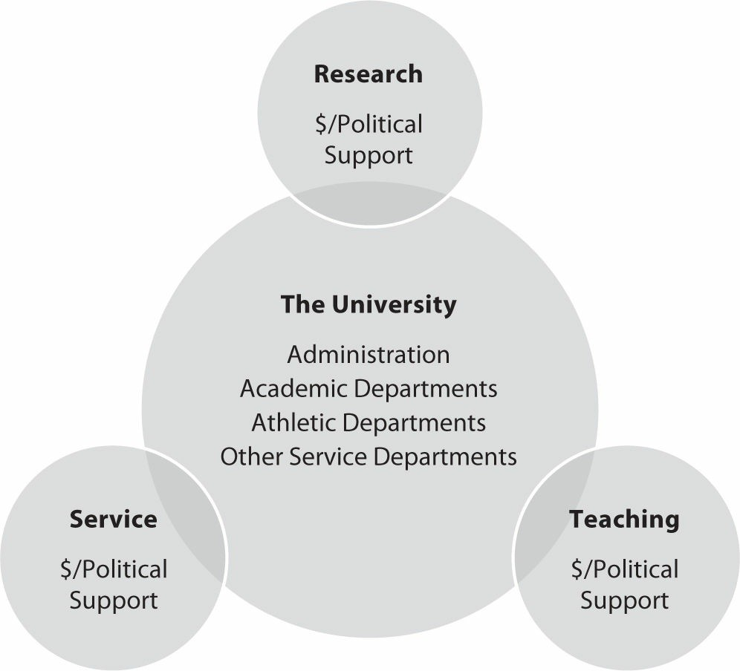
Figure 10.1. University Administrators and the Values of Campus Hierarchy.

Some academic departments also have a service-entertainment contribution, but it is here that athletic departments truly shine. Members of the athletic department, from the AD through the associate ADs, on down to coaches and assistants, and finally the athletes themselves, provide entertainment services. Students have demanded and enjoyed these entertainment services practically since universities were formed. More important, these entertainment services are also enjoyed by millions of others throughout society. Some of them are boosters who then also contribute resources to their favorite university. UAs see these as resources that contribute to the pursuit of their own goals of research, teaching, and service.
Academic departments indeed contribute to the UA goals of research, teaching, and service (Figure 10.1).
Athletic departments also generate resources used to achieve UA goals. Part of the value comes back through tuition dollars paid on the part of scholarship athletes by the athletic department. In addition, other values accrue to the rest of the university, beyond the athletic department bottom line. These are typically grouped as follows (Fort & Winfree, 2013, chap. 3):

Greater giving by alumni and other boosters to the general university fund A larger and better set of student applicants
Favorable general budget treatment by legislators Better faculty and administrators
Value added to athletes, many of who would not be at the university without athletics

Thus, we get another implication of the model: The value of the AD’s efforts will be found in places other than the athletic department bottom line.
One final observation on the monitoring problem rounds out the implications of this general descriptive theory. In the same way that UAs are flexible in terms of facilitating the comparative advantages of units on campus (contributions vary by research, teaching, and service), they also allow ADs more flexibility over revenues than typically deans of academic departments are allowed. But there is a valid economic reason why ADs are allowed this flexibility. While it is easier to observe athletic department success than academic department success, there is much more fluctuation in the former than in the latter. For athletic departments, there can be little disagreement in the final tally of wins and losses, but just which year the department will enjoy great success is much more uncertain than in the academic part of the university.

As a result of this fluctuation, UAs find that athletic departments are most valuable if ADs are allowed to spend the unexpected money they might generate during successful years. Academic deans do not have this discretion. They determine the needs of their departments, put them together in a budget request, and turn it over to the university administration. If spending is lower or revenues are greater than anticipated, UAs retain control over any positive balance.
Combined with the result of the institutional design described earlier, a reasonable conclusion is: “Institutional support” to athletics is not a subsidy, it is an incentive reward, and it should be expected that spending would always rise to meet revenues.

BIG-TIME COLLEGE SPORTS SPENDING
Rather than just looking at spending results as a simple measured statistic, there is also an opportunity to seek understanding of those outcomes using the implications of a descriptive model. (For a description of the data sources on college sports revenues and expenses, see Fort & Winfree, 2013, chap. 1).

The Value of the AD’s Efforts Is Not Just in the Athletic Department Bottom Line
Fort and Winfree (2013, chap. 3) assess the work in the literature that estimates the values across the university generated by athletics but not found on the athletic department’s bottom line. Typically, these values are small but statistically detectable. They then go on to show that looking only at the absolute size of the values generated by the athletic department to the rest of the university cannot be the end of the economic story. The rest of the economic story of the values created for UAs by college sports begs the question: Do UAs get their money’s worth from their investment in college sports?
The first thing to notice is that the size of the investment in athletics by UAs, compared to the rest of the investments they make across the entire university, is really quite small. Here is an easy comparison for 2012, the most recent aggregate data reported through the NCAA (Fulks, 2013). The median of reported generated revenues, that is, not including institutional support, is $40.6 million. The median of total reported revenues from all sources, that is, including institutional support, is $56.0 million. Simple subtraction shows that institutional support at the median is about $15.4 million, or around 26% of total revenues. Rest assured that this $15.4 million median investment is a very small percentage of the “median” university total budget. So, while the conclusion from the literature is that the values generated by college sports are small, so is the investment made in athletics compared to the investment decisions made by UAs across all of the units at their university.
On the question of the return on this small investment, Fort and Winfree (2013, chap. 3) offer the following insight. For the most recent publicly available data at the level of individual institutions, 2010–2011, the smallest athletic department budget was at Washington State University. The total 2010–2011 Washington State budget was
$843.7 million, and the athletic department budget was $40.6 million. But it is not the entire athletics budget that is of interest—UAs earn their return on just the part that they invest, that is, “institutional support.” That investment was
$9.9 million at Washington State, a truly trivial 1.2% of the total university budget. Now, 73% of that $9.9 million investment, or $7.2 million, came back directly to the university from the athletic department to cover athletic scholarships. If, in addition to that $7.2 million, there were only another $3.2 million generated in other values across the rest of the university, then UAs at Washington State would earn a 5% return on their investment. And that
$3.2 million would be a small amount indeed to find in the university total budget of $843.7 million, just 0.38%. Fort and Winfree also provide the same comparison for the median-sized athletics budget at the University of
North Carolina and for the largest budget department, the University of Texas. The results there were simply startling
in terms of the return earned on the investment in the athletic department by UAs. But the main point is that investments are small, returns are too, but the percentage return is quite healthy.

Not a Subsidy but an Incentive
The descriptive model tells us that ADs will always spend all that they get; revenues will equal expenses. To put it a bit more precisely, the correlation between revenues and spending should be unity. And this comparison should include all revenues, including the investment by UAs. Further, budget deficits can occasionally occur in the real world for the usual reasons of mistakes under uncertainty, but they cannot persist. After all, budget deficits under the descriptive model serve nobody’s best interest. So, what do the data say?

Our insight comes from the NCAA’s own report of annual operating revenues and expenses (Fulks, 2013). (Examining annual operations ignores capital, that is, facilities spending, but not everything can be covered in a single chapter; the student is referred to Orszag and Orszag [2005a, 2005b].) Figure 10.2 combines the data from those NCAA reports for FBS athletic departments (Fort, 2010, also produced a figure like this in a presentation at the NCAA Convention in 2009). The first thing to observe in Figure 10.2 is the steady increase in both revenues and expenditures over time. The real (adjusted for inflation) annual growth rates in the median of reported revenues and the median of reported spending were both 4.6% (quite large relative to the typical real growth rate in the economy at large). The second thing to notice is that spending rises over time to meet rising revenue. For fully 50 years, median reported revenues equal or exceed median reported spending, consistent with the implication of the descriptive model. Putting just a little more precision to it, at the median of revenues and the median of spending, the correlation between revenues and expenses is 0.995. Essentially, the “median” athletic department has enjoyed tremendous revenue growth and spent every dollar.
Figure 10.2 shows only a bit of a variation on this same theme for the departments reporting the largest revenues and expenses to the NCAA (the former have been reported only since 1985). First, the real annual growth rate in the largest reported spending is 5.8% (and essentially the same at 5.5% for revenues). Again, this rate is quite large relative to the typical real growth rate in the economy and also relative to the growth rate for the median program reports. Second, for fully 25 years, revenues equal or exceed spending, again, consistent with the prediction of the descriptive model. Another interesting comparison concerns the correlation, a bit lower 0.946 for the largest reports. Unlike their median counterparts, the largest athletic departments do not spend everything they bring in. We know that the observed surplus amounts typically go to athletic department endowment funds for future construction projects.
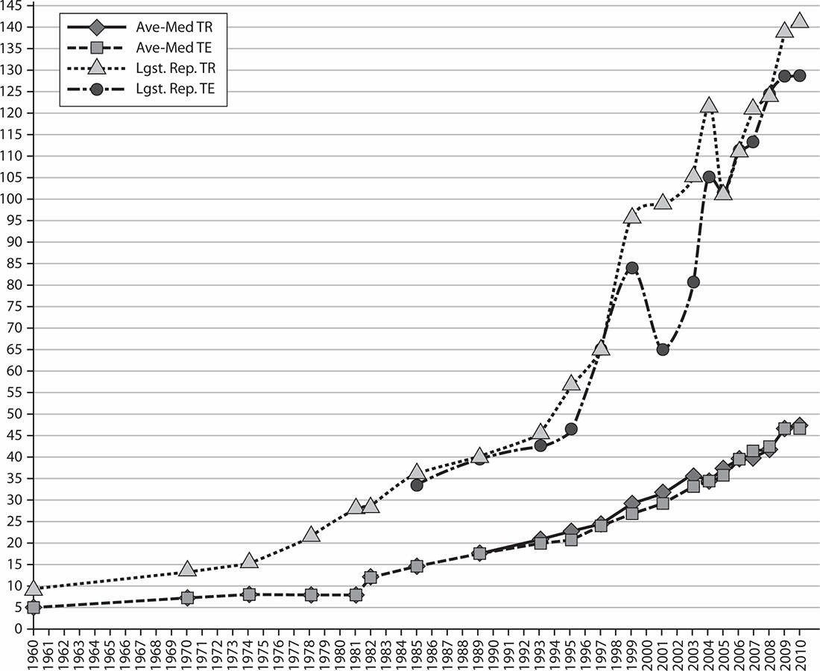
Figure 10.2. FBS Operating Revenues and Expenses (2009). TR = total revenue; TE = total expenses. (Source: Calculated from the data in Fulks (2011). Note: Largest Reported Total Revenue omits 2006 because the report that year is just not believable ($260.7 million $2009). Upon inquiry by the author, the NCAA responded that a particularly large gift to that program was responsible. But gifts are not operations so the figure omits this anomaly.)

Of course, this is only part of the story. They may be doing it effectively, but are UAs choosing the right level of college sports activity? We now turn to that question.

IS SPORTS SPENDING CONSISTENT WITH ACADEMIC MISSION?
Economically, it appears the returns, also small, generate a reasonable return on that investment. But is even this small level somehow the “right” level? And here simple economic lessons end. In the policy arena, all concerned will have their opinion and rightfully so, since universities hold a special place in society (and most of them are at least partly publicly funded). The remainder of the chapter asks, “What is a modern university expected to do in the

first place and how is it to cover the costs of doing so?”
Figure 10.1 detailed what universities do—research, teaching, and service. Research is pretty straightforward, and we will not spend much more time on this one. Revenues to do research come in the form of legislative budget allocations and, more importantly, outside research grants and contracts. Controversies arise occasionally over the types of research done at universities (a recent example is stem cell research) but not over the idea that one of their fundamental academic missions is to do research in the first place.
Teaching, at first blush, also seems straightforward. Undergraduate and graduate students are exposed to varieties of thought processes, trained to do particularly challenging vocational activities, and also allowed the freedom to explore issues on their own. But the university mission here is not so simple as just providing faculty, classrooms, labs, and a forum. The undergraduate and graduate “college experience” is multidimensional; one dimension is students demand to be entertained.

STAKEHOLDER PERSPECTIVE

Reflections on Managing College Sports
James Duderstadt is a past president of the University of Michigan (1988–1996). He was a nuclear engineer of renown and dean of the Engineering School at Michigan before taking the post, so he is clearly a capable and intelligent person. In his book Intercollegiate Athletics and the American University: A University President’s Perspective (2003), he shares his insights into managing big-time college sports at one of the nation’s premiere academic and athletic institutions.
The book offers an interesting perspective since Duderstadt’s story is often cast in terms of relative risk—the medical school can threaten the institution financially, while the athletic department can threaten its integrity and reputation. He notes that athletic directors and coaches long for autonomy but simply cannot have it. Such autonomy (quoting from the introduction) “is a prescription for disaster in the complex political environment of the contemporary university.” He also notes that, despite these potential problems and complexities, there is a place for sports on campus (although he laments their overcommercialization). Most importantly, he puts his finger right on the main points behind this chapter. Duderstadt clearly states and enumerates that the cause of any illness found, and the remedy as well, lies within the institutions governing college sports. He is quite specific that it is university administrators, at their own institutions and through both their athletic conferences and their membership in the NCAA, who bear primary responsibility for college sports outcomes.
Duderstadt pulls no punches and freely admits that there can be problems with college sports. But in the same breath he is quick to point out that the culprit is not really ambitious coaches, or thoughtless greedy athletes, or single-minded athletic directors. To blame them is to ignore the fact that most people in intercollegiate athletics are people of integrity trying to do their best to succeed within the rules. In addition, to blame them distracts attention from the true source of any remediation—governing boards and university presidents.

Originally, students wanted to participate in sports, and universities quickly figured out how to make it available to them safely. In the modern context, students participate in intramural sports and as fans of sports played at a higher level than they can play themselves. Once, student-fans simply wore raccoon coats, sang “Boola Boola,” cheered, and waved pennants. Now student-fans pay 24-hour TV and social media attention to their college teams. On this dimension at least, sports spending is in keeping with the academic mission—students want sports.
The reader at this point almost certainly says to himself or herself, all well and good but surely national TV broadcasts with immense rights fees go beyond the requirement to entertain students? Fair enough, but let’s look closer at the provision of entertainment by universities. Universities provide a variety of entertainment services under the academic umbrella, from guest lectures on a range of topics to fine arts entertainment not otherwise provided by private promoters. But they also host popular superstars promoted privately but hosted in public university facilities simply for the notoriety—for example, Drake’s appearance at the University of Texas, Arlington, and Ke$ha’s at Southern Methodist University.
So it is with big-time sports. They are another demand on the university by clientele that contribute money and support, collected by UAs along the service dimension, that further its research, teaching, and service goals. The binding nature of long-term alumni and other booster relations makes the provision of sports entertainment a service that pays in currency important to UAs. It is, then, quite in keeping with the academic mission that these types of services also are provided.

But observing that the provision of services is in keeping with the academic mission still does not settle the issue of whether these entertainment offerings occur at the “right” level. So let’s get to the heart of the criticism that the attention paid to athletics is overblown, almost always coupled with skepticism over its academic contribution. The dominant argument goes that sports pull students away from their studies without adding anything academically legitimate. But to what extent is that simply an observation about the particular niche that sports has been driven to at the university rather than an invitation to open discussion about the academic legitimacy of college sports?

CONCLUSION
By and large, oversight in the principal-agent relationship between UAs and their ADs produces benefits that appear to be worth the dollar investment. As with any oversight system, there will be failures. Most are small. Catastrophic results like those at SMU and Penn State have been few and far between. But whether the attention to college sports is at the right level is a complex issue that can only be informed, not solved, by the application of economic logic and data analysis. As with everything at the university, the level of attention and resources devoted to college sports is deserving of careful consideration. That discussion in the policy community concerned with universities will always be best served by less rhetoric, more process recognition, and more data-driven analysis. Using models like the one presented here is a good step in that direction.

