RTI Case Study: Laney
Laney is a student at Rosa Parks Elementary.
Every day, Laney receives 45 minutes of intensive, individualized instruction in Tier 2 in addition to 90 minutes of instruction in Tier 1. When Laney first begins Tier 2 intervention, Ms. Jacobs administers a brief reading assessment and determines that Laney has difficulty with decoding. Using this information, Ms. Jacobs begins working with Laney on letter-sound correspondence and sight words. After three weeks of collecting progress monitoring data (six data points — two probes per week for three weeks) from Laney, Ms. Jacobs evaluates these data using a method known as the four-point rule. She examines the relationship between the four most recent data points on Laney’s graph and goal line. She uses these data to determine whether Laney is not making adequate progress.
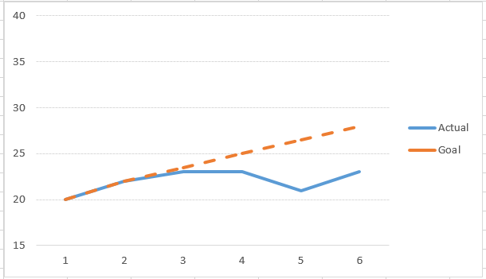
This graph shows Laney’s data point graph and goal line graph. The x-axis is labeled “1 through 6” in one-point intervals. The y-axis is labeled “15 through 40” in five-point intervals. Laney’s data points are in red and are as follows for weeks 1 through 6: 20, 22, 23, 23, 21, and 23. Laney’s goal line stretches from 20 at week 1 to 28 at week 6. Laney’s first three data points are around the goal line, but her last three data points fall below the goal line.
When Laney doesn’t respond adequately to Tier 2 intervention, her teacher refers her for a special education evaluation.
Laney’s parents indicate that there are no hearing and vision impairments to her continuing struggles with reading. Laney is well-liked by her peers and her teachers are not aware of any environmental or cultural disadvantage, motivation, and situational trauma as potential factors.
Based on the information provided, begin the process of drafting a 250-500 word summary of Laney’s current educational performance that could later be incorporated into the Present Level of Academic Achievement and Functional Performance (PLAAFP) section of an IEP.
Adapted from: The IRIS Center for Training Enhancements. (2008). RTI (part 5): A closer look at tier 3. Retrieved from
http://iris.peabody.vanderbilt.edu/module/rti05-tier3/#content

