Novant Health
Daniel Adams
d.adams.2011@mymail.jcsu.edu
Bus455-Sr. Investigative Research Paper
Dr. Kimberly Hunley
October 25, 2015

Novant Health was formed July 1, 1997 by the merger of Carolina Medicorp of Winston-Salem, North Carolina and Presbyterian Health Services of Charlotte. North Carolina (Novant Health startup story, 1997). Novant Health is a not-for-profit integrated healthcare system based out of Winston-Salem, North Carolina that’s comprises of 15 medical centers and 1,123 doctors in 343 clinic locations as well as numerous outpatient surgery centers, medical plazas, rehabilitation programs, diagnostic imaging centers and community health outreach programs. Novant Health employs 24,400 employees and physician partners’ care for patients and communities in North Carolina, Virginia, South Carolina and Georgia (Novant Health startup story, 1997).

We strive every day to bring our mission, vision and values to life. We demonstrate our commitment to you in a variety of ways. Novant Health’s Mission: Novant Health exists to improve the health of our communities, one person at a time (Novant Health, 2015, Para.3). The Vision statement…We, the Novant Health team, will deliver the most remarkable patient experience, in every dimension, every time. Learn more about how we are making healthcare remarkable (Novant Health, 2015, Para.5). Values Compassion…We treat our customers and their families, staff and other healthcare providers as family members with kindness, patience, empathy and respect (Novant Health, 2015, Para.7).

The main product that Novant Health offers is a wide range of medical services. They range from several Novant Health physician practices, Inpatient, outpatient centers, each element committed to delivering a remarkable healthcare experience for you and your family. With world-class technology, personal connections, and care that’s easier to access and understand, Novant Health is with you every step of the way on your journey to health and wellness.

Novant Health has three major competitors: Greenville Health System, Wake Forest
Baptist Medical Center and Carolinas Healthcare all three these healthcare systems are major Competitors with each other. It’s the simple fact that they all offer a variety of basic and specialty healthcare services to their surrounding areas. Healthcare service to the
surrounding areas. A The problem arrives significant challenge presents itself whenever you have your direct competitors within close proximity in the same region and they all offer the exact same type of services. Those living in the regions being served by these healthcare systems have options to choose from when considering their healthcare needs while the healthcare systems struggle to carve their niche and stand out amongst their competitors.

The problem for Novant is the simple facts that they are located in the same area were several of their competitor offer health care service to their patient. They all also offer the exact same type of technology to sever their patients who visit their facilities. Which makes it hard for Novant to separate them self from there competitor in the health care service. This allows patients the opportunity to shop around for more competitive health care rates.

Vividly picture your target audience as a person, someone who is or could be real to you. For any healthcare organization and practices of all types hospitals, manufacturers, physicians and surgeons, dentists, pharmaceuticals or groups the more specifically you define the target audience, the greater your ability to inspire a positive response (Stewart Gandolf, (2010).).

The major competitors’ target market is the same as Novant Health’s target market which, is to offer affordable healthcare throughout the region, so patients are inclined to visit their local medical facility for medical treatments. Within the Charlotte market Novant competitors have been able to purchase land and property to establish their brand of healthcare service. One of the things that I noticed about the competitors is that they are providing level one medical service, means that meaning they can handle a wide range of emergency injuries (example: train derailment, major chemical spills, bomb threats, and fatal shooting). Novant may be better known for their ability to allow patients to review personal medical records, schedule appointments, and make payments online. From a personal standpoint I could see an international diversity within the medical staff at both Carolina Medical Center and Novant Health.

When examining the potential for a new business or product, a SWOT analysis can help determine the likely risks and rewards. SWOT, which stands for Strengths, Weaknesses, Opportunities and Threats, is an analytical framework that can help your company face its greatest challenges and find its most promising new markets (Goodrich, R 2015 ).

A business SWOT Analysis is a great framework for new and old business to maximize their full business potentials. All new business owners should want to do a business analysis on their new business adventure. This will allow them a great chance to see their business Strengths, weakness, Opportunities and Threat with the potential to grow.
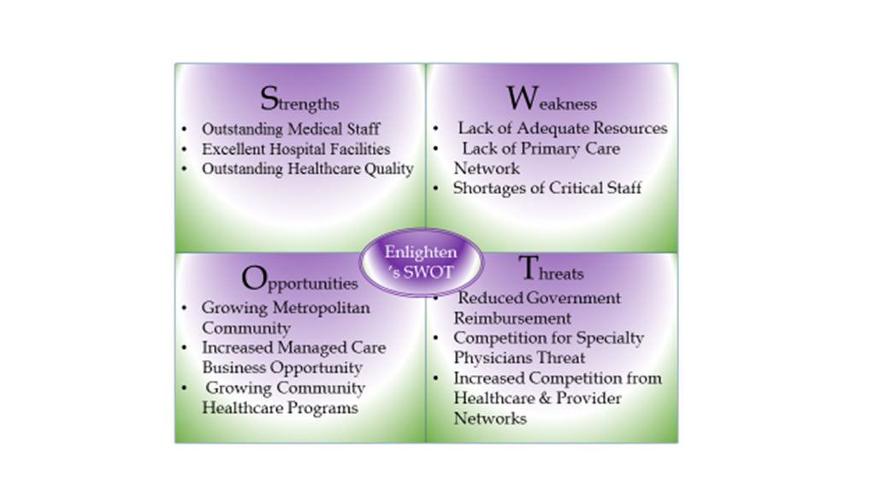
Health systems around the world face the same fundamental challenge: how to deliver broad access to health services while improving quality of care and controlling costs. Greater competition has often been proposed as a solution that elegantly addresses each element of that challenge. (Insight & Publication. (2010), Para.1).

In a normal market, competition drives relentless improvements in quality and cost. Rapid innovation leads to rapid diffusion of new technologies and better ways of doing things. Excellent competitors prosper and grow, while weaker rivals are restructured or go out of business. Quality-adjusted prices fall, value improves, and the market expands to meet the needs of more consumers. (Insight & Publication. (2010), Para.3).

Novant Health major competitors’ target markets suggests that competitive markets in health care can offer patients greater quality, more options, and lower costs. The Federal Employees Health Benefits Program and Medicare Part D serve as two illustrative examples of competition in health care today. Proper reforms to add further competition to the health care industry would be quite significant and would further America’s position as the world’s leader in health care for years to come (Dayaratne, K (2013).).

Novant Health target markets are those individual or family members who are seeking out medical attention for their illness. In the healthcare field there is no limitation on age, gender and religion preference to receive medical treatment at Novant Health. Treatment range from Pediatric care, Rehabilitation centers, Neurological centers and Retirement homes which covers a wide range of individual whom may need some form of medical service.

Carolina Medical Center is one of Novant Health major competitor which is a trauma one facility. Facilities are designated/verified as Adult and/or Pediatric Trauma Centers. It is not uncommon for facilities to have different designations for each group (i.e. a Trauma Center may be a Level I Adult facility and also a Level II Pediatric Facility) (American Trauma Society).

One of the thing that Novant Health does better than there major competitors is that we can offer charity assistance to our patients at 100% for those who may qualify. A nonprofit hospital means the facility does not pay either state or local property taxes or federal income taxes because it is considered a charity, and proves certain community benefits in accord with state and federal guidelines (Medicare Newsgroup (2015).).

To be able to offer outstanding healthcare quality Novant will need to keep recruit and retain outstanding medical staff within our excellent hospital facilities. At Novant health continue to struggle with the lack of a Primary Care Network and understaffed facilities. There are several opportunities for growth in the community Novant serves.

When using the EFE matrix we identify the key external opportunities and threats that are affecting or might affect a company. Where do we get these factors from? Simply by analyzing the external environment of a company.

IFE Matrix force Strengths and weaknesses are used as the key internal factors in the evaluation. When looking for the strengths, ask what do you do better or have more valuable than your competitors have? In case of the weaknesses, ask which areas of your company you could improve and at least catch up with your competitors? The general rule is to identify 10-20 key external factors and additional 10-20 key internal factors, but you should identify as many factors as possible.

Each key factor should be assigned a weight ranging from 0.0 (low importance) to 1.0 (high importance). The number indicates how important the factor is if a company wants to succeed in an industry. If there were no weights assigned, all the factors would be equally important, which is an impossible scenario in the real world. The sum of all the weights must equal 1.0. Separate factors should not be given too much emphasis (assigning a weight of 0.30 or more) because the success in an industry is rarely determined by one or few factors (Jurevicius, O (2014).).

 | External Factor Evaluation Matrix (EFE)
 | Opportunities | Weight | Rating | Weighted Score |  |  | Return to Start
1. | Mecklenburg county 2% increase for 2013 population | 0.03 | 4 | 0.12
2. | Reports forecast an increase in Primary Care Physicians needed in the region to balance the demand for health and wellness programs. | 0.09 | 2 | 0.18
3. | Increase in corporate businesses moving into the Novant coverage regions. | 0.05 | 2 | 0.10
4. | Increase in government transportation funding for health and wellness appointments | 0.07 | 4 | 0.28
5. | Increase in available land within the Novant coverage area. | 0.05 | 4 | 0.20
6. | Increase interest of specialists to join large care networks like Novant. | 0.03 | 2 | 0.06
7. | Increase the partnership with local churches within Novant Health region. | 0.08 | 1 | 0.08
8. | Increase awareness at the local High School about healthy eating habits. | 0.12 | 3 | 0.36
9. | Increase awareness about sexual disease in the community. | 0.04 | 2 | 0.08
10. | Offer health education to new business that have move to the local areas. | 0.04 | 1 | 0.04
 | Threats | Weight | Rating | Weighted Score
1. | Competition within the region increasing annually (CMC, etc.). | 0.06 | 4 | 0.24
2. | Decreased government funding for healthcare (is this really true with the Affordable Care Act)? | 0.05 | 4 | 0.20
3. | Lower wage earners inability to pay for health coverage. | 0.09 | 3 | 0.27
4. | Major corporation moving outside of the Novant health care coverage areas. | 0.01 | 2 | 0.02
5. | Primary Physician using other outsources facilities for their patient service. | 0.03 | 2 | 0.06
6. | Decrease in network health insurance options to patients. | 0.07 | 1 | 0.07
7. | The increase of Mini clinics (CVS, Walgreen, etc.). | 0.03 | 1 | 0.03
8. | Decrease in patient visiting to doctor offices. | 0.02 | 1 | 0.02
9. | Physicians moving to larger city for better pay for their health care service. | 0.01 | 2 | 0.02
10. | More family is having fewer babies in the region due the decrease in employment. | 0.03 | 4 | 0.12
 | TOTALS | 1.00 |  | 2.55
 | Internal Factor Evaluation Matrix (IFE)
 | Strengths | Weight | Rating | Weighted Score
1. | Remarkable Healthcare Service | 0.03 | 4 | 0.12
2. | Great Customer Service | 0.01 | 2 | 0.02
3. | Employment Benefits | 0.05 | 2 | 0.10
4. | Employment Diversity | 0.02 | 1 | 0.02
5. | Healthcare Technology System | 0.03 | 1 | 0.03
6. | Fair Pay | 0.07 | 1 | 0.07
7. | Self-service discount for employees and family member | 0.03 | 2 | 0.06 |  |  | Return to Start
8. | Have the able to offer 100% Financial Charity to patient who qualifies. | 0.05 | 2 | 0.02
9. | Recognized for Medical Achievement and Wards | 0.07 | 2 | 0.14
10. | Excellent employee morale | 0.06 | 4 | 0.24
 | Weaknesses | Weight | Rating | Weighted Score
1. | Old Medical facilities | 0.08 | 5 | 0.05
2. | Out dated medical equipment | 0.05 | 3 | 0.06
3. | Short Staffing | 0.07 | 2 | 0.14
4. | Closing of medical facilities creates avoid in rural areas | 0.04 | 1 | 0.04
5. | Patient education | 0.08 | 3 | 0.23
6. | Disruptions in IT service | 0.03 | 4 | 0.12
7. | Increase in resubmitting claims | 0.08 | 2 | 0.06
8. | Overcrowding in the ER | 0.02 | 1 | 0.09
9. | Time management | 0.03 | 1 | 0.03
10. | Patient satisfaction | 0.10 | 2 | 0.20
 | TOTALS | 1.00 |  | 1.84

There are many factors that determine the success or failure of a healthcare business or professional practice in today's dynamic regulatory, reimbursement, and competitive environment. One of the most important of these factors is management’s ability to react to changes by making timely, informed decisions regarding the organization’s operational direction and financial performance. Among the most useful management tools available to achieve this objective are benchmarking, a well-established financial analysis process (Cimasi, R (2004).).
Healthcare industry survey benchmarking data may be obtained from several publicly available sources, enabling an analyst to compare detailed financial, operational, and clinical performance with similar peer group data. The survey data should be as current as possible. Publication delays of a year or more are not uncommon, so it’s easy to mismatch data from different years, diminishing the efficacy and applicability of the analysis to current and projected future operations. This is particularly true for medical practices because year-to-year changes can be significant and material in a rapidly changing reimbursement and regulatory environment (Cimasi, R (2004).).

Even though non-profit hospitals have faced rising charity care costs and a generally tough operating atmosphere over the past several years, hospitals are still reporting strong operating and leverage ratios (Herman, Bob, 2013). On the trailing twelve months basis Current Liabilities Novant as decreased faster than the Industry's Current Assets, this led to improvement in Industry's Working Capital Ratio to 1.58; Working Capital Ratio remained below Healthcare Facilities Industry average. Within Healthcare sector 3 other industries have achieved higher Working Capital Ratio. Working Capital Ratio total ranking has improved to 31, from total ranking in previous quarter at 39.

Based on the financial ratios Novant Health is in a solid position with their total asset. They are doing a fair job converting revenue into profits. Which will give them leverage if Novant want to pursue over option in the medical field? They would have the capability to gather up funds to make improvement on old facility, purchase new facility and give out pay raise to their employee’s.

Novant Health should revised their mission from Novant Health exists to improve the health of our communities, one person at a time. Novant Health is committed to collaborating
with community partners to improve the health status of community residents, address root causes of health disparities, and educate community members around prevention and self-care”. All healthcare facilities should work on making the mission statement more visible and available to the public.

Create “healthy community” demonstrations to evaluate the effects of a full complement of health-promoting policies and programs. Demonstrations should integrate and develop successful models that can be widely implemented and that include multiple program approaches and sources of financial support. Each “healthy community” demonstration must bring together leaders and stakeholders from business, government; health care and nonprofit sectors to work together to plan implement and show the impact of the project on the health of the community (Wood, Robert).

A healthy community is one where people have good physical and emotional health. But this is more than just the absence of illness. A healthy community promotes well-being and offers a high quality of life. Healthy communities can be measured along five dimensions which contribute significantly to people’s ability to thrive (Bruce 2011). Here are five dimensions includes Social Networks, Physical Assents, Economic Opportunity, Human Development and Local Institutions which all plays a vital role in a healthy community.

Healthy Community is a growing team of businesses, organizations, health care professionals and individuals who have united to improve the community’s health, focusing on four nationally recognized health concerns. These health issues affect the community’s quality of life with significant personal, physical and financial consequences for everyone. Read on to learn what you can do to help make it your Healthy Community (N.D).

Based on the recommendation Novant may want to partner with other North Carolina Government agencies and other health care organization to promote a “healthy community”. This will bring together other leader to help change eating habit within the community. They will set down with Government officials to promote changes within Food Stamps system, so family can only purchase healthy food items. Novant can also help companies to build a strategic plan to allow employees the time to exercise during work hours. Then those employees will go back to the school system to request that these kids by allow more time to exercise during school.

References
American Trauma Society http://www.amtrauma.org/?page=TraumaLevels
Bruce April (2011) What is a Healthy Community http://communitycheer.org/indicators/health/what-is-a-healthy-community/
Cimasi, R (2004). Financial Benchmarking and Ratio Analysis
in the Health Care Industry. http://www.cpareport.com/Newsletter%20Articles/2004%20Articles/FinancialBenchmarking_Oct_2004.htm
Dayaratna, K (2013). Competitive Markets in Health Care: The Next Revolution
Competitive-markets-in-health-care-the-next-revolution
Goodrich, R. (2015). SWOT Analysis http://www.businessnewsdaily.com/4245-swot-analysis.html#sthash.ElY7T88K.dpuf
Gandolf, S. (2010). A Critical Health Care Marketing Success Factor
http://www.businessnewsdaily.com/4245-swot-analysis.html#sthash.ElY7T88K.dpuf
Health begin at Home http://www.myhealthycommunity.com/
Hargett, F. (2014). Novant Health 2014 annual financial information http://www.novanthealth.org/home/about-us/company-information/financial-profile/annual-financial-information.aspx
Herman, B (2013). 14 Statistics on Hospital Operating Ratios
http://www.beckershospitalreview.com/finance/14-statistics-on-hospital-operating-ratios-2008-2011.html
Johnson, Robert (n.d.). Commission to build a Healthier America http://www.commissiononhealth.org/HealthyPlaces.aspx The Medicare Newsgroup (2015).
What Is the Difference between Nonprofit Hospitals and For-
Dash, P & Meredith, D (2010) When and how provider competition can improve health care delivery
http://www.mckinsey.com/insights/health_systems_and_services/when_and_how_provider_competition_can_improve_health_care_delivery
Profit Hospitals? http://www.medicarenewsgroup.com/news/medicare-faqs/individual-faq?faqId=31a98723-ad91-4801-9bd8-1f968a7c0f1b
PWC (2013) Independent Auditor's Report http://emma.msrb.org/EA595749-EA466150-EA862461.pdf
Wei, Y (n.d.) summit.sfu.ca/system/files/iritems1/6829/etd0426.pdf.

