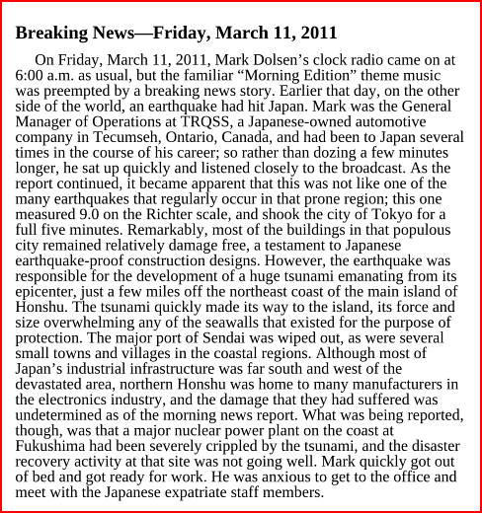
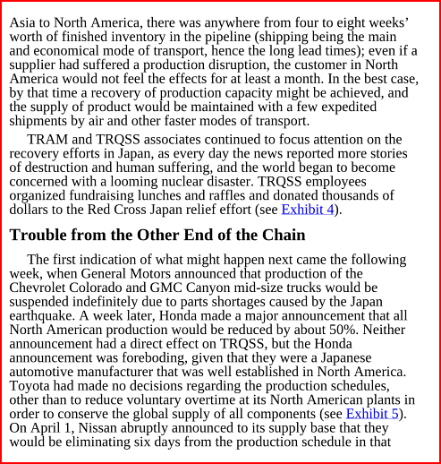
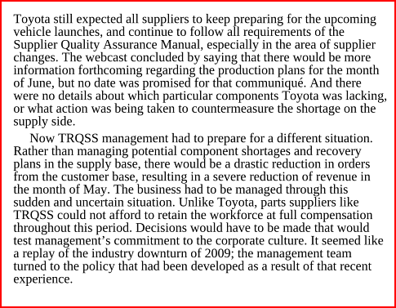
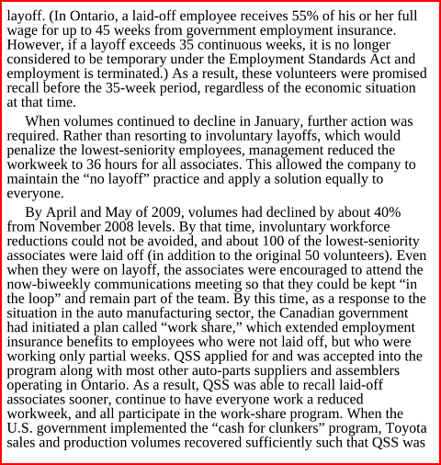
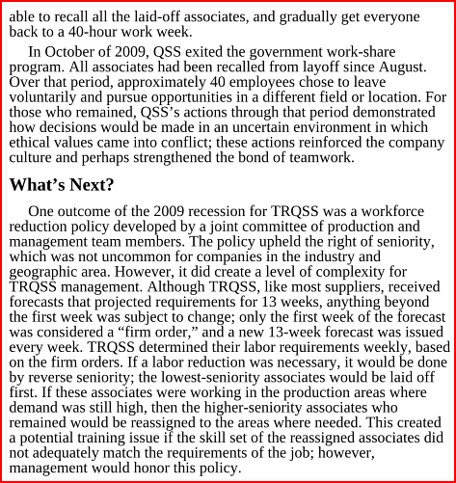
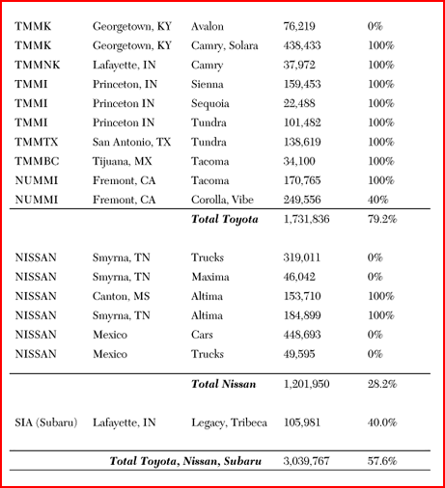
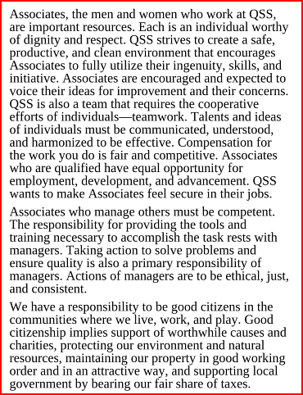
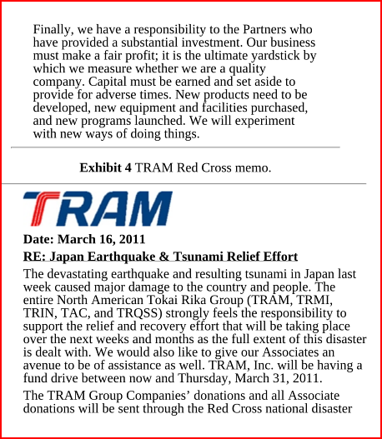
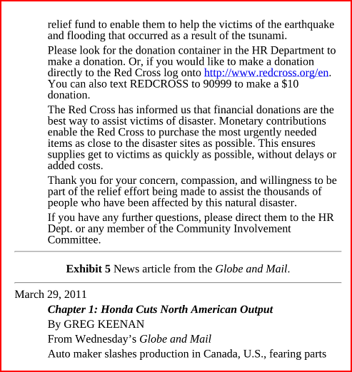
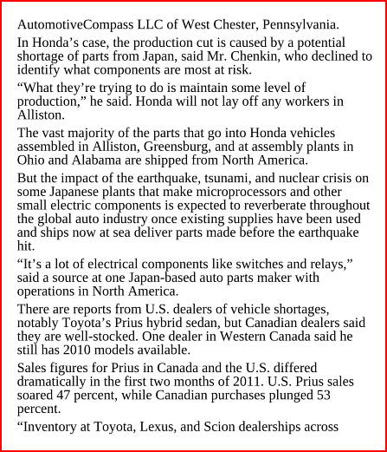
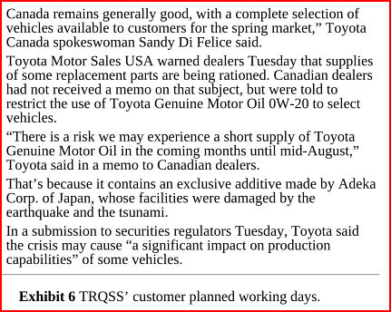

1. What were the effects of the earthquake and tsunami in Japan upon the operations of TRQSS?
2. What are the pros and cons of Toyota’s keiretsu system for supply chain management? Should
Toyota’s Lean Supply Network be modified to mitigate the effect of natural disasters?
3. What strategies could Toyota and TRQSS (or any other supplier) employ to improve supply chain
resiliency?
4. How does the existence and utilization of temporary workers affect the ethical behavior of the
organization? How might this be addressed?
5. Describe the most important values at TRQSS and the effect of the Japanese culture upon these
values.

