Perhaps more important than choosing strategies is evaluating their effectiveness. Decision makers are faced with the complexity of gathering organizational performance data, reviewing results, assessing and analyzing the information, and making an informed decision on what to do next. This strategy management part of the process is all within the context of an ever-shifting competitive environment.

In this assignment you will construct an evaluation framework that may be appropriate for the Dell Corporation. Develop a deeper understanding of review, evaluation, and identifying four academic studies from scholarly journals that are relevant to the topic. The four studies should have been conducted within about the last three years.

For this assignment, create a PowerPoint (or a similar program). Using Figure 9.2 on the next page as a basis and example, construct a strategy-evaluation framework that may be useful to the Dell Corporation. In other words, customize and create a framework that contains elements necessary for review, evaluation, and control.
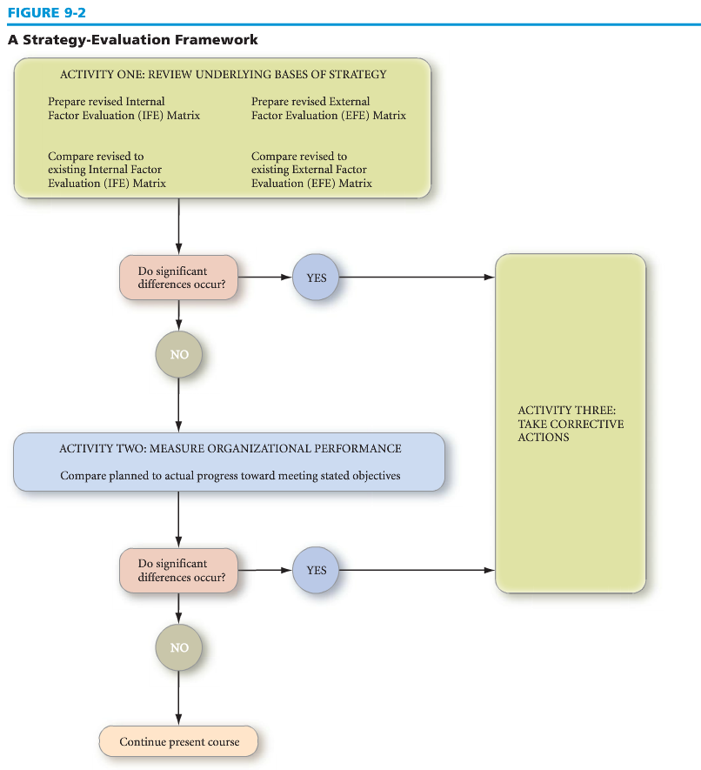
Then, in the notes section of the PowerPoint slide, provide an explanation of why this framework was a good choice to meet the demands of 21st century issues and unique aspects that are related to the Dell Corporation.
Should be around 5 slides plus a cover slide and references slide
APA Formatted
Plagiarism free as it will be checked

