- Before beginning this exercise, review the Strategy-Formulation Analytical Framework below. This Critical Thinking assignment focuses on Stage 2: The Matching Stage.
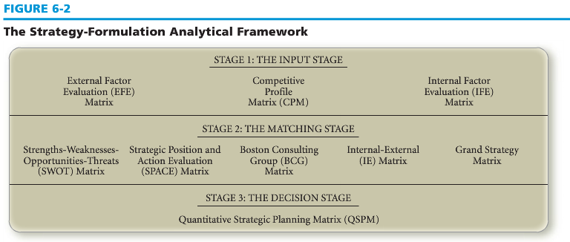
Then, choose two tools that are used in the matching stage that are appropriate for the Dell Corporation; there are a number of tools/matrixes displayed and explained in the textbook. At least one of those tools for this assignment must come from your textbook (SWOT Matrix, SPACE Matrix, BCG Matrix, IE Matrix, Grand Strategy Matrix).
Write an executive summary to include the following:
  - An overview of the Dell Corporation
  - An explanation of the Strategy-Formulation Analytical Framework (Figure 6-2)
  - The synthesized findings from Stage I: The Input Stage
  - The rationale for the Stage 2 tools that you chose for this assignment
You may use figures and tables within the executive summary to condense information if you wish.
Include both Stage 1 and Stage 2 exhibits that you have developed as Appendixes. Adhere to APA standards for tables, figures, and appendixes. Your well-written paper should meet the following requirements:
  - Be 1-2 pages in length (but no more than 2 pages)
  - Cite a minimum of three outside sources.
  - Be formatted according to Graduate Level APA standards

