ELEC 152
MODULE 5: MESH & NODAL ANALYSIS; SUPERPOSITON THEOREM
M5A1
Problem 1. Calculate the value of voltage across R2 by doing the appropriate source conversion.
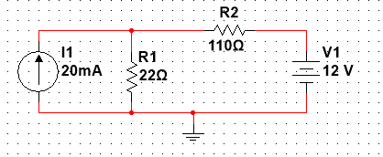

Problem 2. (a) Write the loop equations for the following circuit, simplifying as much as possible. (b) Solving the equations, calculate the power dissipated or absorbed by each source.
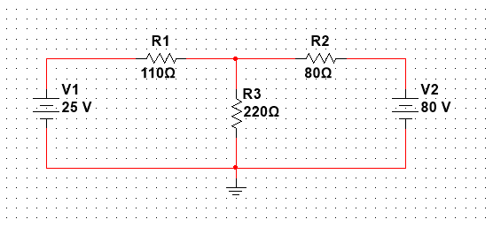

Problem 3. (a) Write the loop equations for the following circuit, simplifying as much as possible. (b) Solving the equations, calculate the power dissipated or absorbed by each source.
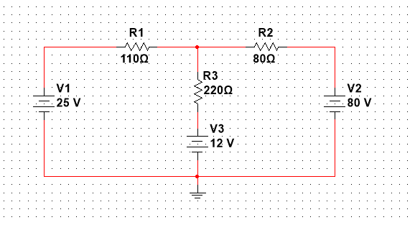

Problem 4. Using nodal analysis, calculate the values of voltages V1 and V2:
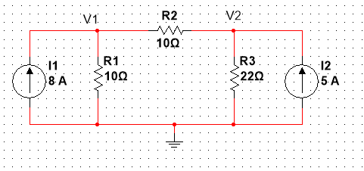

Problem 5. Using nodal analysis, calculate the values of voltages V1 and V2: 