Example Final Exam Problems
ρ_{water} = 1000 kg/m³ $y (x, t)=A\cos{(\frac{2π}{λ}}x-\frac{2π}{T} t)$
P_{atm} = 1.013 x 10⁵ Pa
g = 9.80 m/s²

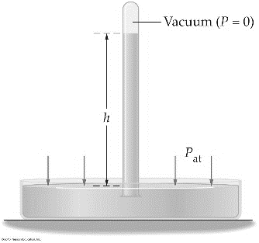
- A simple barometer is made by taking a tube that is open at one end and closed at the other, filling it with fluid, and inverting it so that the open end is submerged in a bowl (open to the atmosphere) of the same fluid. See image below. If the fluid used to make a barometer is water, what will be the height of the column of water in the tube?

- A cube of material with volume 0.09m³ is found to weigh 9966.6 N in air, and 9084.6 N in water. What is the buoyant force acting on the cube of material when it is fully submerged in water?

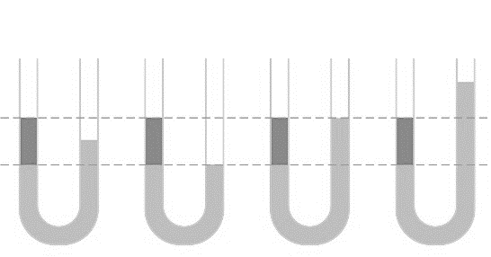
- A U-shaped tube that is open on both ends is filled with a fluid (light gray), a second fluid (dark gray) is then added to the left hand side of the tube. Which of the following is not possible?

- A cube with mass 0.0216 kg, measuring 3 cm on each side is floating in water. What volume of the cube is above water?

- A particle is in simple harmonic motion along the x axis. The amplitude of the motion is A. When it is at a certain position, x = x₁, its kinetic energy is K = 5 J and its potential energy (measured with U = 0 at x = 0) is U = 3 J. When it is at x = –A/2, the kinetic and potential energies are:

- A particle is in simple harmonic motion along the x axis. The amplitude of motion is A. At what value of x is potential energy U = (¹/₃) K?

- A simple harmonic oscillator consists of a mass m and an ideal spring with spring constant k. The particle oscillates as shown in (i) with period T. If the spring is cut in half and used with the same particle, as shown in (ii), the period will be:
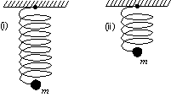

- A pendulum of mass 2.0 kg has a length of 1.0 m, and falls through a distance of 0.10 m. Assuming that your pendulum is on Earth, what will its period be?

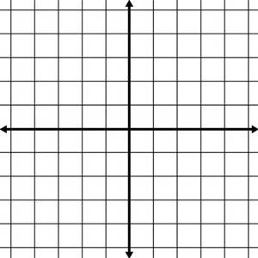
- Which equation corresponds to the following waveform? Waveform not shown.
  - $y \left(x, t\right)=4\cos{(\frac{2π}{3}}x+\frac{π}{3} t)$
  - $y \left(x, t\right)=8\cos{(\frac{2π}{3}}x+\frac{π}{3} t)$
  - $y \left(x, t\right)=4\cos{(\frac{2π}{3}}x+\frac{2π}{3} t)$
  - $y (x, t)=8\cos{(\frac{π}{3}}x-\frac{2π}{3} t)$
  - $y \left(x, t\right)=4\cos{(\frac{π}{3}}x+\frac{π}{3} t)$

- Find the frequency of the shown standing wave pattern occurring in air in a tube of length
2.0 m that is closed at one end. Assume the wave is a sound wave. Pattern not shown.

- A stationary observer hears a frequency of 512.6 Hz from a vehicle that is driving away and emitting a sound with a frequency of 550 Hz. What is the speed of the vehicle?

Final Exam: Possible Short Problems (If it was not a midterm, it will probably be on the final.)
-Height of fluid in Simple Barometer
-Archimedes's Principle - Submerged Objects Density & Buoyant Force
-Archimedes's Principle - Floating Objects Volume Above/Below Fluid surface
-Mass-Spring - Potential and Kinetic Energies (U + K = E). Find how U and K compare for different values of x.
-Match Position-Time Graphs to Equations
-Period of Mass-Spring or Pendulum
-Intensity vs. Intensity Level: Given one, solve for the other.
-Displacement (y) as a function of position and time (x, t): Relate Equations to graphs
-Doppler effect
-Standing wave patterns on strings and in air columns
-Superposition of waves
-Reflection from fixed end, non-fixed end
-Index of refraction and speed of light
-Snell's Law
-Critical Angle
-Mirror Equation/Lens Equation for Single Mirror/Single Lens system
-Magnification Equation
-Single slit interference, Double slit interference, Diffraction gratings
-Change in length due to temperature
-Change in length, shape, volume, due to applied force
-Radiated/absorbed power
-Heat Conduction through rods and windows
-Working off food Calories
-Radiating food Calories
-Calorimetry
-RMS speed of ideal gas
-Latent heat and phase change

