Lesson 6: Problem Set 3 (40 Points)

Name: Ashley Flores

This Problem Set has four problems with multiple parts. Each problem is worth 10 points total. You are required to SHOW ALL YOUR WORK and give complete explanations when appropriate.

Don’t hesitate to use words to explain what you are doing along the way. Circle or highlight the final answers in yellow. Be sure to include units where appropriate. It is recommended that you print the problem set worksheet and work the problems manually. You may scan the completed worksheet or take a picture of the worksheet. Insert the picture or scan into a Word document for submission. Upload the final document to submit.

The four questions below constitute Lesson 6 Problem Set and will be graded.
Answer the questions below:
- Two boxes A and B are connected by a lightweight cord (disregard the mass of the cord). Box A is to the right of Box B. The mass of Box A is 10.0 kg. The mass of Box B is 12.0 kg. A person pulls on Box A with a force of 40 N.

  - What is the acceleration of each box?

Mass of Box A = 10.0 kg
Mass of Box B = 12.0 kg
Total Mass = 24 kg
Force = 40 N
Use equation a = F/m

Acceleration of the system:
a = 40 N/22 kg = 1.8 m/s²

  - What is the tension in the cord that connects the two boxes?

Force = 40N
Use equation: F =ma
Use mass of Box B
Mass of Box A is initial mass

F = (12 kg) (1.818 m/s²) = 21 N

- Two boxes A and B are connected by a lightweight cord (disregard the mass of the cord). Box A has a mass of 5.0 kg and rests on a horizontal table. The coefficient of kinetic friction between the box and the table is 0.20. Box B has a mass of 2.0 kg and hangs over the table via a frictionless, massless pulley. Assume the cord does not stretch (i.e., the boxes have the same acceleration).
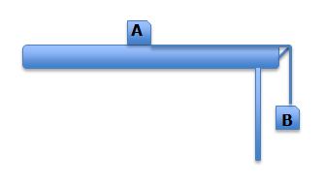

  - What is the acceleration of the boxes?

Box A = 5.0 kg
Coefficient of kinetic friction = .20
Box B = 2.0 kg

Box B:
F =ma
F = 2 kg (9.8 m/s²) = 19.6 N

Normal force acting on Box A:
F = ma
F = 5 kg (9.8 m/s²) = 49N
.20 Kinetic friction (49 N) = 9.8 N

Use equation:
a = F/m
a = 9.8N/7 kg = 1.4 m/s²

  - What is the tension in the cord that connects the boxes?

N = (5 kg)(9.8 m/s²) = 49
m1g-T =m1a
T-fk =m2a

(5)(9.8) – T = (5)(1.4)
49 – T = 7
-T = -42
T = 42

42 -

17 N

- A box is given an initial speed of 3.0 m/s up an incline where the angle θ =22º. Use the diagram below to define the x-y axes. Assume the original position is on the ground (x_{o} and y_{o} = 0). Ignore friction.

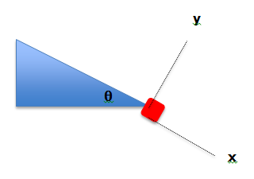

- How far up the plane (in meters) will the box go?

- How much total time (in seconds) elapses (starting at
time = 0) before the box returns to its original position?

- One end of a spring is attached to a 2.0-kg block. The other end of the spring is attached to a motorized top locomotive. The train moves forward (to the right) at 5 cm/s. The spring constant is 50 N/m, and the coefficient between the block and the surface is 0.60. The spring is at its equilibrium position at time = 0 s when the train starts to move.

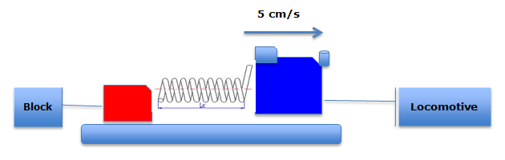

- Draw an appropriate free body diagram.

- How far down the table does the train go before the block begins to slip?

- How much time (in seconds) elapses before the block begins to slip?

