Network Security

June 14, 2017

Network Security- CS653

“This task contains portions of material that were originally submitted during the [1701B] in [Operating Systems Security-CS652] with [Susan Cole].”

Table of Contents
Project Outline and Requirements (Week I) 3
Company Profile 3
Overview of Network and Existing Security 3
Description 3
Network Topology 4
Network Protocols 4
Connectivity Methods and Network Equipment 5
Current Security Devices 5
Risk Assessment (Week II) 7
Inventory of Devices and Key Assets 7
Prioritizing Assets 9
Risk Assessment Tools and Methodologies 12
Security Architecture Plan (Week III) 13
Technologies 13
Security Controls 17
Mitigation of the Risks 17
Security Policies (TBD) 19
Policy I. Guarantee all OS patches are applied and up to date 19
Policy II. Enforce passwords are strong and changed regularly 19
Policy III. Report suspicious bogus emails to the proper authorities 19
Policy IV. Antivirus Policy 20
Policy V File Exchange Policy 20
Incident Response (TBD) 22
Reporting Incidents 22
Evaluating and Testing Incident Response Plan 25
Implementation Plan (TBD) 27
References 28

Project Outline and Requirements (Week I)

Company Profile
Dynamic Engineering Software Inc. is a company that empower organizations to change into advanced undertakings for a definitive upper hand. Dynamic Engineering Software specialty relies on providing custom configurations of security programs. Some of Dynamic Engineering Software’s customers include the federal government and other private sector organizations. With a variety of services ranging from inventory functions to configuration management (CM) and visitor control features, Dynamic Engineering Software employs 130 employees. DES Inc is headquartered in West Virginia, 30 percent of the workforce count with a telework agreement which allows them to perform their duties remotely. DES Inc is reaching its sixth year of operations.

Overview of Network and Existing Security

Description
Currently, Dynamic Engineering Software counts with 140 laptops computers with Windows 10 operating system, eight Blade servers running UNIX operating system to host a Red Hat open source cloud infrastructure that enables Linux, and Windows virtual machines that host enterprise-wide virtual systems and applications. Six RHEL 7 physical servers that host the enterprise Oracle database infrastructure. In addition, the company counts with two EMC Symmetrix VMAX 180TB enterprise storage system. Dynamic Engineering Software runs on two redundant OC3s optical carrier fiber connection that connects Dynamic Engineering Software network to a carrier-based Managed Trusted Internet Protocol Services (MTIPS). These connections are separated to the enterprise local network by a demilitarized zone (DMZ) that is filtered, monitored, and managed by Dynamic Engineering Software’s CISCO’s next-generation firewalls, Intrusion Prevention System (IPS) appliances and Identity Services Engine (ICE) security layer.

Network Topology
Dynamic Engineering Software counts with a completely connected network topology which can be defined as the presence of direct connections between all sets of hubs/nodes. This complete or mesh topology comprises hubs and contains (n-1)/2 coordinated connections. This network topology allows for all devices to connect with many redundant interconnections among the network nodes. When this topology is used, each of the nodes obtains a connection to every single node within the network. This topology can be a very costly system technology and is to a great degree unfeasible for big networks. Be that as it may, when it is set, it gives a high level of unwavering quality because of the vast amount of repetitive connections amongst hubs thus assortment of ways for the information. The two-hub system is likewise measured as a complete linked network.

Network Protocols
Some of the network protocols set for Dynamic Engineering Software network include Transmission Control Protocol/Internet Protocol (TCP/IP). This protocol provides a set of rules governing all types of communication between each computer connected to the internet. This protocol provides specific commands on how data will be packed, delivered, received, and how this will be spread. Another protocol in place for the organization is a Domain Name System (DNS). This protocol enables the establishment of user/server network communication systems. When users send a request or receive a response this is coming from the DNS servers. DNS actualizes a conveyed database to store names and last-known address data for every single open host on the Internet. Last but not least, a Dynamic Host Configuration Protocol (DHCP) is also in place. This protocol provides host computers with automatic allocated configurations coming from a server in order to omit configuring each network host manually. One of the advantages of having this protocol is that if in any given moment an address needs to be changed, this can be changed at the DHCP server only. These are some of the protocols put in place for the organization.

Connectivity Methods and Network Equipment
The connectivity method utilized by Dynamic Engineering Software is an Optical Carrier 3. This provides a network transmission line that can perform up to 155 megabits per second. This provides internet access and multi node connectivity to the entire network. The network components at each of the nodes communicate between themselves via fiber optics. Dynamic Engineering Software’s network equipment includes 12 Cisco Catalyst 3850 Series Switches each with 48 ports and 2 Cisco 4000 Series Integrated Services Routers.

Current Security Devices
Currently, the organizations counts with a Cisco Firepower 2100 Series for unlimited users which also counts with Next-Generation firewall attributes, SSL VPN services, anti-X, and IPsec capabilities. This also counts with cryptographic attributes and dual multicore structure that enables and improves firewall and other threat detection functions at the same time. Furthermore, 16 to 24 ports are available to support other network devices. This security device allows for access control to the network, limiting and protecting resources from unauthorized users, securing information, and increasing network uptime. “Employee productivity is increased by controlling file sharing, instant messaging, spam, phishing, and other emerging threats” (Cisco, 2017). Deployment of this system is quick and easy to manage, which saves the company time and financial resources since operational costs are reduced. The organization count with Sophos Next-Gen Endpoint Protection for blocking malicious infections such as viruses, worms, malwares and spywares. This software depend on signatures to confront malware. For this antivirus solution Sophos will be the organization’s service provider. Firewall, and Next-Gen services and tools will be provided by Cisco.

Risk Assessment (Week II)
It is well known that IT organizations confront a storm of proficiency, cost requirement furthermore, consistence issues each day. Now and again it appears like managing these issues comes first over what IT is in charge of in any case, conveying business administrations that specifically bolster and engage the assortment of computerized processes that drive the center business. IT organizations are responsible for delivering business services, doing as such requires having the correct building obstructs set up, particularly the IT resources that involve those business administrations. Portable workstations, servers, switches, center points, databases, applications; there are many classes, several sorts and an apparently perpetual assortment of building blocks that include the organization’s foundation. All are associated, all are connected and all are responsible for supporting the general population, forms and exchanges that power an organization's business.

Inventory of Devices and Key Assets
This incorporates procedures and devices that the organization uses to distinguish and deal with all gadgets getting to the system, for example, printers, tablets, phones, computers and anything with an IP address. It is fundamental to track, control access, counteract access, and rectify network access by every conceivable device. Without a proper asset inventory control, the organization’s network is vulnerable. Attackers will target the organization in a constant basis in search of vulnerable devoices connected to the network. For instance, perpetrators will look for laptops or computers that do not count with the essential patches or any other security update therefore, compromising this device or devices that have not been properly updated and secured. In order to avoid this type of situation it is necessary to conduct inventory of all devices connected to the network. This can be done by deploying a programmed asset inventory tool that will allow for the creation of initial asset inventory of those systems/devices that are connected to the organization’s network.
For instance, Open-Audit is an application that allows the organization to precisely know what is on the system/network, how it is designed and when it variates. Open-Audit is compatible with Windows and Linux frameworks. Basically, this system is database that can be questioned by means of a web interface. Information about the system is embedded through a Bash Script for Linux or VBScript for Windows. Currently, there are 140 laptops, 140 desktops, 140 iPhone 6 smartphone, 14 network printers, and 6 servers, 12 Cisco Catalyst 3850 Series Switches each with 48 ports and 2 Cisco 4000 Series Integrated Services Routers operating in Dynamic Engineering Software Inc. network. Additional key assets for the organization include information such as all product designs, blue prints, and confidential files including government information, and personal identifiable information (PII), copyrighted material, trade secrets and the organization’s agenda related to forthcoming plans. Personnel also comprise the organization’s key assets. Information can be considered the key asset of most if not all organizations. Information resources have certain risks that associate with them, dangers from losing the assets, having them fall into the wrong hands, getting adulterated or any number of different issues. By considering these dangers an organization will ideally be ready to alleviate against them and develop alternate courses of action. Figure 1 shows an asset registry that can be used for information assets and can also be modify for other types of assets.
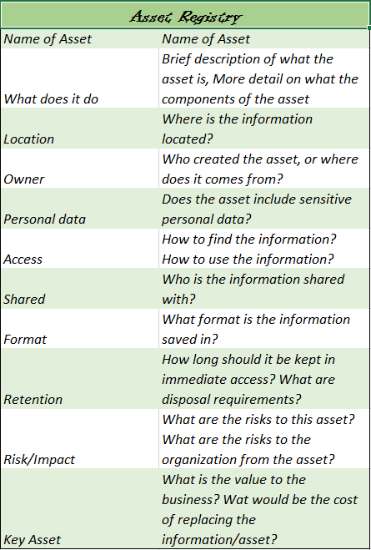
Figure 1. Asset Registry.

Prioritizing Assets
Prioritizing assets so that resources can be better organized, requires that the organization survey the criticality of those advantages in connection to the sorts of dangers they confront and the probability of those dangers happening. Doing as such limits the remediation scope. It is basic that the criticality of every benefit is adjusted with the seriousness of the dangers confronted so that a risk level can be resolved for every asset. Notwithstanding the estimation of a specific resource for an organization, another prime thought is regardless of whether that benefit is liable to any compliance or governance prerequisites that may need to meet certain safety efforts. For instance, servers that contain and store client data such as human resources documents must be restricted to particular users as well as the information within should be encrypted.
When establishing asset prioritization evaluations, an assortment of logical data is likewise basic to accumulate, for example, resource sort, design status, and weakness status. This sort of data should be gathered from numerous sources, including the IT division for data with respect to arrangements and vulnerabilities, the specialty unit that uses the resource to evaluate business hazard, and the legitimate office for surveying consistence necessities. Figure 2 and 3 show Dynamic Engineering Software Inc. assets and its priority value on a scale of one to 10 and the risks faced by the organization, its impact, likelihood and
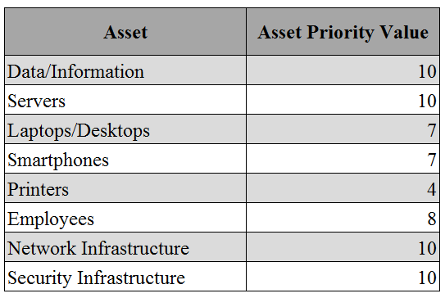
Figure 2. Assets and Assets Priority Value.

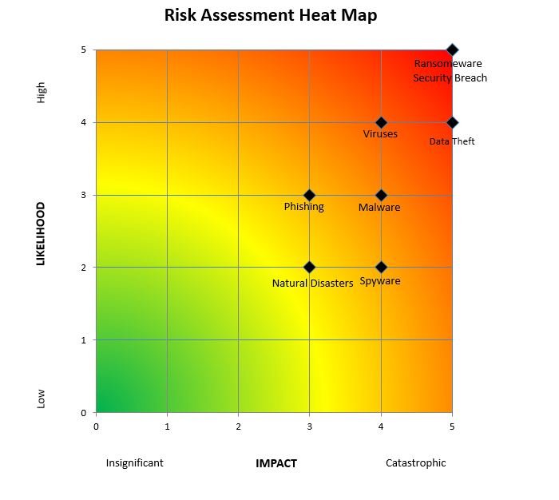
Figure 3. Risk Assessment Heat Map.
Figure 3 identifies the risks that may impact Dynamic Engineering Software Inc. environment. In order to examine and select fitting mitigation processes, a risk assessment can be made for every asset once data gathering has been finished. For instance, if a danger is probably going to happen, yet the results are negligible in light of the fact that the asset is of little esteem, simple, minimal effort mitigation procedures can be appointed to it. On the off chance that a risk is very far-fetched to happen, however the results are grave on the off chance that it does, that asset can be given a higher remediation priority. Accordingly, remediation choices can be chosen that have the best cost/advantage adjust for lessening hazard. Rating resources by criticality is a standout amongst the most fundamental procedures in making business coherence abilities and is center to successful hazard administration. Making an organized perspective of all benefits, as indicated by their business esteem, will help in guaranteeing that remediation endeavors are engaged where they are required most, and also guaranteeing consistence with commands that request that the most basic resources are ensured.

Risk Assessment Tools and Methodologies
The following tools and techniques were used to conduct Dynamic Engineering Software Inc. risk assessment:
- Risk probability and impact assessment
- Probability and Impact Matrix
- Risk Categorization
- Vulnerability Assessment
There is an unmistakable separate between the need to oversee hazards crosswise over associations and the procedures that associations have set up for doing as such. The best way to viably oversee hazards over an association is through execution of powerful procedures.

Security Architecture Plan (Week III)
With the increased cases of cyber security ranging from malware, viruses to security breaches and natural disasters, it is essential that appropriate technologies be carefully and purposefully be installed to prevent and lower the incidences of data loss to third parties. Therefore, alternatives to do so will be explored through a wireless system technology WPA2-PSK that can be used for protection against malware, spyware, ransom ware, phishing, data theft, viruses, and security breaches and natural disaster.

Technologies
The Wi-Fi Protected Access 2-Pre –Shared Key is a technique for securing a network using discretionary Pre-Shared key (PSK) authentication. Originally, the WPA2-PSK was specifically designed for home users without an enterprise authentication server.WPA2 provides excellent protection, and it is also easy to apply. Encryption with a WPA2-PSK requires the provision of a paraphrased English passphrase of 8 to 653 characters to the network router. Temporal Key Integrity Protocol in conjunction with the network SSID the technology generates unique encryption keys to be used by each wireless client (Agarwal, Biswas and Nandi, 2015). Additionally, the WPA2 makes use of secure encryption algorithm AES that is very complex to be cracked WPA2 uses the Counter Mode with Cipher Block Chaining Message Authentication Code Protocol based on the Advanced Encryption Standard Algorithm (AES) for both authentication and data encryption.
Furthermore, the WPA2 technology is applicable both for personal users and enterprises protection. In personal mode application, the PSK is integrated with SSID to produce a Pairwise Master Key after which the client and the AP provide exchange information using the PMK to generate the Pairwise Transient Key (Vanhoef, Piessens and iMinds-DistriNet, 2016). In an enterprise application, after a successful authentication using one of the EAP methods, the client and AP receive messages from the server that both use in creating the PMK.They then exchange the information to create the PTK and then the PTK is used for encrypting and decrypting messages.WPA2-PSK is a better technology fit for controlling the stated threats since it is a right element for personal data security. With the Wi-Fi network, you can be bale to control who connects to the network as well as ensuring the privacy of transmissions since communications cannot be read by others as they travel across the network.
WPA2-PSk placement is considerate of a Wi-Fi-wireless network, and therefore this technology should be placed within Dynamic Engineering Software Inc. setting WIFI wireless network for efficient control of accessibility and protection of personal records and other valuable information. With the technology, the company personnel would be able to configure each WLAN node such as access points, wireless routers, client adapters and bridges using the plain English passphrase (Vanhoef, Piessens and iMinds-DistriNet, 2016). Besides, the technology being wireless is critical in authenticating when users connect to the network because it is password enabled and hence anybody who wants to access it must have the password for them to access the system. In addition to the aforementioned technology, IDS/IPS, firewalls, switches and routers will be placed to protect the network infrastructure and therefore the data and other critical assets within the network. Figure 4 offers the Dynamic Engineering Software Inc. network infrastructure along with the technologies that will protect this.
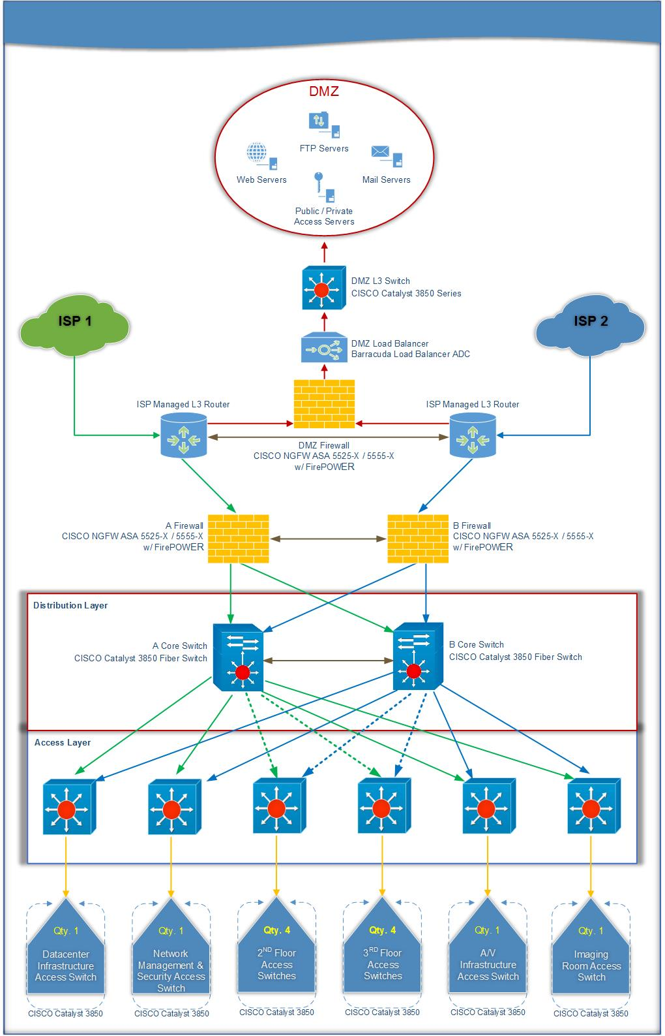
Figure 4. Dynamic Engineering Software Inc.
Understanding the wireless security networks is one of the most challenging parts because it demands adequate consideration of how best to implement them and therefore the need to correlate them with the OSI model. Installation of a wireless technology requires attention to the wireless intrusion detection and prevention factors that protect your software against threats to the WPA2 as well as those from the wireless WLAN.The technology has the Encrypted Logarithm that has the ability not only to detect and block the security threats, but it is also able to identify the physical location of the offender.
Additionally, the placement plan of the wireless technology is critical in the identification of the IPS signature that scans the data that stream in the organization Wi-Fi system for authentication purposes.WPA2 has 802.11i data link which coupled with the AES provide for a higher level of encryption and security on the data stream from the access point to the company network and therefore it is easy for the company IT department to maintains their safety profile (Vanhoef, Piessens and iMinds-DistriNet, 2016). Layer three of OSI model focus on the Network Access control lists and therefore in the WPA 2 technology plan, the system is well fitted with password controls for regulating access to the network. The password enabled system facilitates the control and deny medical records from streaming as well ensuring that the actual IP address and network identifier to the greater internet.
The centralized location of the WPA2 technology also ensures that only data streams of a known connection state will be allowed to transverse through the stem while the unknown stream will be discarded. The added layer of security enhances authorized configuration of the destination in the centralized controller. Moreover, WPA2 technology lets network administrators configure access to WLAN based on connection type or end user authentication and thus easy to identify a login made from an unknown PC.

Security Controls
Dynamic Engineering Software Inc. personnel must protect sensitive data such as personal records that are transverse between companies systems and Wi-Fi networks. Data safety in technological organizations concerns itself with the safeguarding facilities, adequate restriction to access resources and protection of private information. Hence deficits in data security in a technological setup are hard to identify which pose a threat to data security (Vockley, 2016). Organization managed devices, as well as those devices brought in the company staff and guests contribute to the diversity and the complexity of the network management. Without proper Wi-Fi security in place, unauthorized use could hack the Wi-Fi packets to gain access to the company’s network. Confidentiality and non-exposure is also another security control that is of concern as well as the man in the middle attacks company data.

Mitigation of the Risks
Wi-Fi security risks are moderated through good security practices, and hence a foundation of high safety is the enterprise version of the general protected access that is best fit in this situation. The technology provides both access control and privacy of information as they travel across the network. Therefore, deploying WI-FI certified equipment and services which are required to implement the WPA2 security protocols. In mitigation of the confidentiality risk, the WPA2 enterprise uses AES encryption in ensuring overall protection of data from reaching unauthorized persons. The packets are encrypted such that it is only the authorized recipient can decrypt the packets and view data. Mitigating the man in the middle attacks requires configuration of every Wi-Fi devices to ensure that they connect only to trusted networks.
In summation, WPA2 provides a strong security foundation through the use of the WPA2 enterprise and hence a critical technology in security risks management. Administrators should look forward to deploying WI-FI certified and efficient equipment for network use. The recommendation made emphasize on the deployment and configuration of WPA2 in Dynamic Engineering Software Inc. as well as management of the WI-FI devices by the company administrators to avoid traversing personal records, trade secrets and other sensitive critical data to unauthorized persons.

Security Policies (TBD)
Mitigating risks in the organization is essential and key for security . Policies are a great way to maintain this risks at bayThe policy is defined as the principle that is followed by the company so as to make decisions. It provides the guidelines of the set of the activities that are supposed to be used (Kayser et al. 2016). Also, makes the HR to have an easy task while conducting all of its operations. The main advantage of a policy is that it set rules that management and staff should follow hence eradicating conflict. The following are some of the policies that will be implemented for Dynamic Engineering Software Inc.
Policy I. Guarantee all OS patches are applied and up to date- Administrators will utilize computerized tools, if accessible, to develop a specific list of all at present installed programming on servers, workstations, and other network gadgets. A manual review will be directed on any framework or gadget for which a mechanized device is not accessible.
Policy II. Enforce passwords are strong and changed regularly- Passwords must be changed every 60 days and this must not contain the user’s account name, this should be at least eight characters long, should contain uppercases and lowercase letters along with numbers and non-alphanumeric characters. Users will be informed to change old passwords, if for some reason an account becomes expired this will be disabled until password is properly reset. This will ensure that accounts are monitored and disabled once expired.
Policy III. Report suspicious bogus emails to the proper authorities- The email server will count with additional protection against malware. Besides having the standard protection tool, the email server or intermediary server will also incorporate which will be utilized to output all email for infections as well as malware. This scanner will examine all email as it enters the server and output all email before it leaves the server. Also, the scanner may filter all stored email once every week for infections or malware.
Policy IV. Antivirus Policy- Dynamics Software INC will use a single antivirus protection tool and this tool will be Symantec Endpoint Protection. Some requirements apply for this policy. The protection tool must be operate in real time on all systems to include client computers and servers. The antivirus library should be updated once a day, as a minimum. Scans should be performed at least once per week on all users’ stations and servers.
Policy V File Exchange Policy- This policy will describe the specific approaches in which files can be transferred/sent into the network by employees and staff. This will specify all approved approaches including FTP transmission to a FTP server. Also, file transferring to a web server with an approved file upload program must be provided. The strategy and sort of programming to be utilized to filter the documents for hostile content before they are totally moved into the system will be provided as well. It will likewise indicate the refresh recurrence for the examining programming.
A quality policy should be built in a way in which enhances consumer’s satisfaction and mostly security, these are to be followed by a systematic manner. The policy ensures that the company is improving its performance and also the delivery of the services. Certain standard has already been set that are supposed to be attained by everyone, including every worker in the company (London, C. 2005). To monitor the policy, the managing director ensures that all employees are aware of what is expected from them. Also, ensuring that all the systems needed are in place and if of any change, it is communicated in advance. Another way is by the setting of the standard to be followed by each employee in an organisation.
In the organisation those who fails to reach the standard set by the company will be considered violators. The perfect punishment for those who do not attain the requirement that is needed will be subjected to a certain punishment. Each employee/staff will have a certain level of point per year, which will be deducted as he/her engage in a violation of the company policies. A target is going to be set is a certain mark, once this is reached then the employee will be fired. Failure to engage in proper web, computer, password and other policy procedures that are being offered will amount to three points. If the points accumulate to 40, the employee will be laid off. The organization standard will be reviewed after every month, and if of any adjustment, it will be communicated by memos, email, and active presentation offered throughout the organization’s premises. Hence the operation will make sure that the employees are always kept on toes with the organisation standard.
Another policy is the information security policy which has the mandate to preserve the company’s asset. Some documents that are meant to be protected and never to be accessed by unauthorised people outside the organisation. The only way to monitor the policy is by creating a password that is not to be given to everyone in the organisation. Data and companies proceedings are the things that are protected. Another way of ensuring that they are safe is by monitoring the activities of the employees. This is done by interconnecting of the computers and seeing what each one is sharing.
The only way to punish those who are found guilty is by violating the policy is by firing them and opening legal proceedings. Before hiring the employee, they are supposed to be informed of the firm stand if anyone is found violating the rules. IT expert should be hired to ensure that the system is not vulnerable to hacking. The system should be checked after every week and updated.

Incident Response (TBD)
With the help of a good ICT department, it is easy to detect any case of external source accessing the company information. Each department is entrusted with its responsibilities that are meant to be followed. All departments report to the manager who is in charge of the section. Manager reports all the activities taking place to the managing director of the company. Therefore, if there is an incident, there is a protocol that is followed (Shorr et al. 2008). Any incident that is reported is reported to the manager in charge of the section which informs the managing director.
If an incident arises the protocol if followed, then the general director classifies the incident according to the origin. For instance, if the incident is that of hacking the system the IT department is the one responsible. Classification of the incident depends on nature and the section that it has originated from. The management has set departments within the organisation. Each department has its mandate and jurisdiction. Some of the incidents that may affect the industry are public opinion and internal affairs. The criteria of the incident depending on the damage that has already been done and the procedure that is going to be successfully used so as to mitigate (Arabi et al. 2012).

Reporting Incidents
Some of the incidents that are mostly reported are a notable severe occurrence, minor notable occurrence, significant incidents and reportable incidents. For each of the following identified have its way to respond to it. The manner in which each incident is going to arise is what will dictate the method that is going to be used. Starting with serious incidents, they are supposed to be given priority in the institution and everyone within the organisation is expected to respond to the crises. Secondly is reportable, where the manager is the one supposed to deal the incident. An example of the incidents in this phase includes worker negligence, inappropriate use of the organisation resources among others.
The third type of the significant incidents they are handled by the managing director of the organisation. The example that is under this phase is missing worker, mistreatment and cases of theft among other. Hence it is mostly concerned with the proper treatment of the employees and the firm. The minor occurrence is given response depending on the weight they have in the organisation. After the incident has been identified there is an immediate response. The plan that is used depends on the weight if it is a case of hacking the system the hacker is blocked and traced. Therefore an immediate action is taken regarding the nature of the incident so as not to affect the whole organisation. The second one is that legal claims are laid against those who have violated the organisation. If the incident cannot be solved within the organisation or it is against the constitution police are involved.
For instance, an incident that is considered a low severity will have small impact on systems and/or individuals and will have no risk of proliferation. In the other hand, a medium severity event can adversely impact affect non-critical systems or services within the organization. This can also disrupt departmental network system. Now, a high severity incident can certainly pose significant impact on a vast amount of systems, users and other infrastructures. This will also bring potential financial risks and even possible legal liability to the organization. High severity incidents have the potential of spreading to other systems producing serious damages. Figure 5 shows a clarification matrix for incident response.

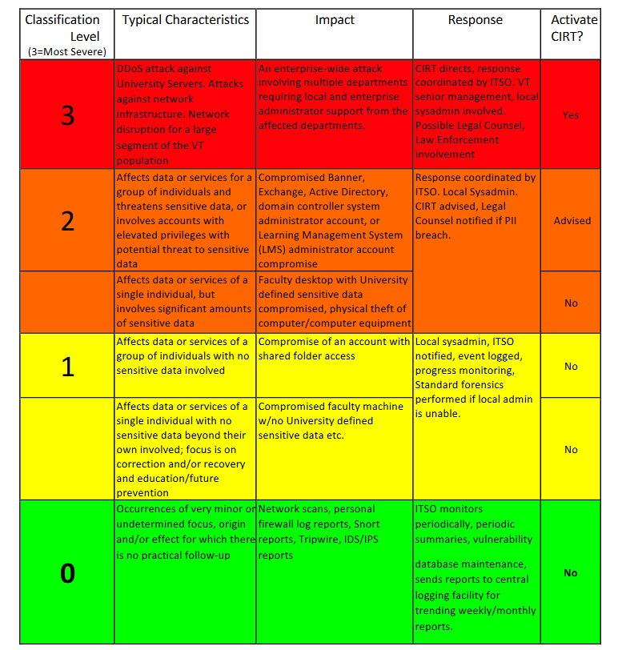
Figure 5. Incident Response Classification Matrix
After mitigating the issue that was identified it is the duty of the manager is to ensure that a repeat of the same will not be witnessed again. So as to make sure that the incident will not be repeated an evaluation considering the damage left behind should be carried on.
Preparing for incidents is always an important phase for any organization. For instance, if the organization counts with a poor logging and auditing practices this will certainly make the job more tedious and stressful. Therefore, it is essential to enable logging up to the highest detail level that the servers can process. Carrying out this process will allow for more information to be obtained in case something needs to be reconstructed or troubleshooting server issues as well. This process can be used with UNIX and open source OS as well. For instance, when talking about Windows OS, one can play with the logging settings by utilizing Event Viewer Administrative Tools. Each of the logging level settings can be adjusted. Furthermore, some other processes that can be taken for UNIX OP include reviewing log files, installing software firewall tools, installing clean version of the OS on the affected system and analyze intrusion. Last, utilizing IDS will allow for the identification, analysis, and tracking of threats and security incidents. There are different methods and techniques that can be used to carry out forensic analysis on information systems. In order to do this, there are several tools that can help in the process. One of these forensic tools include Fport which is a process identification tool for Windows OS. This tool is of great for investigating suspicious activity. “Fport looks for open TCP or UDP network ports and prints them out along with the associated process id (PID), process name, and path” (Howlett, 2005). Isof is a port and process identification tool that enables the association of open files with procedures and users. This also provides reports regarding the network port X or Y service is using, allowing great capability when tracking an active program within the network. This tool can be used with UNIX and open sources.

Evaluating and Testing Incident Response Plan
Evaluating, testing and updating the incident plan is key for the successful resolution of future incidents. This steps are very important, if not the most essential for maintaining an effective plan. Some of the elements that can be helpful during the phase of evaluation, testing and updating are the following:
- Was the incident detected and analyzed effectively by the teams?
- Was the response to the incident appropriate? Or could response efforts have done thigs differently?
- Was the danger controlled and eliminated properly? Timely?
- Was the gathered information shared through proper channels during the incident? Proper personnel?
These series of questions will allow to determine if there is any need to update, adjust or eliminate roles and responsibilities with the end to strengthen security. All departments should be involved in the post-incident evaluation process. This will enable better communication and understanding of how to manage incidents. It is basic to audit and test the organization’s interior communication plan before a security occurrence happens. Honing the correspondence chain spares valuable time when an incident raises. Time is of the quintessence, and communication systems have a tendency to be the principal asset to separate amid security occurrences. In addition to this suggestions, it is also recommended to carry out exercises that will help test and evaluate the incident response plan. These exercises include tabletop and functional exercises among others.

Implementation Plan (TBD)

References
Agarwal, M., Biswas, S., & Nandi, S. (2015). Advanced stealth man-in-the-middle attack in wpa2 encrypted wi-fi networks. IEEE Communications Letters, 19(4), 581-584.
Arabi, Y., Alamry, A., Al Owais, S. M., Al-Dorzi, H., Noushad, S., & Taher, S. (2012). Incident reporting at a tertiary care hospital in Saudi Arabia. Journal of patient safety, 8(2), 81-87.
Bulgurcu, B., Cavusoglu, H., & Benbasat, I. (2010). Information security policy compliance: an empirical study of rationality-based beliefs and information security awareness. MIS Quarterly, 34(3), 523-548.
Cisco. (2017a.). Cisco 40000 Series Integrated Services Routers. Retrieved from http://www.cisco.com/c/en/us/products/routers/4000-series-integrated-services-routers-isr/index.html
Cisco. (2017b.). Cisco Firepower 2100 Series Retrieved from http://www.cisco.com/c/en/us/products/security/firepower-2100-series/index.html
Cisco. (2007). Cisco Catalyst 3850 Series Switches. Retrieved from http://www.cisco.com/c/en/us/products/switches/catalyst-3850-series-switches/index.html
Computer Hope. (2017). TCP/IP. Retrieved from https://www.computerhope.com/jargon/t/tcpip.htm
Computer World. (2015). Do you know How to Protect your Key Assets? Retrieved from http://www.computerworld.com/article/2892229/detecting-the-insider-threat-do-you-know-how-to-protect-your-key-assets.html
Hewlett Packard. (2006). Understanding Inventory, Configuration and IT Asset Management. Retrieved from http://www.techworld.com/cmsdata/whitepapers/4315/4aa0-6093enw.pdf
Howlett, T. (2005). Open Source Security Tool: Practical Applications for Security. Retrieved from https://ebooksbvd.my-education-connection.com/read/9781323593431/filed9e172_xhtml
Kayser, J. B., Mooney-Doyle, K., & Lanken, P. N. (2016). Definitions and policy. Palliative Care in Respiratory Disease (ERS Monograph). Sheffield, European Respiratory Society, 1-20.
London, C. (2005). Management effects on quality policy implementation. The TQM Magazine, 17(3), 267-278.
MacMillan, I. (2015). Do you Understand your Company’s Knowledge Assets? Retrieved from https://www.weforum.org/agenda/2015/04/do-you-understand-your-companys-knowledge-assets/
Microsoft. (2003). What is DHCP? Retrieved from https://technet.microsoft.com/en-us/library/cc781008(v=ws.10).aspx
Mitchell, B. (2017). DNS (Domain Name System). Retrieved from https://www.lifewire.com/definition-of-domain-name-system-816295
Networking Specialists. (2017). How to Identify and Protect your Company’s Key Assets. Retrieved from https://www.gfnetspec.com/how-to-identify-and-protect-your-companys-key-assets/
Shorr, R. I., Mion, L. C., Chandler, A. M., Rosenblatt, L. C., Lynch, D., & Kessler, L. A. (2008). Improving the capture of fall events in hospitals: combining a service for evaluating inpatient falls with an incident report system. Journal of the American Geriatrics Society, 56(4), 701-704.
Sophos. (2017). Next-Gen Protection. Retrieved from https://www.sophos.com/en-us/products/endpoint-antivirus.aspx
Vanhoef, M., Piessens, F., & iMinds-DistriNet, K. U. (2016, August). Predicting, Decrypting, and Abusing WPA2/802.11 Group Keys. In 25th USENIX Security Symposium (USENIX Security 16) (pp. 673-688). USENIX Association.
Vockley, M. (2016). Making Wireless Work: A Look at What Hospitals Are Doing. Biomedical Instrumentation & Technology, 50(2), 92-101.

