Instructions: Using the study below and your skills working with SPSS, answer all the following questions. Use the SPSS data set named DataAnalysisFIU#1.sav for your data set.
Study: You just collected data for a study that looks at conformity. Participants are shown a vertical line (“Standard Line”) followed by three lines of varying length (“Comparison Lines”). That is, they are presented with the following picture:
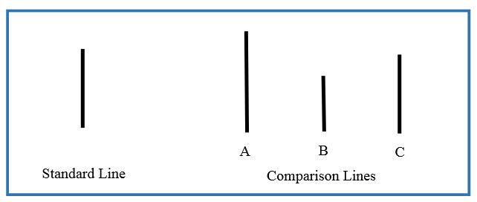
Participants are asked to choose which of the three comparison lines matches the length of the original standard line (which, obviously, is Comparison Line C). They are randomly assigned to make their choice within one of three “Group” conditions: 1) they compare lines in a group of strangers (“strangers”); 2) they compare lines in a group of close personal friends (“friends”); or 3) they compare lines in a group that is made up of both strangers and friends (“mixed group”). All group members make their choice out loud, with the participant making his choice last. Unknown to the participant, all groups are comprised of experimental confederates who have been told to pick a specific line (“Line A”). Since the real participant responds last after all other participants chose Line A, the experimenter wants to see if the participant will similarly choose the incorrect Line A. The research thinks the participant will conform more frequently (choose the incorrect line) when his personal friends are among the group members.
All group are asked two questions about each comparison line. For example, when asking about Comparison Line A, the participant is asked: 1). Is Comparison Line A the same length as the Standard Line (Yes or No)? 2). On a scale ranging from 1 (not at all likely) to 9 (extremely likely), how likely is it that Comparison Line A is the same length as the Standard Line? When asking about Comparison Line B, the participant is asked: 1). Is Comparison Line B the same length as the Standard Line (Yes or No)? 2). On a scale ranging from 1 (not at all likely) to 9 (extremely likely), how likely is it that Comparison Line B is the same length as the Standard Line? When asking about Comparison Line C, the participant is asked: 1). Is Comparison Line C the same length as the Standard Line (Yes or No)? 2). On a scale ranging from 1 (not at all likely) to 9 (extremely likely), how likely is it that Comparison Line C is the same length as the Standard Line?

Question 1: What is/are the independent variable(s) in this study, and how many levels are there to each?

Question 2: What is/are the dependent variable(s) in this study, and what scale of measurement are they based on (NOIR).

