Intelligence Theories Analysis
Maureen Rogerson
University of Phoenix
Dr. Tanya Bradwell
June 5, 2017
Intelligence Theories Analysis
- Primary mental ability intelligence theory- Louis L. Thurstone
- The Triachic theory of intelligence- Robert Sternberg
- Measuring intelligence function
- Difference between intelligence and academic excellence

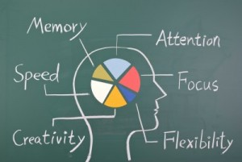
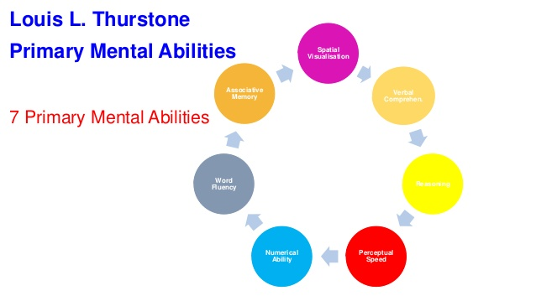

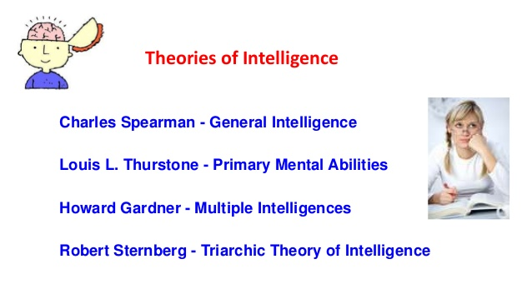

Primary mental ability intelligence theory- Louis L. Thurstone
The psychologist, Louis L. Thurstone came up with the primary mental ability intelligence theory. Using the approach, he explores seven different abilities of the mind, and these are verbal comprehension, spatial visualization, associative memory, numerical ability, reasoning, fluency of word as well as perceptual speed. These abilities he explained are the most relevant and should be used to determine the level of intelligence for anyone, including children. In the article, “Are you smart, or smart enough?” by Leon F. Seltzer, the impact of these mental abilities are analyzed. After the analysis, he reports that being intelligent necessarily does not show in the academic performance of an individual and therefore, brilliance is not a measure of intelligence.

The Triachic theory of intelligence- Robert Sternberg
Robert came up with a report in which he categorized intelligence into three categories. First, the analytical abilities that enable a particular person to solve the problems that are in their environment. The second type is the creative intelligence which is the capacity and ability to experience new circumstances where they apply their experiences in the past as well as the skills they have to overcome the situation. In the article, “Intelligence, sleep, and school achievement” by Joseph A. Buckhalt helps to explore the tragic theory of intelligence. The author studies a group of children and their sleeping patterns. He also explores their achievement in school. The findings show that intelligence is higher for children that had long hours of sleep.

Measuring intelligence function
To measure intelligence, it is important to consider some factors. These are as discussed below. One, the reasoning capacity of an individual. The ability to make the right choice when presented with a given situation can be used to show the reasoning capacity of an individual. Those that respond appropriately could be highly intelligent while those that do not respond as anticipated are of little intelligence. The second measure of intelligence is the analytical abilities of an individual. The analytical capabilities enable an individual to identify the existing problems in a situation and give the right solution to overcome these challenges.
Difference between intelligence and academic excellence
Life is comprised of many factors. Some of these include academics and while others require wisdom as to make the right choices. Intelligence helps an individual to reason and analyze different situations and then make the best choice out of it. On the other hand, academic intelligence only enables people to solve academic problems but fail when it comes to matters relating to life decisions.

References
- Are You Smart, or Smart Enough? | Psychology Today. (n.d.). Retrieved from https://www.psychologytoday.com/blog/evolution-the-self/201705/are-you-smart-or-smart-enough
- 3 New Findings On Human Intelligence | Psychology Today. (n.d.). Retrieved from https://www.psychologytoday.com/blog/finding-the-next-einstein/201607/3-new-findings-human-intelligence?collection=1098993
- Intelligence, Sleep, and School Achievement | Psychology Today. (n.d.). Retrieved from https://www.psychologytoday.com/blog/child-sleep-zzzs/201612/intelligence-sleep-and-school-achievement?collection=1098993

