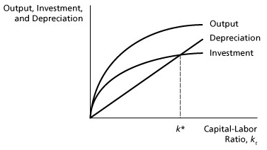
Suppose now there is a one-time permanent increase in total factor productivity.
a) Demonstrate how the change affect the Solow diagram, i.e., which function(s) in the graph above is (are) affected and how? Provide clear explanation.
b) How do(es) the change(s) described in (a) affect the steady state? Explain.

