Implementation

The first step to start fabrication of the project it is collect the components, on this basis, chose iron to manufacturing automatic lifter.
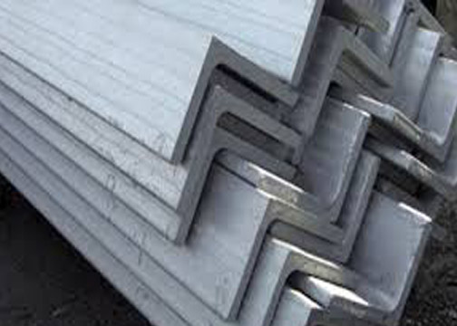
In beginning start to building the base of the lifter by using the iron triangle shape. The shape of the base rectangular, so the length of the base 70 cm and the width is 60 cm. for this step the parts fixed by using welding.

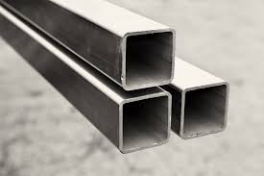
The second step is make the ribs by putting a hole in the center of iron square bar and fixed the between together by using the bolts. choose this type of iron for not happen any bending of the ribs during use the lifter.

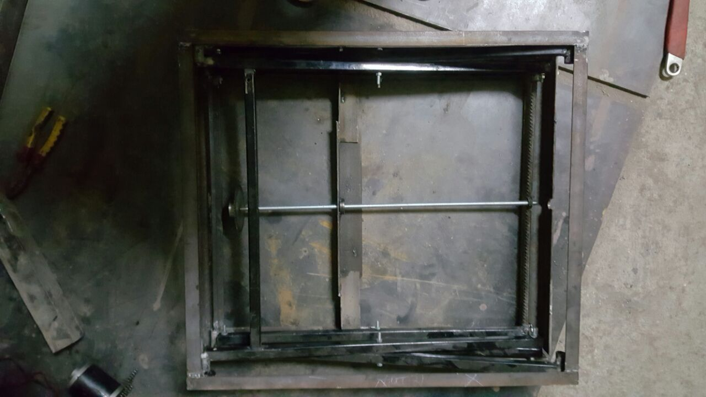
The third step it is make the upper base and in this step, use same iron to building the first base to be more consistency shaped of lifter.

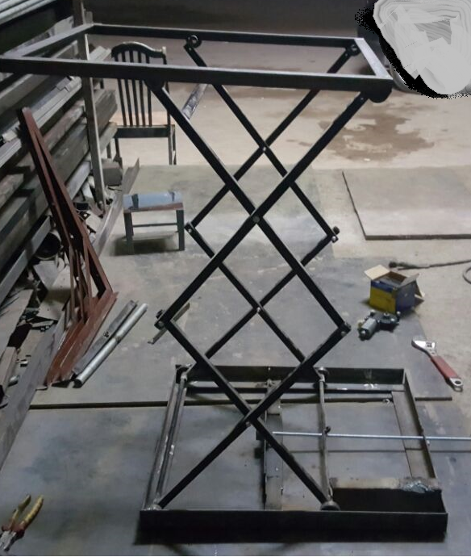

In this figure show the shape of the lifter after built by using iron. In the next steps shown how to make liter is working by fixing the DC motor, Gears and chain.

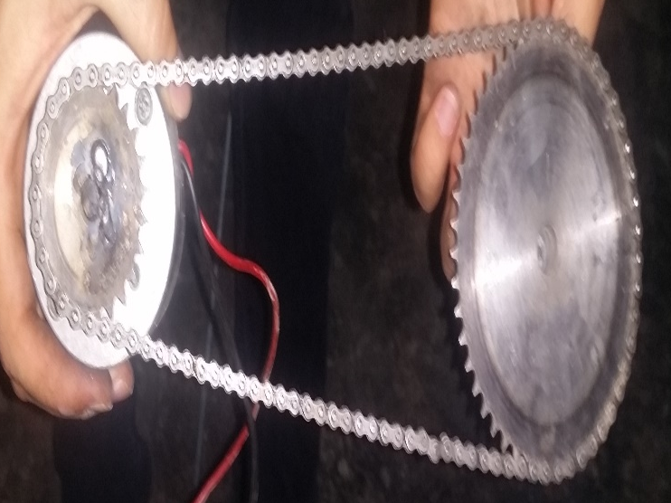
In this step, connect the chain with two gears, the big gear 28 teeth, and second small gears 14 teeth.
The small gear is fixed in the DC motor, so this design same idea of bicycle to work in comfortably way.

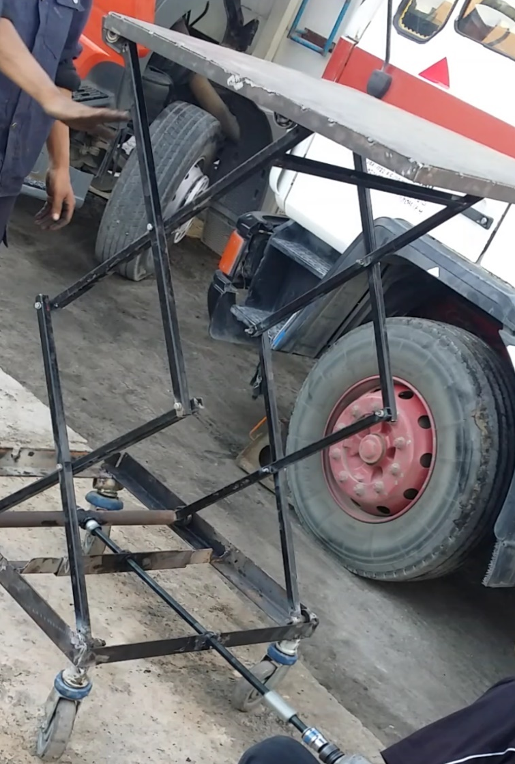
This final stage of fabrication of project after fixed the wheels and after but the moving base. Also in this stage testing the project under different condition and try to make sure it is works great

Chapter 5 result and analysis
In this chapter, will discuss the result of scissor lifter, will test four different weights to determine the durability of the lifter, with measuring torque, the time required to reach the highest point and the maximum load of the lifter

show figure the final prototype for scissor lifter. where the base go up 1.6 meters and the base is 60cm*70cm=4.2 m². So will

 | 5K | 15K | 25K | 50K
Torque | 5*10 ms⁻²  50N*1.6m  =80 Nm | 15*10 ms⁻²  150N*1.6m  =240 Nm | 25*10 ms⁻²  250N*1.6m  =400 Nm | 50*10 ms⁻²  500N*1.6m  =800 Nm
Time | 8s | 13 s | 18 s | 22s
Speed | 1.6m/8s  0.2 ms⁻¹ | 1.6m/13s  0.123 ms⁻¹ | 1.6m/18s  0.08 ms⁻¹ | 1.6m/22s  0.072 ms⁻¹

The table shown the torque of the DC motor when increase the mass on the other hand the increase time and decrease speed. Deduce there are an inverse relationship between mass and speed, also direct relationship between mass and time determination

After use the excel program, the figure show the result of the table torque under different condition of load and after that calculate speed with time.

