Part I. Aerobic Target Zone
- To determine your exercise heart rate target zone, take 220- your age =
______ Maximum Heart Rate (MHR)

- Then multiply that by 0.80. This is your upper range of where your heart rate should be. ______
- Multiply that number (220 – your age) by 0.50; that is your lower range. ______
Part II. Cardiovascular Fitness
Go on a treadmill, a pre-determined mile long trail or track and record how long it takes to run or walk a mile: ______minutes.
How does that compare to your reference group below?

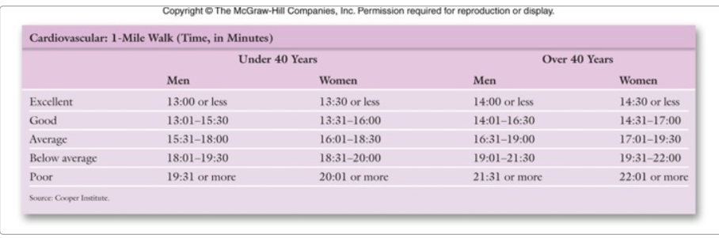

Part III. Push-Ups
Lie face down on the floor. Get on your toes and hands (or on your hands and knees). And record the number of push-ups you can do: ______ Number of Push-Ups
How does that compare to your reference group below?

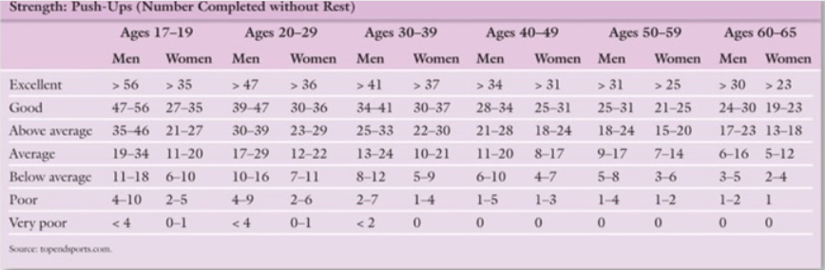

Part IV. Curl-Ups
Lie on your back with your knees bent, feet flat. Rest your hands on your thighs. Now squeeze your stomach muscles, push your back flat and push your upper body high enough for your hands to touch the tops of your knees. Don’t pull with your head or neck, and keep your lower back on the floor. Record how many curl ups you can do in a minute:
______ Number of Curl-Ups
How does that compare to your reference group below?

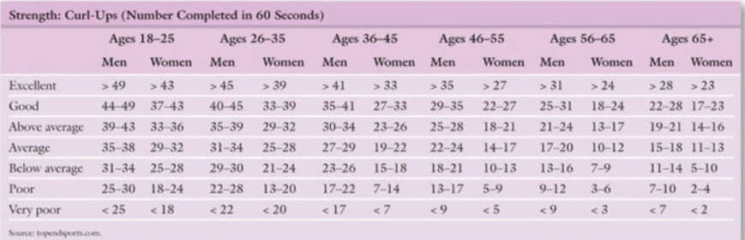

Part IV. Sit-and-Reach
Place a yardstick on the floor and apply a two foot piece of tape on the floor perpendicular to the yardstick, crossing at the 15 - inch mark. Sit on the floor with your legs extended and the soles of your feet touching the tape at the 15 inch mark, the 0- inch mark facing you. Your feet should be about 12 inches apart. Put one hand on the other, exhale, and very slowly reach forward as far as you can along the yardstick, lowering your head between your arms. Keep your knees from bending and don't bounce! Note the farthest inch mark you can reach. Don't hurt yourself by reaching further than your body wants to. Relax, then repeat 2 more times. Record your results.
How does that compare to your reference group below?
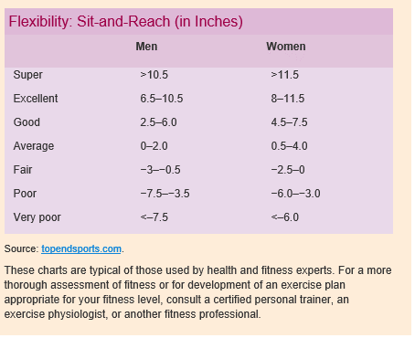
Questions:
- Define fitness. Define flexibility.

- What was your hypothesis? (It is acceptable if your hypothesis wasn’t supported by the data.)

- Describe what you found, including your results and responses for each of the above sections. Be specific about your performance in each area. You aren't getting graded on your performance, but rather on your thoroughness and thoughtfulness in completing the lab.

- Did your findings support your hypothesis? If not, speculate on what happened.

- What changes occurred as you began to run or walk? Why did that happen?

- Were you in the “aerobic zone?” What does that mean?

- What are some things that can affect aerobic fitness?

- What are the benefits of aerobic exercising?

- What did you notice as you started doing curl-ups? What happened after one minutes of doing curl-ups? Why did that happen?

- What is the benefit of doing curl-ups? What energy system were you using?

- What category did you fall into for each activity? Were you surprised at your fitness level? Why or why not?

