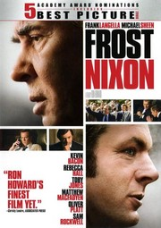
GSR 300: Preserving our Past for the Future: Creating Films for Deaf StoryCorps
Name ________________________________
Questions for the film – Frost/Nixon
1. Why did President Richard M. Nixon resign the office of the President of the United States and leave office on August 9, 1974?

2. Why did David Frost, a British talk show host, want to interview President Nixon after he resigned from office?

3. Why did the director of Frost/Nixon, Ron Howard, include actual footage of news reports that happened during the time of Watergate and Nixon’s resignation from office?

4. Why did Nixon and his people agree to be interviewed by David Frost? (There are a few reasons – please explain one).

5. Why are several people “interviewed” throughout this film? How do these interviews help the audience?

Over
6. Jim Reston, Bob Zelnick, and John Birt work together to research topics about Nixon. What do they hope to have Frost achieve during these interviews?

7. How do Jim Reston, Bob Zelnick and John Birt prepare for the interviews? How do they help Frost?

8. Describe the setting for the interviews. (Where did the interviews take place? What was the lighting like? How many cameras were used?)

9. Why did John Birt, Bob Zelnick, and Jim Reston think that the first three interviews did not go well?

10. How did David Frost get Nixon to confess that what he did was wrong during the last interview? What were his interviewing techniques like during this interview?

Reflect and write on these questions

- What film techniques did Director James Marsh use in order to tell the exciting story of Philippe Petit’s journey as he prepared to walk across a wire between the two towers of the World Trade Center in New York City?

- This film won an Academy Award for Best Documentary in 2009. What features do you think made this an Academy Award winning film?

