123
Place answers on Answer Sheet

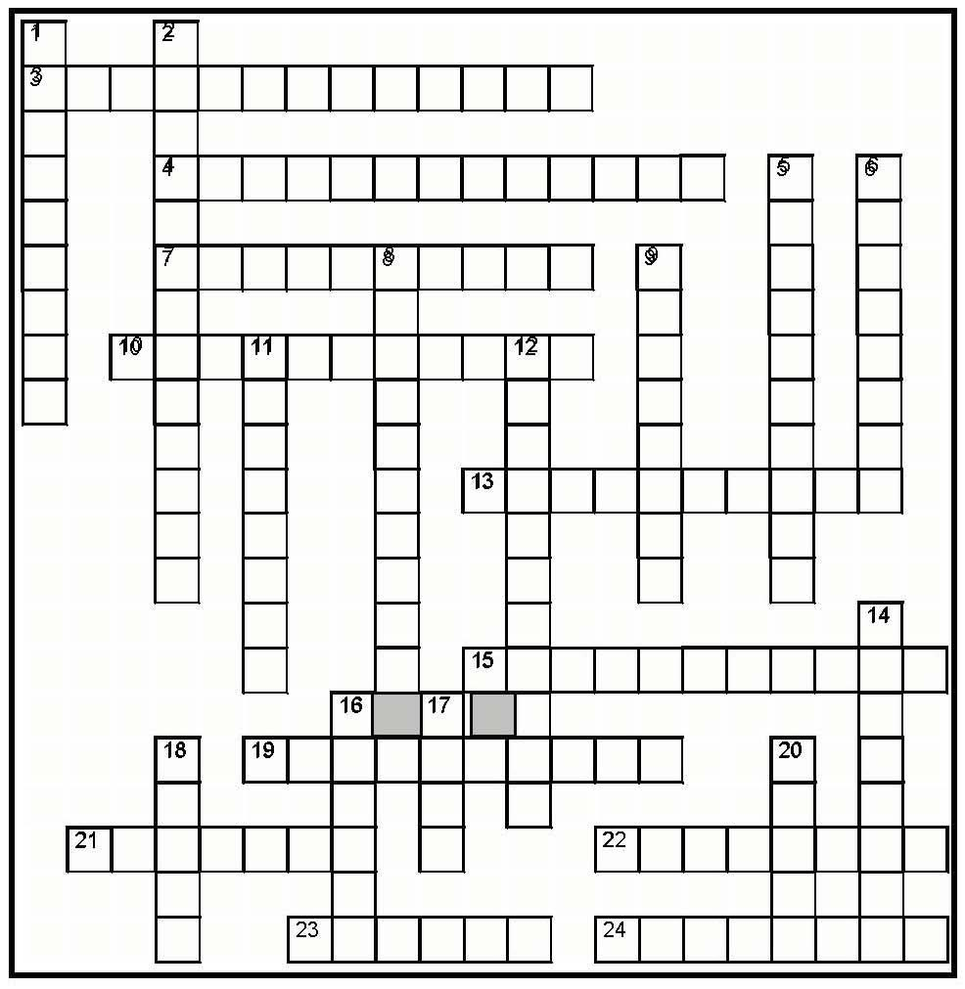
ACROSS
- With this, a contract is discharged by the law; Argument: “it can’t be done,” as opposed to “I simply cannot do it.”
- A unilateral contract offer cannot be revoked if the offeree has undertaken performance
7 This is the process of transferring to another all or part of one’s duties arising under a contract; one can always do this unless the performance is “too personal”
10 “A sheriff cannot claim a reward if he captures a criminal because his employment contract already requires him to do so. STATEMENT: The principle involved here is called “ duty.”
13 Where a contract is cancelled and the parties are returned to pre-contract status; can be done by the parties agreeing, or by their conduct, or by the law
15 With negotiations (also known as “invitations to negotiate”), this is not an offer, so cannot be “accepted;” Examples are advertisements, catalogues, and circulars
19 A contract that results when an offer can be accepted only by the offeree’s 100% COMPLETED performance (no contract comes into existence until the act is completely PERFORMED); “a promise for an act”
- I say, “I offer to sell you my car for $5,000.” You say, “I accept … it’s a deal! But, I’ll pay you
$4,000 instead.” STATEMENT: This is not a contract because this results in being a “ offer.”
- A contract that is binding, but may be legally avoided at the option of a party. This contract is not valid, void or unenforceable, but is “ ”
- If this “statute of” arises, the law requires that certain contracts must be in writing to be enforceable in court. NOTE: There is STILL a contract that the parties can VOLUNTARILY perform upon … it is only important if one of the parties refuses to perform: then it cannot be enforced (in court)
- With this kind of “performance” a court will require a breaching party to exactly do the thing contracted for; a very rare remedy … especially if damages could make the parties whole

DOWN
- A type of contract that arises when a promise is given in exchange or a return promise
- The thing of value that is “bargained for” in a contract; could be a benefit or detriment
- The effect of this makes a contract unenforceable, and a court will not usually aid either party; contract is often void because the parties are “in pari delicto”
- This involves the substitution of a new contract
for a previous contract and the removal of the original party’s rights and duties, substituted with a new party
- The act of transferring to another all or part of one’s rights arising under a contract; could be the rights to money, property, services, etc. However, cannot “increase the duty of the obligor”
- A contract is unenforceable if it is this kind; often offered on a “take-it-or-leave-it” basis where one party has stronger (unfair) bargaining advantage, and dictates terms

- A promise is enforceable even though it has no consideration if one can successfully argue this “promissory” thing. -Must contain a promise, reliance on that promise by the promisee, and a situation where it would be fair” for the courts to “stop” the promisor from denying contractual responsibility
- Although a minor’s contract is usually voidable, the contract is enforceable against him if the subject matter was for these. NOTE: A minor’s “station in life” is important in determining whether the items are these, or instead, luxuries
14 These kinds of “promises” are unenforceable because they are too vague and have no consideration. They seem to say something, but fail because they are uncertain (e.g., “I will pay you for the car … if I feel I can” (spelled backward)
- The reason why question #21 Across (above) is not a contract is because the “acceptance” violates “The Image Rule”

- This “consideration” is NOT consideration. It is an act completed BEFORE the contract is made; this cannot be consideration because one cannot negotiate (later) for something that was already done (previously)
- This is where a lender charges an illegal rate of interest on a loan; depending on the state: can make the whole contract void, OR principal collectible and up to the legal % rate for interest (and forfeit the balance), OR principle only (forfeiting all interest)
20 This is a kind of “contract” that is “Implied in Law;” -a fictional contract imposed by the courts in the interests of “fairness” and justice; usually imposed to avoid the “unjust enrichment” of one party at the expense of another

©2015

